- In Power BI Desktop, create a calculated column named 'OrderAmountINR' in a Sales table that multiplies the 'OrderAmount' column by 83 to convert USD to INR.

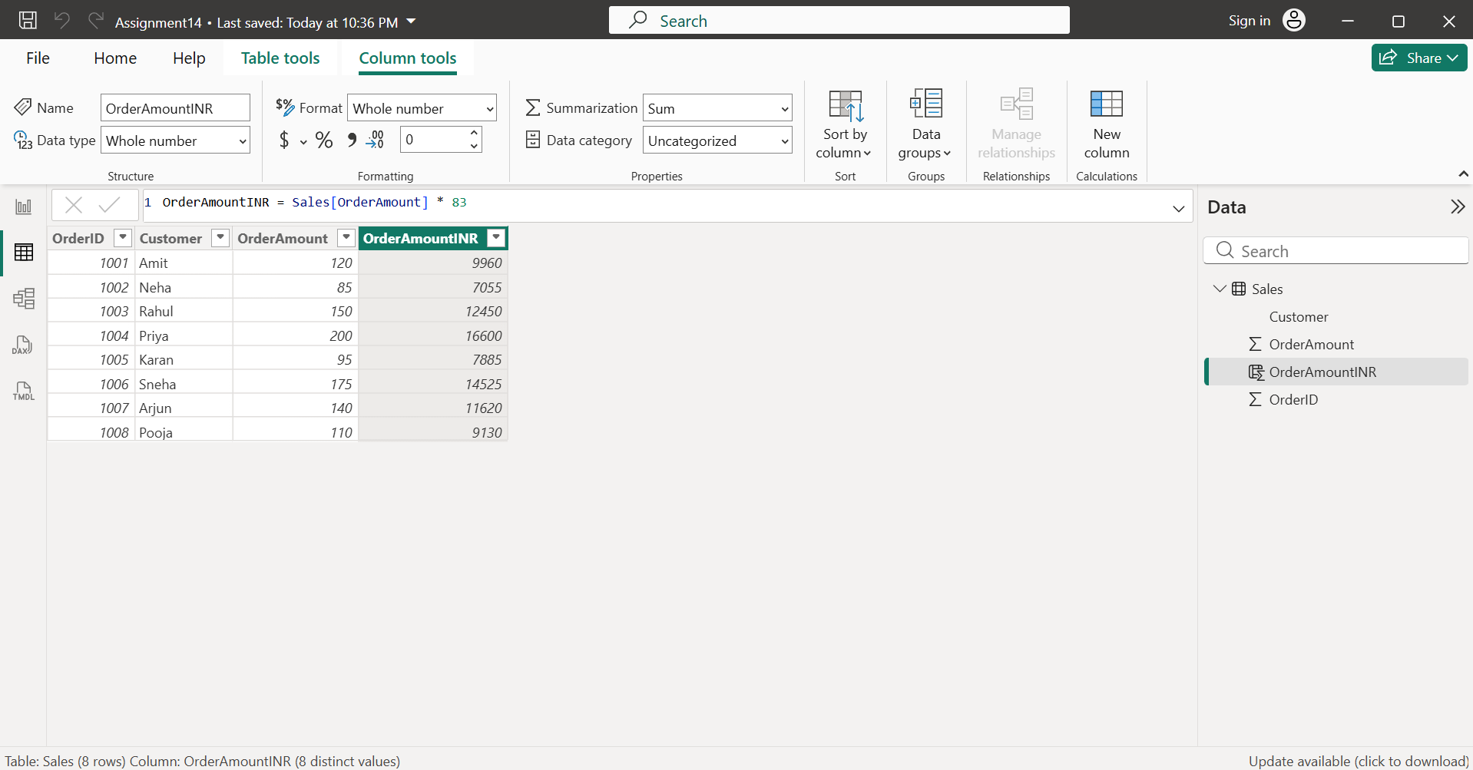
- Imported the Sales.csv dataset into Power BI Desktop. Created a calculated column named OrderAmountINR using the following DAX formula:
OrderAmountINR = Sales[OrderAmount] * 83
- The new column converts the OrderAmount from USD to INR by multiplying each value by 83.

- Build a DAX measure called 'TotalLikes' that sums up the 'Likes' column in a SocialPosts table, similar to how Instagram shows total likes for a user.

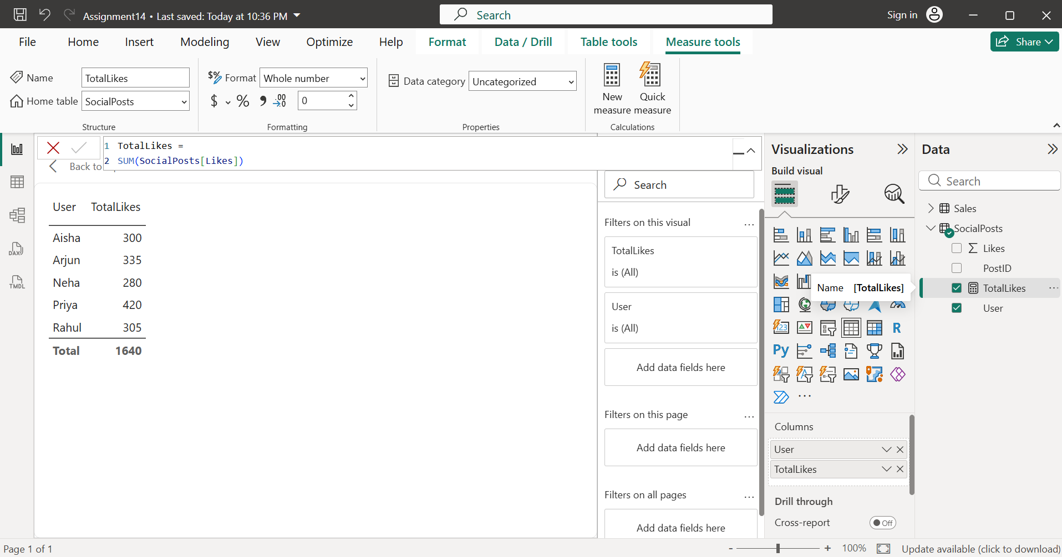
- Imported the SocialPosts.csv dataset into Power BI Desktop. Created a DAX measure named TotalLikes using the following formula:
TotalLikes = SUM(SocialPosts[Likes])
- Used this measure in a Table visual to display the total likes for each user.

- Create a slicer for 'Genre' in a Movies table and use a DAX measure to display the average 'UserRating' for the selected genre, like filtering movies by category on BookMyShow.

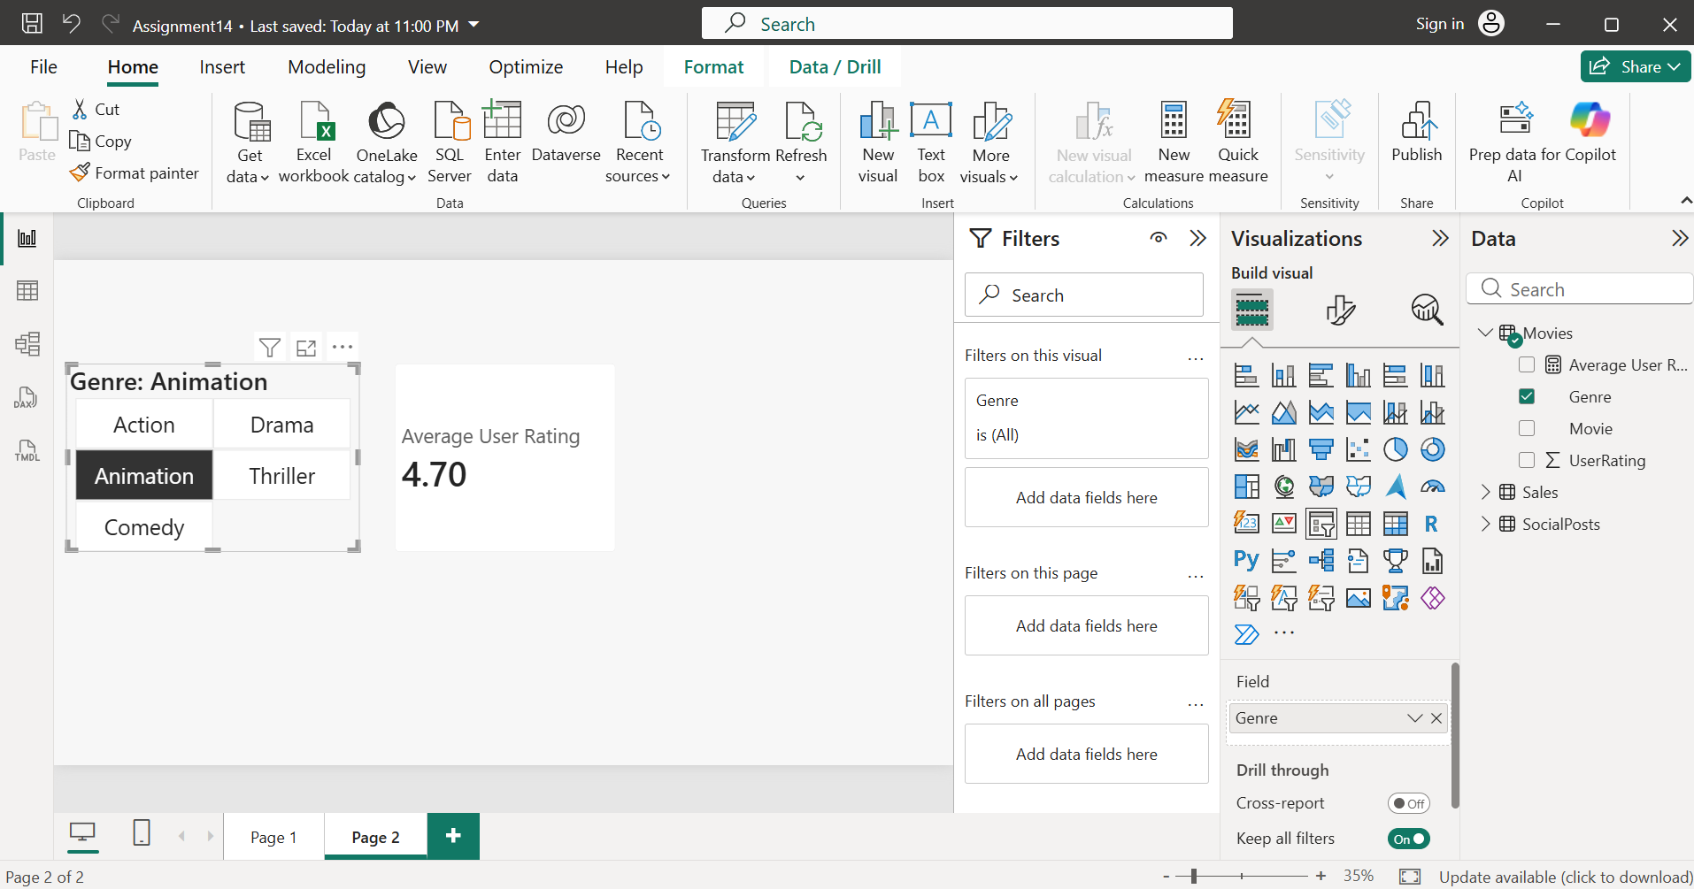

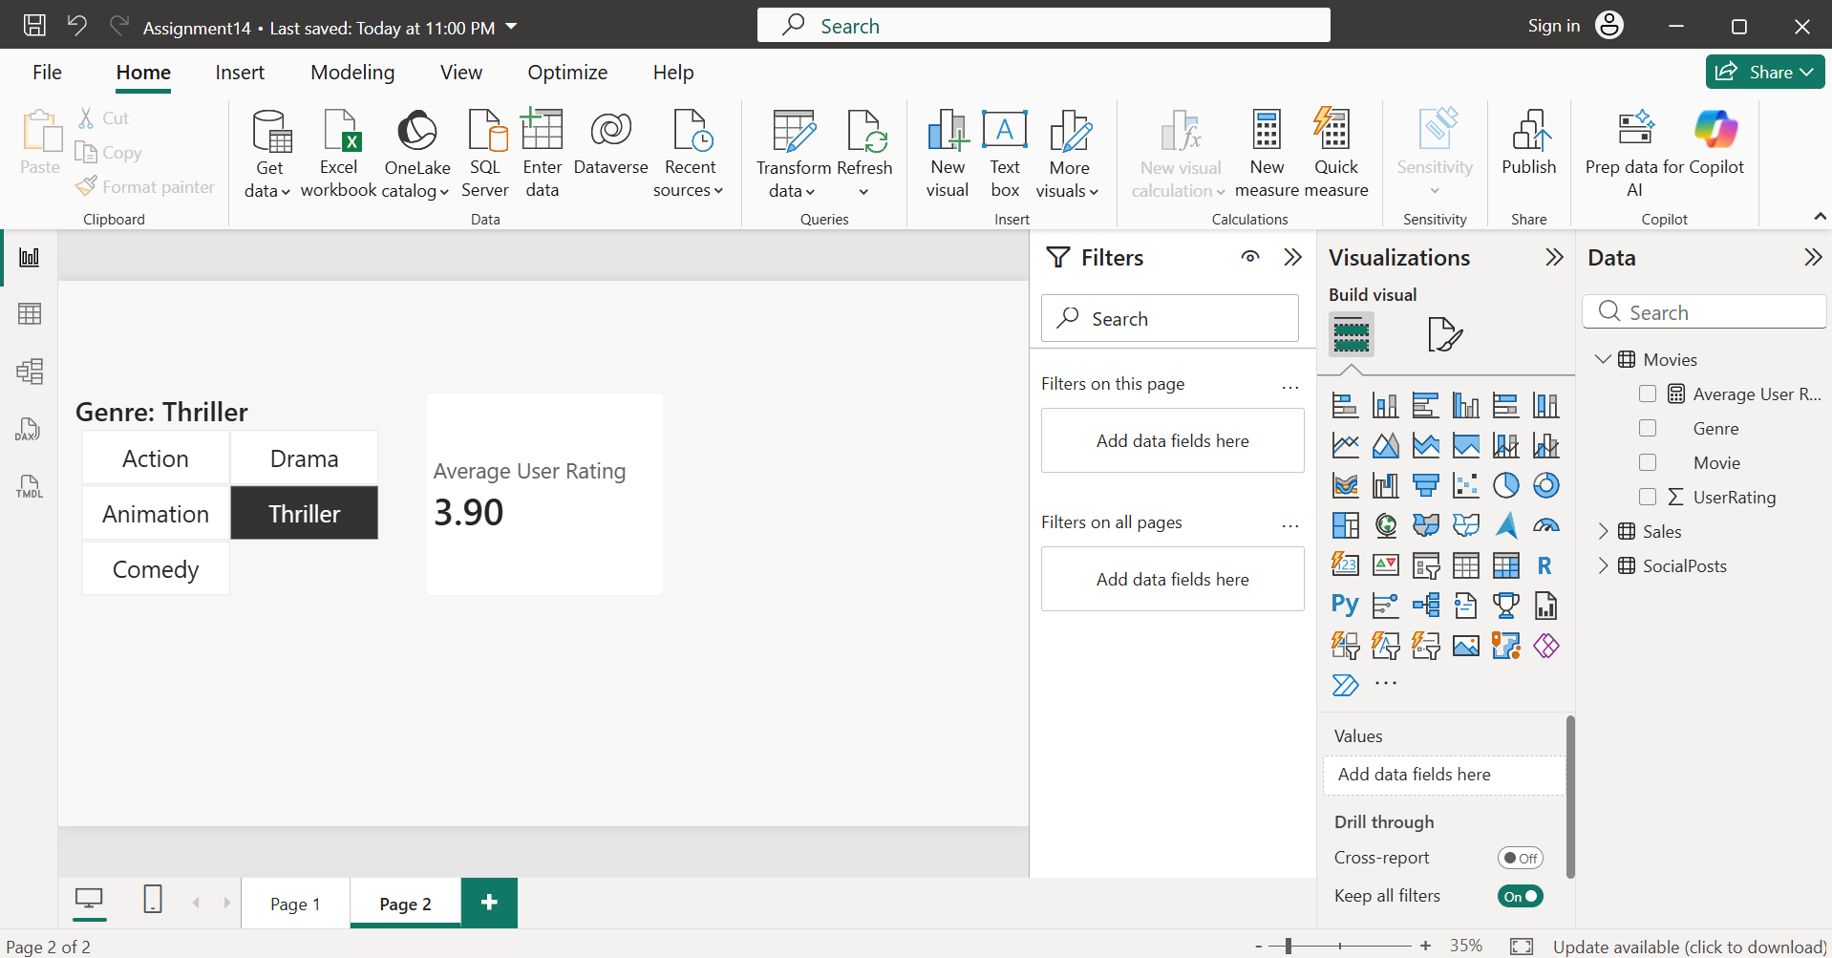
- Imported the Movies.csv dataset into Power BI Desktop. Created a DAX measure named Average User Rating using the formula:
Average User Rating = AVERAGE(Movies[UserRating])
- Added a Slicer using the Genre field and a Card visual displaying the Average User Rating measure. When a genre is selected in the slicer, the card automatically updates to show the average user rating for that genre, similar to filtering movies by category on BookMyShow.

- Compare calculated columns and measures by creating both: a calculated column 'DiscountedPrice' (Price - Discount) and a measure 'TotalDiscountedSales' (sum of DiscountedPrice) in a Flipkart-style Products table.<br><br><em><strong>Hint:</strong> Observe how each updates when you use filters or slicers.</em>

- Comparison between calculated column and measure is as follows:

Calculated Column | Measure
Calculated for every row when the data is loaded or refreshed. | Calculated only when the visual is displayed.
Stored in the table. | Not stored in the table.
Shows a value for each product. | Returns a single aggregated value (or one per filter context).
Does not change its row values when a slicer is applied. | Changes automatically based on slicers and filters.

- When no filter is applied:

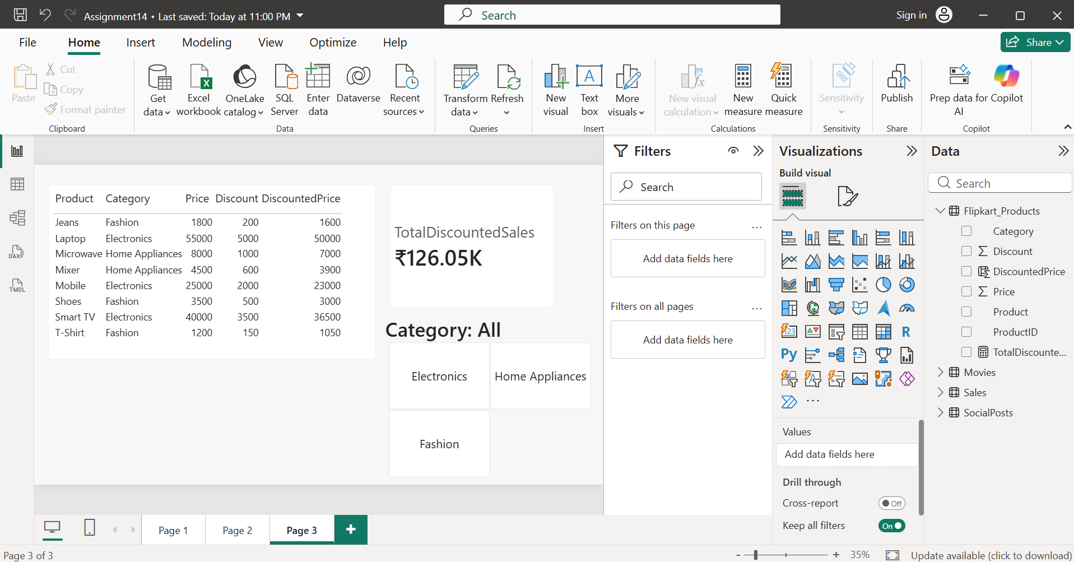

- On applying filter:
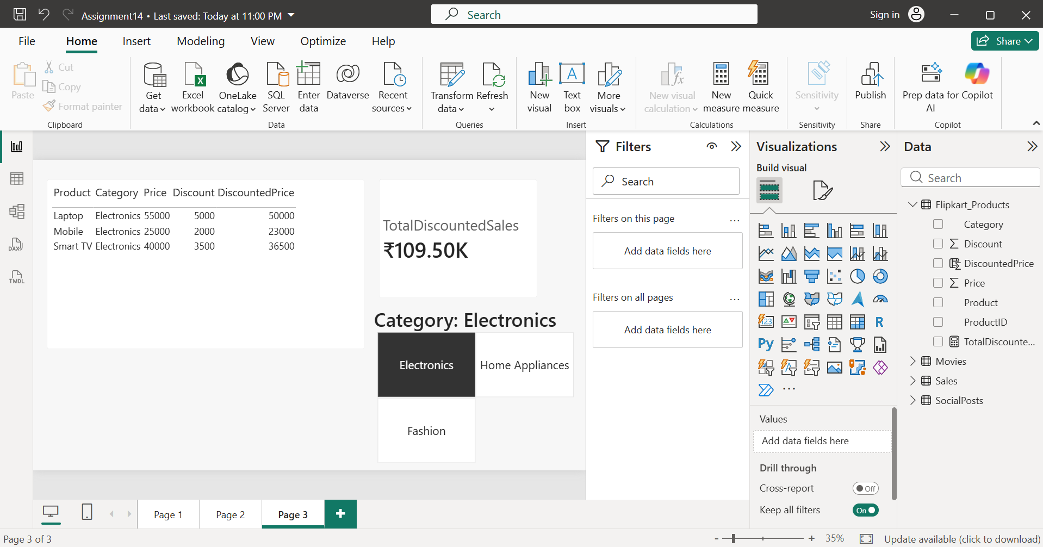

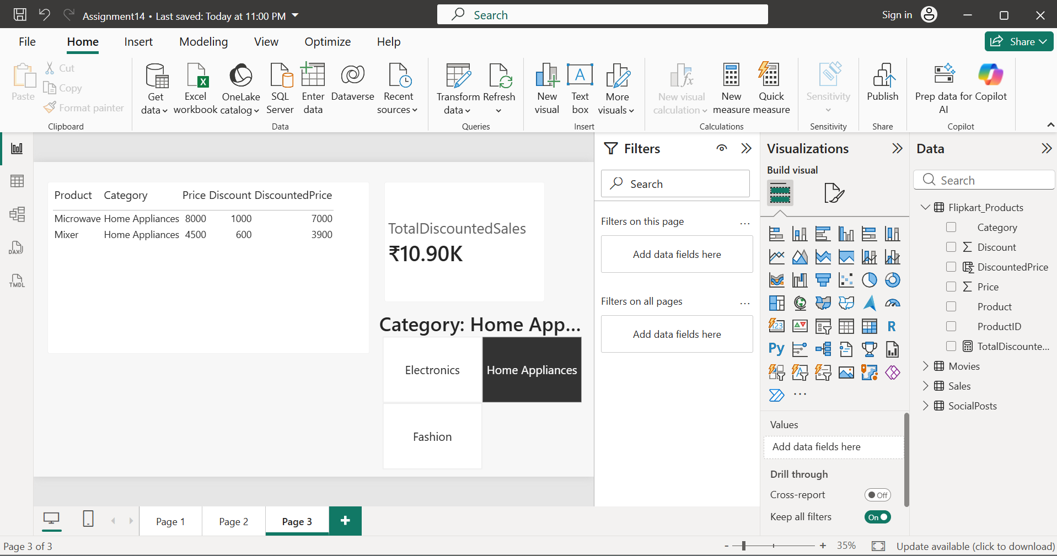

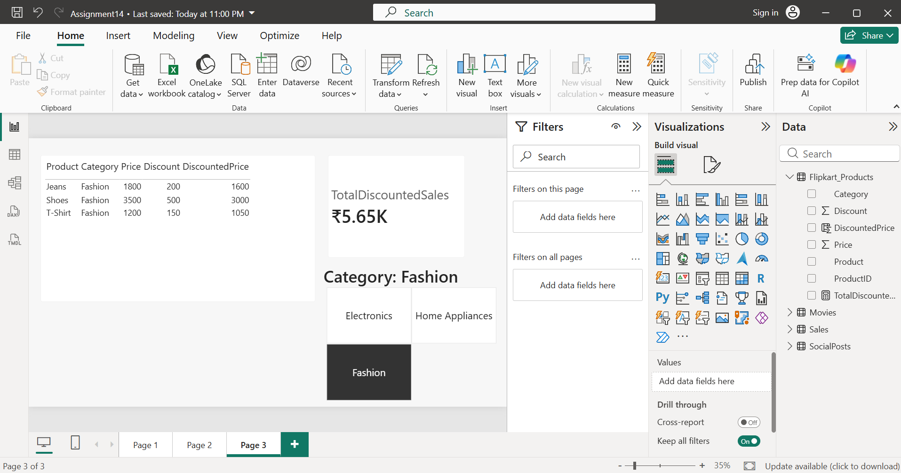
- Imported the Flipkart_Products.csv dataset into Power BI Desktop. Created a calculated column named DiscountedPrice using:
DiscountedPrice = Flipkart_Products[Price] - Flipkart_Products[Discount]
- Then created a measure named TotalDiscountedSales using:
TotalDiscountedSales = SUM(Flipkart_Products[DiscountedPrice])
- Displayed the calculated column in a Table visual and the measure in a Card visual. Added a Category slicer to observe the difference: the calculated column stores a value for each row, while the measure dynamically recalculates the total discounted sales based on the selected filter or slicer.

- List all the DAX data types you used in the above tasks and give one example of a real-world app field (from Zomato, Paytm, etc.) that would use each type.

DAX Data Type | Used In | Real-World Example
Whole Number | Likes, OrderAmount, Price, Discount | Likes on an Instagram post, Order Amount in Flipkart
Decimal Number | UserRating | Movie rating on BookMyShow (e.g., 4.7)
Text | User, Genre, Product, Movie | Product Name in Flipkart, Genre in BookMyShow
Currency (Fixed Decimal Number) | OrderAmountINR, DiscountedPrice, TotalDiscountedSales | Product Price in Flipkart, Transaction Amount in Paytm

