- In Power BI Desktop, create two tables: 'Restaurants' (with columns RestaurantID, Name, Cuisine) and 'Reviews' (with columns ReviewID, RestaurantID, Rating, Comment). Identify and set the primary key and foreign key relationships between these tables.

- Created two tables namely, ‘Restaurants’ and ‘Reviews’ using “Enter Data” feature from Home -> Data:
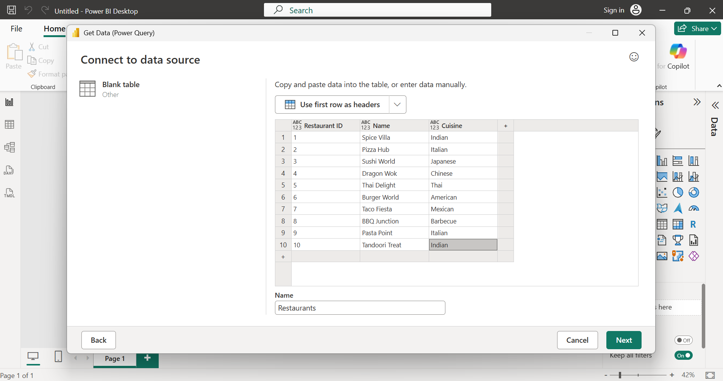

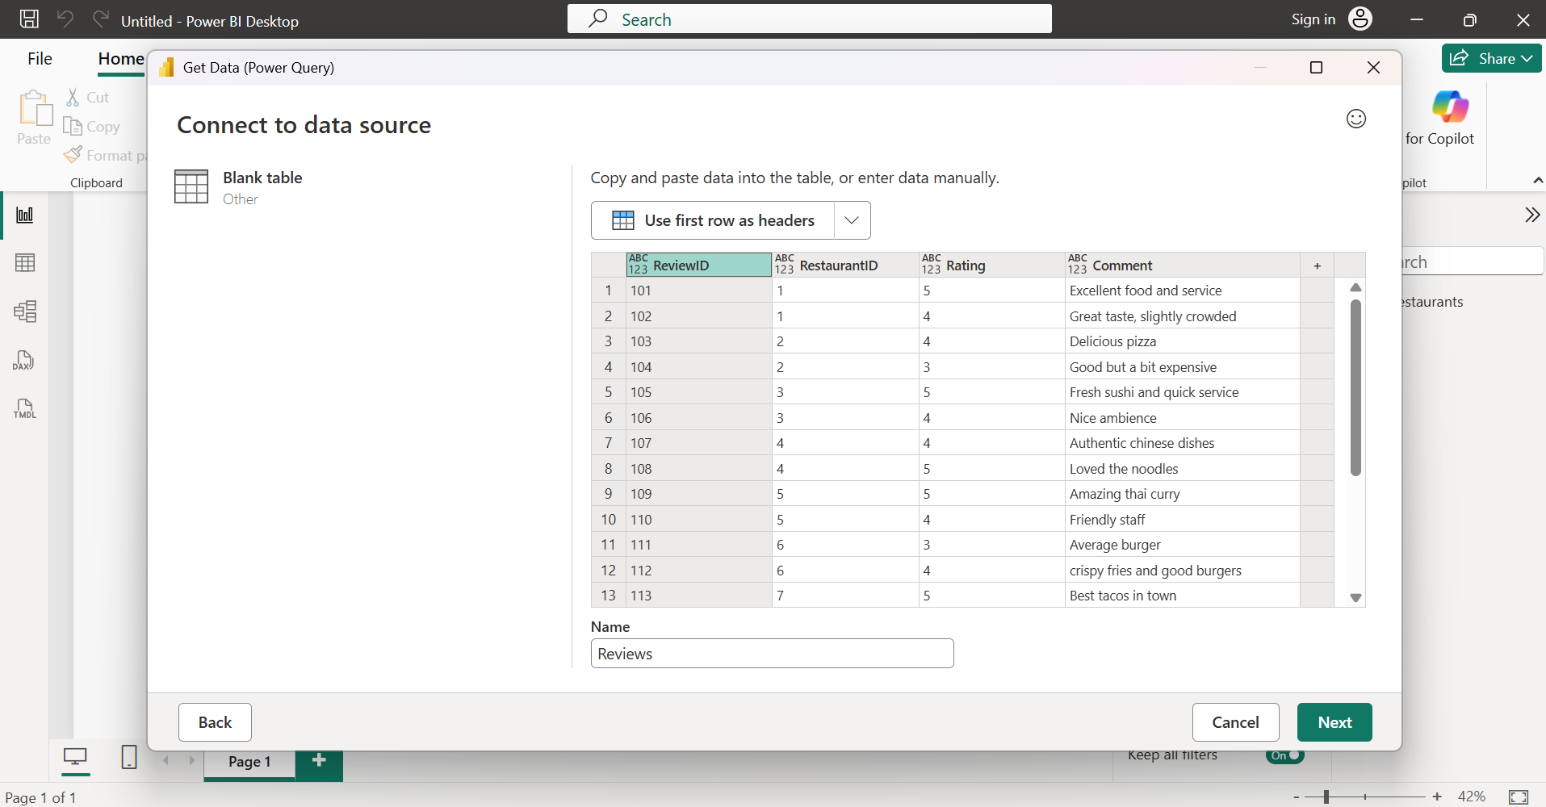
- Then went to model view, and created “one-to-many” relationship between restaurants and reviews table. “Restaurant ID”, is primary key in Restaurants table and foreign key in Reviews table. one-to-many relationship, means each restaurant can have multiple reviews, but each review belongs to only one restaurant:
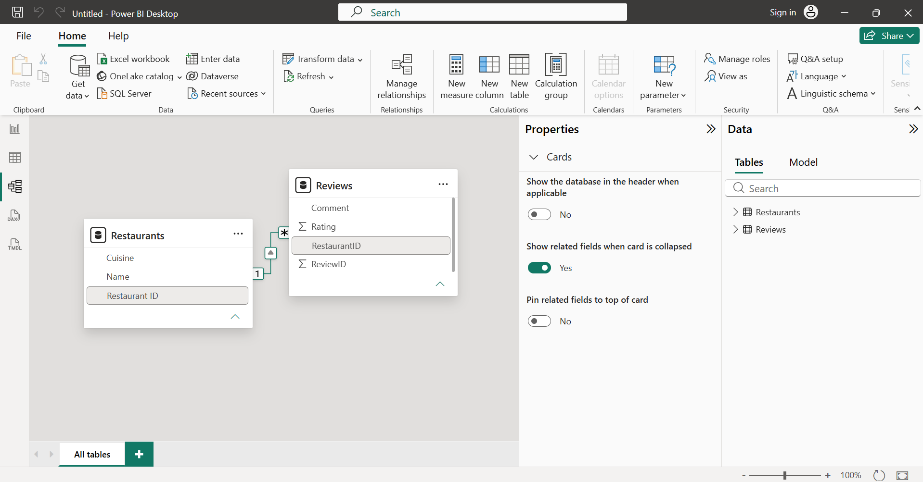

- Design a Star Schema in Power BI for a Zomato-style food delivery dataset by creating a central 'Orders' fact table and at least three-dimension tables (such as 'Customers', 'Restaurants', and 'Dishes'). Connect them using appropriate relationships.

- Created 4 tables: Customers, Restaurants, Dishes and Orders using Home -> Enter Data (under Data section). Then went to Model View and connected the tables as shown in below screenshot:
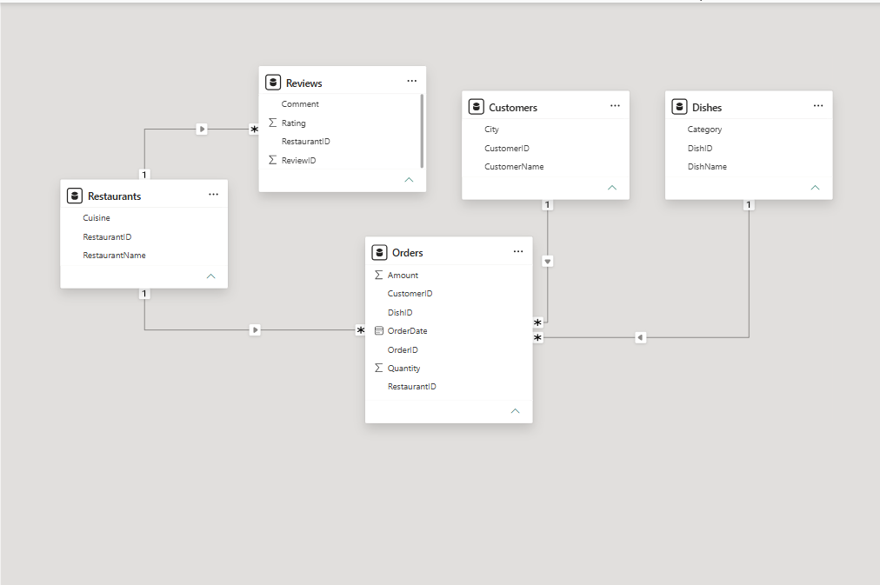
- Fact Table: Orders
- Dimension Tables: Customers, Restaurants, Dishes
This is a Star Schema because the central Orders fact table is surrounded by dimension tables, each connected through a primary key–foreign key relationship.
- Primary Keys
  - Customers → CustomerID
  - Restaurants → RestaurantID
  - Dishes → DishID
  - Orders → OrderID
- Foreign Keys (in Orders)
  - CustomerID
  - RestaurantID
  - DishID
- A Star Schema was successfully designed for the Zomato-style food delivery dataset. The Orders table was created as the central fact table, while Customers, Restaurants, and Dishes were created as dimension tables. Appropriate one-to-many relationships were established using primary and foreign keys. This schema improves data organization, simplifies analysis, and enables efficient reporting in Power BI.

- Modify your Star Schema from the previous task into a Snowflake Schema by normalizing one of the dimension tables (for example, split 'Restaurants' into 'Restaurants' and 'Locations'). Update the relationships in Power BI accordingly.<br><br><em><strong>Hint:</strong> Use the Model view to manage and visualize the new relationships.</em>

- Created new locations table:
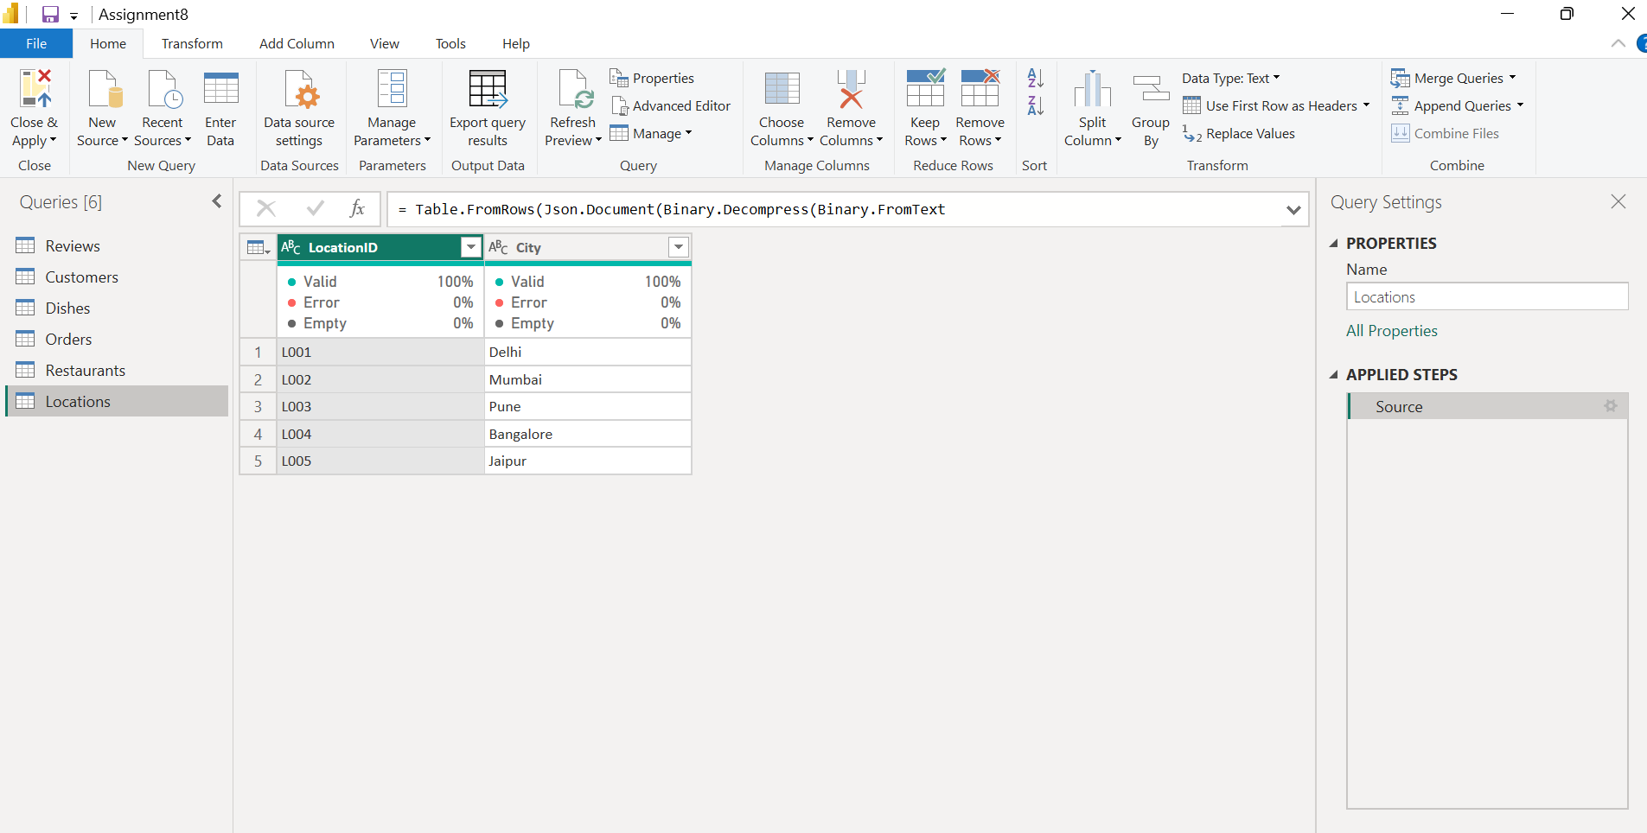
- Removed ‘City’ column from restaurants table in order to normalize the restaurant table. Now, location data is stored only once in locations table:
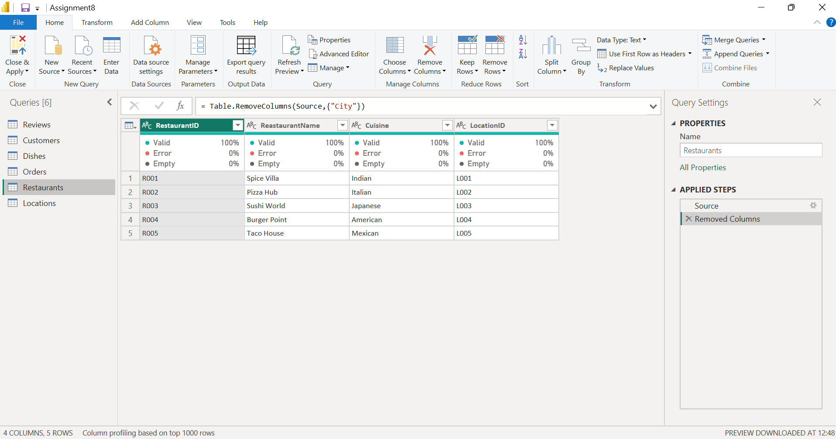
- In the Star Schema, all descriptive information was stored directly in the Restaurants table.
- In the Snowflake Schema:
  - Restaurant details remain in the Restaurants table.
  - Location details are moved to a separate Locations table.
  - The Restaurants table stores only a LocationID reference.
- This reduces data redundancy and makes the data model more normalized.
- The Star Schema was successfully converted into a Snowflake Schema by normalizing the Restaurants dimension. A new Locations table was created, and the Restaurants table now references it using LocationID. The relationships were updated in the Model view, resulting in a more normalized data model that reduces redundancy while maintaining accurate relationships.

- In Power BI, import two tables: 'Users' (UserID, Name, Email) and 'Playlists' (PlaylistID, Name, UserID). Then add a third table 'Collaborators' (PlaylistID, UserID) to represent many-to-many relationships where multiple users can collaborate on multiple playlists. Set up the correct relationships and explain how Power BI handles this scenario.

- Created 3 tables: Users (UserID, Name, Email), Playlists (PlaylistID, Name, UserID) and Collaborators (PlaylistID, UserID).
- Then went to model view, and created 3 relationships there as shown in below screenshot
  - One-to-Many (1:*) relationship from Users[UserID] table to Playlists[UserID] table, meaning one user owns many playlists.
  - One-to-Many (1:*) relationship from Users[UserID] table to Collaborators[UserID] table, meaning one user can collaborate on many playlists.
  - One-to-Many (1:*) relationship from Playlists[PlaylistID] table to Collaborators[PlaylistID] table, meaning one playlist can have many collaborators.
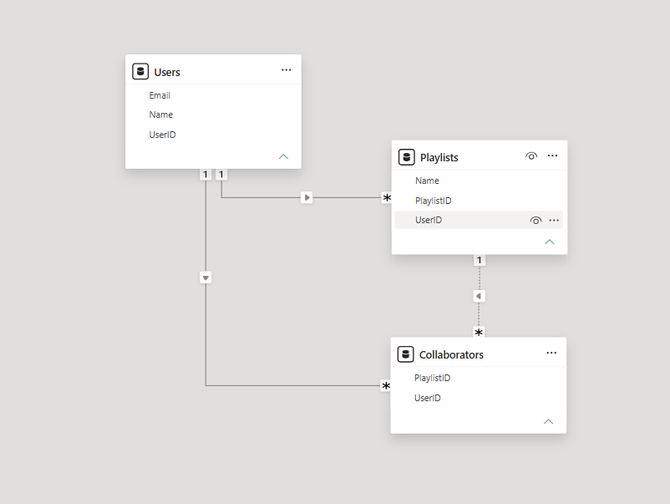
- Power BI does not connect Users directly to Playlists for collaboration. Instead, it uses the Collaborators table as a bridge (junction) table.
- When you select a user:
  - Power BI checks the Collaborators table.
  - It finds all playlists where that user is listed as a collaborator.
  - It then filters the related playlist data.
- This approach avoids duplicate records and keeps the data model organized.
- Primary Keys:
Table | Primary Key
Users | UserID
Playlists | PlaylistID
Collaborators | No single primary key (the combination of PlaylistID + UserID uniquely identifies each collaboration.

- Relationships
From | To | Cardinalty
Users -> Playlists | UserID | One-to-Many
Users -> Collaborators | UserID | One-to-Many
Playlists -> Collaborators |  | One-to-Many

- Three tables—Users, Playlists, and Collaborators—were created in Power BI. The Collaborators table acts as a bridge table to model the many-to-many relationship between users and playlists. One-to-many relationships were established from Users to Collaborators and from Playlists to Collaborators, allowing Power BI to accurately represent playlists with multiple collaborators while maintaining a normalized and efficient data model.
- Given a Power BI model where the 'Orders' table is not showing correct totals for each 'Dish' because of a missing relationship, use the Model view to identify and fix the issue by creating the appropriate one-to-many relationship.<br><br><em><strong>Hint:</strong> Check for unmatched keys or inactive relationships.</em>

- Created two tables – ‘Orders’ and ‘Dishes’ then inserted table visual in report view, Added columns – DishName (from Dishes Table) and Amount (from Orders table). But the result was every dish shows the same total amount. This happened because the tables are not connected:
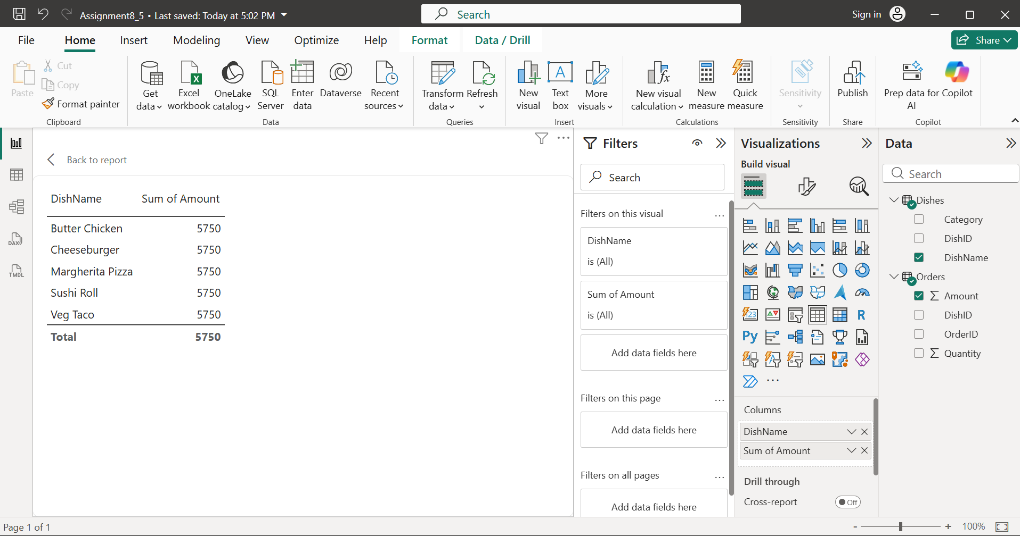

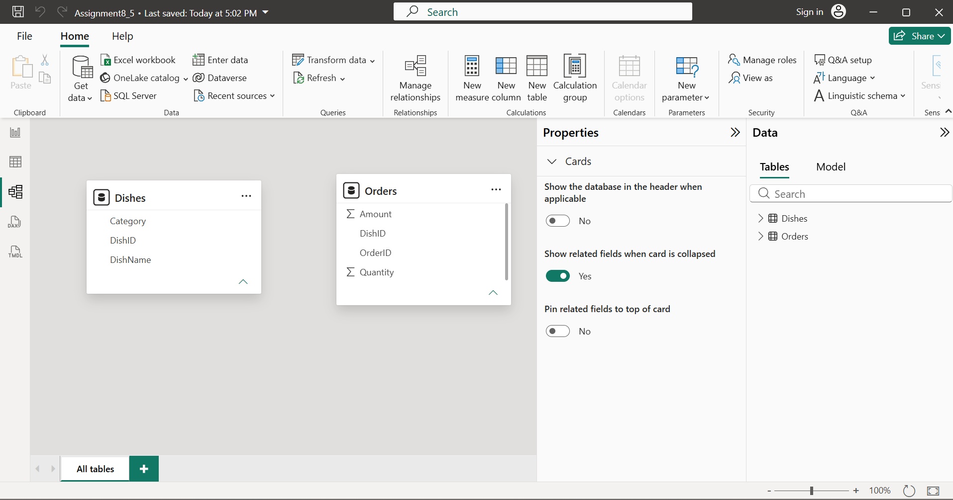

- Hence, created relationship between Dishes and Orders table using Home -> Manage Relationships:
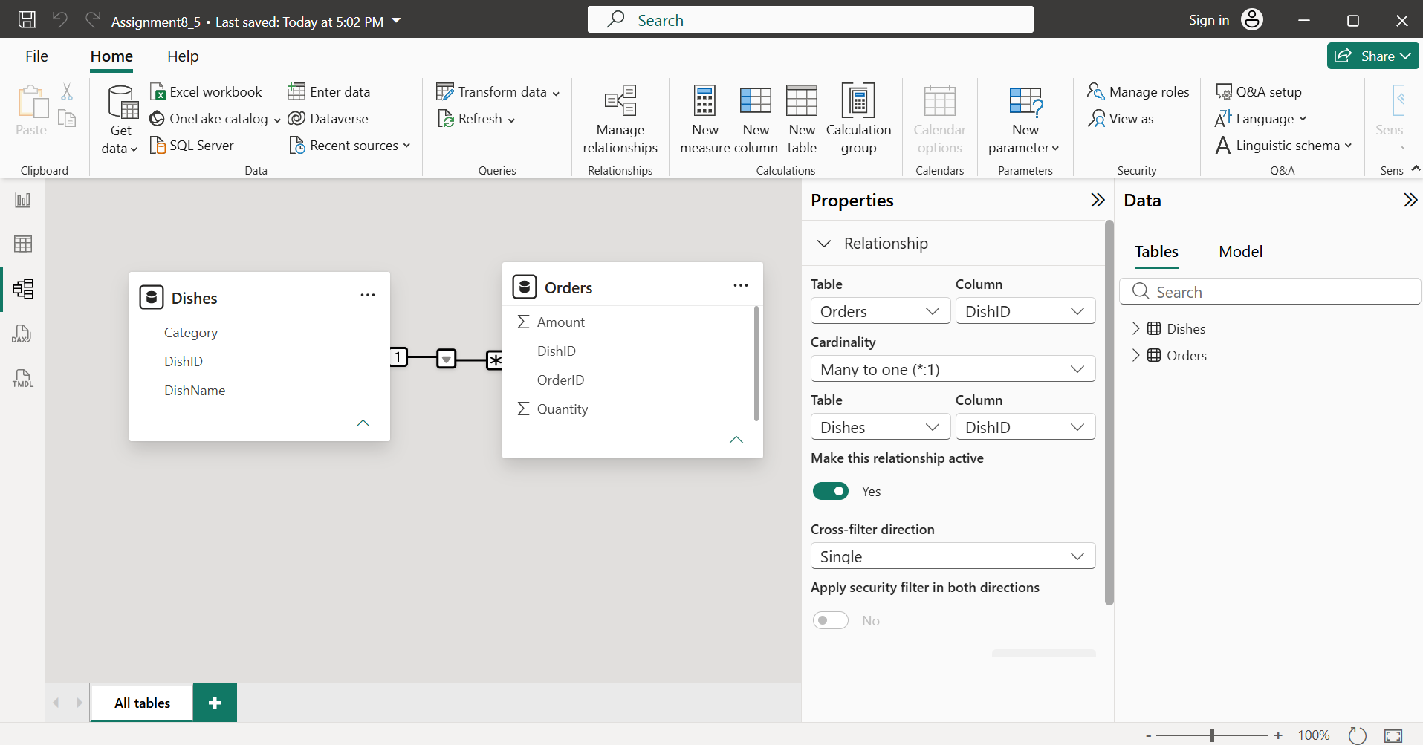

- Now, the table visual shows the correct totals which means now Power BI knows which orders belong to each dish:
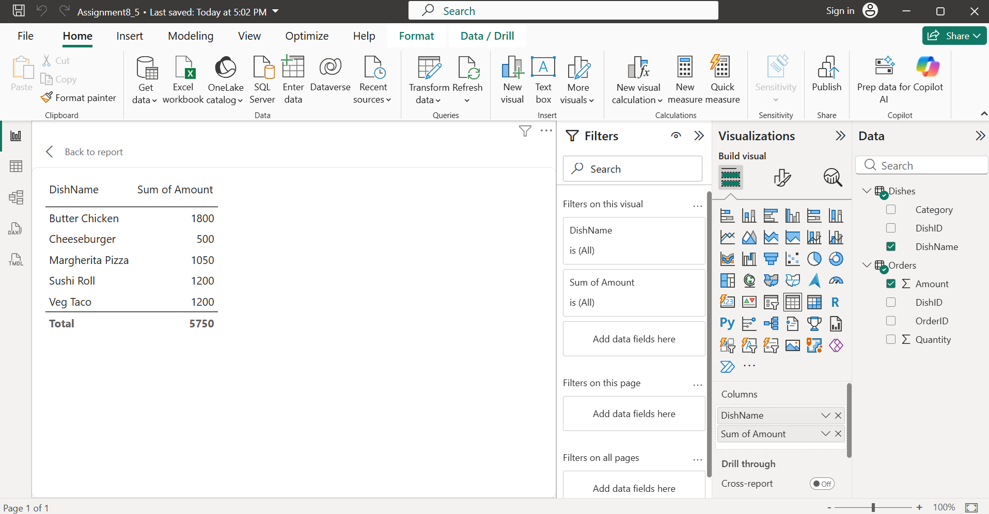

- Final Relationship:
From Table | To Table | Column | Relationship
Dishes | Orders | DishID | One-to-Many (1:*)

- The issue occurred because the Orders and Dishes tables were not related. In the Model view, a one-to-many relationship was created using the DishID column, with Dishes on the one side and Orders on the many sides. After creating an active relationship, Power BI correctly matched each order to its corresponding dish and displayed accurate totals.

