- In Power BI, create a table with a column of order dates (at least 10 random dates from the past year) and add a calculated column using the TODAY() function to display the number of days since each order.<br><br><em><strong>Hint:</strong> Use DATEDIFF([OrderDate], TODAY(), DAY).</em>

- Imported the Orders.csv dataset into Power BI Desktop. Created a calculated column named Days Since Order using the following DAX formula:
Days Since Order = DATEDIFF(Orders[OrderDate], TODAY(), DAY)
- Displayed OrderID, OrderDate, and Days Since Order in a Table visual. The calculated column dynamically updates each day because it uses the TODAY() function.

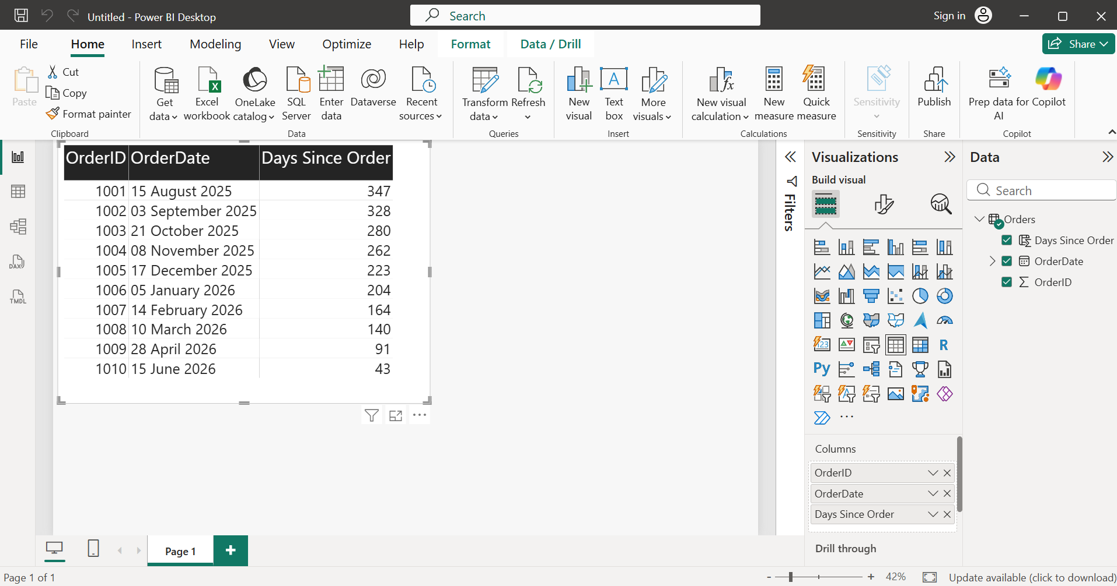

- Add a new column to your table that shows the same period last year's order date for each order using the SAMEPERIODLASTYEAR() function.

- Note: SAMEPERIODLASTYEAR() is a DAX time intelligence function that works with measures and a marked Date table. It cannot be used directly in a calculated column. Therefore, to create a new column showing the same date in the previous year, the EDATE() function was used.
- Same Period Last Year = EDATE(Orders[OrderDate], -12)
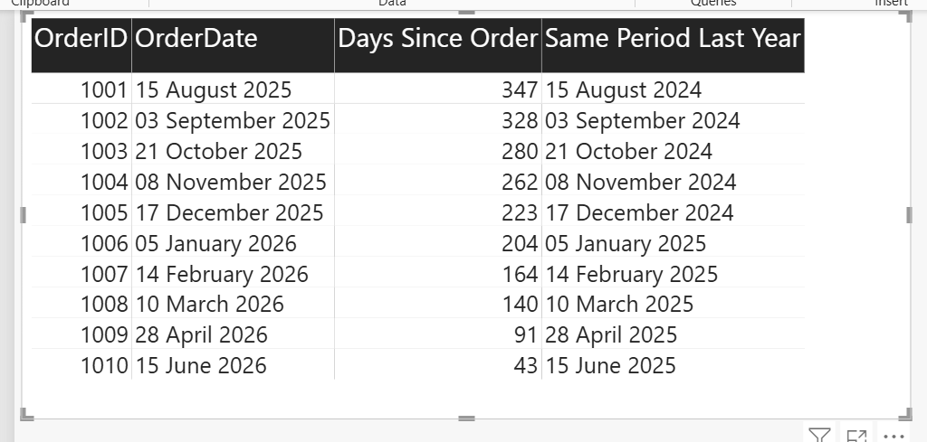
- Create a measure that uses the DATEADD() function to calculate the total sales from the previous month and display it in a card visualization.

- Imported the Sales.csv dataset into Power BI Desktop. Created a Date Table and related it to the Sales table. Then created the following DAX measure:

Previous Month Sales =
CALCULATE(
SUM('Sales(2)'[Sales]),
DATEADD(DateTable[Date], -1, MONTH)
)

- Displayed the measure in a Card visual to show the total sales from the previous month:

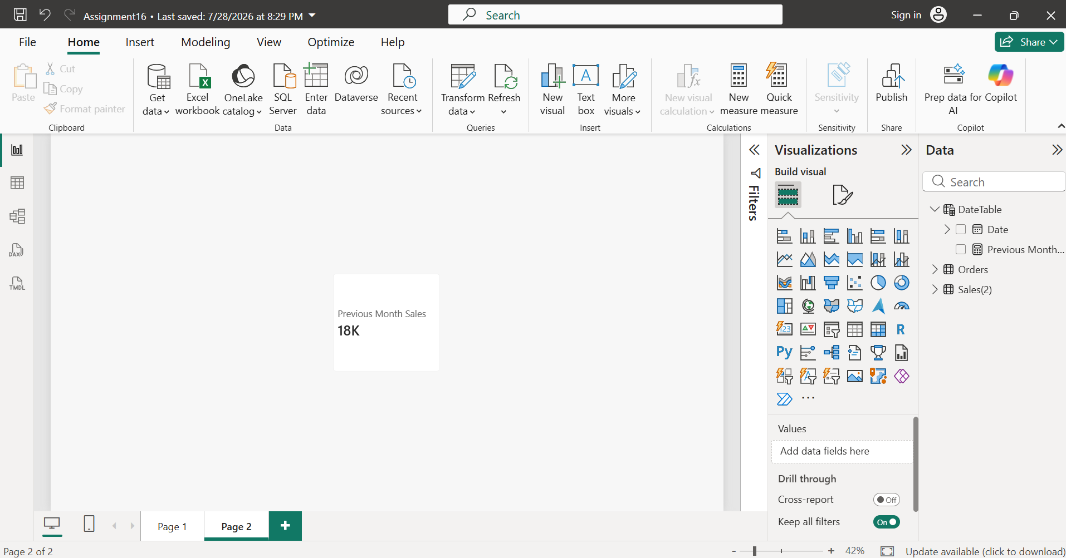

- Use the FORMAT() function to display each order date in the format 'dd-MMM-yyyy, dddd' (e.g., '05-Jun-2023, Monday') in a new column.

- Created a calculated column using the FORMAT() function:

Formatted Order Date =
FORMAT(Orders[OrderDate], "dd-MMM-yyyy, dddd")

- The new column displays each order date in the format dd-MMM-yyyy, dddd, such as 15-Aug-2025, Friday. The formatted date was displayed in a Table visual along with the original order details:
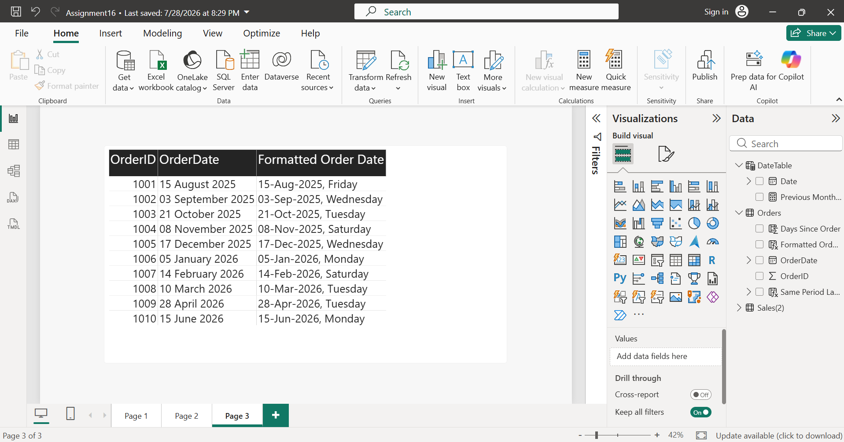

- Given a column of product codes like 'MOB1234IN', use the LEFT() and RIGHT() functions to extract the first three characters (category code) and the last two characters (region code) into separate columns.<br><br><em><strong>Constraint:</strong> Do not use any custom M code — only DAX functions.</em>

- Created two calculated columns using DAX:
  - Category Code

Category Code =
LEFT(Products[ProductCode], 3)

  - Region Code

Region Code =
RIGHT(Products[ProductCode], 2)

- These columns extract the first three characters as the Category Code and the last two characters as the Region Code from each product code. The results were displayed in a Table visual as shown in the screenshot on next page:
