- Open Power Query Editor (PQE) in Power BI and load a sample dataset of IPL cricket matches (download from Kaggle or use any CSV with match details).

- IPL cricket match dataset in Power Query Editor:
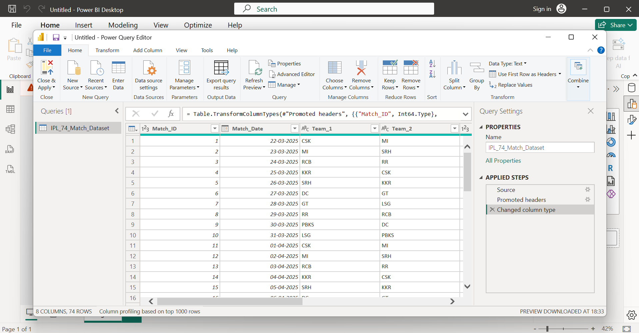

- In PQE, remove all columns except for 'Team 1', 'Team 2', 'Winner', and 'Venue' to focus only on the most relevant details for a quick match summary.

- As asked removed other columns except, ‘Team 1’, ‘Team 2’, ‘Winner’ and ‘Venue’:
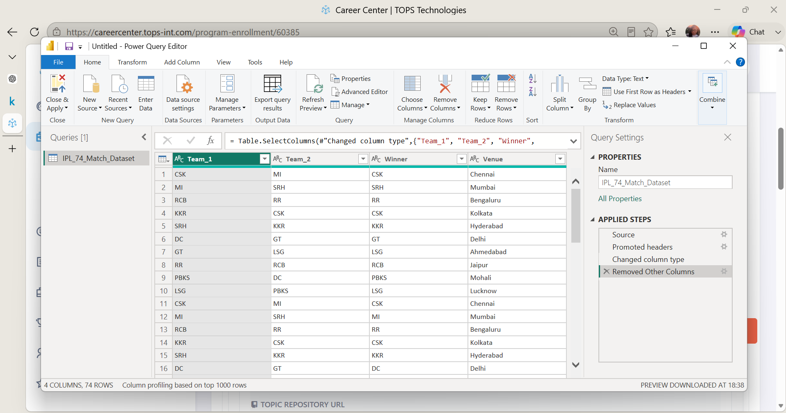

- Use the Remove Rows feature in PQE to delete the first 2 rows and any rows where the 'Winner' column is null or empty.

- Deleting first two rows:
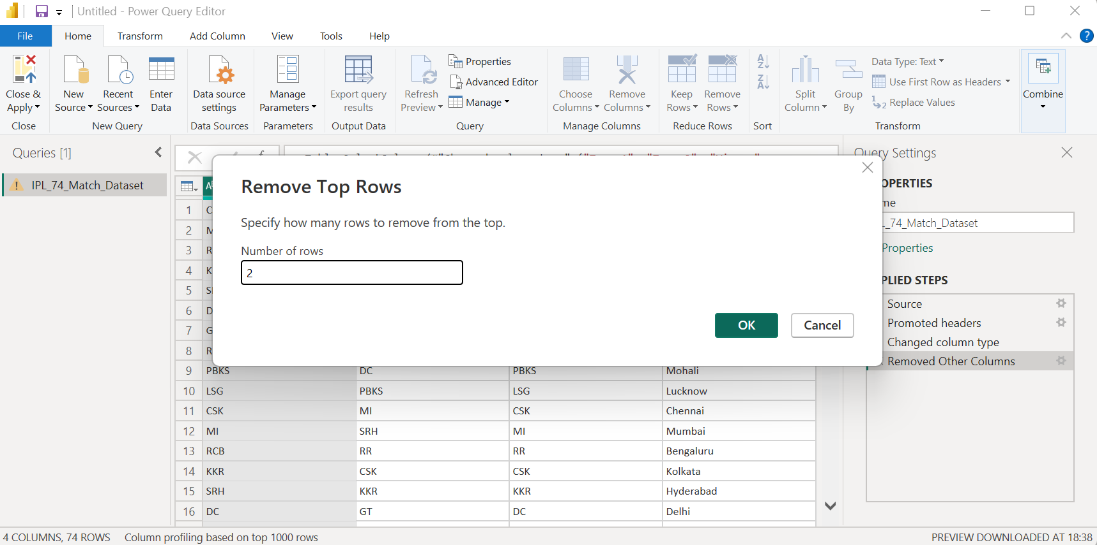

- Deleted First two rows:
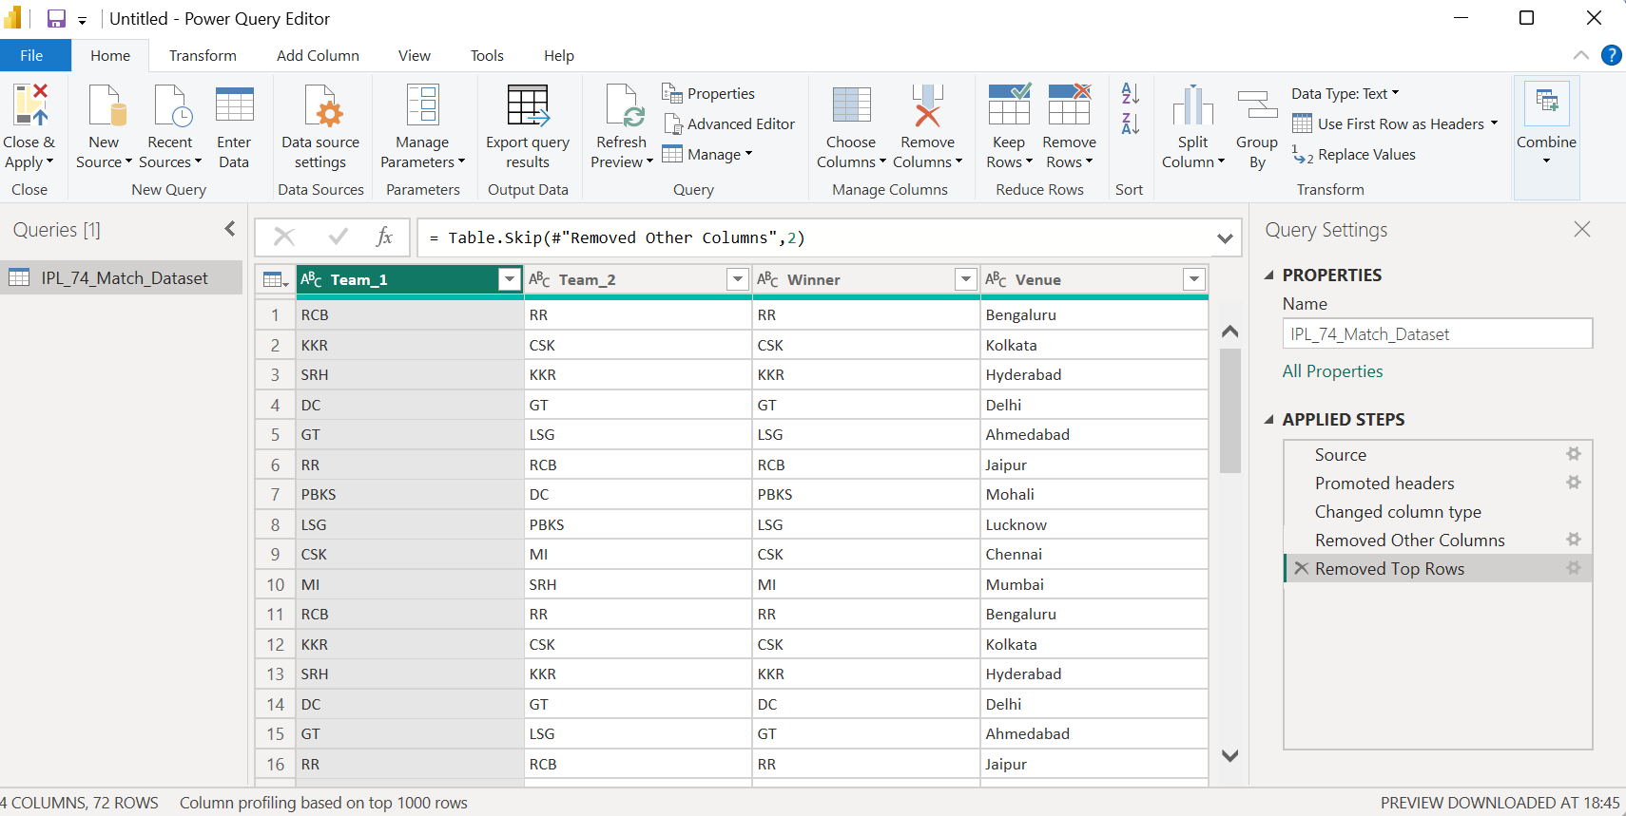

- After removing rows where winner column is null or empty:
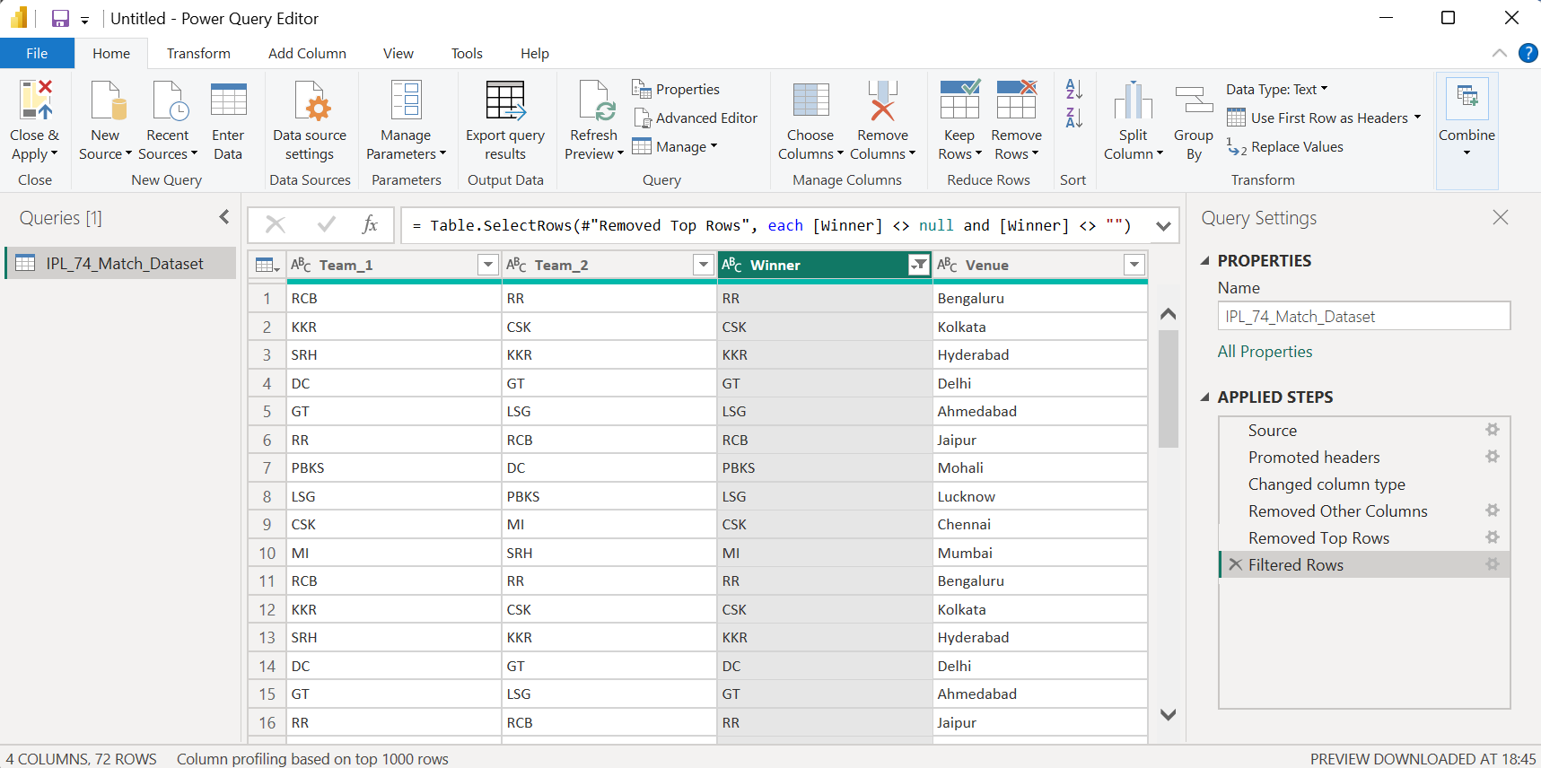

- Find and remove duplicate rows in your IPL dataset based on 'Team 1', 'Team 2', and 'Venue' columns.<br><br><em><strong>Hint:</strong> Use the 'Remove Duplicates' option after selecting these columns.</em>

- Before Removing Duplicates:
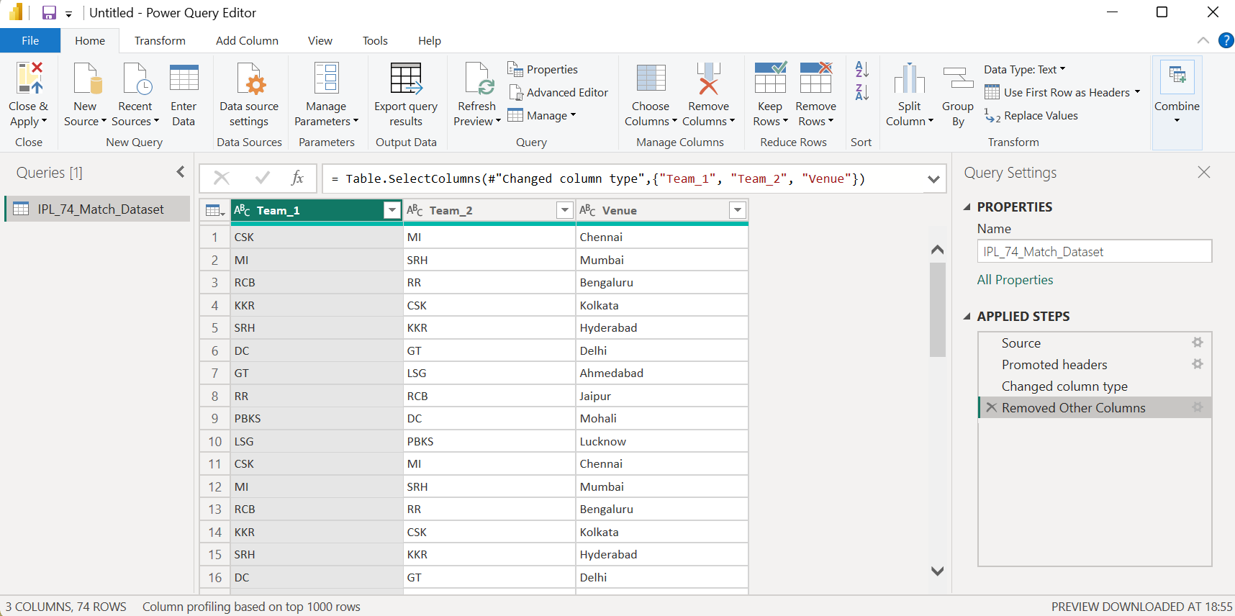

- After removing duplicates:
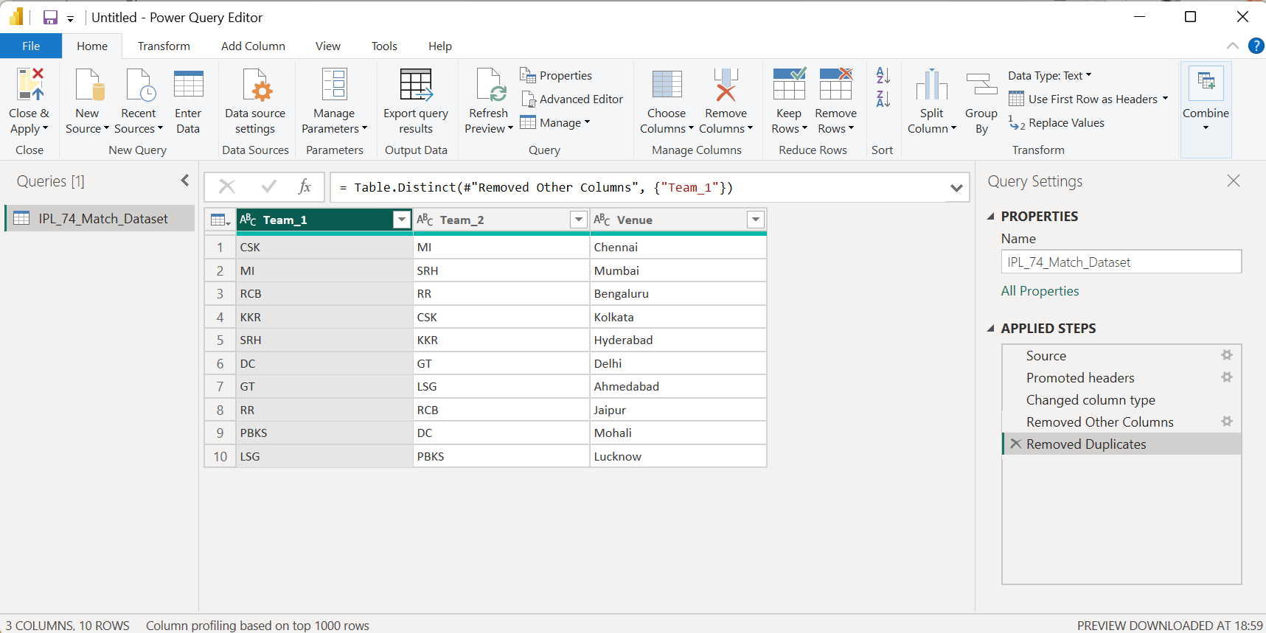

- Selected the Team 1, Team 2, and Venue columns and used Remove Duplicates in Power Query Editor. This removed repeated match records having the same team combination and venue, ensuring that only unique matches remained in the dataset.

- Handle any error rows in your dataset by replacing errors in the 'Winner' column with the value 'Unknown', then load the cleaned data to Power BI.<br><br><em><strong>Hint:</strong> Right-click the column and use 'Replace Errors'.</em>

- Replacing errors in the ‘Winner’ column with the value ‘Unknown’.
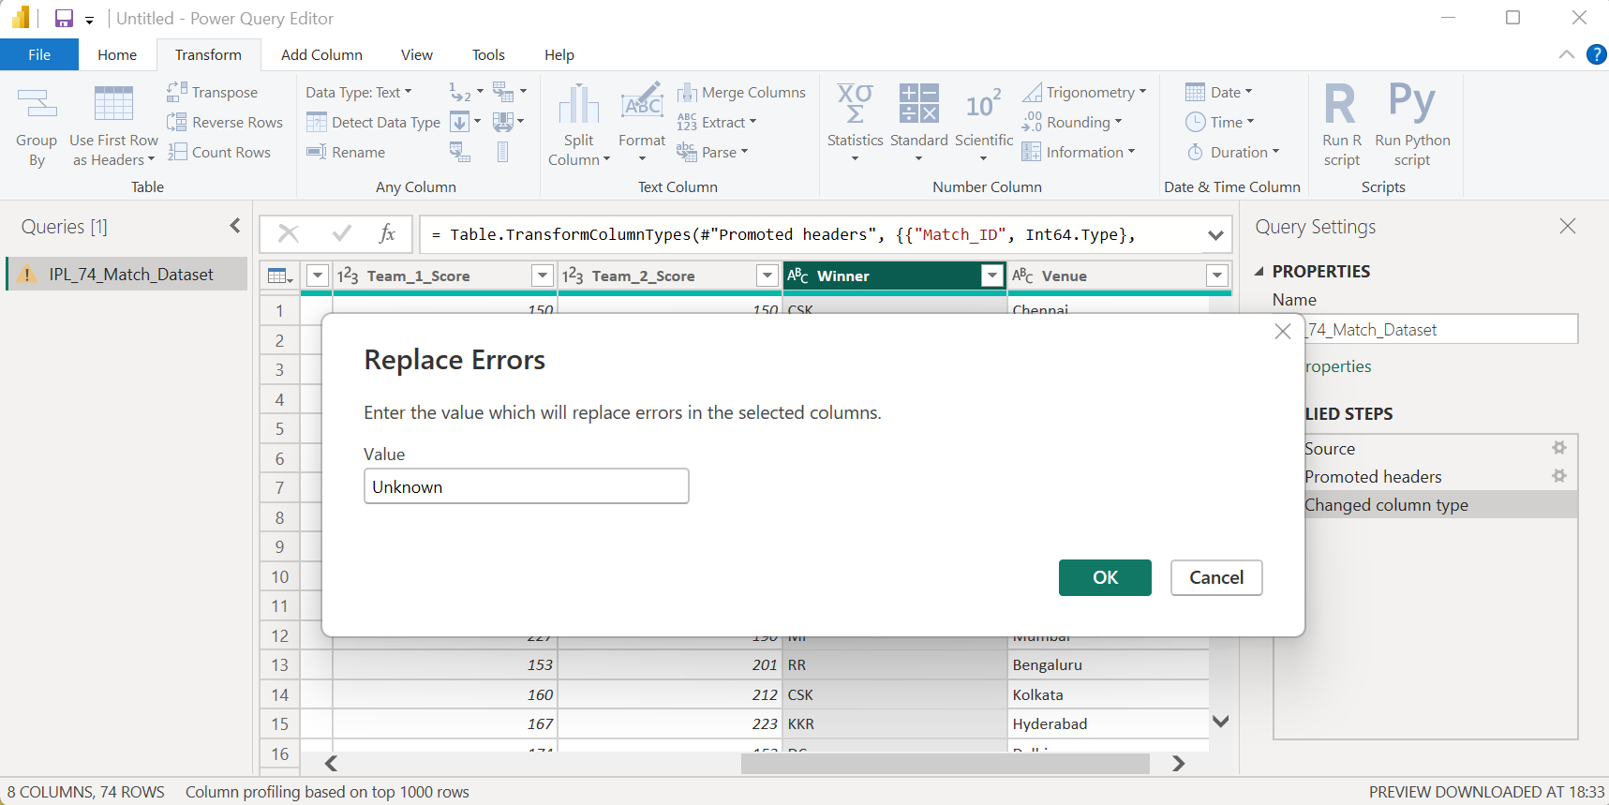

- Loaded transformed data for further analysis and reporting:
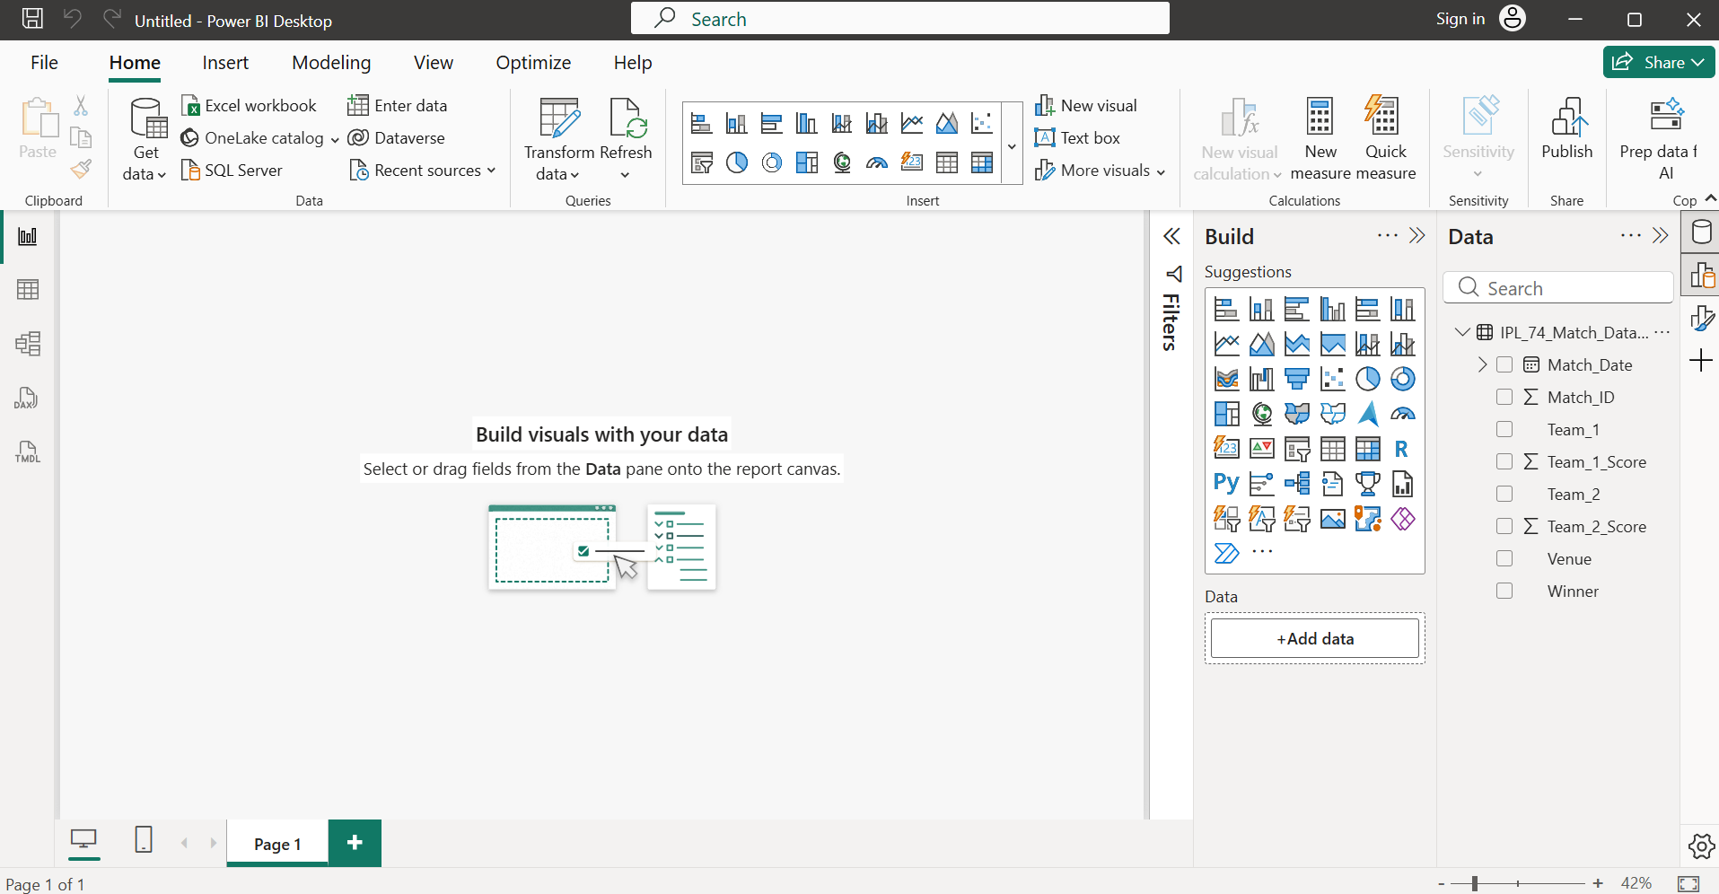

- Used the Replace Errors feature in Power Query Editor on the Winner column and replaced all error values with "Unknown". After cleaning the data, selected Close & Apply to load the transformed dataset into Power BI for further analysis and reporting.

