- Import two CSV files into Power BI: one with a list of restaurants (restaurant_id, name, city) and another with customer reviews (review_id, restaurant_id, rating). Use Merge Queries to join these tables on restaurant_id using an Inner Join, and create a table visual showing each restaurant's name and its average rating.

- Table with a list of restaurants:
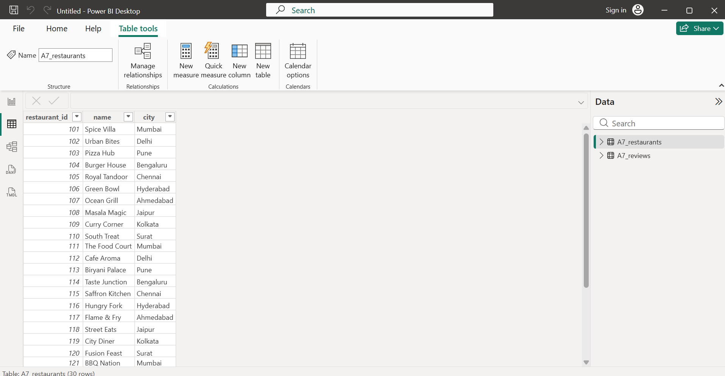

- Another table with customer reviews:
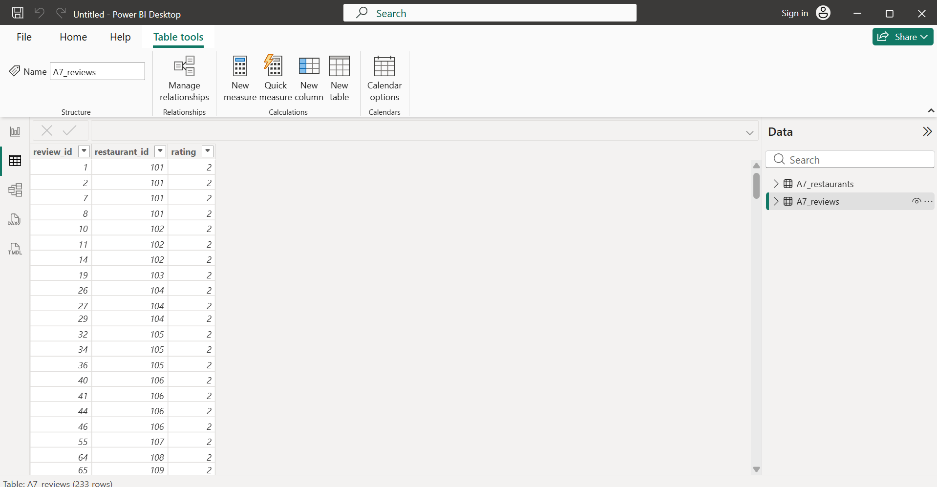

- Joining both tables with merge query:
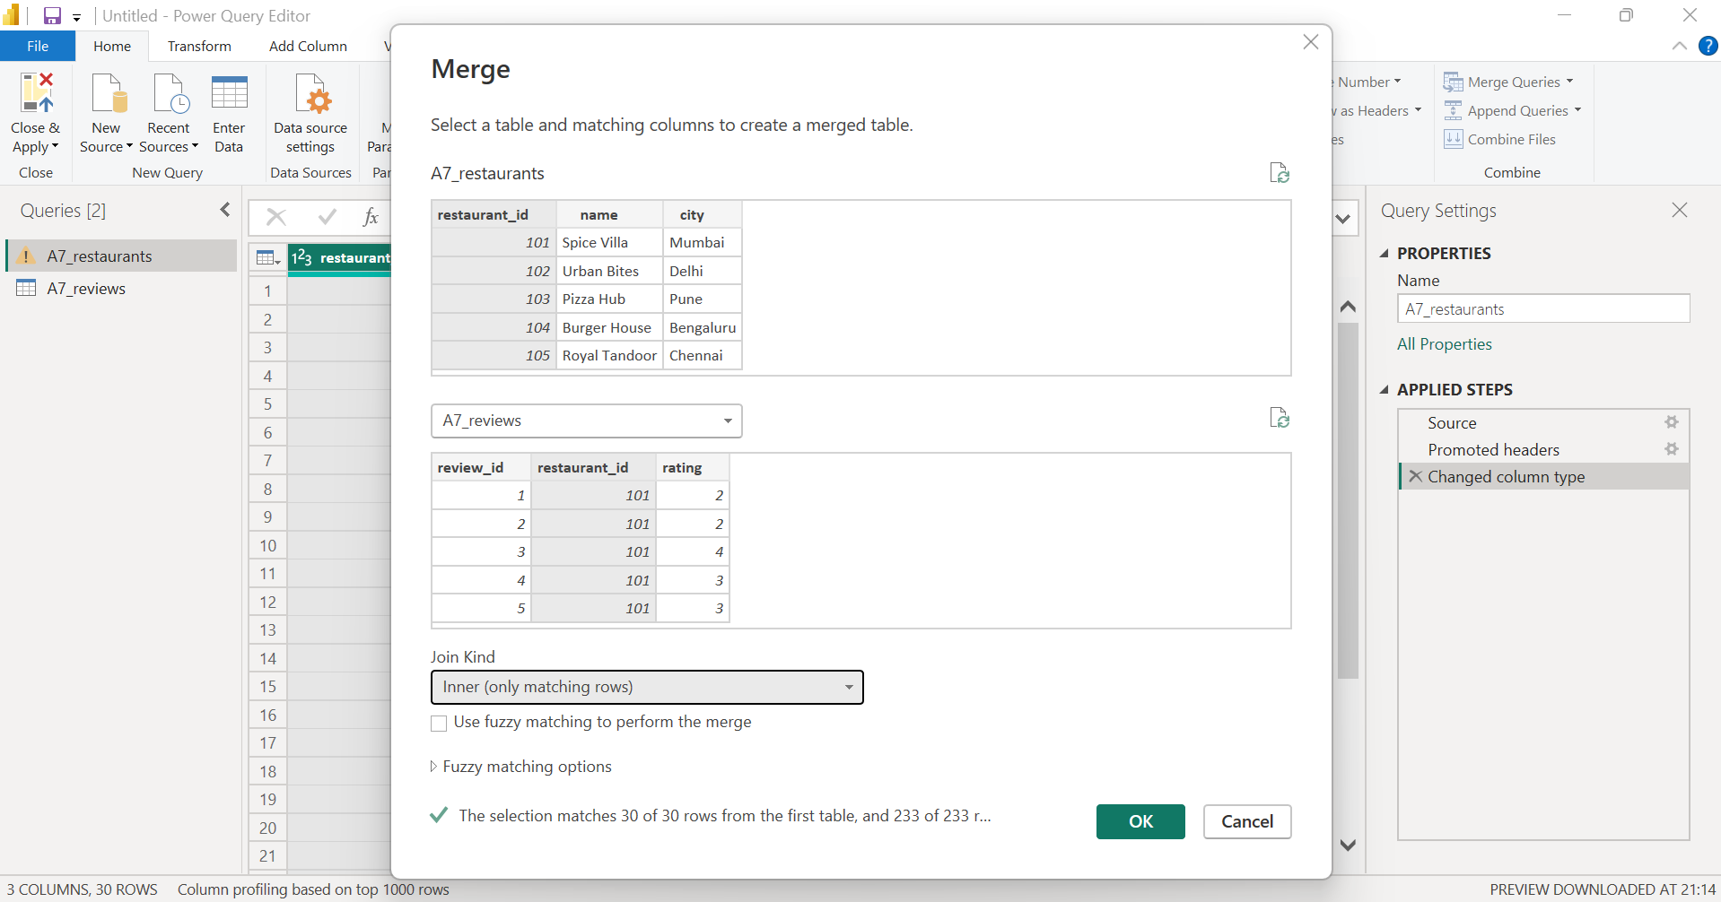

- Resulting table after joining the two tables:
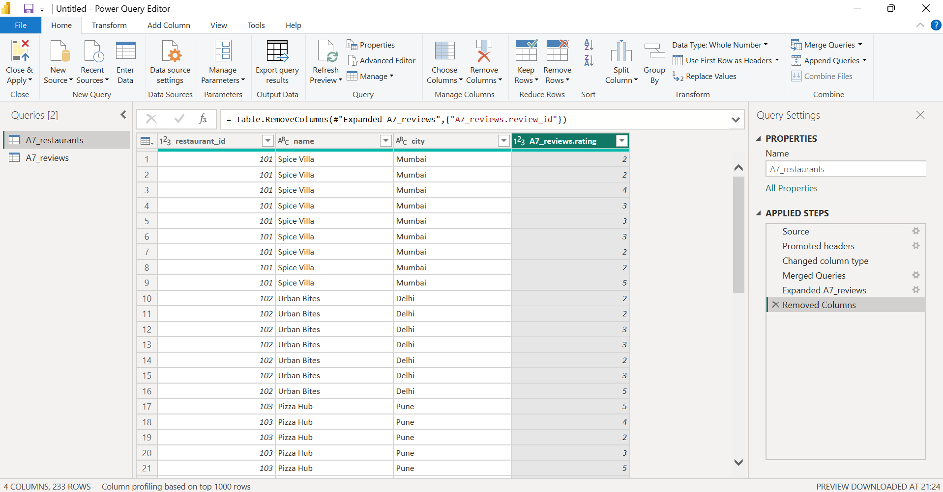

- Below is the table visual showing each restaurant’s name and it’s average rating:
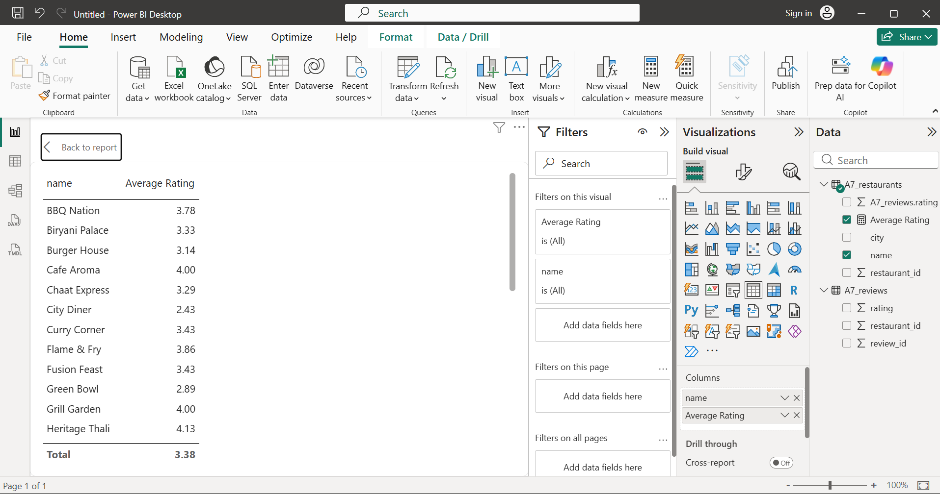

- Use Append Queries in Power BI to combine two tables: one with this month's Zomato orders and another with last month's orders (both with columns: order_id, user_id, amount). After appending, create a summary table showing total orders and total amount spent per user.

- Applying append query to combine the two tables:
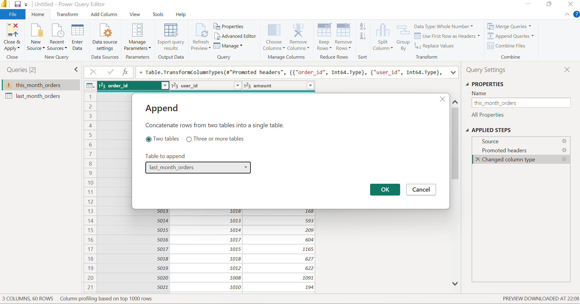

- Summary table showing total orders and total amount spent per user:
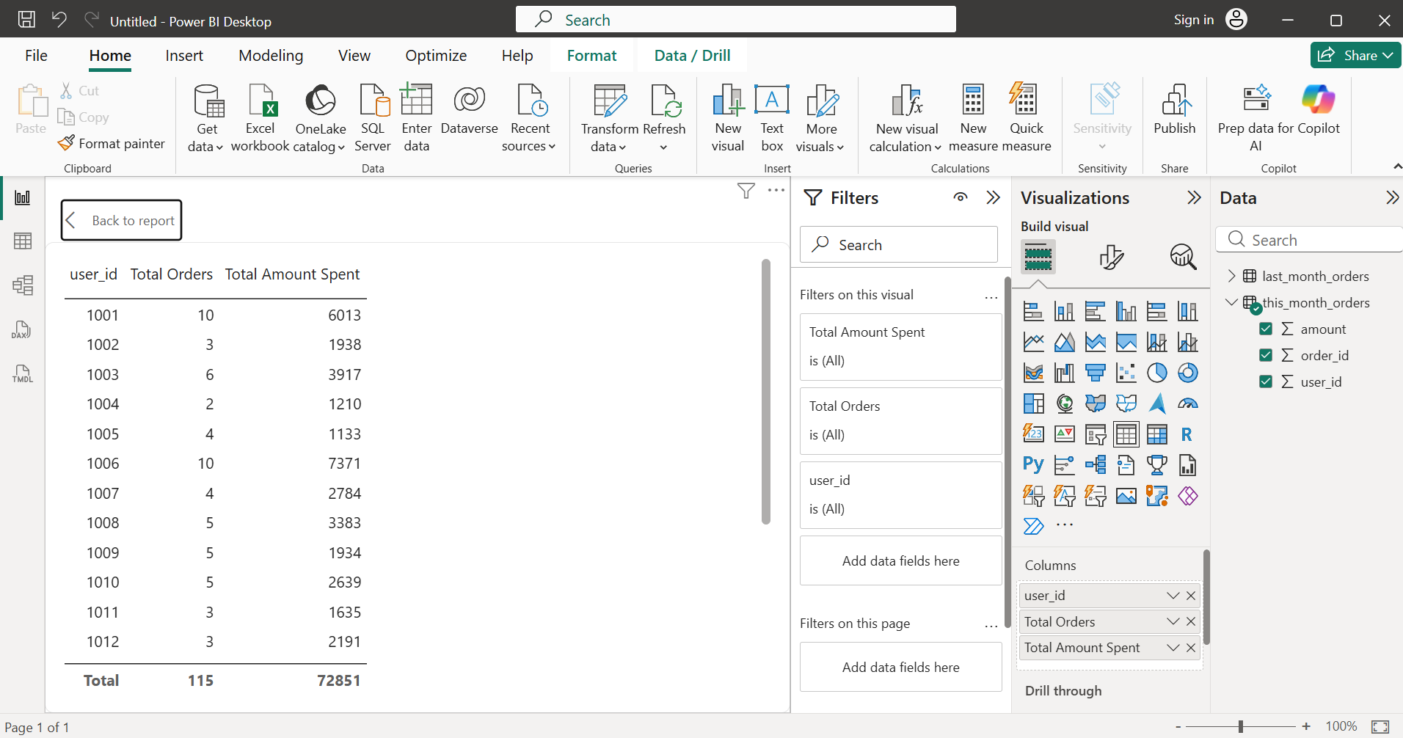

- Given a folder containing multiple CSV files of IPL match scores (same columns: match_id, team, runs), use Power BI's 'Combine Files from Folder' feature to load all data into a single table and create a bar chart showing total runs per team.

- Combining files from folder to load all data into a single table:
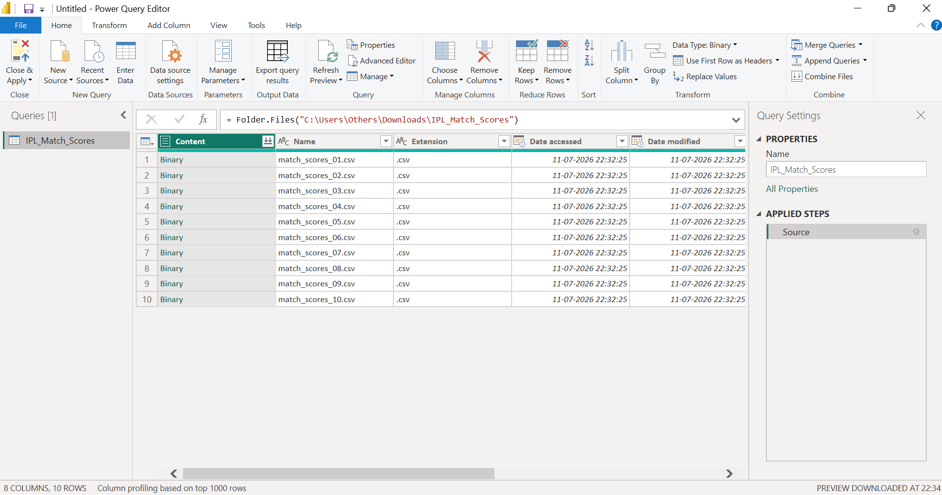
- Clustered bar chart showing total runs per team:
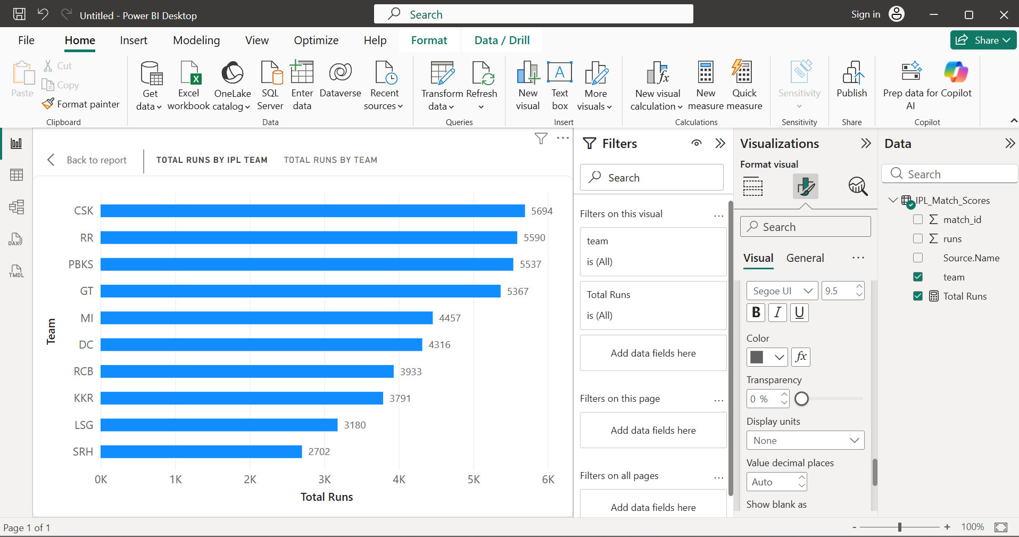

- Open the Query Dependencies View in Power BI for your current report and take a screenshot showing how your queries (from the previous tasks) are connected. Write 2-3 sentences explaining what the arrows and boxes represent in your setup.<br><br><em><strong>Hint:</strong> Focus on how Merge, Append, and Folder Combine steps create dependencies between queries.</em>

- Screenshot showing how power queries are related to each other:
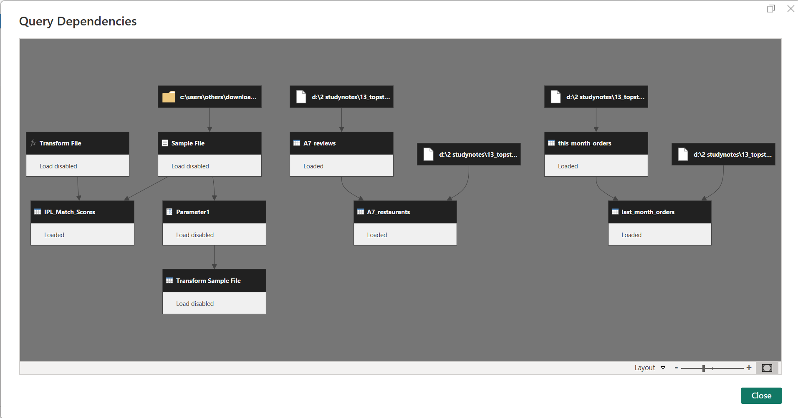

- In the Query Dependencies view, each box represents a Power Query query or helper query used to load and transform data. The arrows show how one query depends on another, indicating the flow of data through the transformations. In my report, the Merge operation depends on the Restaurants and Reviews queries, the Append operation depends on the two monthly orders tables, and the Folder Combine feature creates helper queries (such as Sample File and Transform File) that feed into the final combined IPL dataset.

