- Open Power BI Desktop and import a dataset of your choice (for example, a CSV of IPL cricket matches or Zomato restaurant data). Add two visuals (such as a bar chart and a table) and use the Edit Interactions feature to make sure clicking on one visual only highlights data in the other, instead of filtering it.

- Imported the IPL_Matches.csv dataset into Power BI.
- Created a Clustered Bar Chart using Team and Runs.
- Created a Pie Chart using Result and MatchID and Clustered Column Chart using Result and Runs.
- Opened Format -> Edit Interactions.
- Changed the interaction from Filter to Highlight.
- Verified that selecting a team in the bar chart highlights the related data instead of filtering it.
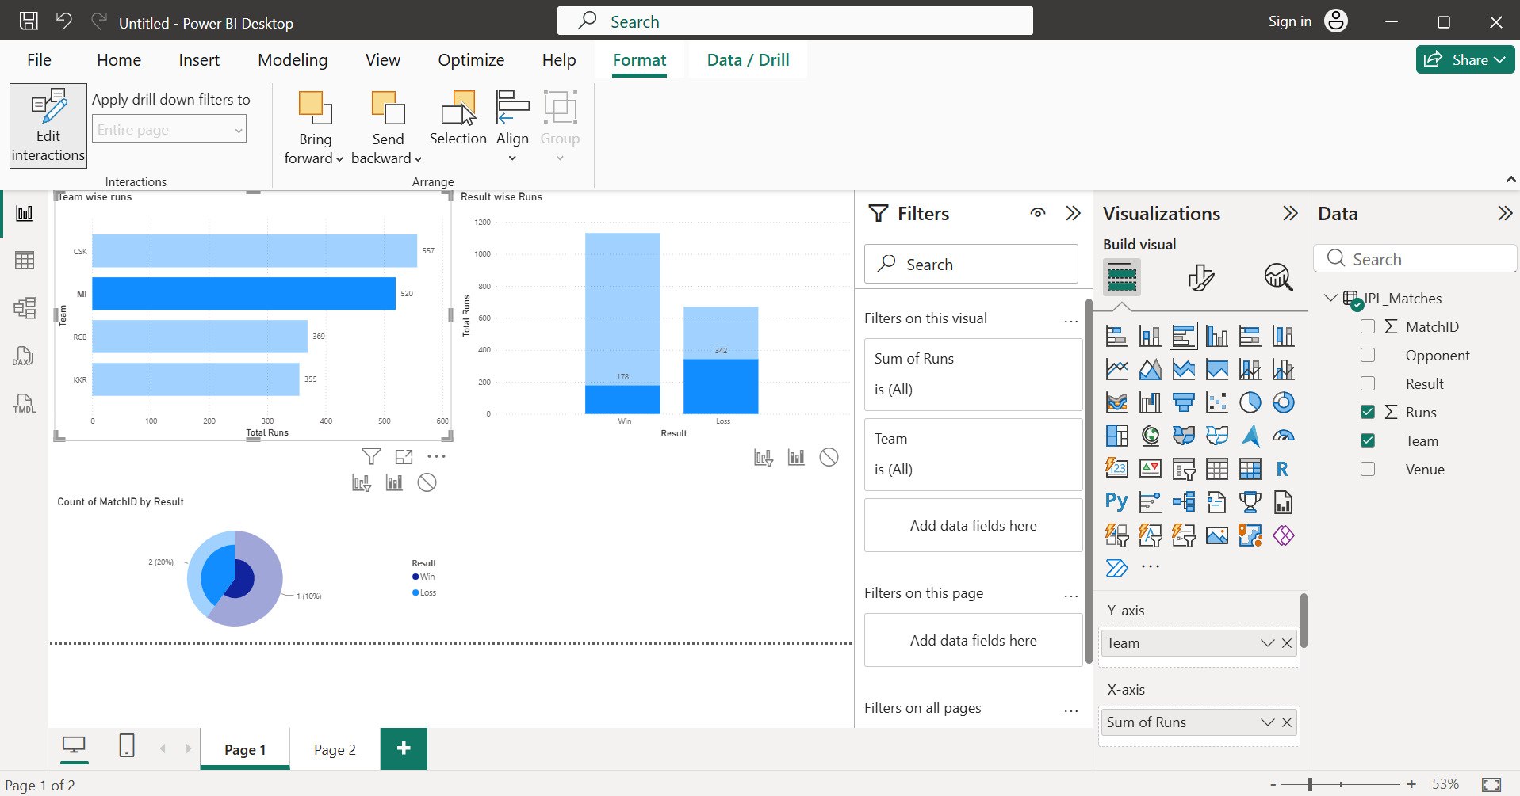

- Create a drill-through page in Power BI that lets users right-click on a Flipkart-style product category in a main report and see detailed information (like average price, top products) for that category on the drill-through page.<br><br><em><strong>Hint:</strong> Use the 'Drill-through' filter well to set up the connection between the main page and the drill-through page.</em>

- Imported the Flipkart product dataset into Power BI.
- Created a main report with a column chart showing product categories.
- Added a new page named Category Details.
- Added the Category field to the Drill-through filter well.
- Created an Average Price measure and displayed it in a Card.
- Added a Table visual showing Product Name, Brand, Price, and Rating.
- Added a Bar Chart to display product prices.
- Inserted a Back button for easy navigation.
- Verified that right-clicking a category on the main page and selecting Drill through → Category Details displayed details only for the selected category.
- Before applying drill through:
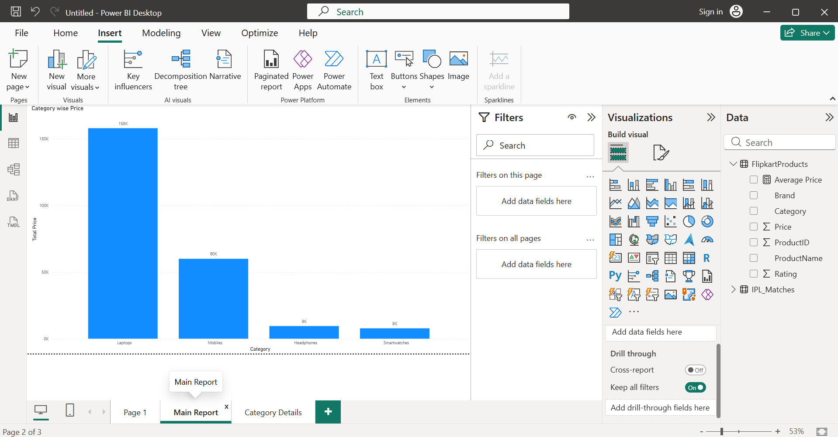
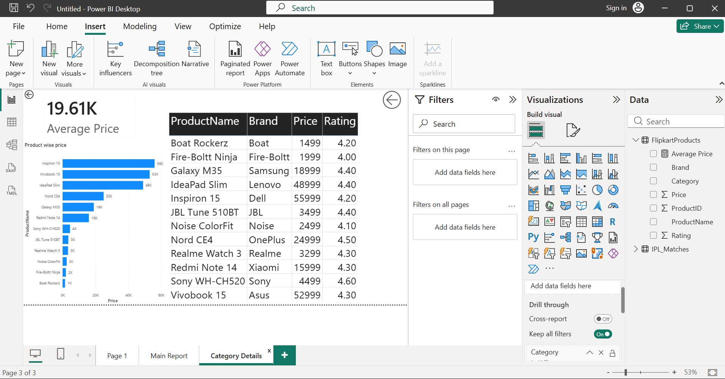
- After applying drill-through on “Mobiles” category:
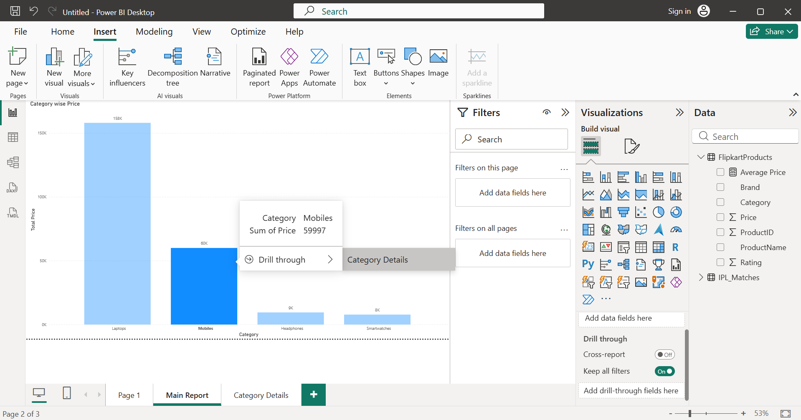
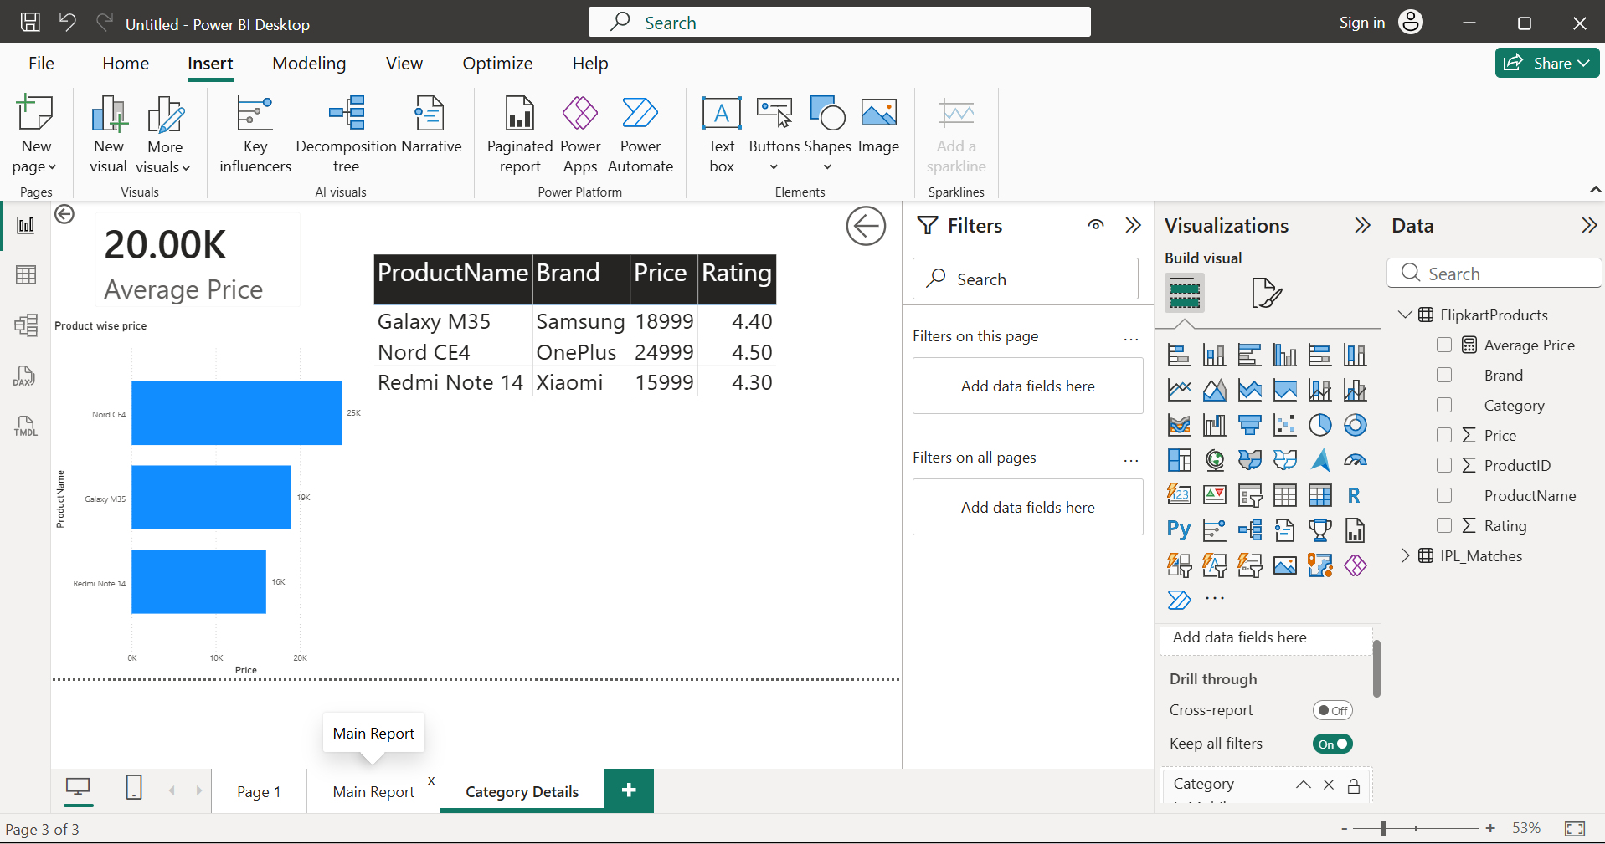

- Design a Power BI report showing a hierarchy similar to Zomato's city > restaurant > cuisine. Enable hierarchical navigation so that users can click to drill down from city to restaurant and then to cuisine in a single visual.<br><br><em><strong>Constraint:</strong> Use at least three levels in your hierarchy.</em>

- Imported the Zomato hierarchy dataset into Power BI.
- Created a hierarchy using the fields City, Restaurant, and Cuisine.
- Added the hierarchy to the Axis of a Clustered Column Chart.
- Added Orders to the Values field.
- Used the Drill Down feature to navigate from City → Restaurant → Cuisine within the same visual.
- Verified that users could explore data across all three hierarchy levels.
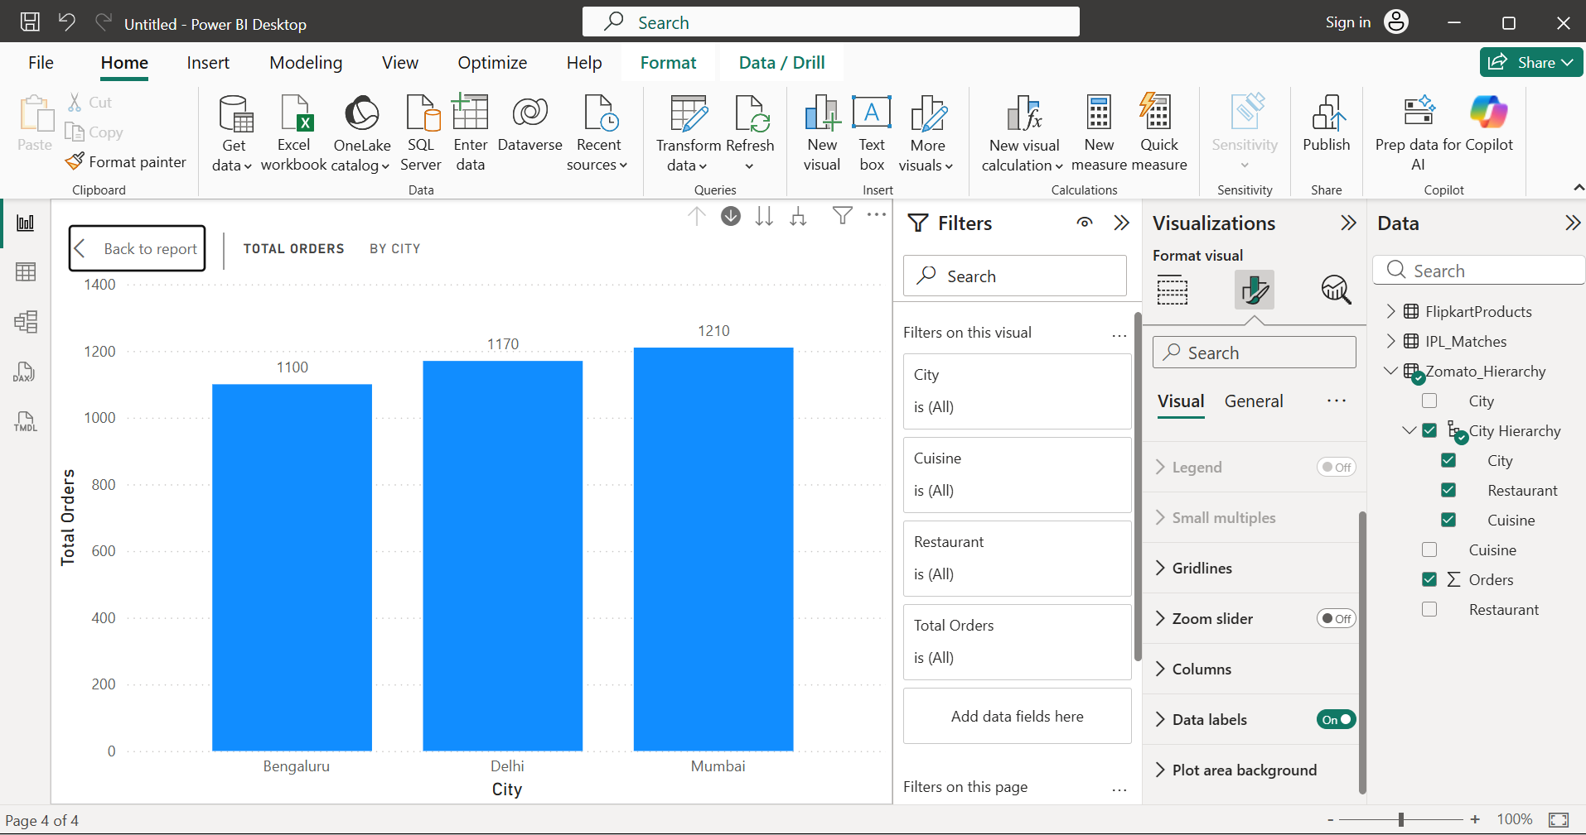
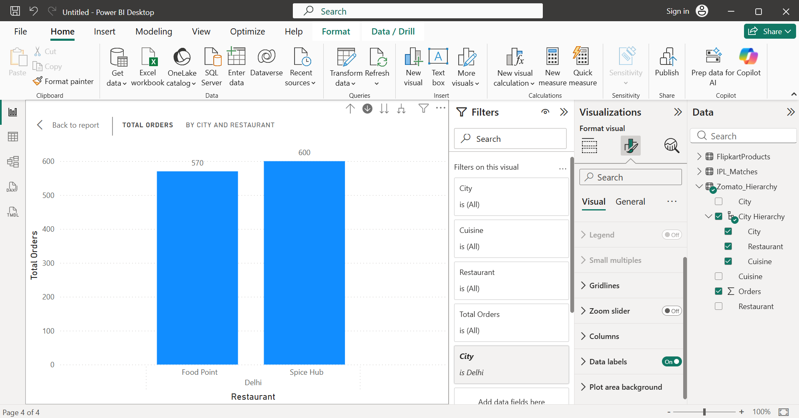
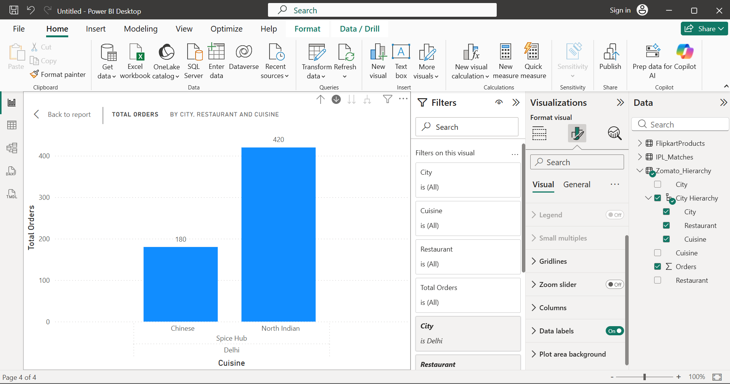
- Take an existing Power BI report you built earlier (any topic) and modify the interactions so that at least one visual does not respond to selections in another visual. Explain in a comment or text box when you would want to use this type of interaction in a real app like BookMyShow or Myntra.

- Opened an existing Power BI report.
- Selected the Column Chart visual.
- Chose Format → Edit Interactions.
- Set the interaction for the Table visual to None.
- Verified that selecting data in the chart no longer affected the Table.
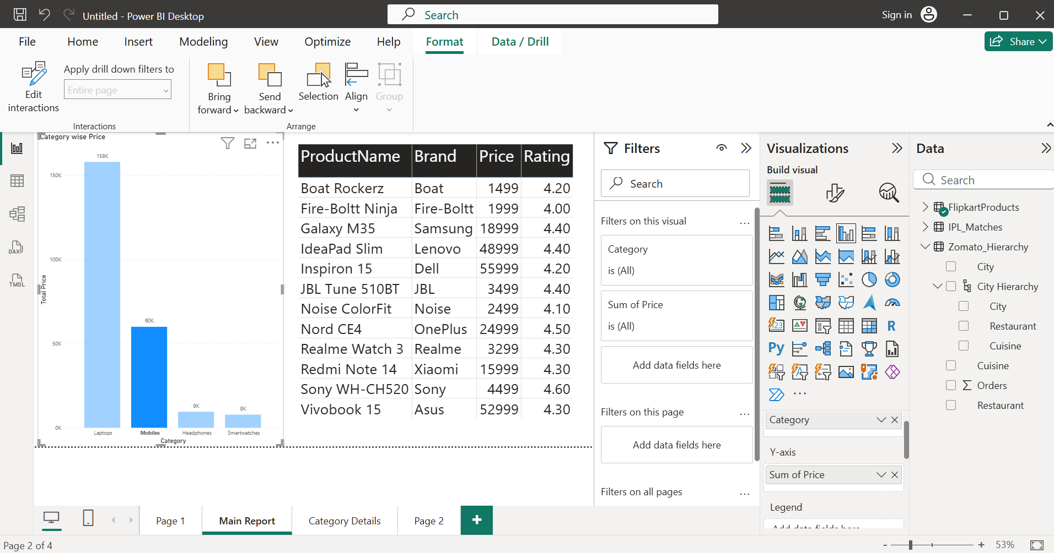
- Real-life Use Case: In applications like BookMyShow or Myntra, some visuals (such as overall sales, total products, or total movies) should remain constant even when users interact with other visuals. Setting the interaction to None prevents those visuals from changing, allowing users to compare filtered information with overall totals.

- Use ChatGPT or Copilot to generate step-by-step instructions for creating a drill-through page in Power BI, then follow those steps using your own dataset (not the one shown in class). After completing, compare the AI's instructions to your actual process and note any differences.<br><br><em><strong>Hint:</strong> Paste the AI's instructions in a text box on your report for reference.</em>

- Generated drill-through instructions using ChatGPT.
- Followed the instructions using a new dataset (Amazon Products).
- Successfully created a drill-through page.
- Compared the AI instructions with the actual implementation.
- Added the AI-generated instructions to the report using a Text Box.

- AI Instructions vs My Actual Process
1. Import a dataset into Power BI.
2. Create a main report with a visual using the field that will be used for drill-through.
3. Add a new report page.
4. Drag the desired field into the Drill-through filter well.
5. Create visuals (Card, Table, Charts) on the drill-through page.
6. Add a Back button.
7. Return to the main page.
8. Right-click a data point and choose Drill Through.
9. Verify that the drill-through page displays only the selected data.

AI Instructions | What I Actually Did
Imported a dataset | Imported Amazon_Products.csv
Created a main report | Created a Column Chart using Category and Price
Added a drill-through page | Created a page named Category Details(2)
Added a drill-through field | Used the Category field
Added visuals | Added a Card, Table, and Bar Chart
Added a Back button | Added a Back button
Tested the drill-through | Right-clicked Electronics and opened the drill-through page

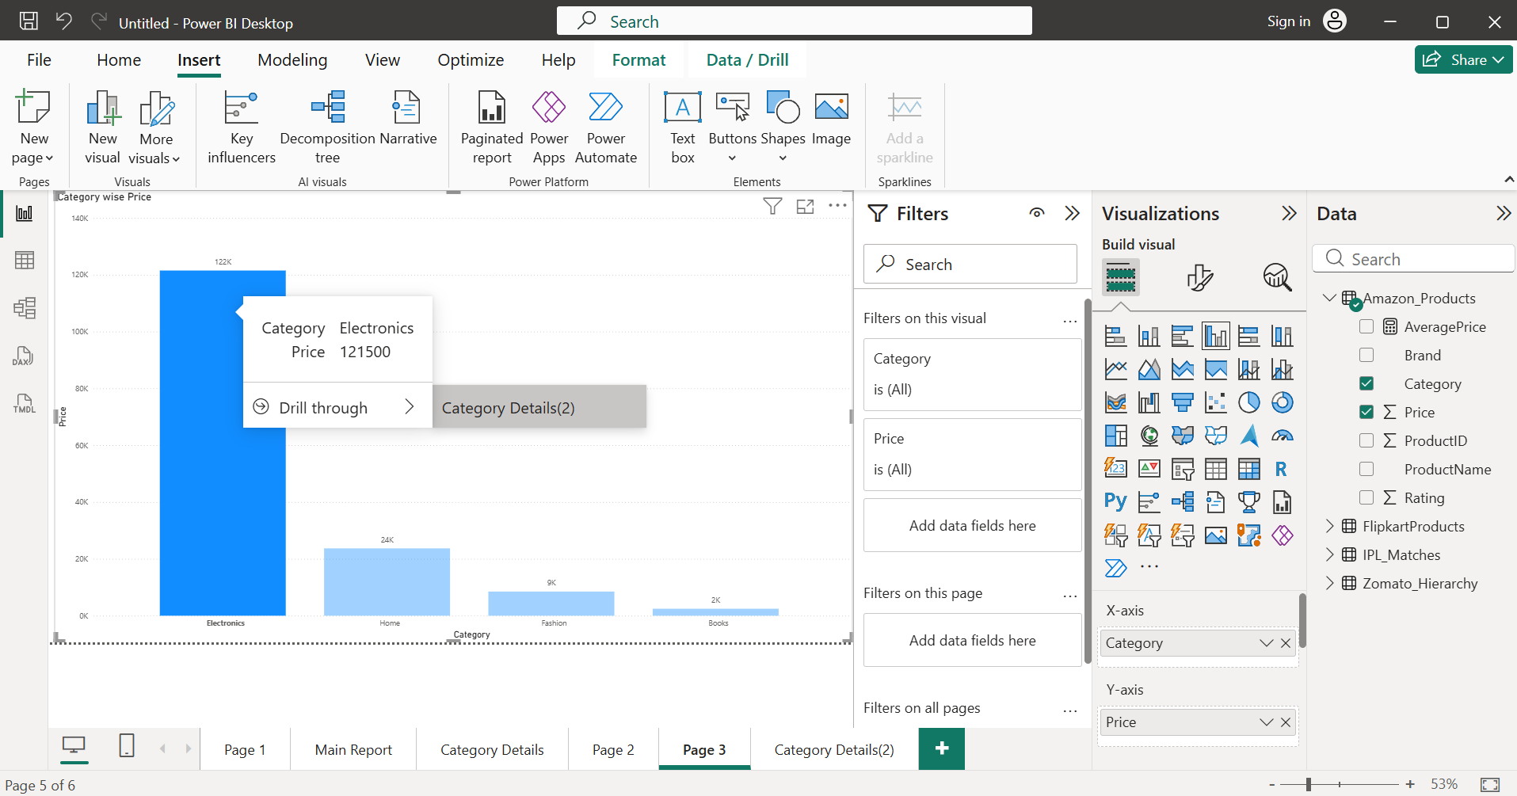
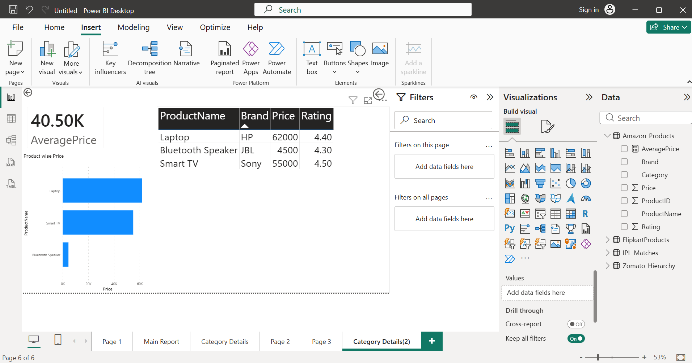

- Differences Observed: The AI instructions were general, while the actual process required choosing the correct fields, creating an Average Price measure, and arranging visuals on the drill-through page. The overall steps matched, but a few practical details (like creating a measure and formatting visuals) had to be completed during implementation.

