- In Power BI, import a sample IPL cricket match dataset and create a model view showing the relationships between Teams, Players, and Matches tables. Set up one relationship as inactive and explain in a comment why it might be useful to have inactive relationships in a sports analytics scenario.

- Created three tables – Teams, Players and Matches. Then created two active relationships
  - One-to-Many relationship of Table Teams with Table Players on column, ‘TeamID’.
  - One-to-Many relationship of Table Teams[TeamID] with Table Matches[HomeTeamID]. This relationship line is solid, which means it is active.
- Created an inactive relationship
  - One-to-Many relationship of Table Teams[TeamID] with Table Matches[AwayTeamID]. This relationship line is dashed, which means it is inactive.
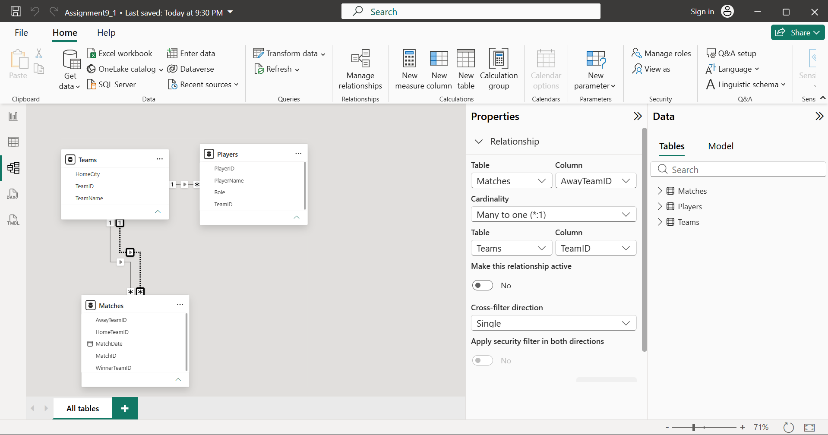
- Why Make One Relationship Inactive?
  - The Matches table has two columns:
    - HomeTeamID
    - AwayTeamID
  - Both refer to the Teams table.
  - Power BI allows only one active relationship between the same two tables when multiple relationships create ambiguity. Therefore:
    - HomeTeamID is kept active.
    - AwayTeamID is set inactive.
  - When you need to analyse matches based on the away team, you can use DAX functions like USERELATIONSHIP() to temporarily activate the inactive relationship in a measure.
- Relationships Summary:
From Table | To Table | Column | Status
Teams | Players | TeamID | Active
Teams | Matches | HomeTeamID | Active
Teams | Matches | AwayTeamID | Inactive
- Imported the Teams, Players, and Matches tables into Power BI and created the required relationships in Model View. The relationship between Teams and Matches using HomeTeamID was kept active, while the relationship using AwayTeamID was set as inactive. Inactive relationships are useful because they allow multiple valid relationships between the same tables without causing ambiguity. They can be activated when needed in DAX calculations using functions such as USERELATIONSHIP().

- Change the cross filter direction between your Matches and Players tables from single to both in the model view. Observe and describe how this affects the filtering of player stats when you select a specific match in your report.<br><br><em><strong>Hint:</strong> Use a slicer or filter in your report to test the impact of the cross filter direction.</em>

- In Question 1, there was no direct relationship between Matches and Players. Since this question is asking to change the cross-filter direction between Matches and Players, we need a common column. Hence, updated the Players table by adding MatchID column.
- Added a slicer and Table visual:

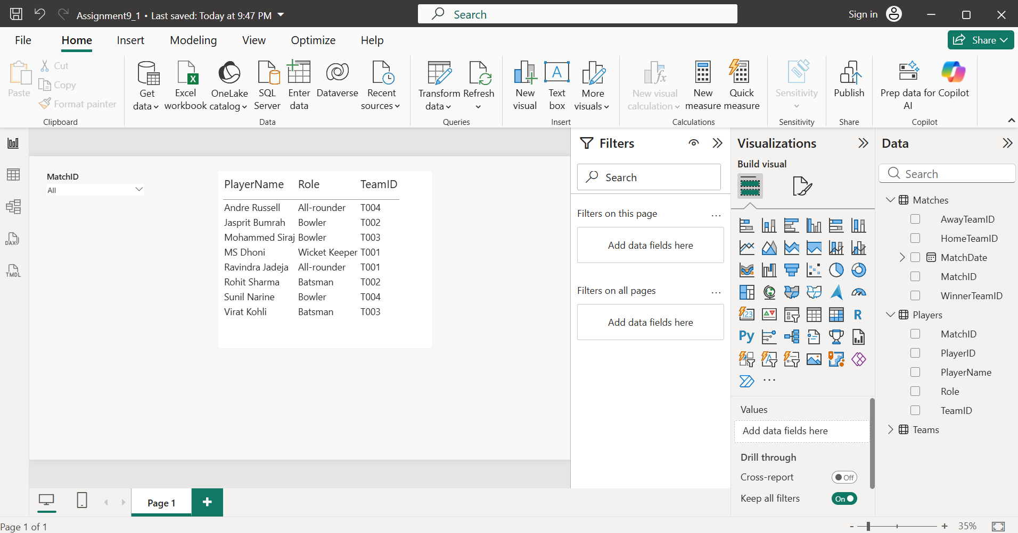
- Tested with Single cross filter:
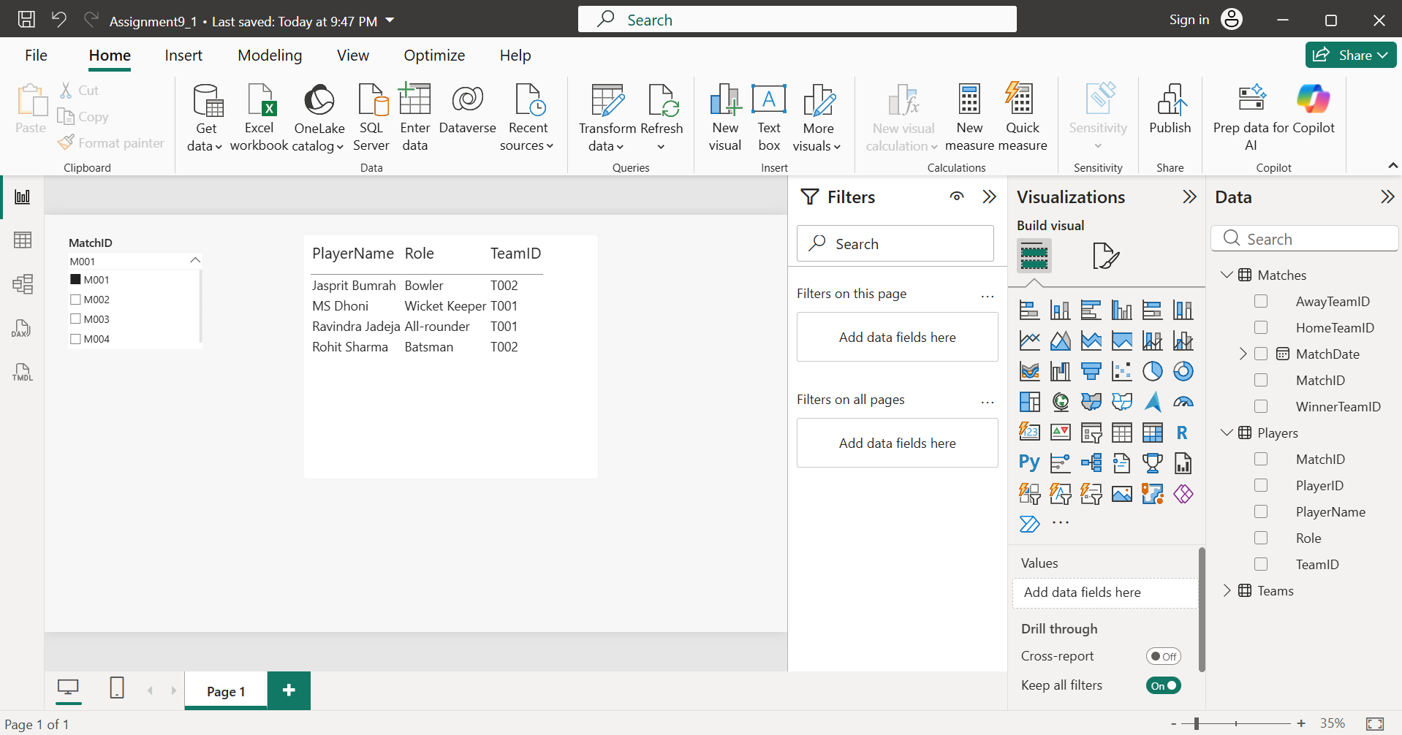
- Changed Cross-filter direction from ‘Single’ to ‘Both’.
- Selected M002 in the slicer.
  - The table now shows only the players linked to M002.
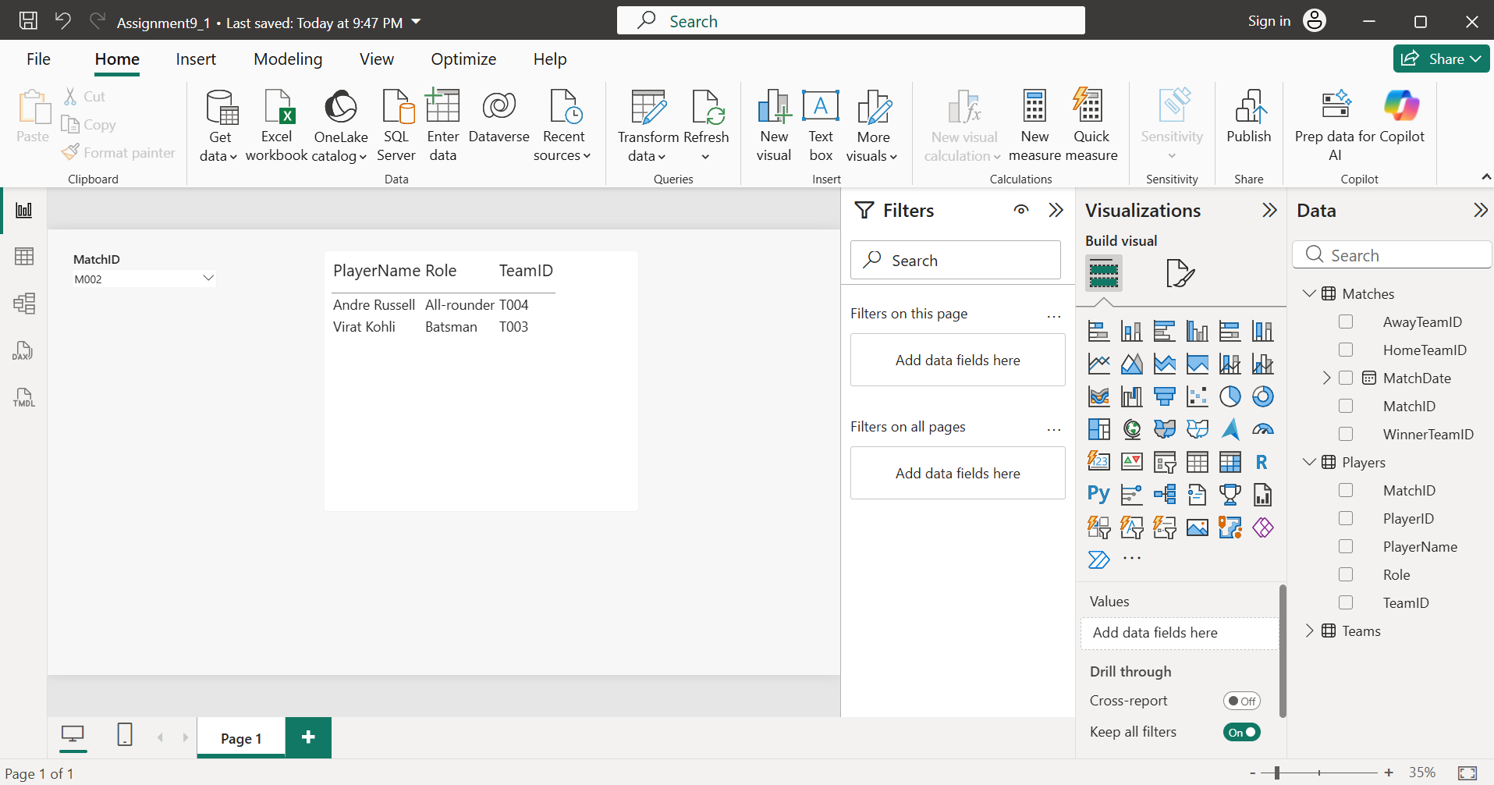
- The difference is that
  - Single Cross Filter
Matches -> Players
Filters flow only from Matches to Players.
  - Both Cross Filter
Matches <-> Players
Filters can flow in both directions.
Selections in related visuals can affect each other through the relationship.
- Observation
  - Before (Single):
    - Selecting a match filters the player table.
    - Filtering works in one direction only.
  - After (Both):
    - Selecting a match still filters the player table.
    - Filters can now propagate in both directions, which can be useful in more complex reports with multiple related visuals.
- The Cross-filter direction between the Matches and Players tables was changed from Single to Both. With the Single direction, filters flowed only from the Matches table to the Players table. After changing it to Both, filters could propagate in both directions, allowing related visuals to interact more flexibly. This is useful in reports where users need filters and selections to affect multiple connected tables, though it should be used carefully to avoid ambiguous filtering paths.

- Hide the PlayerEmail and PlayerPhone fields in the Players table from report view in Power BI, so that only relevant stats are visible to end users viewing dashboards.

- Updated the Players table, added PlayerEmail and PlayerPhone fields. Went to Data View, right-clicked on field, 'PlayerEmail'. Then clicked 'Hide in report view' option. The field name became slightly faded/grey, indicating it is hidden. Repeated the same process for ‘PlayerPhone’ field.
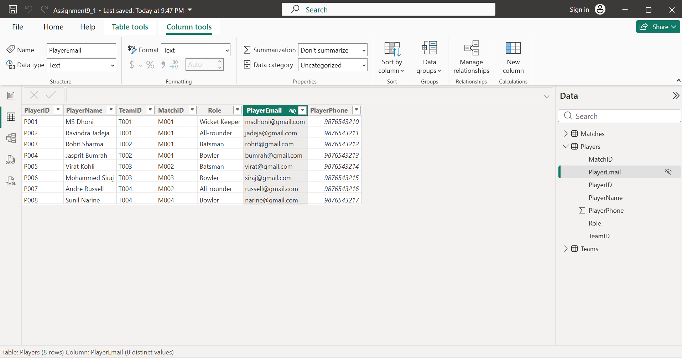
- To verify, went to report view and expanded the Players table in the Fields pane.
  - There only following fields were visible:
    - PlayerID
    - PlayerName
    - TeamID
    - MatchID
    - Role
  - The below mentioned two fields were not visible:
    - PlayerEmail
    - PlayerPhone
- The hidden fields are still stored in the model but are not available for report creators or dashboard users to add to visuals.
- We hide these fields to:
  - keep the Fields pane clean and easy to use.
  - prevent users from accidentally using confidential or unnecessary information.
  - ensure only relevant statistics are available for building reports.
- The PlayerEmail and PlayerPhone fields were hidden using the Hide in report view option in Power BI. These fields remain part of the data model but are no longer visible in the report view, making the Fields pane cleaner and ensuring that end users focus only on relevant player statistics.

- Add a calculated column to the Matches table that labels each match as 'High Scoring' if total runs are above 200, otherwise 'Regular'. Then, create a measure that calculates the average runs per match. Compare how calculated columns and measures behave in your report.<br><br><em><strong>Hint:</strong> Use DAX functions for both the calculated column and the measure.</em>

- Updated the ‘Matches’ table, added ‘Total Runs’ field. Then created DAX column as shown in below screenshot:
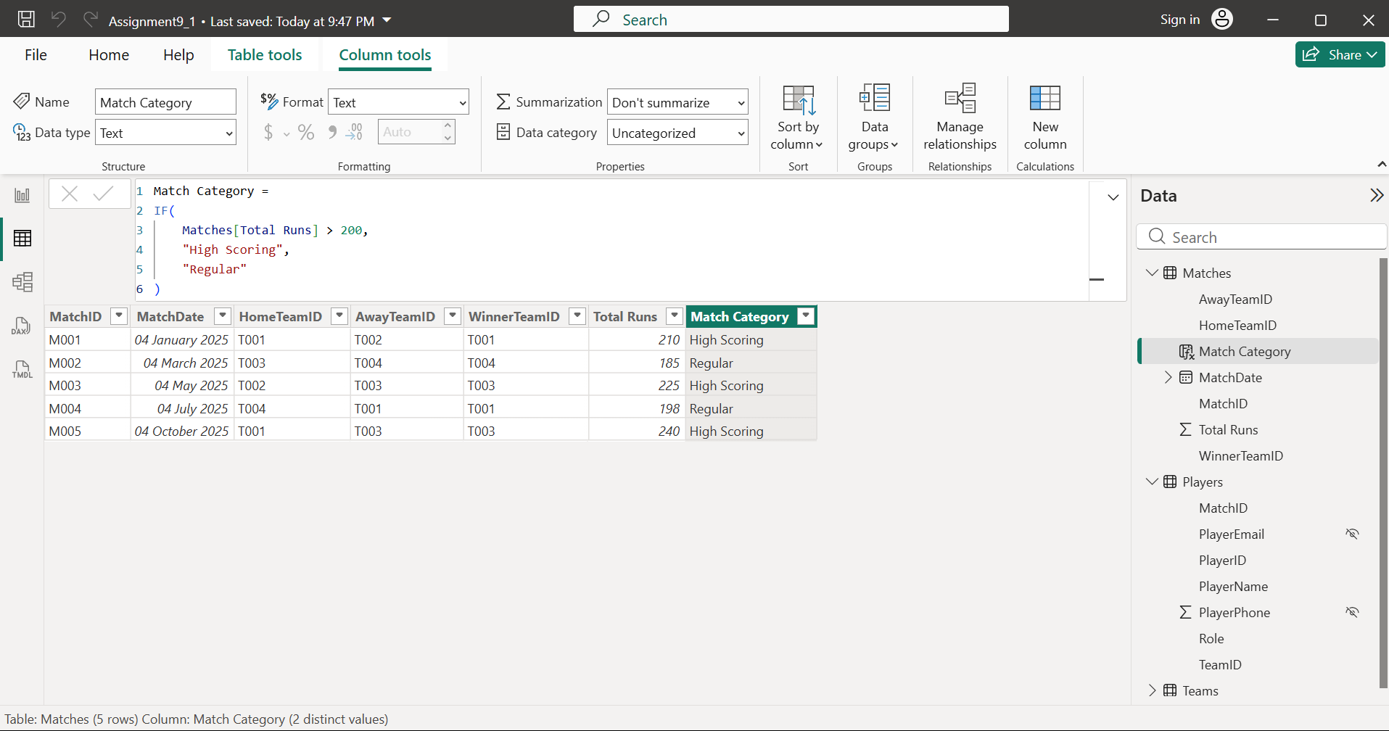
- Created new measure, ‘Average Runs’ as shown in below screenshot. This measure calculates the average runs across the matches in the current filter context:
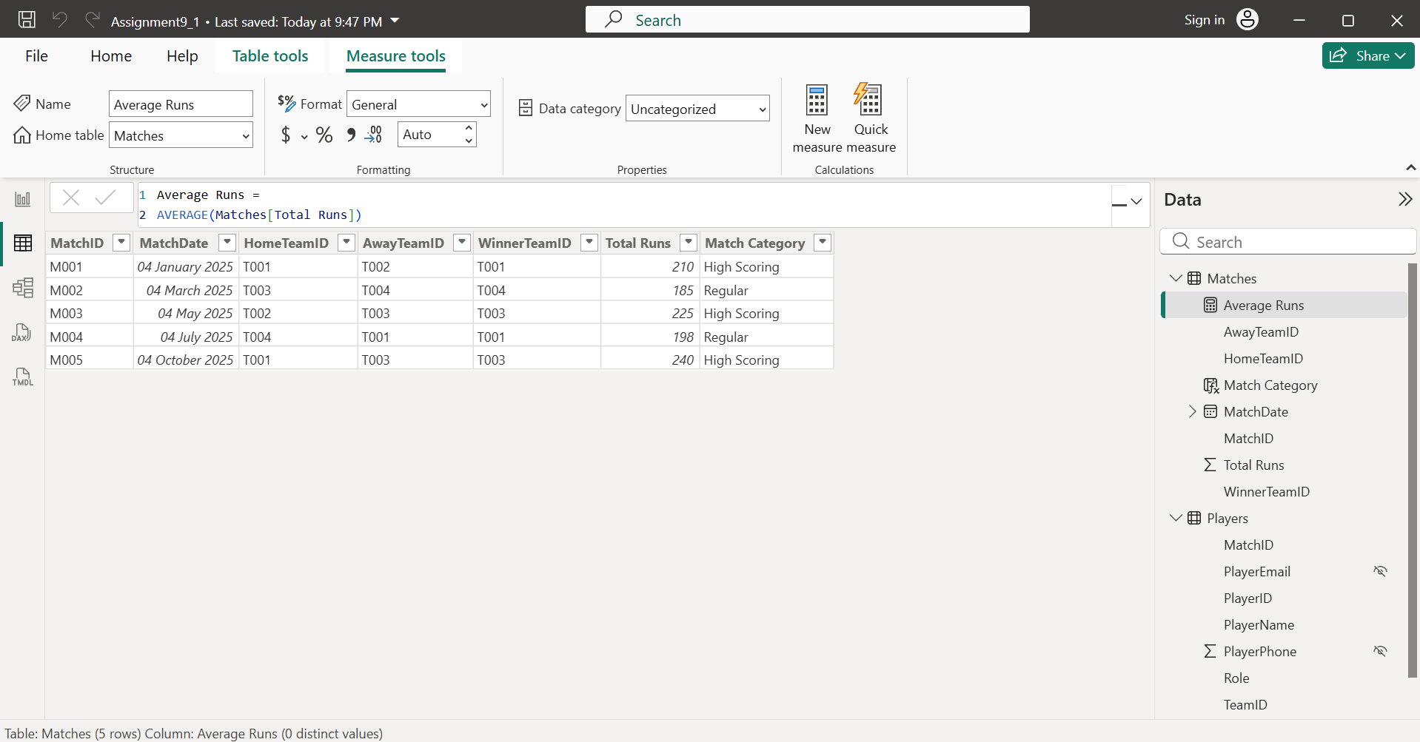
- Inserted a table visual and added
  - MatchID
  - Total Runs
  - Match Category
- Then added card visual and dragged the ‘Average Runs’ measure into it.
- Both is shown in below screenshot:
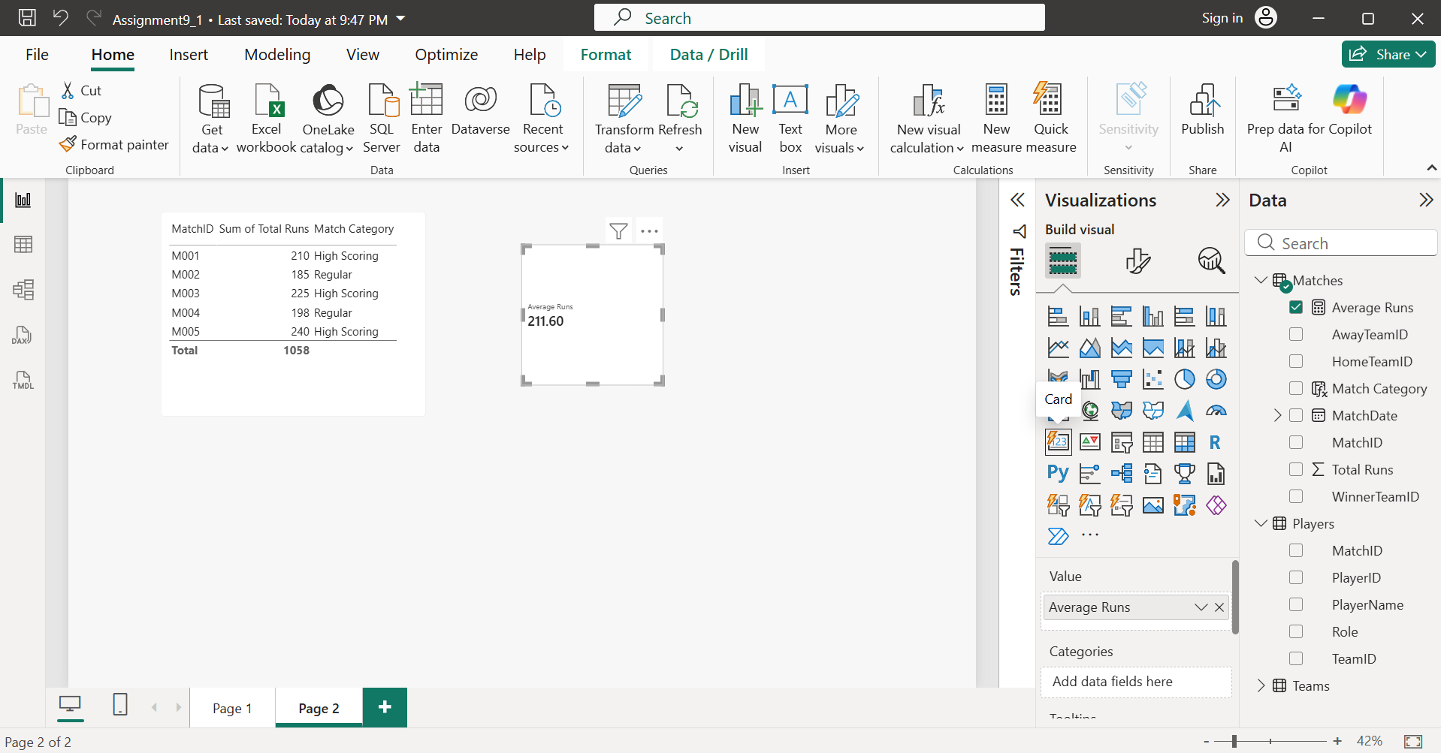
- Comparing Calculated Column and Measure:
Calculated Column | Measure
Created using New Column | Created using New Measure
Stored in the table | Not stored; calculated when needed
Value is calculated for every row | Value is calculated based on the current filter context
Can be used in slicers and grouping | Used for calculations in visuals (cards, charts, tables, etc.)
- Simple Example:
  - Calculated Column
MatchID | Total Runs | Match Category
M001 | 210 | High Scoring
M002 | 185 | Regular
    - The value is fixed for each row.
  - Measure
    - If you filter the report to show only M001 and M003, the Average Runs measure will automatically recalculate using only those selected matches.
- A calculated column named Match Category was created using an IF() function to classify matches as High Scoring or Regular based on the TotalRuns value. A measure named Average Runs was created using the AVERAGE() function to calculate the average runs per match. The calculated column stores a value for each row and is useful for categorization, whereas the measure is calculated dynamically based on the filters applied in the report and is useful for aggregations and analysis.

- Create a date hierarchy in your Matches table (Year > Month > Day) and use it to build a line chart showing the number of matches played over time, similar to how BookMyShow might display movie releases by date.

- Inserted the line-chart visual and used the hierarchy to analyse matches at different date levels as shown below:
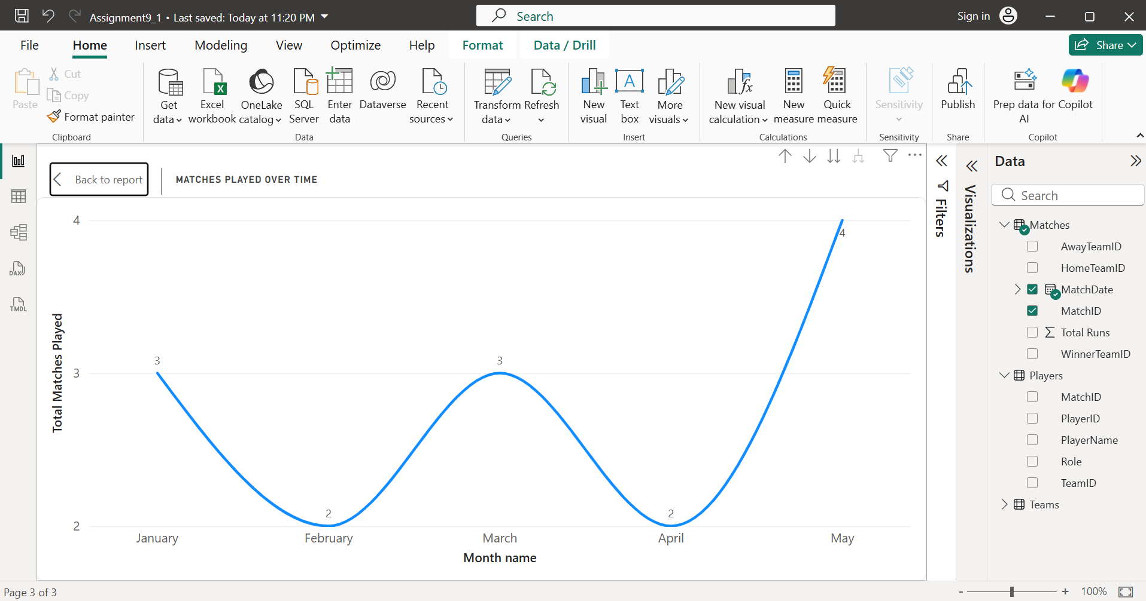
- A Date Hierarchy was created using the MatchDate column, allowing the data to be analyzed by Year, Month, and Day. A Line Chart was created with the date hierarchy on the X-axis and the Count of MatchID on the Y-axis to display the number of matches played over time. This hierarchy enables users to drill down through different levels of time, similar to how BookMyShow analyses movie releases by date.

