- Import a sample dataset of IPL cricket matches into Power BI and create a Table visual that displays Team Name, Runs Scored, and Match Date.

- Imported “IPL_Matches_Sample.csv” file. Added a table visual and displayed Team Name, Runs Scored and Match Date fields as shown below:
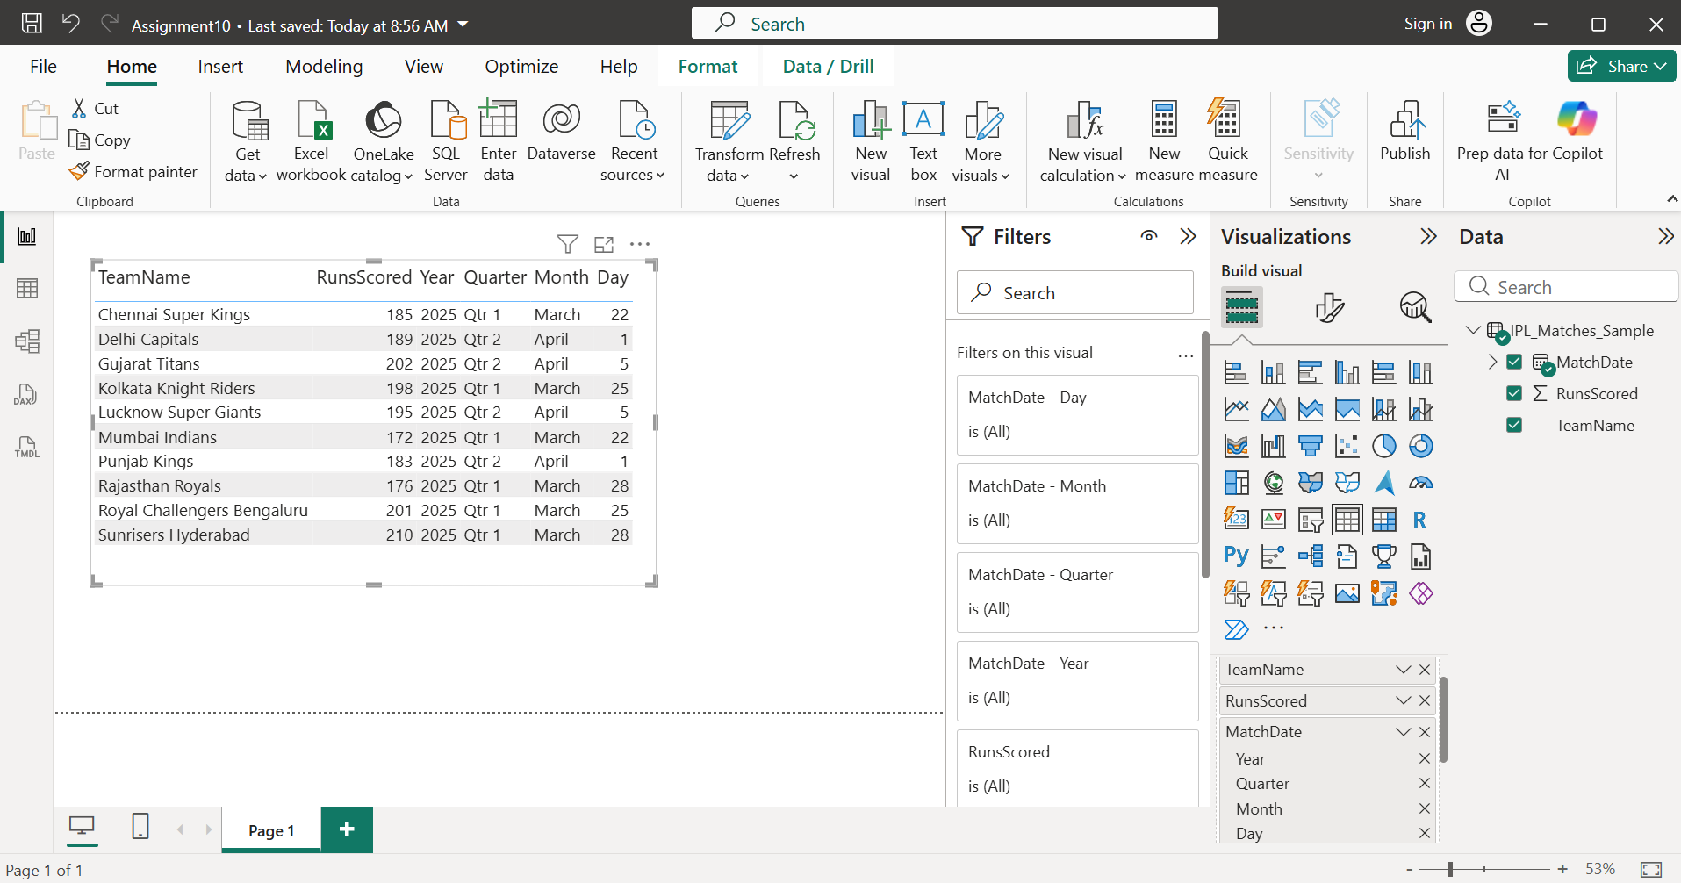

- Using a dataset of Zomato restaurant ratings, create a Matrix visual in Power BI that shows average rating per City and Cuisine type.

- Imported “Zomato_Restaurant_Ratings.csv” file. Inserted matrix visual and added city, cuisine and average rating to it.
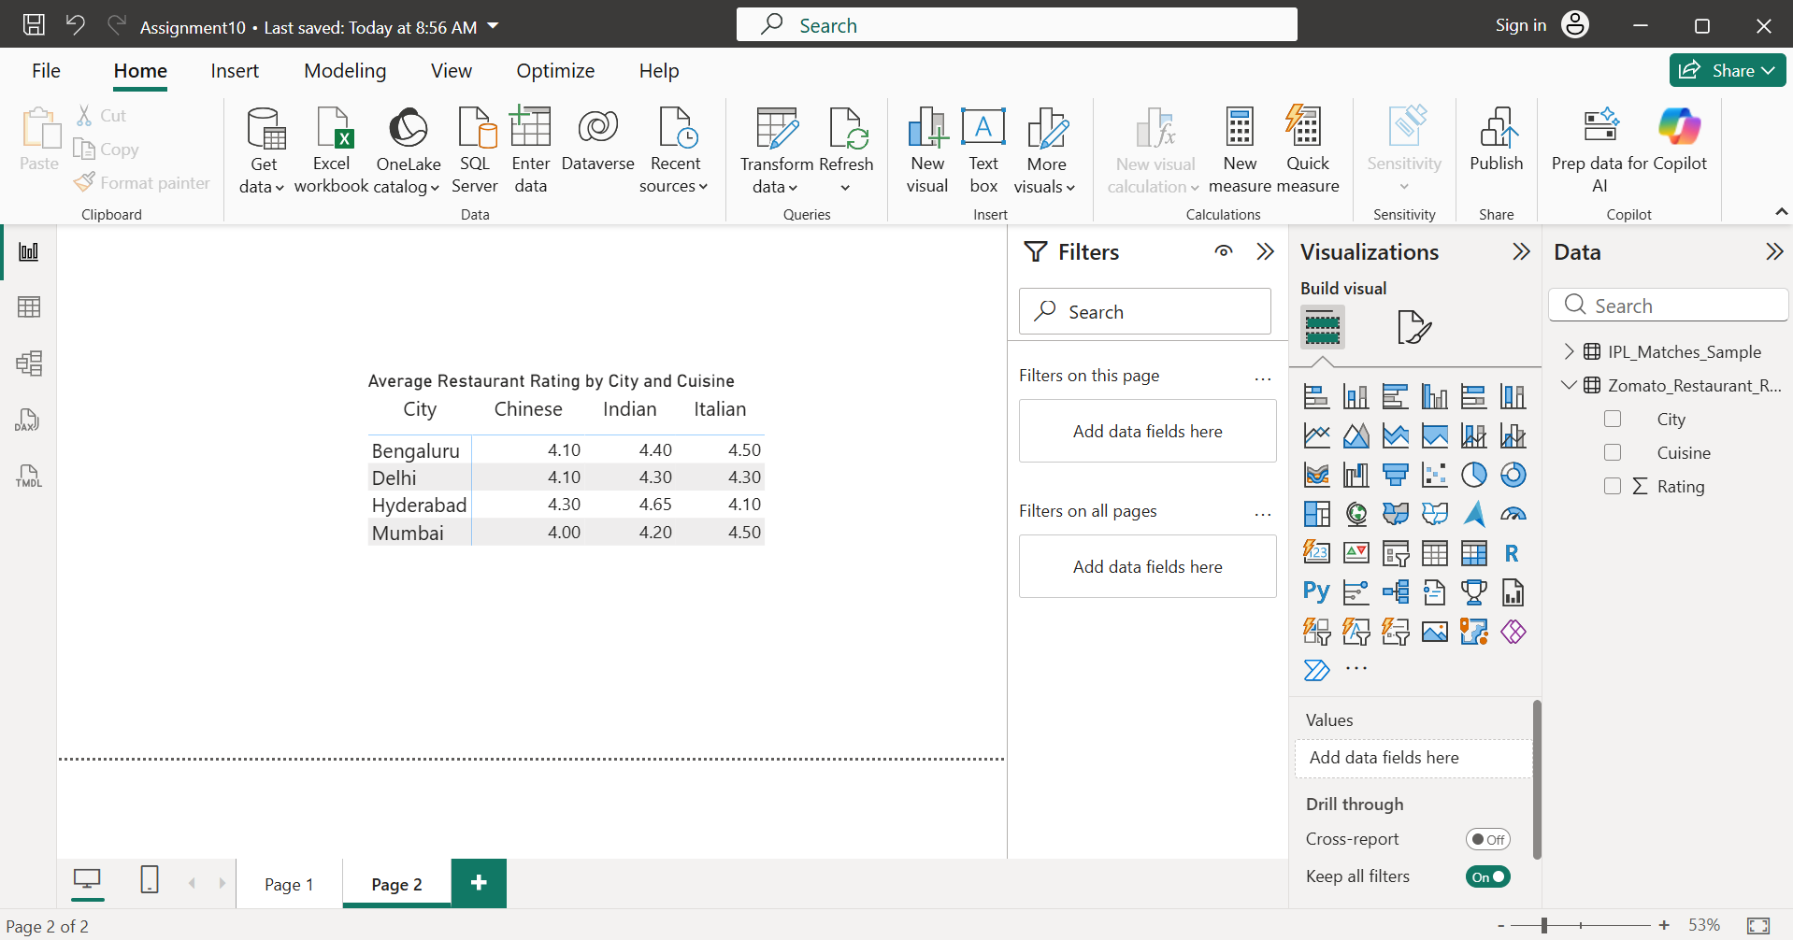
- A Matrix visual was created using the Zomato restaurant ratings dataset. The City field was placed in the rows, Cuisine in the columns, and the Rating field was summarized as Average in the values section. This visualization makes it easy to compare average restaurant ratings across different cities and cuisine types.

- Design a Card visual in Power BI to display the total number of active users from a Flipkart user data file.

- Imported “Flipkart_User_Data.csv” file and created a measure named, “Total Active Users” as shown below:
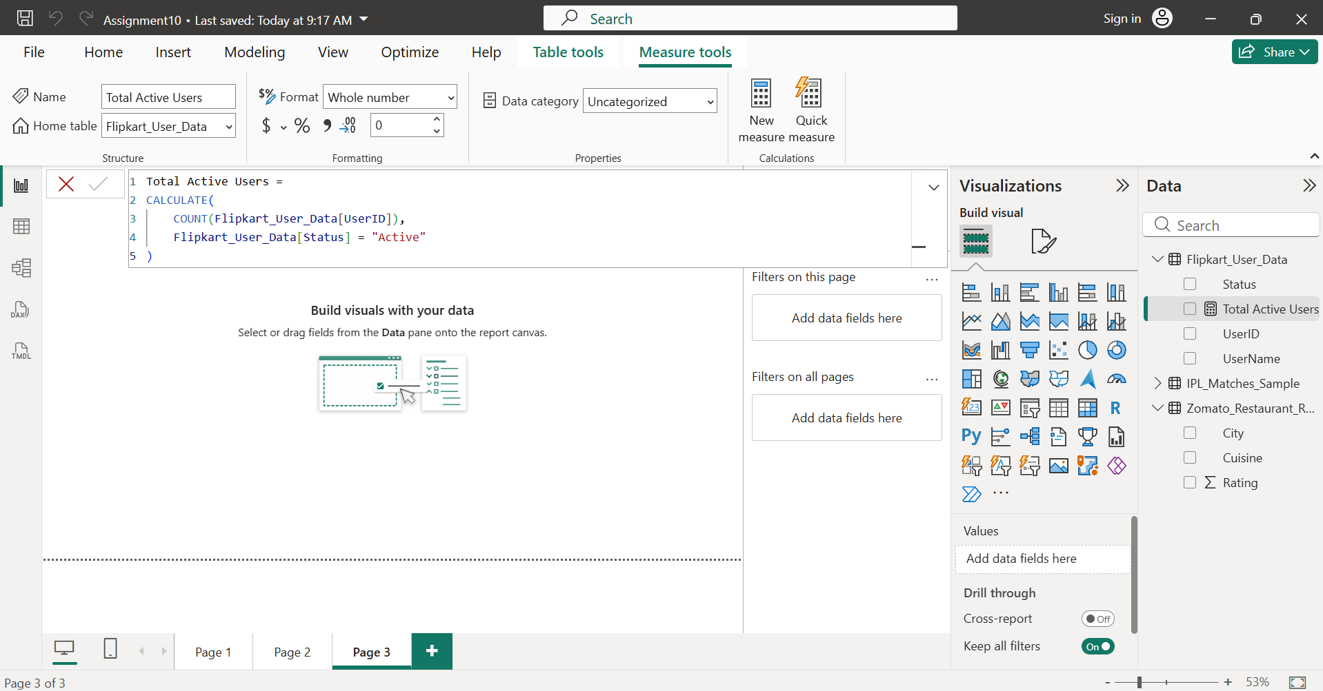

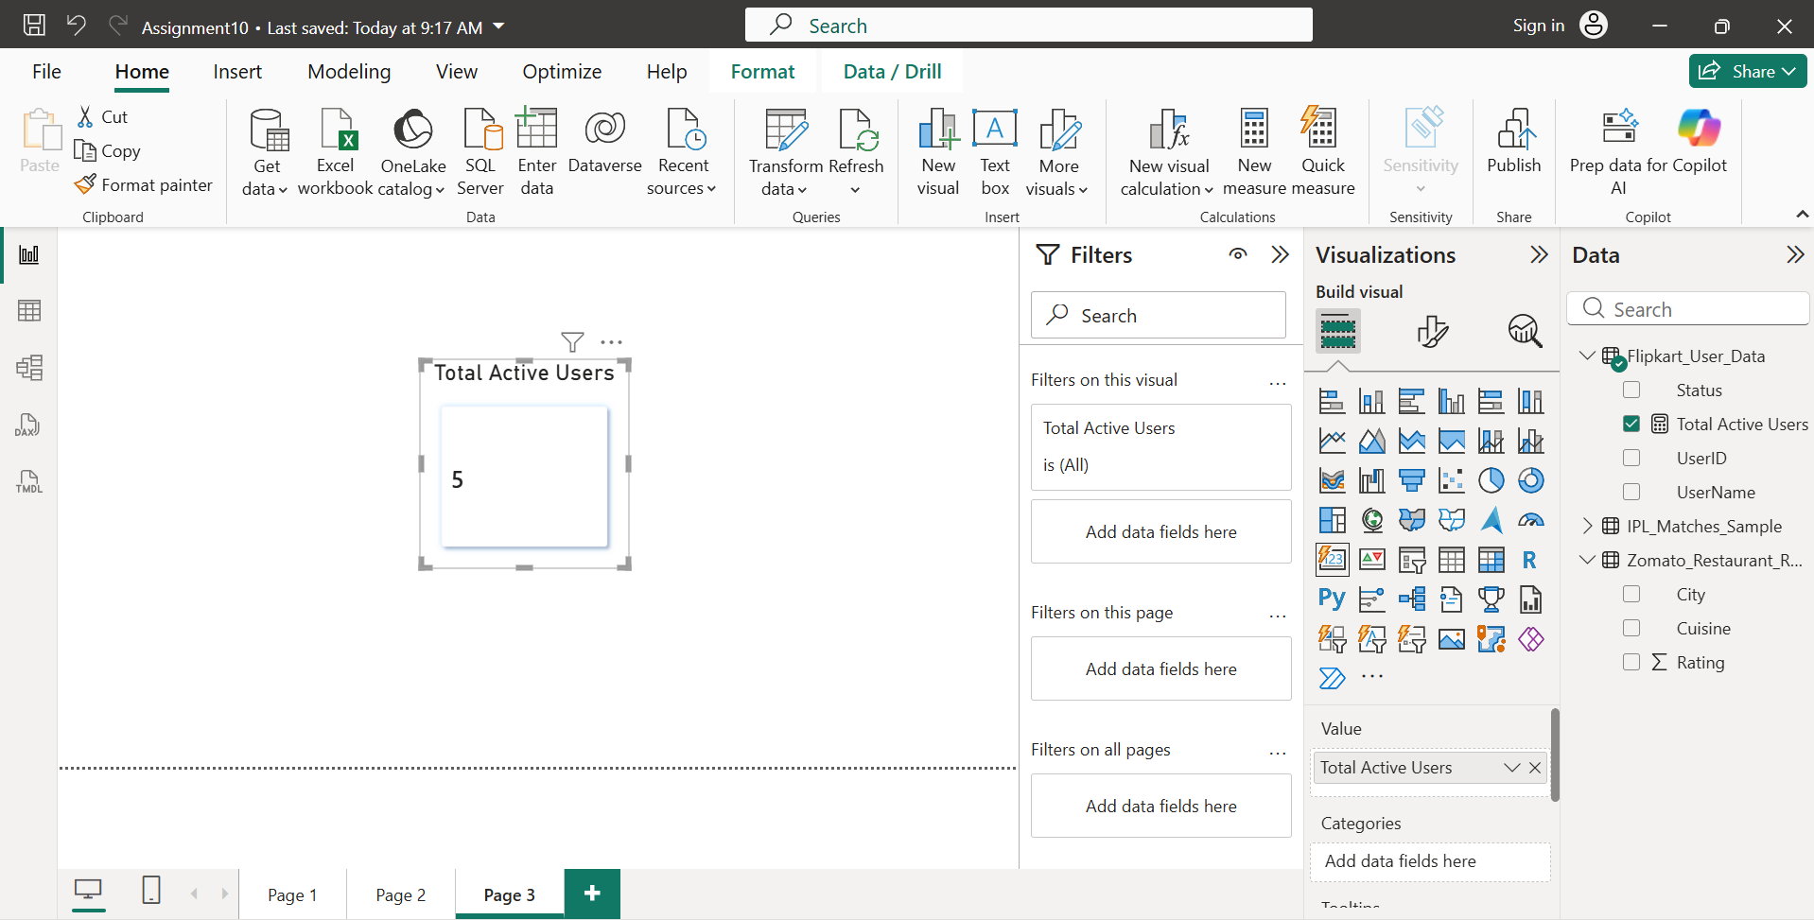

- Created a Card visual to display the total number of active users. Then created a DAX measure named Total Active Users using the CALCULATE() and COUNT() functions to count only users whose Status is "Active". The card dynamically updates if the data or report filters change.

- Build a KPI visual in Power BI that tracks the monthly increase in Spotify premium subscriptions and shows whether the current month’s number is higher or lower than the previous month.

- Imported “Spotify_Premium_Subscriptions.csv” file. Created DAX Measures,
Total Premium Subscriptions =
SUM(Spotify_Premium_Subscriptions[PremiumSubscriptions])

Previous Month Subscriptions =
CALCULATE(
SUM(Spotify_Premium_Subscriptions[PremiumSubscriptions]),
PREVIOUSMONTH(Spotify_Premium_Subscriptions[Month])
)

Monthly Change =
[Total Premium Subscriptions] - [Previous Month Subscriptions]

- Then inserted KPI visual as shown below:
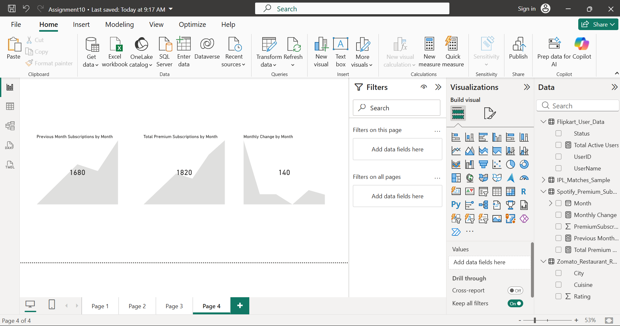
- The KPI visual displays the latest month's premium subscriptions (1820) using the Month field as the trend axis. Comparing June (1820) with May (1680), subscriptions increased by 140, indicating that the current month's subscriptions are higher than the previous month.
- Conclusion: Created a KPI visual to monitor monthly Spotify Premium subscriptions. Added the total premium subscriptions measure in the value field, and used the Month field as the Trend axis. The KPI automatically compares the latest month's subscription count with the previous month, making it easy to identify whether subscriptions have increased or decreased over time.

- Create a Bar or Column chart in Power BI using a BookMyShow movie bookings dataset to compare the number of tickets sold for the top 5 movies.<br><br><em><strong>Hint:</strong> Use the 'Top N' filter to show only the top 5 movies by ticket sales.</em>

- Imported “BookMyShow_Movie_Bookings.csv” file and inserted clustered column chart visual as shown below:
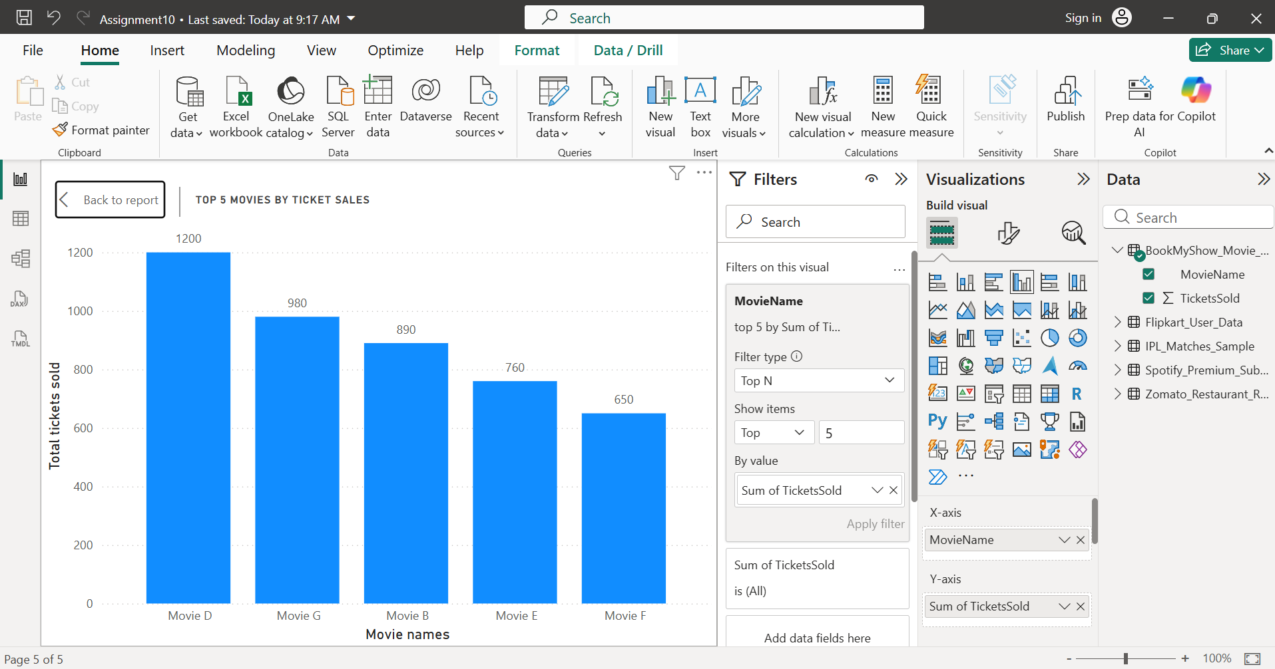
- Created a clustered Column Chart to compare ticket sales for movies. Applied the Top N filter to display only the top 5 movies based on the number of tickets sold. This visualization highlights the best-performing movies and makes it easy to compare their ticket sales.

