- Download and install Power BI Desktop on your computer, then open the application and take a screenshot of the blank report interface.
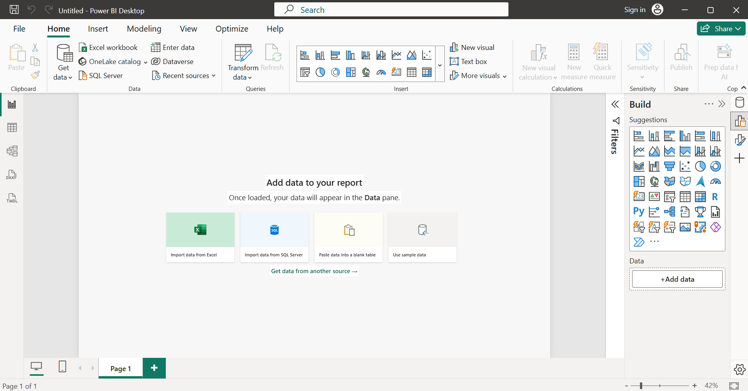

- Explore the Power BI Desktop interface and identify the following components: Report View, Data View, Model View, Fields Pane, Visualizations Pane, and Filters Pane. Write a short description (1-2 lines) for each component.
A short description of the main components of the Power BI Desktop Interface is as follows:
- Report View: Build reports and dashboards.
The primary workspace where you create and design reports by adding charts, tables, maps, and other visualizations.
- Data View: Examine and manage data.
Displays the data loaded into Power BI in a tabular format, allowing you to inspect, transform, and create calculated columns or measures.
- Model View: Create and manage table relationships.
Shows relationships between tables in a visual diagram, helping you manage and configure the data model.
- Fields Pane: Access dataset fields.
Lists all tables, columns, measures, and hierarchies available in the dataset. You can drag fields from here into visuals.
- Visualizations Pane: Create and format visuals.
Contains different chart and visualization types (bar charts, pie charts, tables, maps, etc.) along with formatting options for selected visuals.
- Filters Pane: Filter report data.
Allows you to apply filters at the visual, page, or report level to control which data is displayed in your report.

- Create a new blank report in Power BI Desktop and add a table visual using the Visualizations Pane. Rename the report page to 'My First Dashboard'.
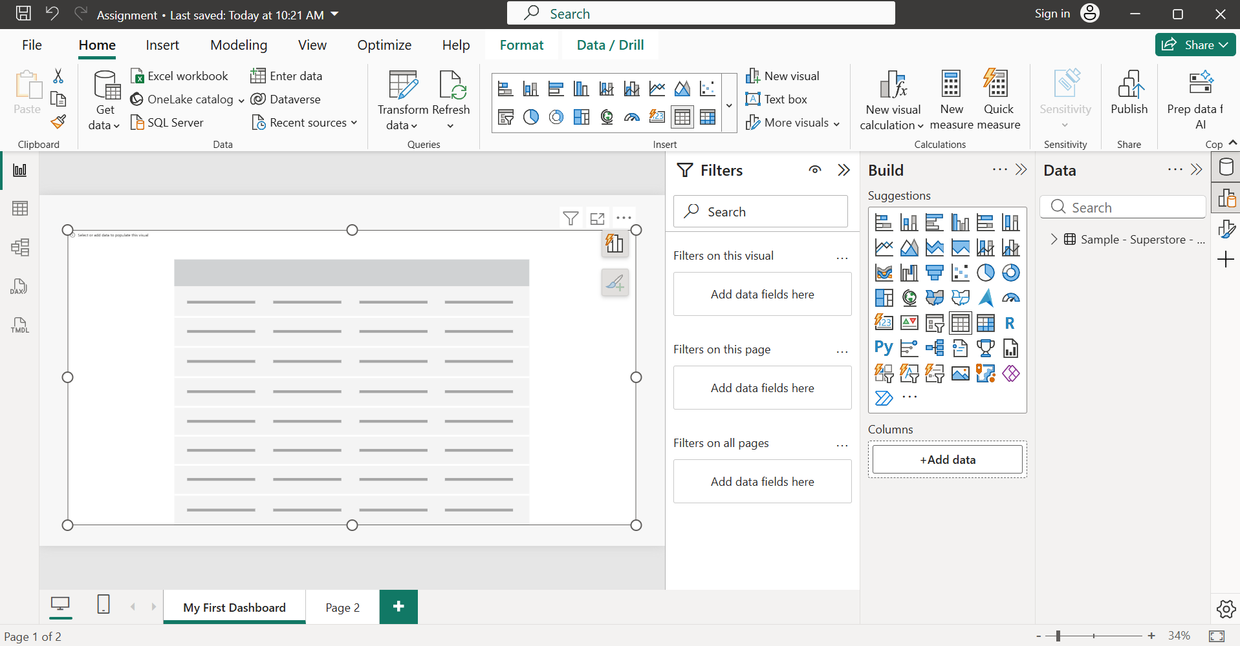

- List 3 key differences between Excel Dashboards and Power BI Dashboards, focusing on features or workflows you noticed while exploring Power BI Desktop.
Sr. No. | Feature | Excel Dashboard | Power BI Dashboard
1. | Data Handling | Best suited for smaller datasets and manual data updates through worksheets, formulas, and PivotTables. | Designed to handle large datasets efficiently and supports automated data refresh from multiple data sources.
2. | Data Modeling | Limited relationship management between tables; often relies on formulas such as VLOOKUP/ XLOOKUP or PivotTables. | Provides a dedicated Model View for creating and managing relationships between tables, enabling more robust data models.
3. | Visualization & Interactivity | Dashboards are built using charts, slicers, and formatting, with limited interactivity. | Offers a wide range of interactive visualizations, drill-through capabilities, cross-filtering, and dynamic reports through the Visualizations and Filters panes.

