- Open Power BI Desktop and connect to an Excel file containing a list of your favourite restaurants (name, cuisine, rating). Load the data using the Import mode.

- Connecting to an Excel File:
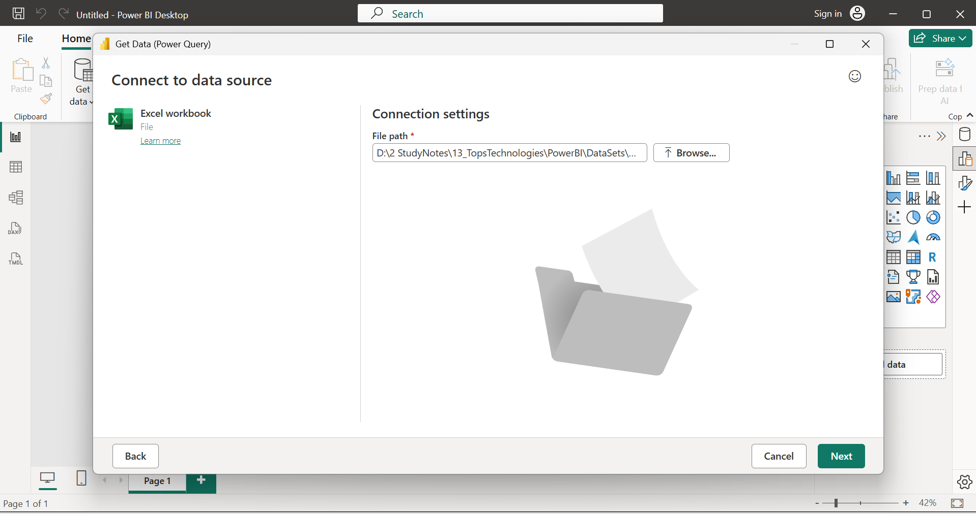

- Selecting Data:
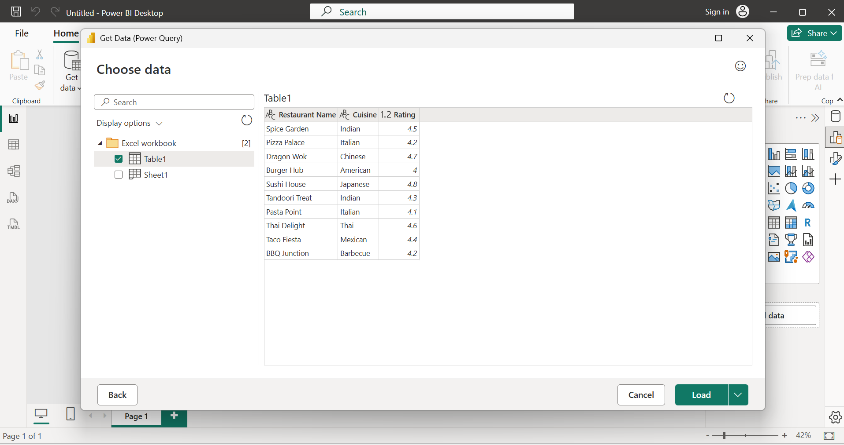
- Loaded Data in Table View:
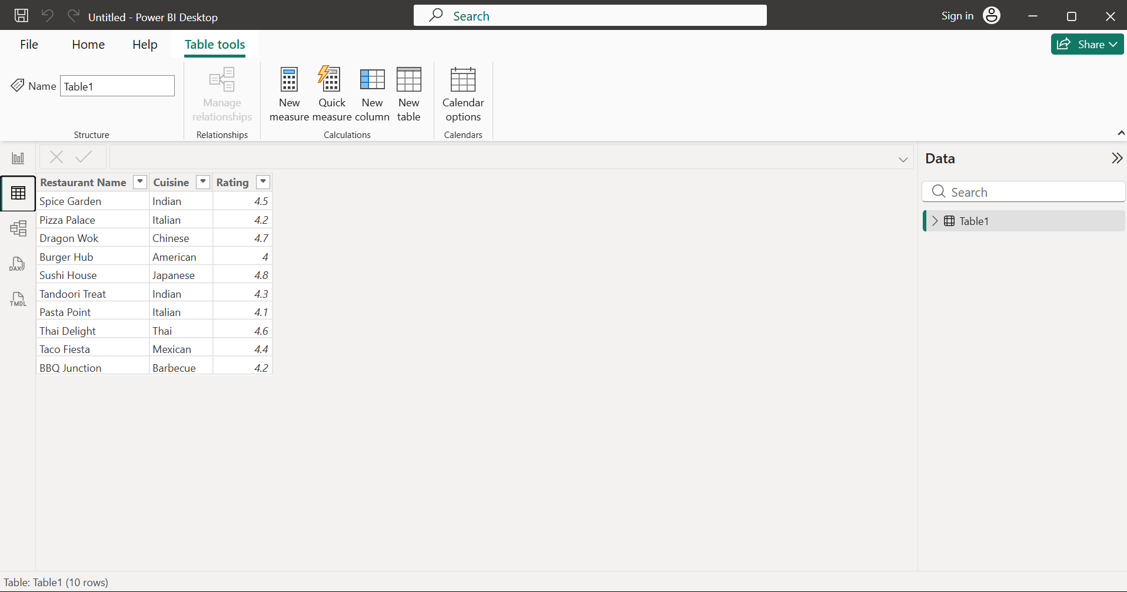

- Table as available in Fields Pane:
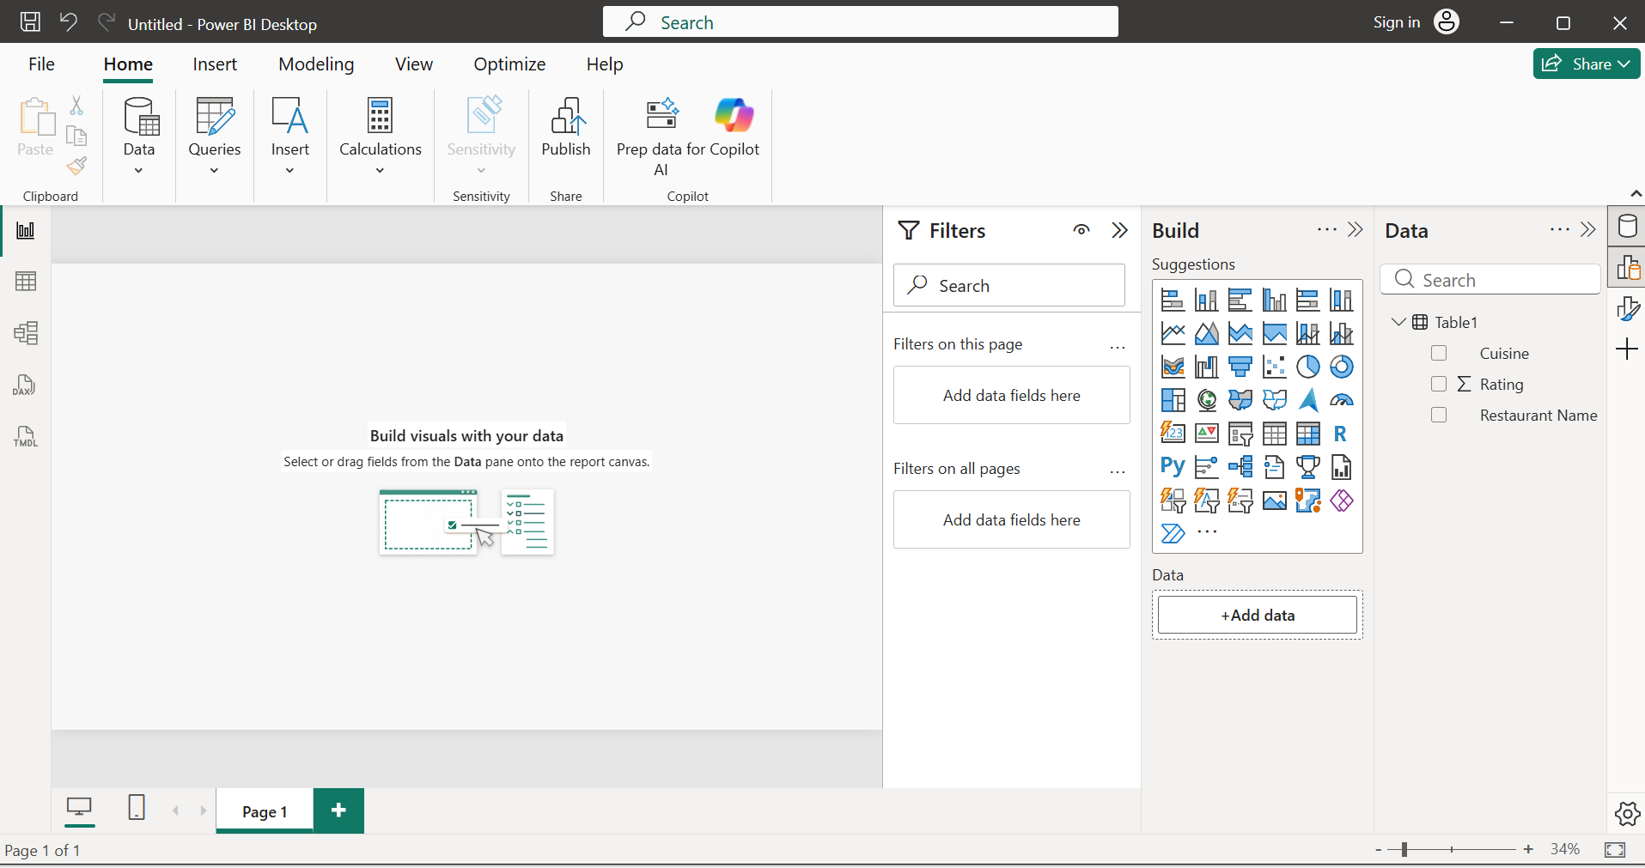

- Connect Power BI Desktop to a CSV file that contains IPL cricket match results (team names, scores, date). Use the DirectQuery mode and explain in one line how DirectQuery differs from Import for this data.
- CSV files do not support DirectQuery in Power BI. When connecting to a CSV file, Power BI automatically uses Import mode. DirectQuery is available only for supported databases such as SQL Server, Oracle, MySQL, etc.
- Connecting to a CSV file:
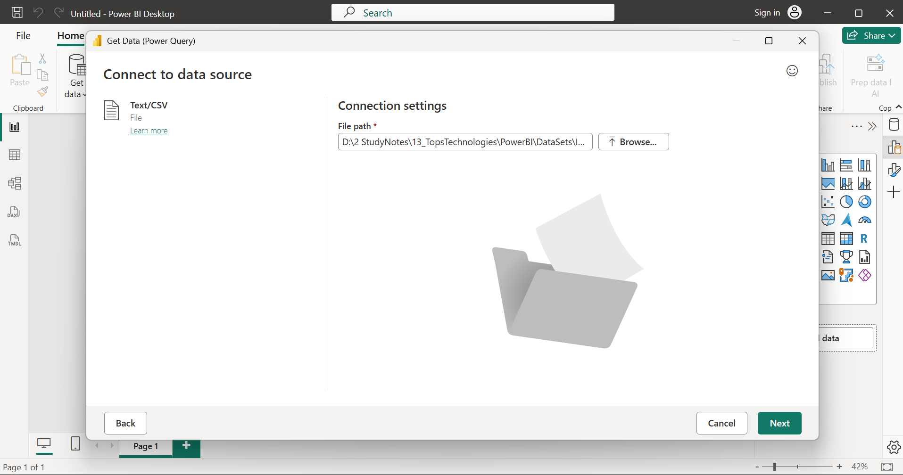

- IPL Data Preview:
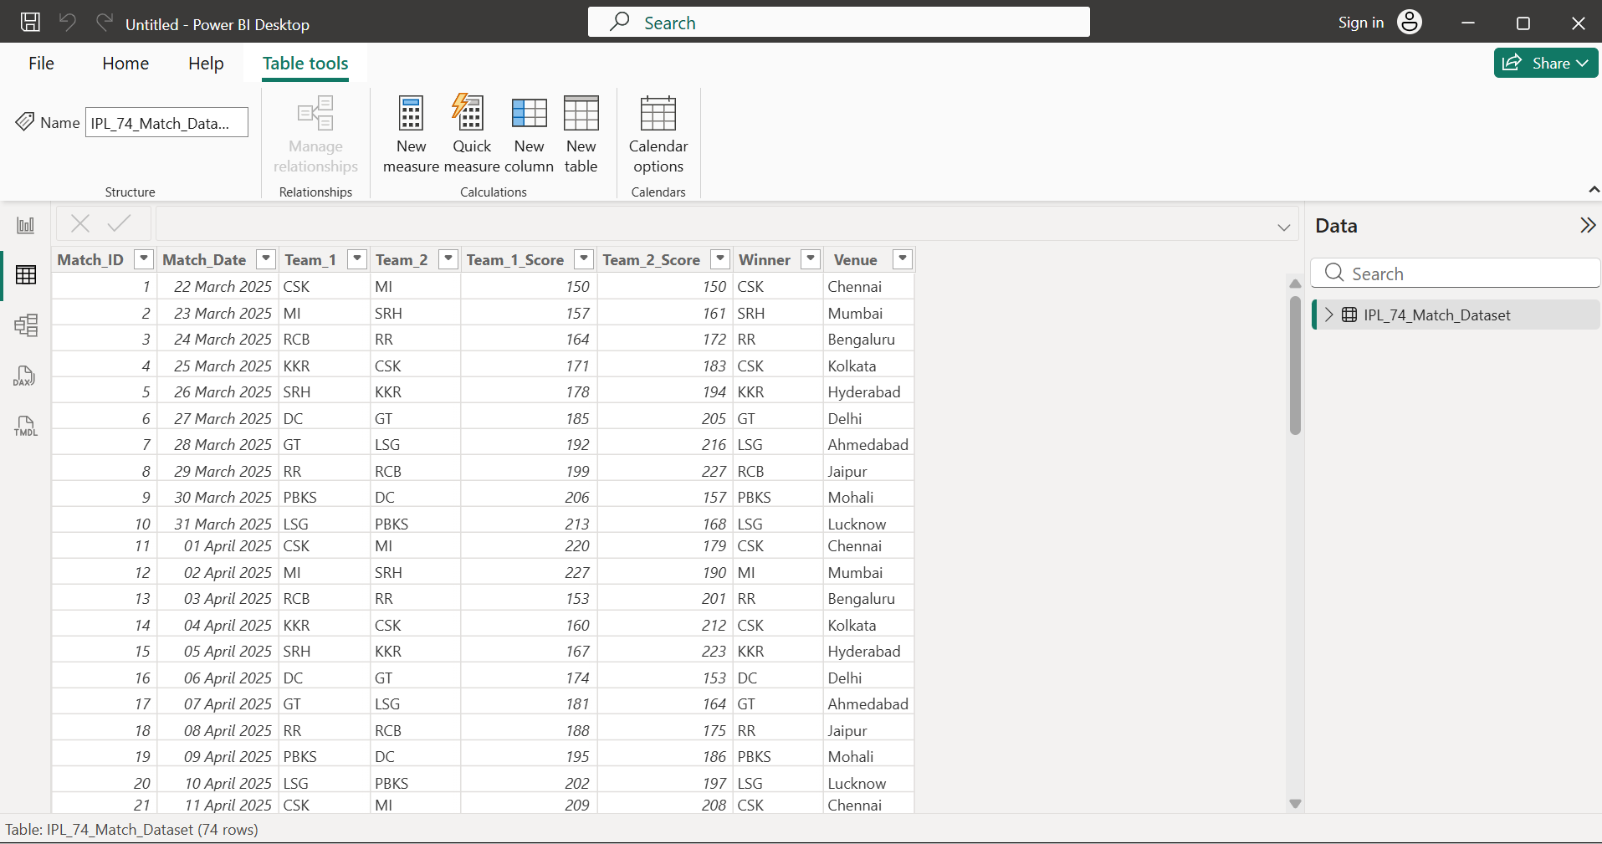
- Import copies the CSV data into Power BI, while DirectQuery keeps data in the external source and queries it live — but CSV only supports Import.
- Clustered Bar Chart that shows No. of matches won by each team:
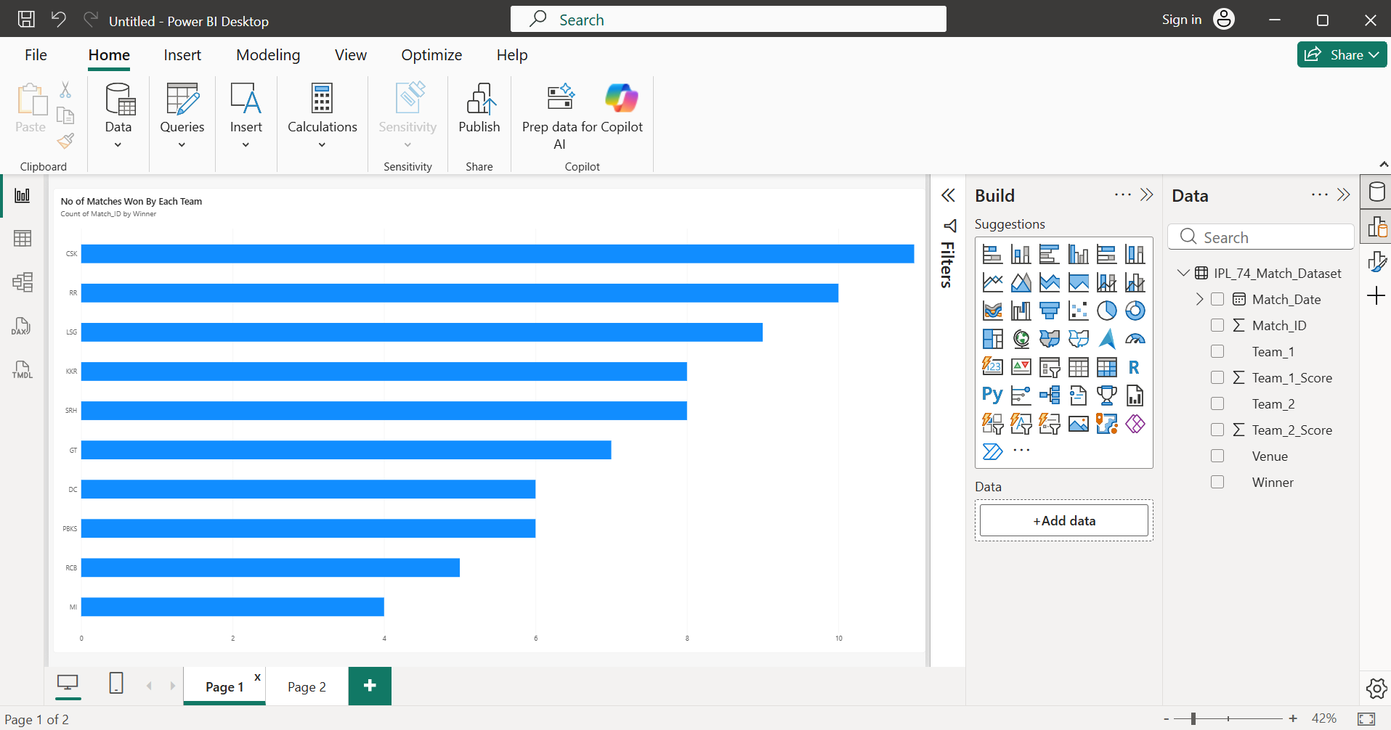

- Use Power BI's Web connector to import trending movie data from a public web page (such as IMDb Top 250 or a similar site). Display the movie titles and ratings in a table visual.<br><br><em><strong>Hint:</strong> Use the 'Get Data' > 'Web' option and enter the URL of the table page.</em>

- Importing Data using Power BI’s Web Connector:
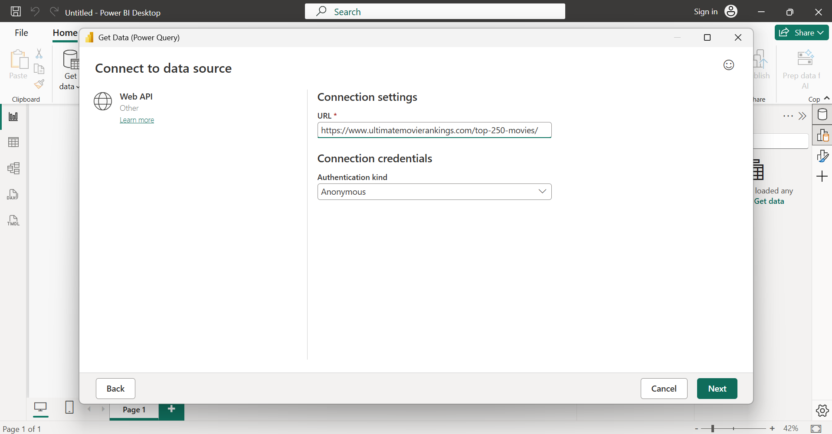
- Movie titles and ratings in table visual:
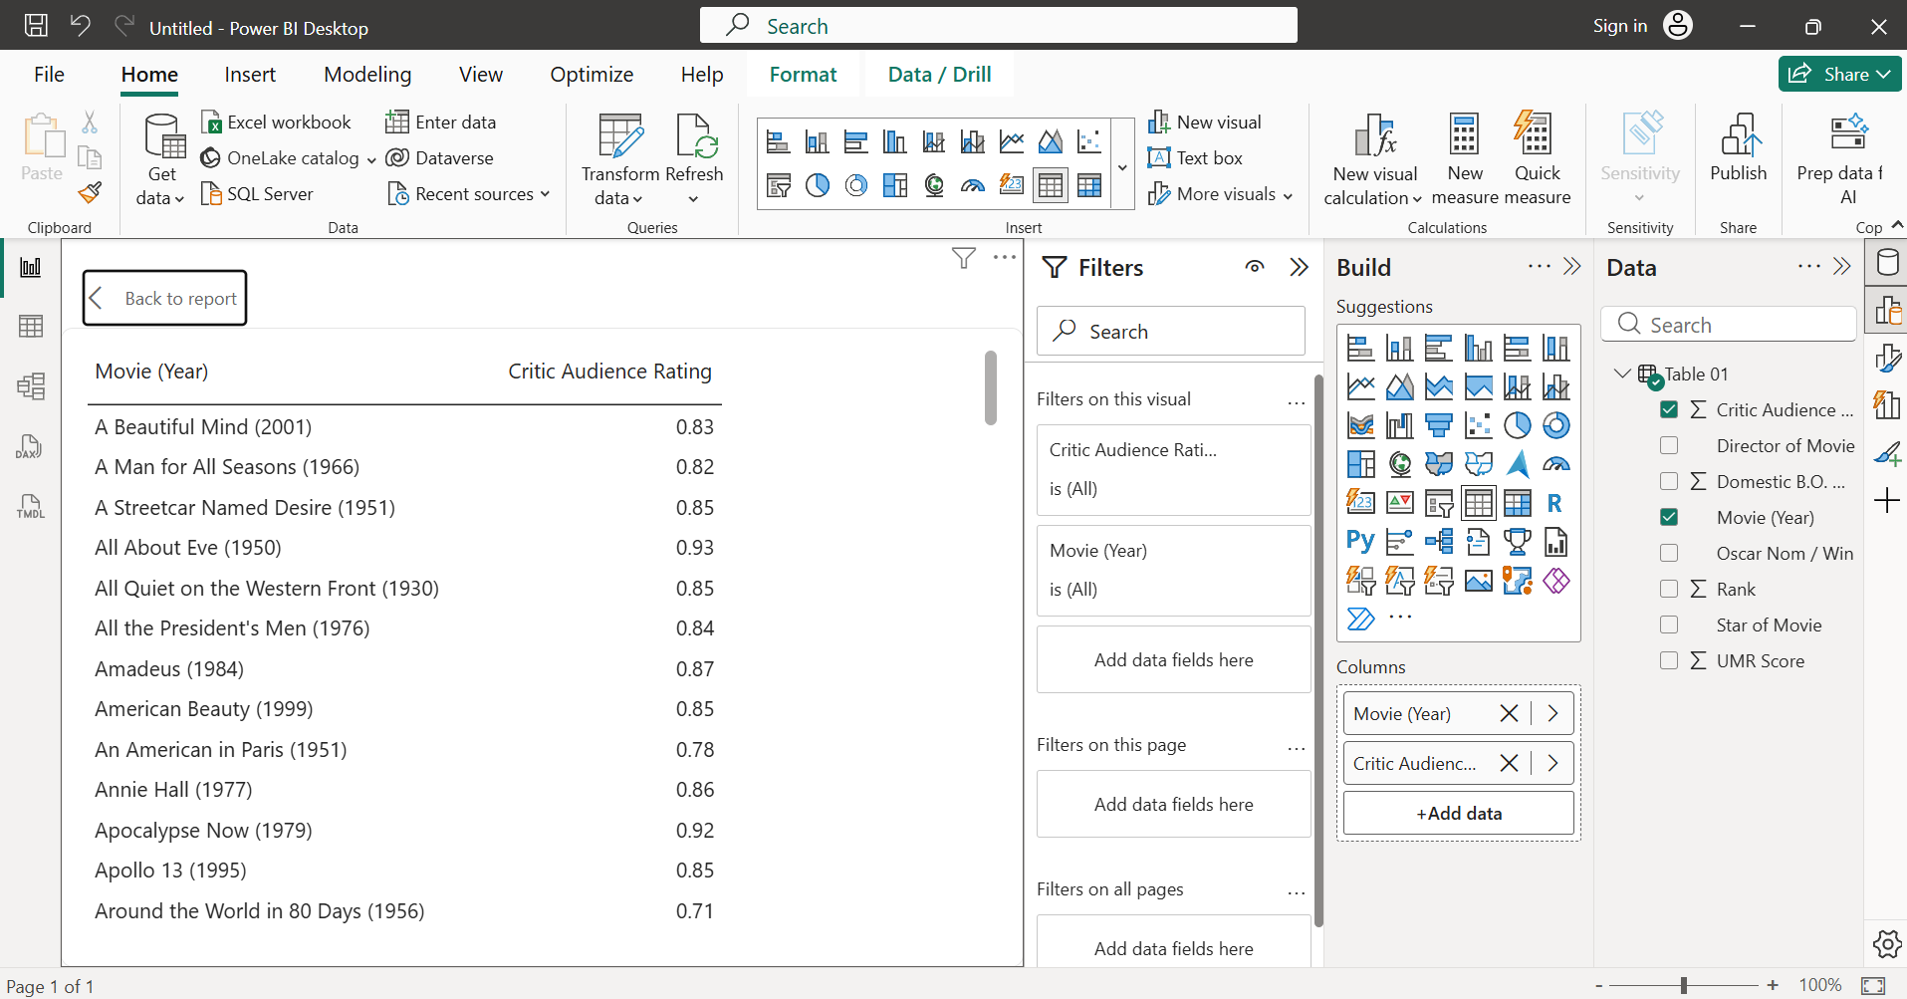

- Connect Power BI to a MySQL or SQL Server database (use a sample database if you don't have your own) and load a table of products (like those on Flipkart or Myntra) with columns for name, price, and category.

- Connecting to Data source by specifying DSN in ODBC connection string:
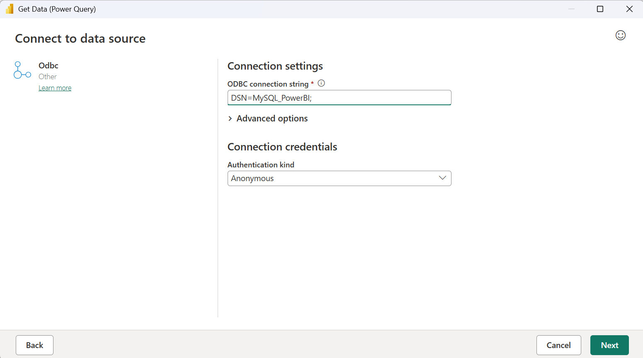
- Selected, “myntra_products” table and loaded it.
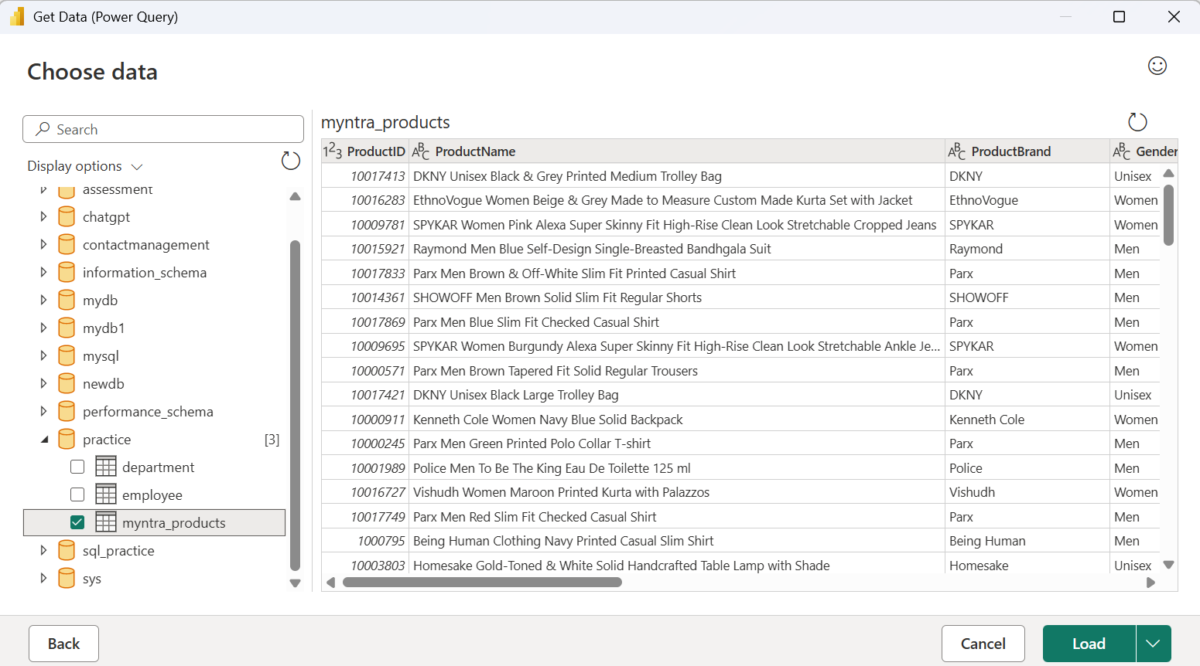

- Combine data from two different sources in Power BI: an Excel file with Zomato restaurant data and a CSV file with user reviews. Create a relationship between the tables and display the average rating per restaurant.<br><br><em><strong>Hint:</strong> Use the 'Manage Relationships' feature to link the tables on restaurant name or ID.</em>

- Data from an excel file:
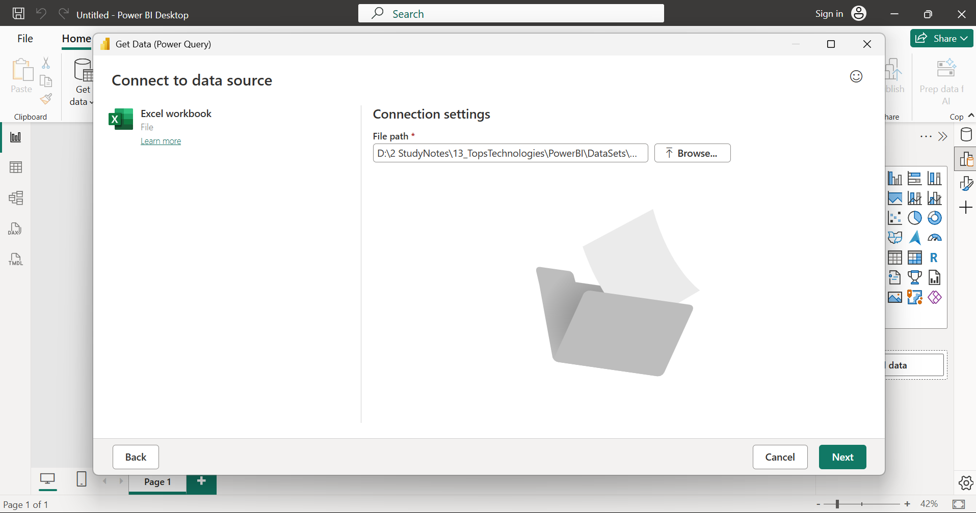

- Data from a CSV file:
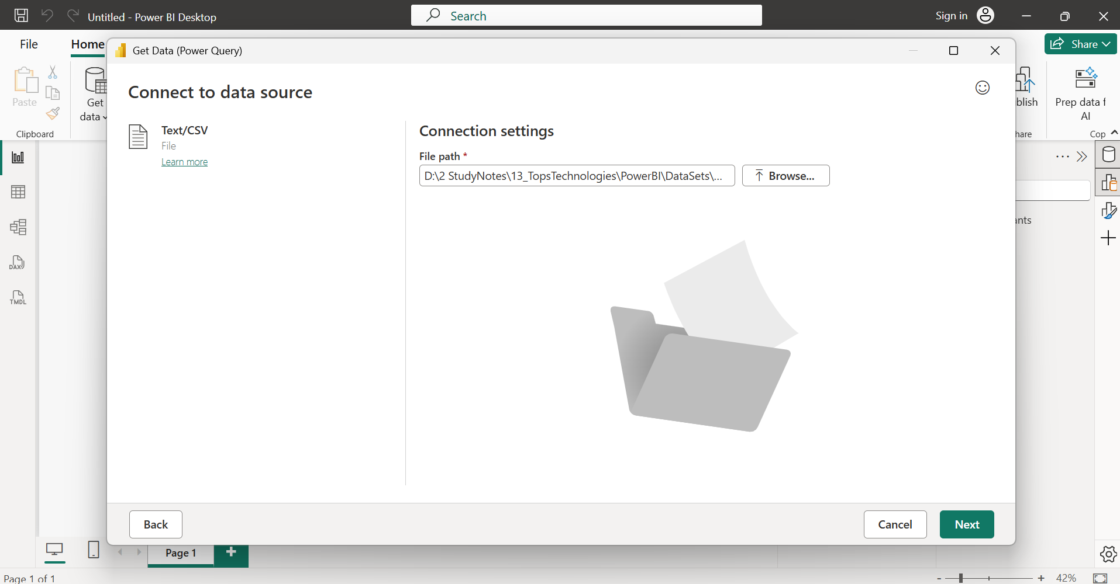

- Portraying established relationship between two tables:
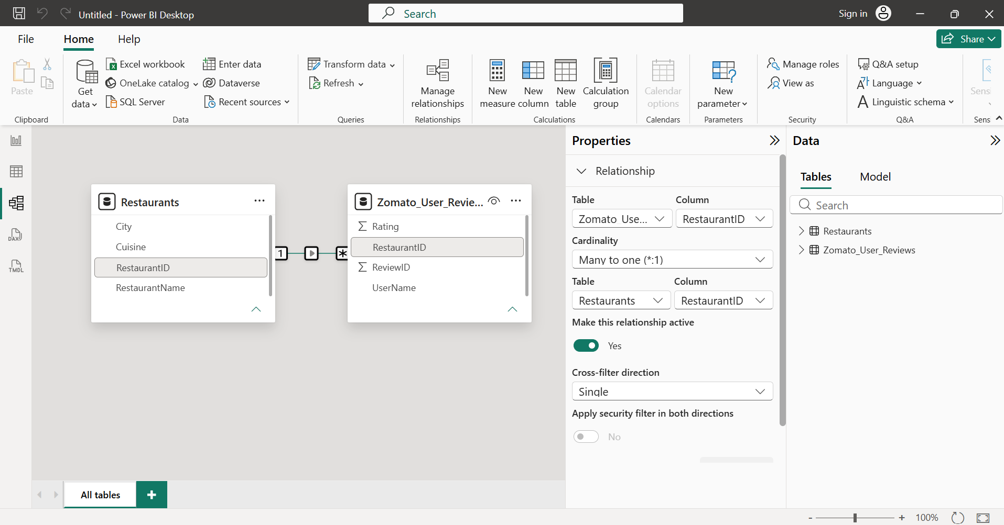

- Average rating per restaurant:
