- In Power BI Desktop, import a CSV file containing a list of food delivery orders (with columns like OrderID, Restaurant, FoodItem, Month1, Month2, Month3) and use the Unpivot Columns feature in Power Query Editor to convert the Month columns into two columns: 'Month' and 'OrderCount'.

- Before Unpivot:
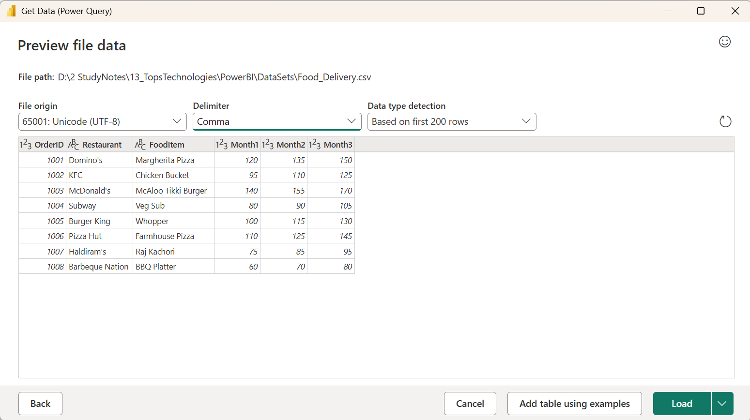

- After Unpivot:
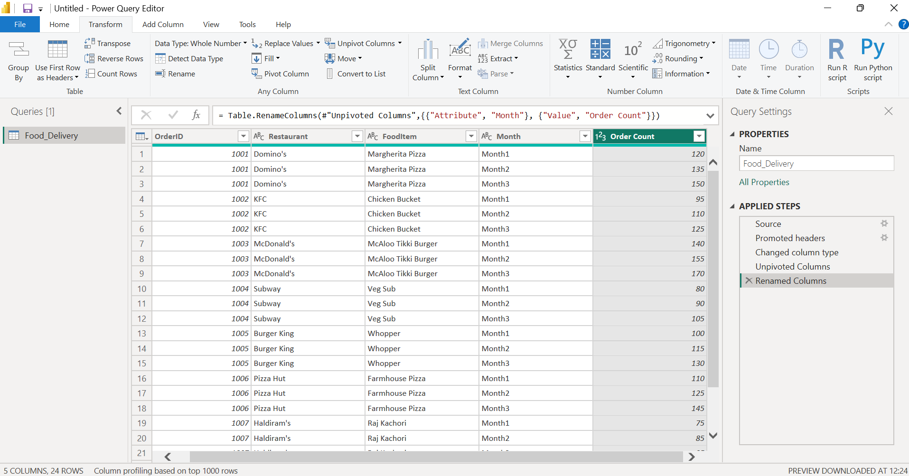

- Imported the Food Delivery Orders CSV file into Power BI and opened it in Power Query Editor. Selected the Month1, Month2, and Month3 columns and used the Unpivot Columns feature to convert them into row values. Renamed the generated columns to Month and Order Count, resulting in a normalized dataset suitable for analysis and reporting. Finally, loaded the transformed data into Power BI using Close & Apply.

- Using Power Query Editor, apply the Group By transformation on a dataset of Flipkart product sales to calculate the total sales amount for each product category and display the result in a new table.

- Dummy dataset:
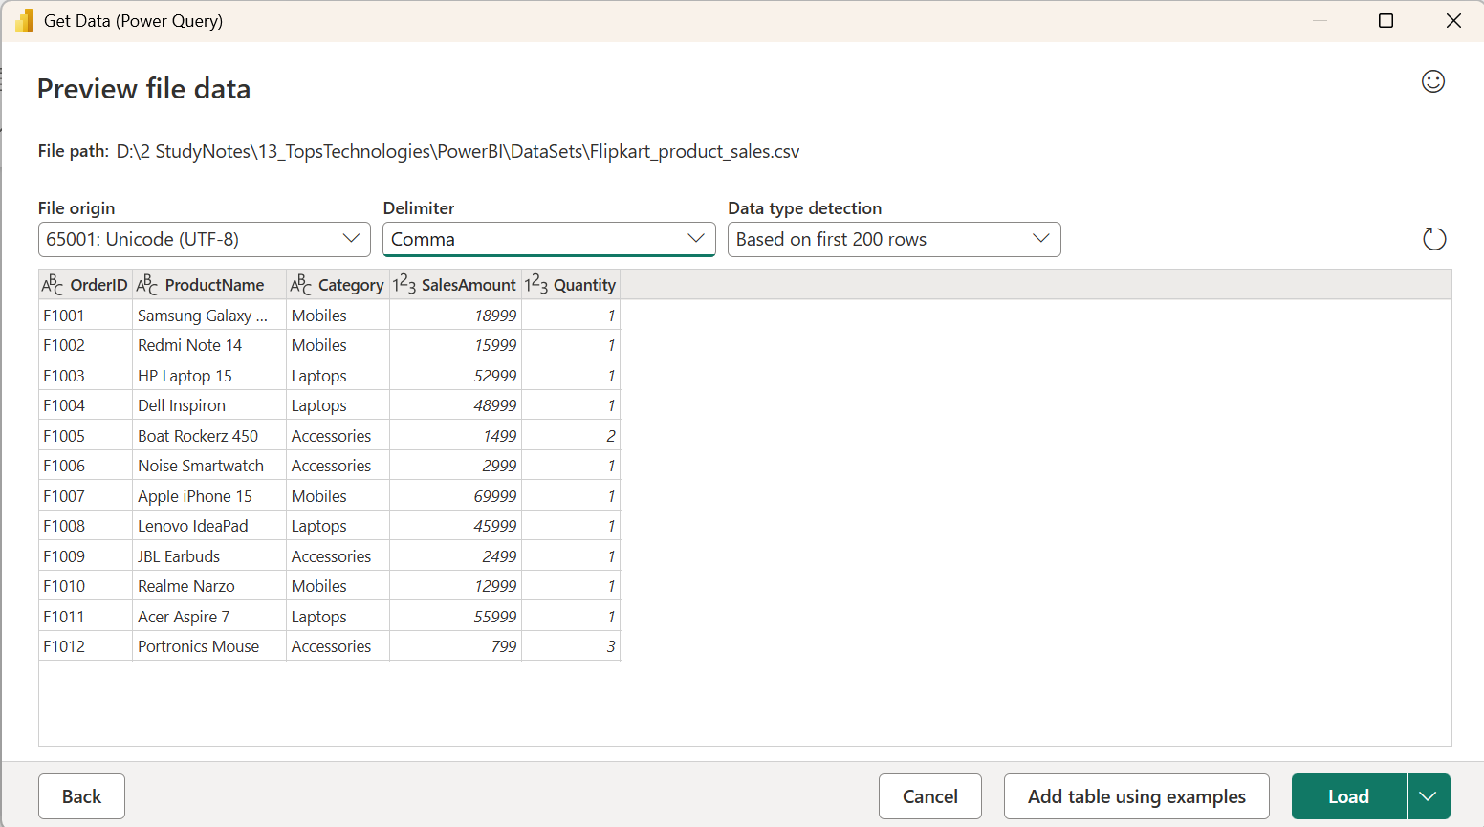

- Applying Group By:
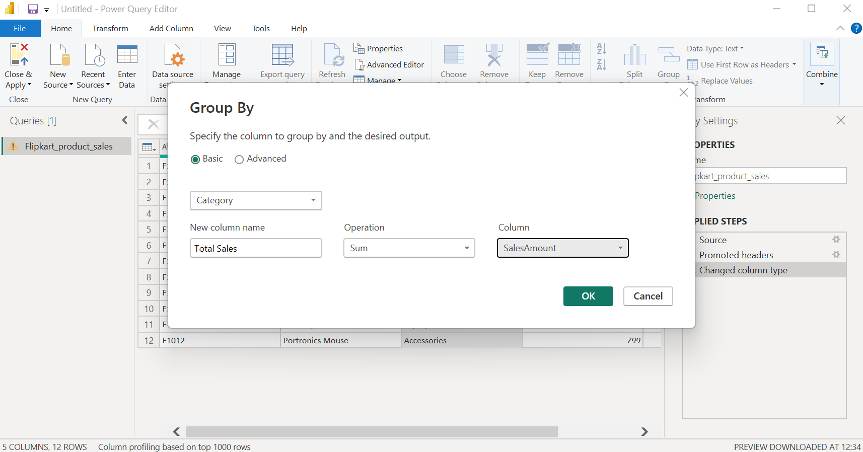

- After Group By:
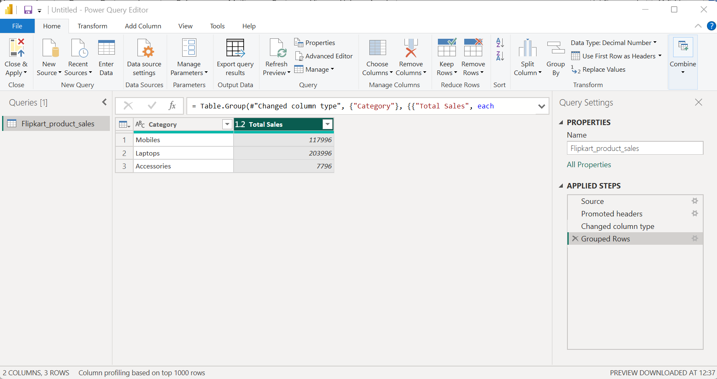

- Imported the Flipkart Product Sales dataset into Power BI and opened it in Power Query Editor. Selected the Category column and used the Group By transformation to aggregate data. Configured the operation to calculate the Sum of the SalesAmount column and named the result Total Sales. The output displayed the total sales amount for each product category in a summarized table, which was then loaded into Power BI using Close & Apply.

- Add a Custom Column in Power Query Editor to a Spotify-style playlist dataset that combines the 'Artist' and 'SongTitle' columns into a single 'DisplayName' column formatted as 'Artist - SongTitle'.

- Original Dataset:
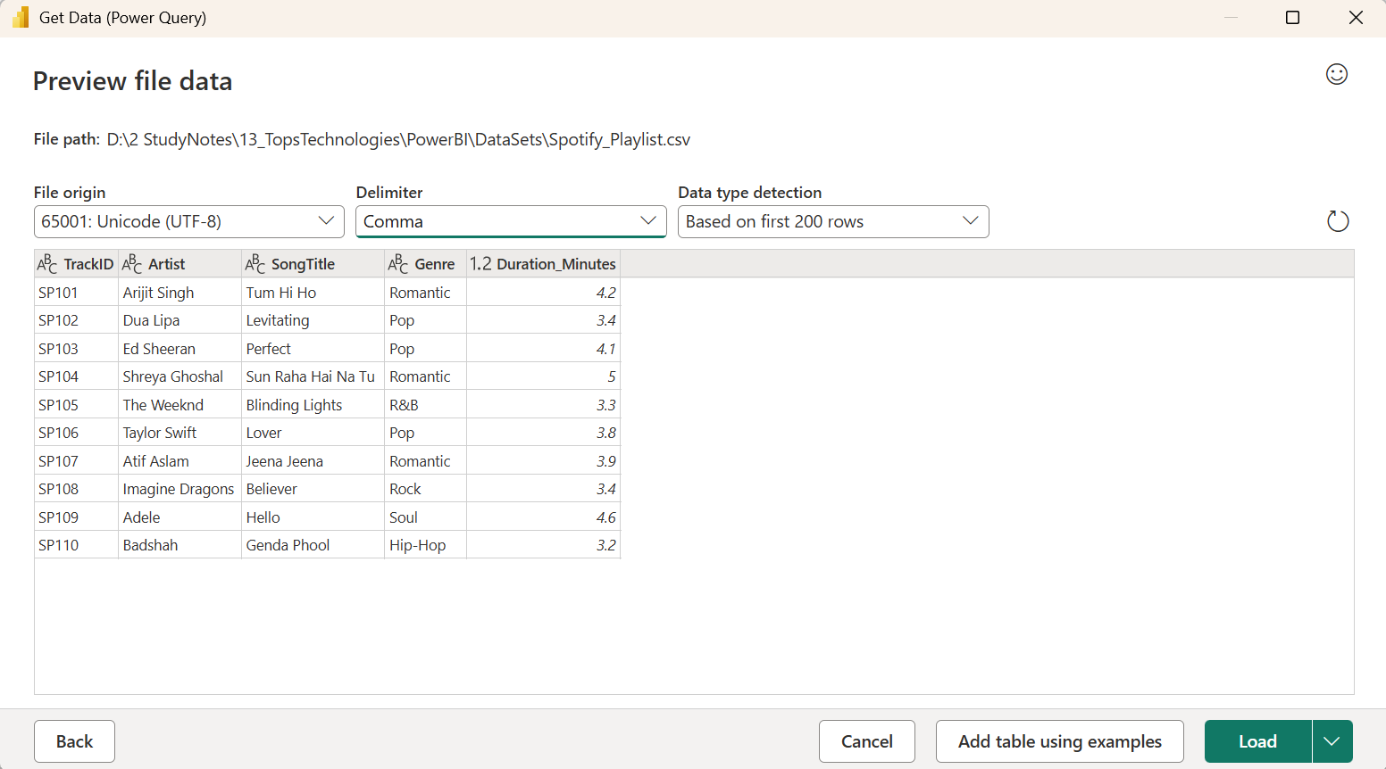
- Adding New Column:
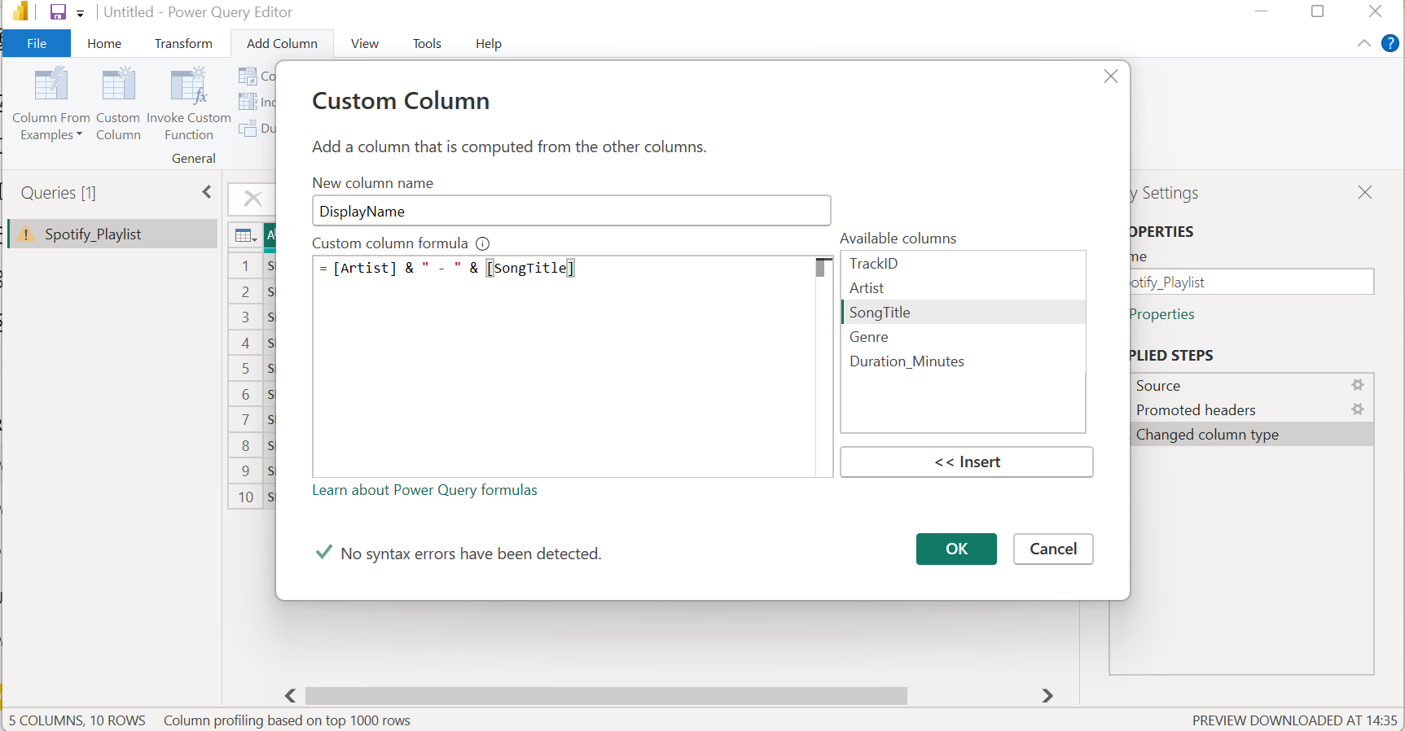

- After adding new column:
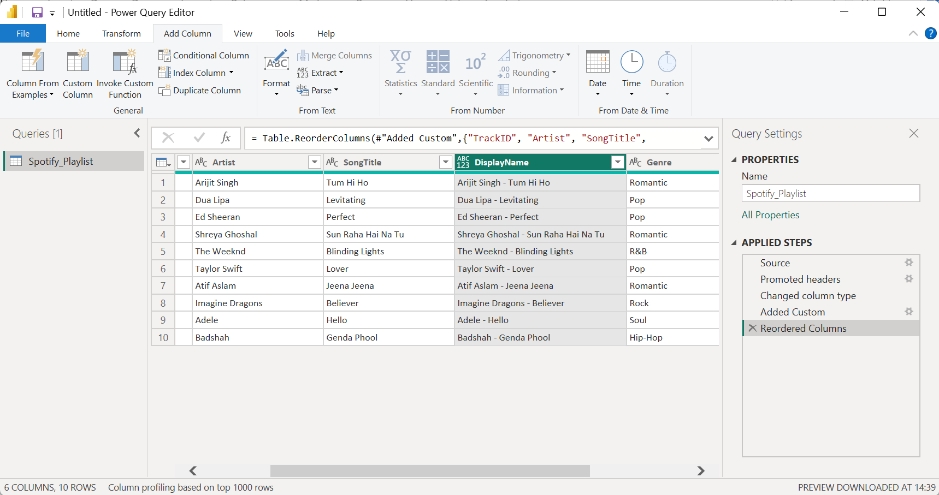

- Imported the Spotify Playlist dataset into Power BI and opened it in Power Query Editor. Used Add Column → Custom Column to create a new column named DisplayName. The formula [Artist] & " - " & [SongTitle] was used to combine the Artist and SongTitle fields into a single text value in the format Artist - SongTitle. The transformed dataset was then loaded into Power BI using Close & Apply.

- Create a Conditional Column in Power Query Editor for a Zomato restaurant ratings dataset that assigns a 'Status' of 'Top Rated' if the rating is above 4.5, 'Average' if between 3 and 4.5, and 'Needs Improvement' if below 3.<br><br><em><strong>Hint:</strong> Use the 'Conditional Column' feature and set up appropriate IF logic for each range.</em>

- Original Dataset:
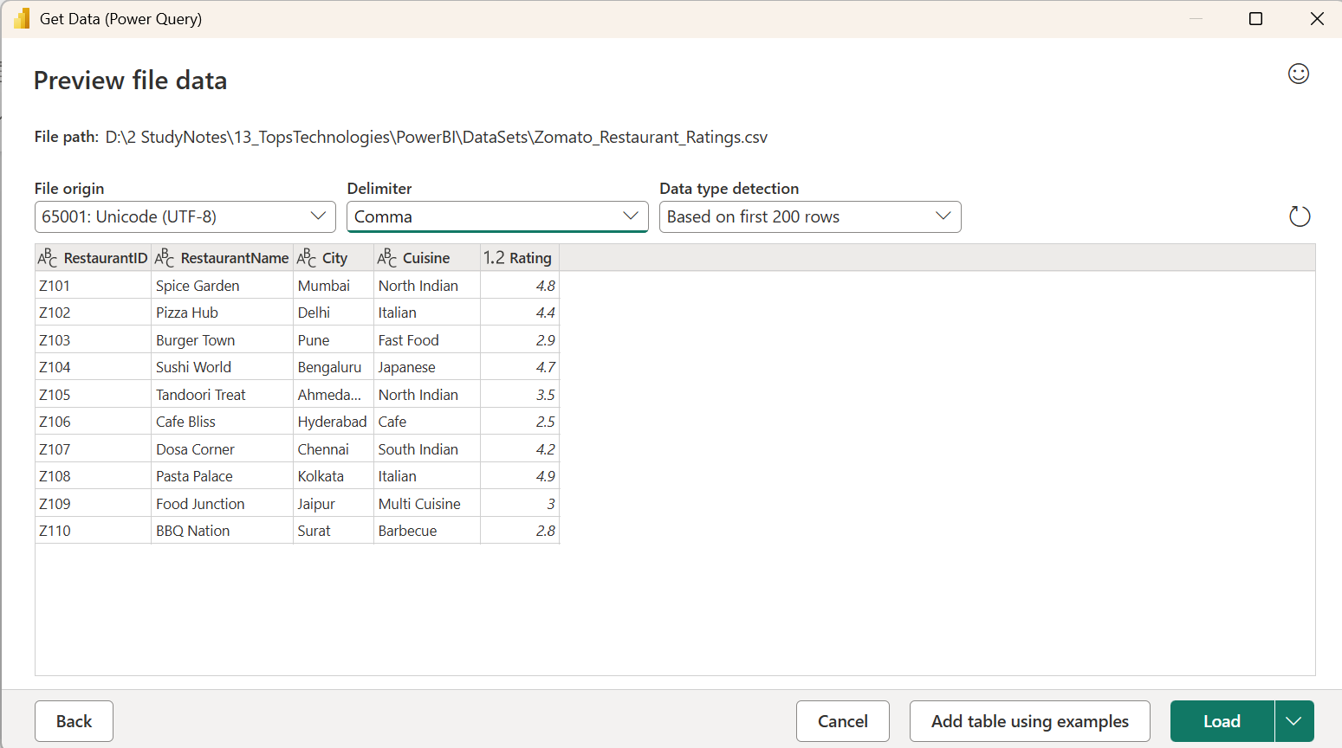

- Adding Conditional Column:
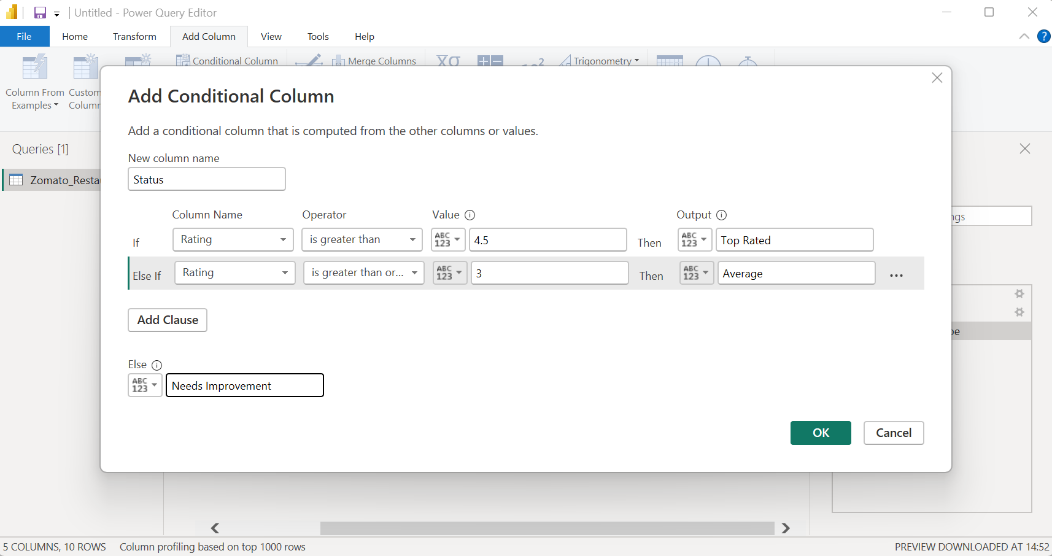

- Resulting Table with ‘Status’ Column:
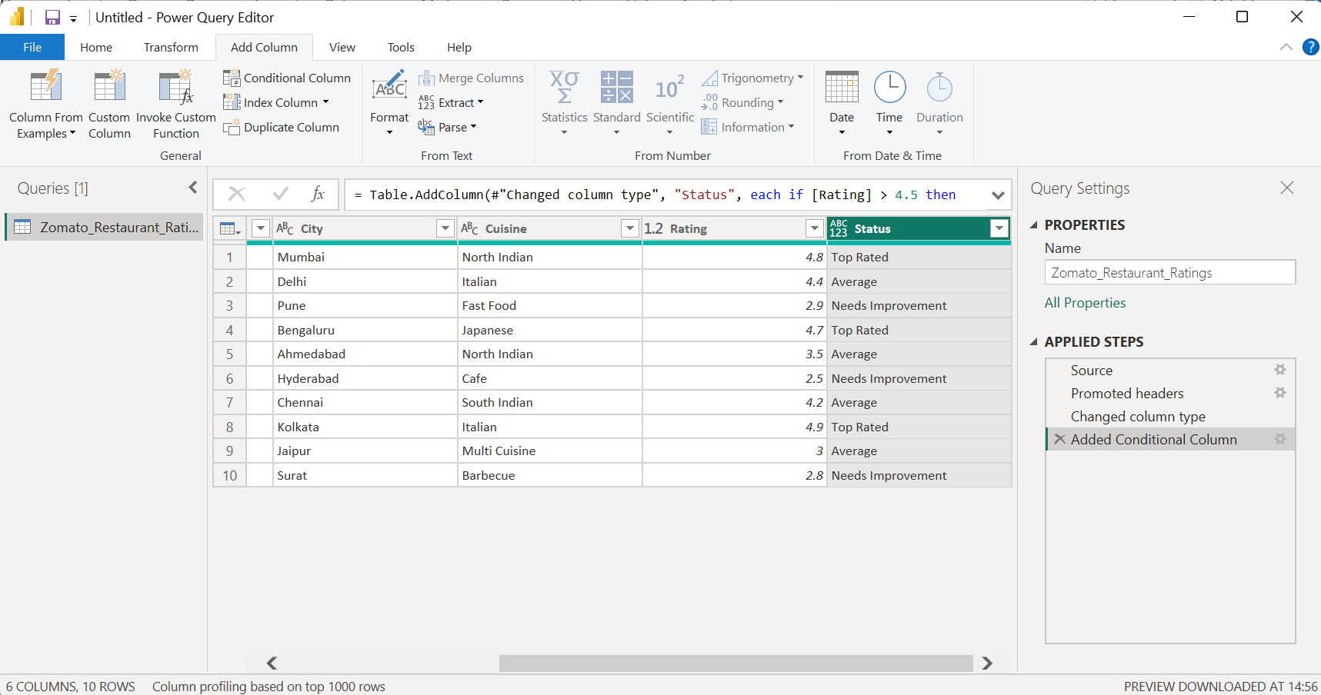

- Imported the Zomato Restaurant Ratings dataset into Power BI and opened it in Power Query Editor. Used Add Column → Conditional Column to create a new column named Status. Restaurants with ratings above 4.5 were classified as Top Rated, ratings between 3 and 4.5 as Average, and ratings below 3 as Needs Improvement. The transformed data was then loaded into Power BI using Close & Apply.

- Use Power Query Editor's AI-powered 'Add Column from Examples' feature to generate a new column in a BookMyShow movie bookings dataset that extracts the first word from each movie title as the 'MovieKeyword'.<br><br><em><strong>Hint:</strong> Start typing the desired output for a few rows and let Power BI suggest the transformation.</em>

- Original Dataset:
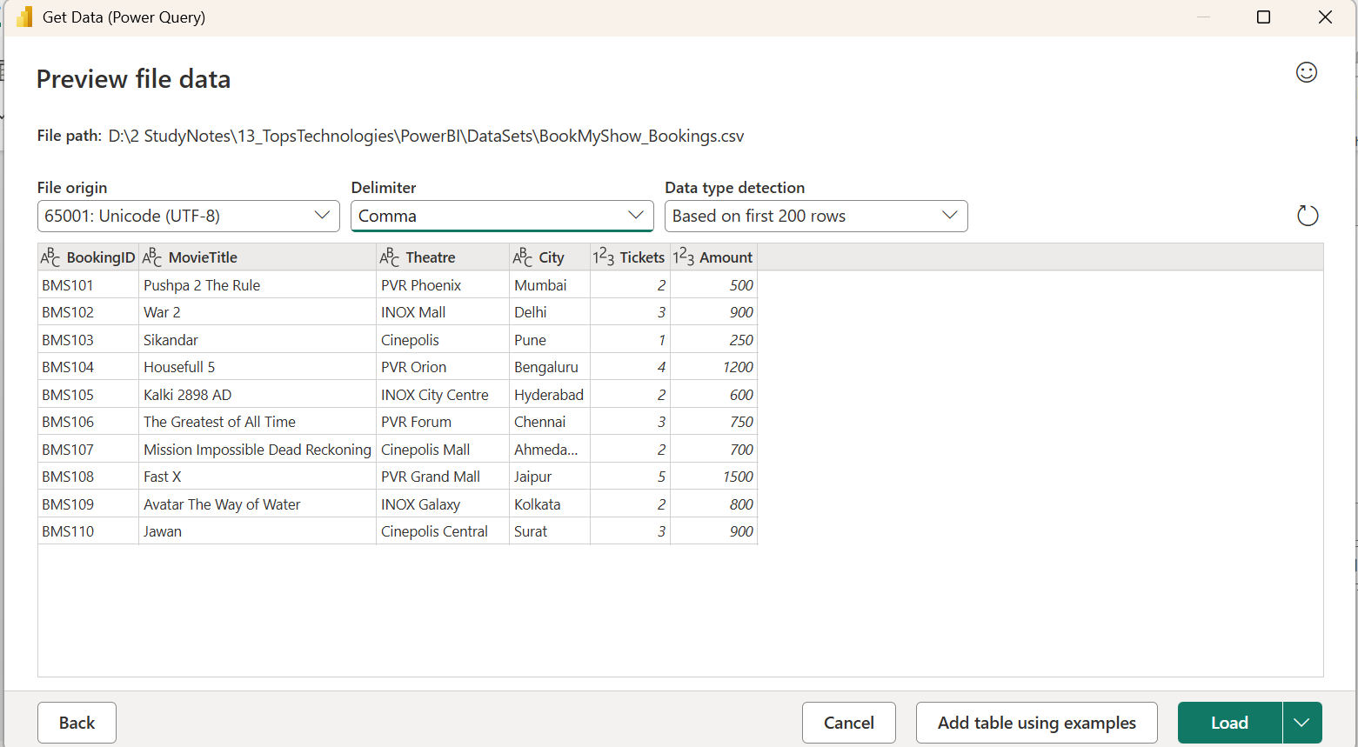
- While creating a new column:
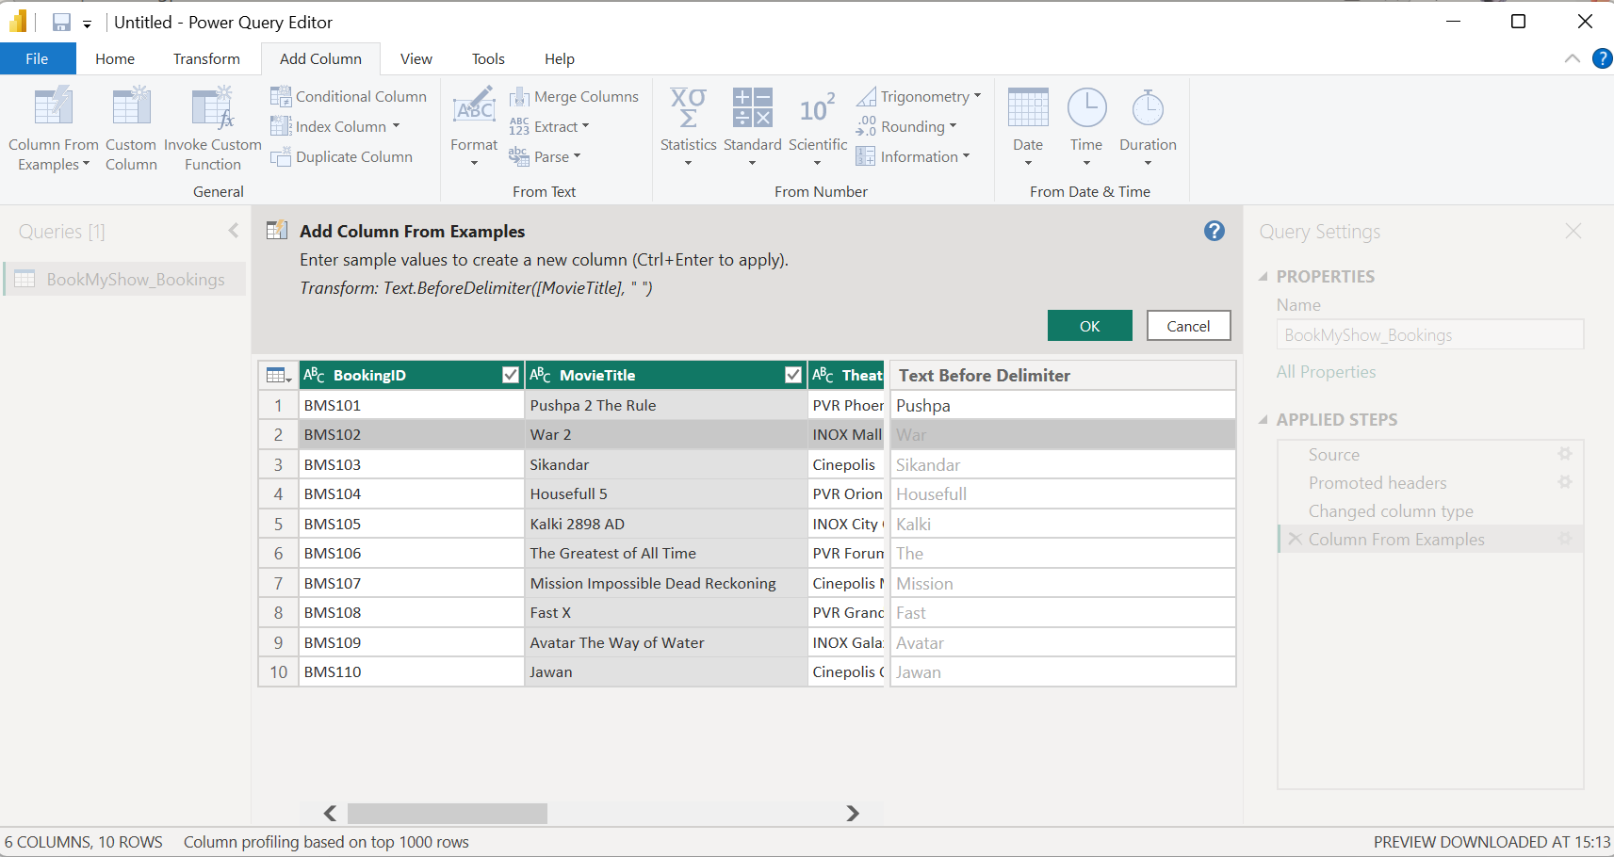

- After creating, ‘MovieKeyword’ Column:
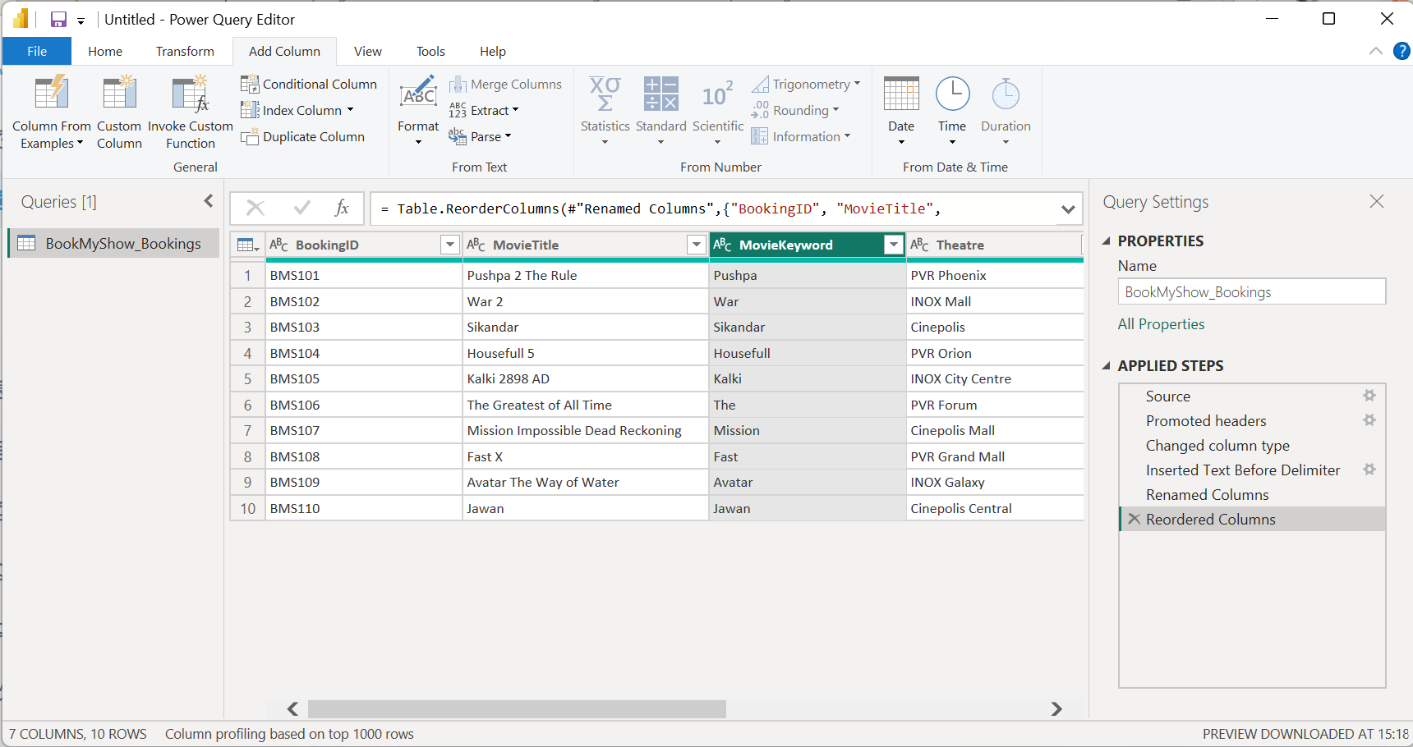

- Imported the BookMyShow movie bookings dataset into Power BI and opened it in Power Query Editor. Used Add Column → Column From Examples and entered sample outputs for a few movie titles. Power Query automatically identified the pattern and generated a new column named MovieKeyword, containing the first word from each movie title. The transformed data was then loaded into Power BI using Close & Apply.

