- Import a CSV file of Zomato restaurant listings into Power BI and use the 'Split Column by Delimiter' feature to separate the 'Restaurant Name - Area' column into two columns: 'Restaurant Name' and 'Area'.

- Before Splitting:
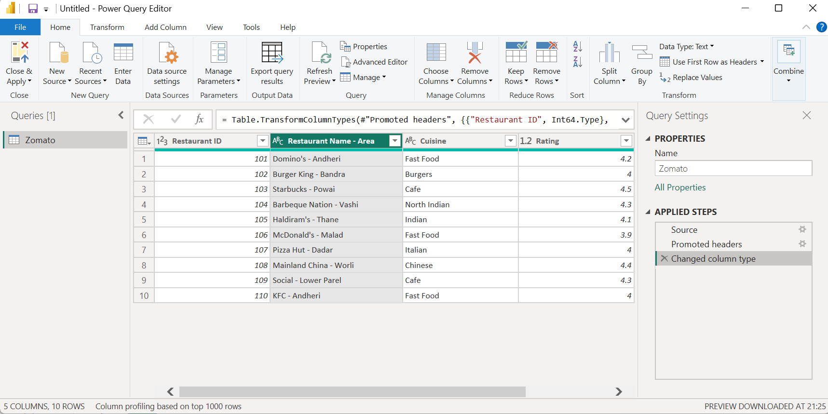

- While Splitting:
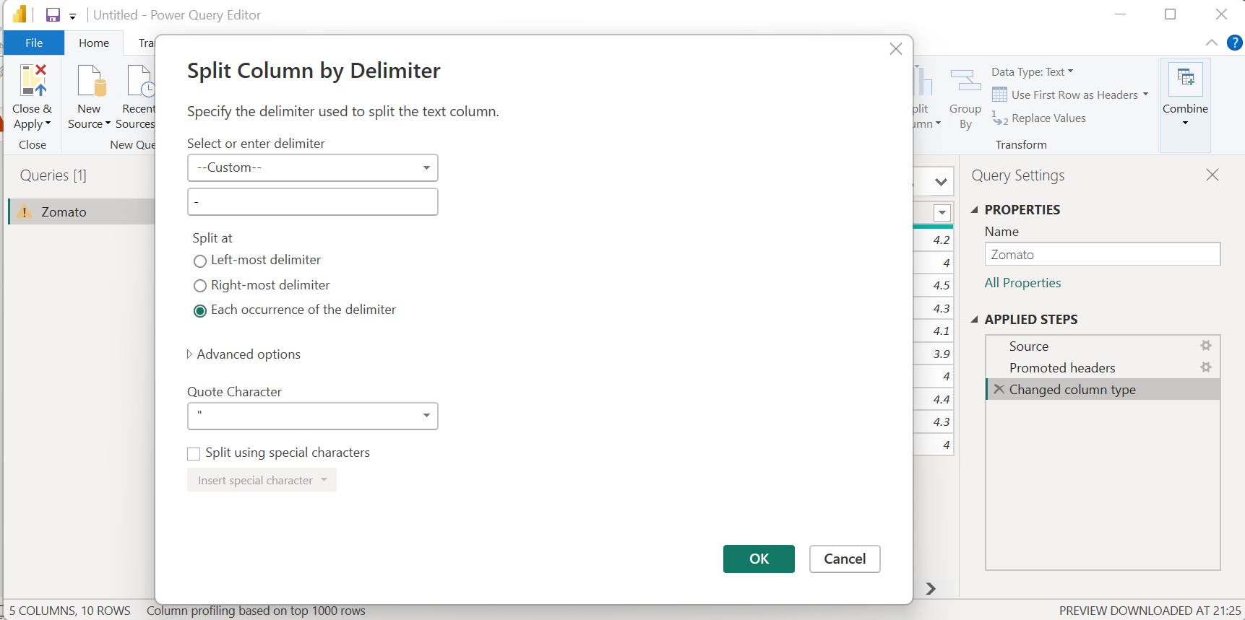

- After Splitting:
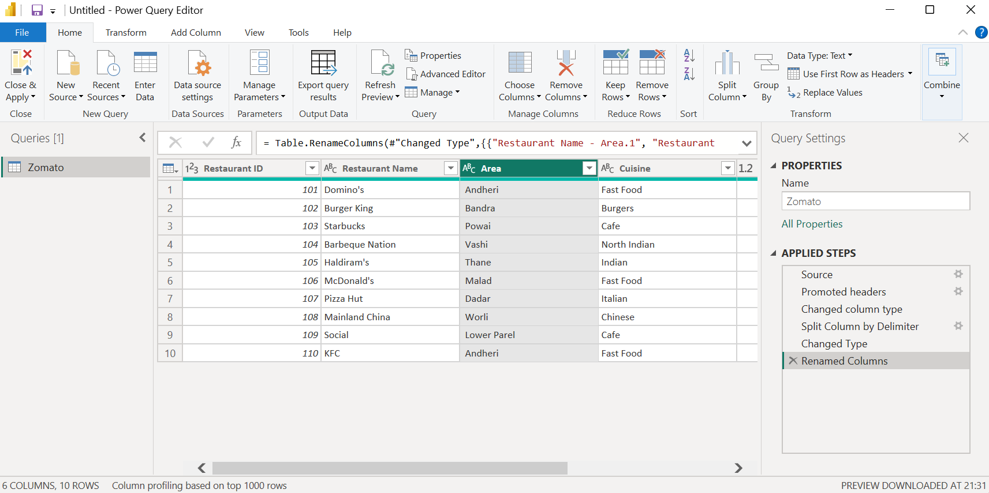

- Imported the Zomato restaurant listings CSV file into Power BI and opened it in Power Query Editor. Used Split Column → By Delimiter on the Restaurant Name - Area column with the hyphen (-) delimiter to create separate Restaurant Name and Area columns.

- Use the 'Merge Columns' feature in Power BI to combine 'First Name' and 'Last Name' columns from a Flipkart user data table into a single 'Full Name' column, separated by a space.

- Before Merging:

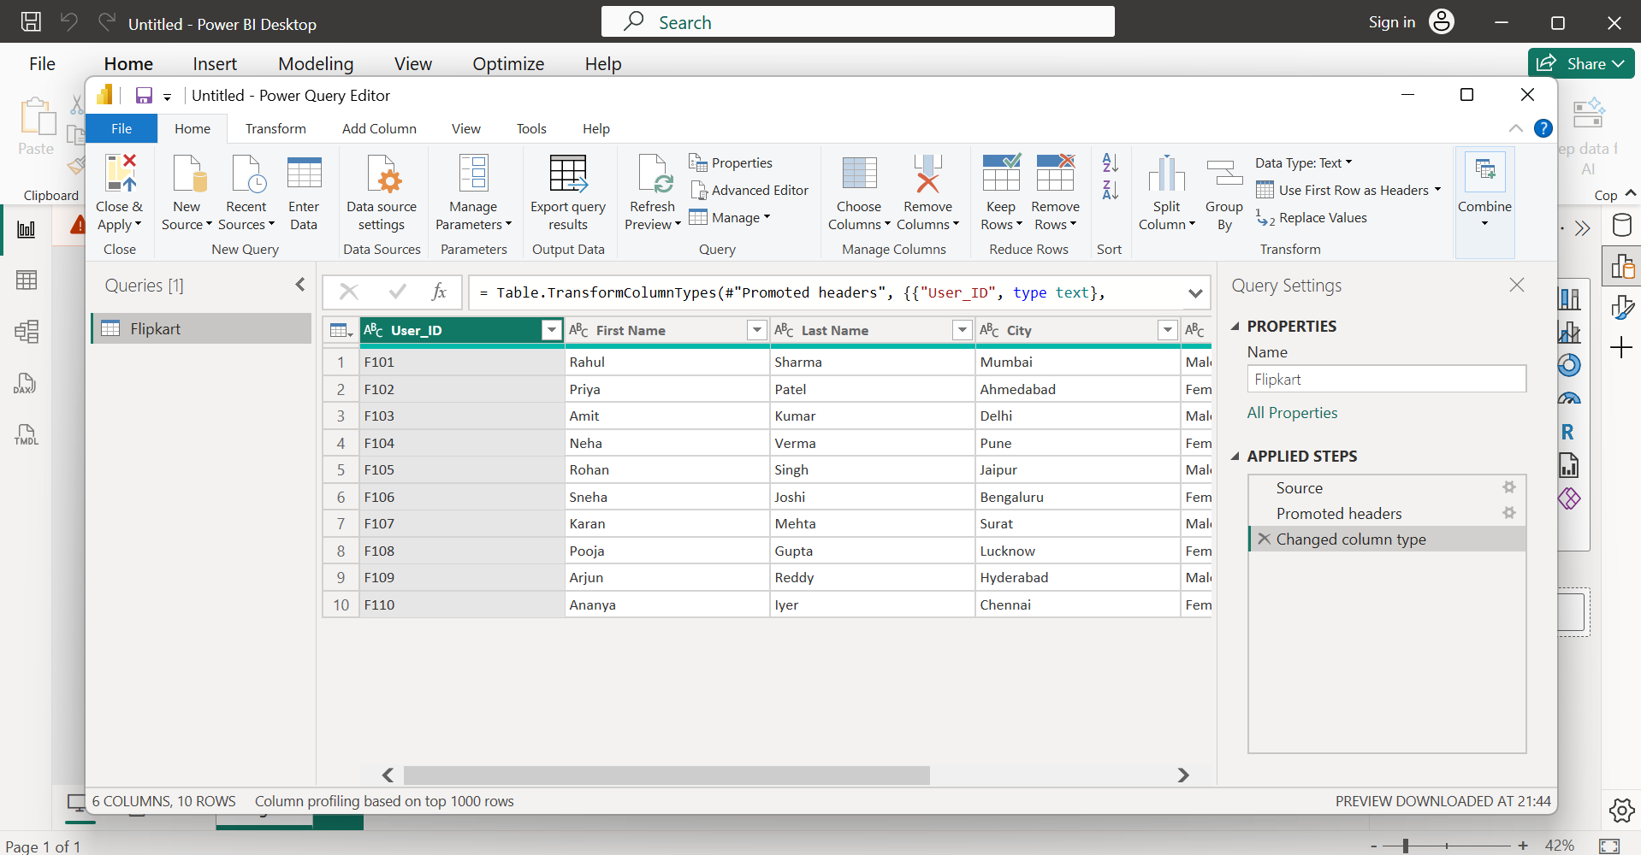
- While Merging:
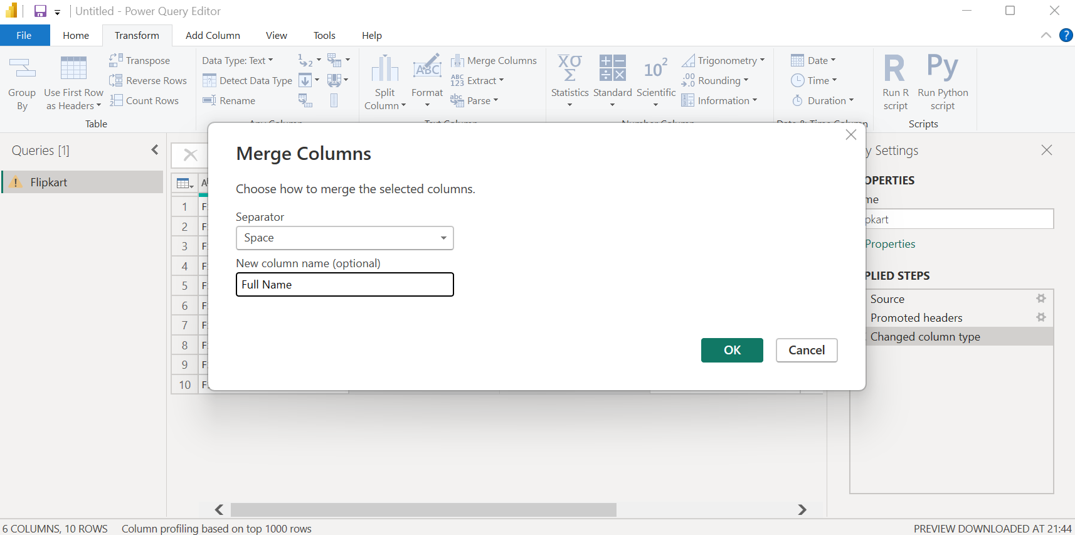

- After Merging:
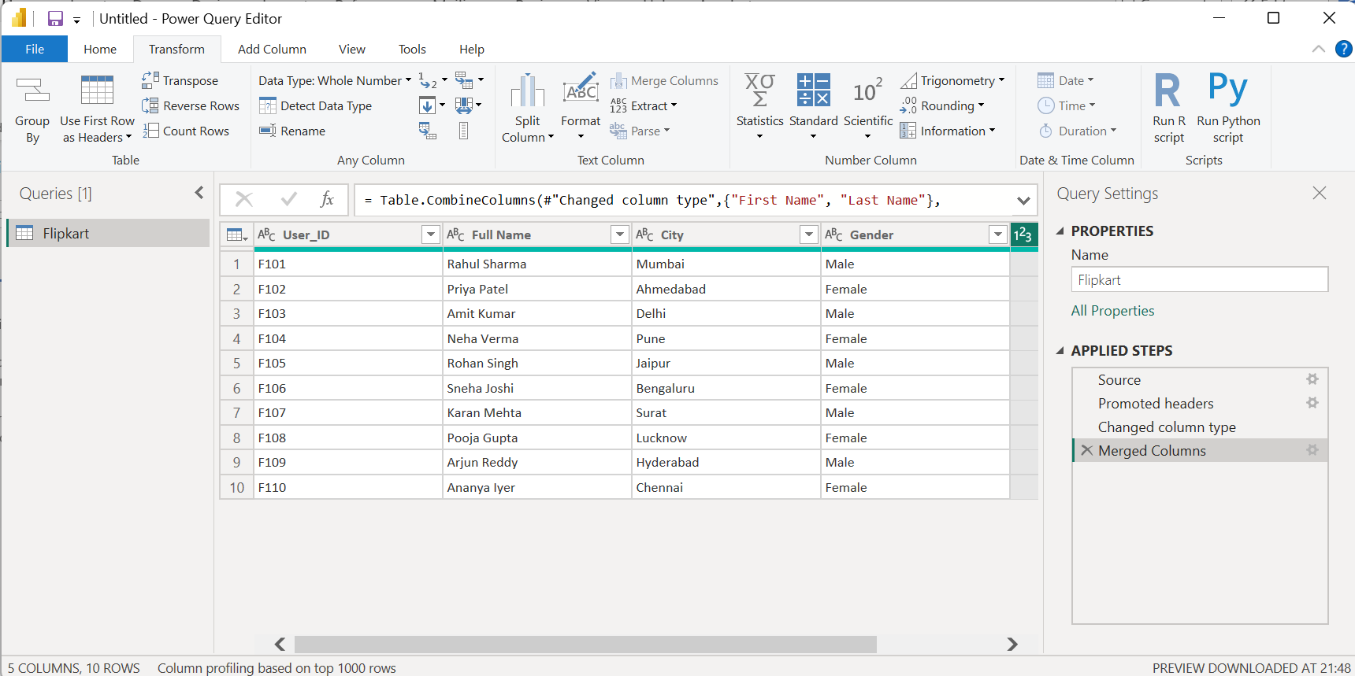

- Imported the Flipkart user dataset into Power BI and opened it in Power Query Editor. Selected the First Name and Last Name columns and used Transform → Merge Columns with a space as the separator. Renamed the merged column as Full Name and loaded the transformed data into Power BI using Close & Apply.

- Replace all instances of the value 'Cancelled' with 'Order Failed' in the 'Order Status' column of a Swiggy orders dataset using Power BI's 'Replace Values' function.

- Replacing values:
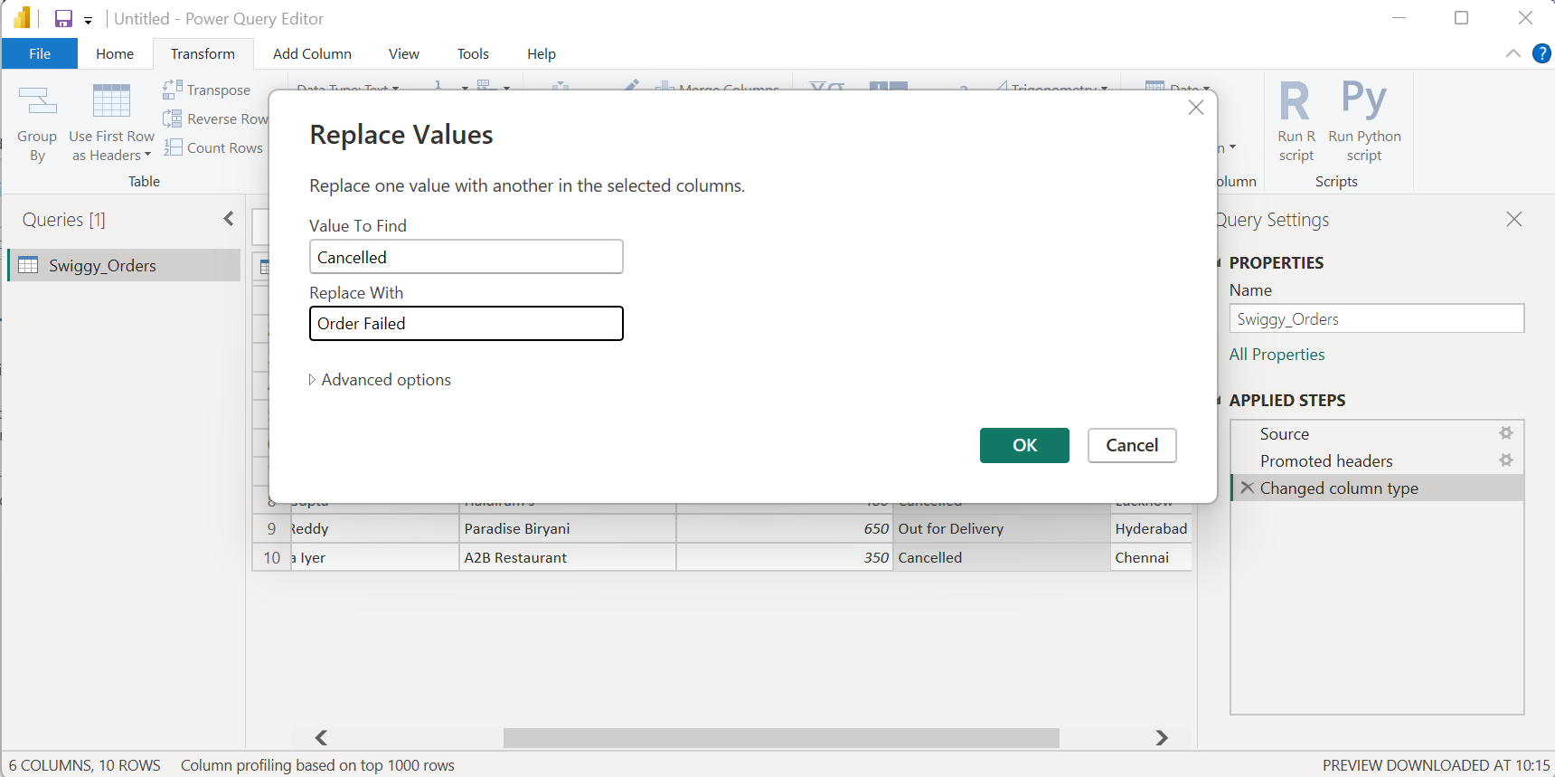

- After replacing values:
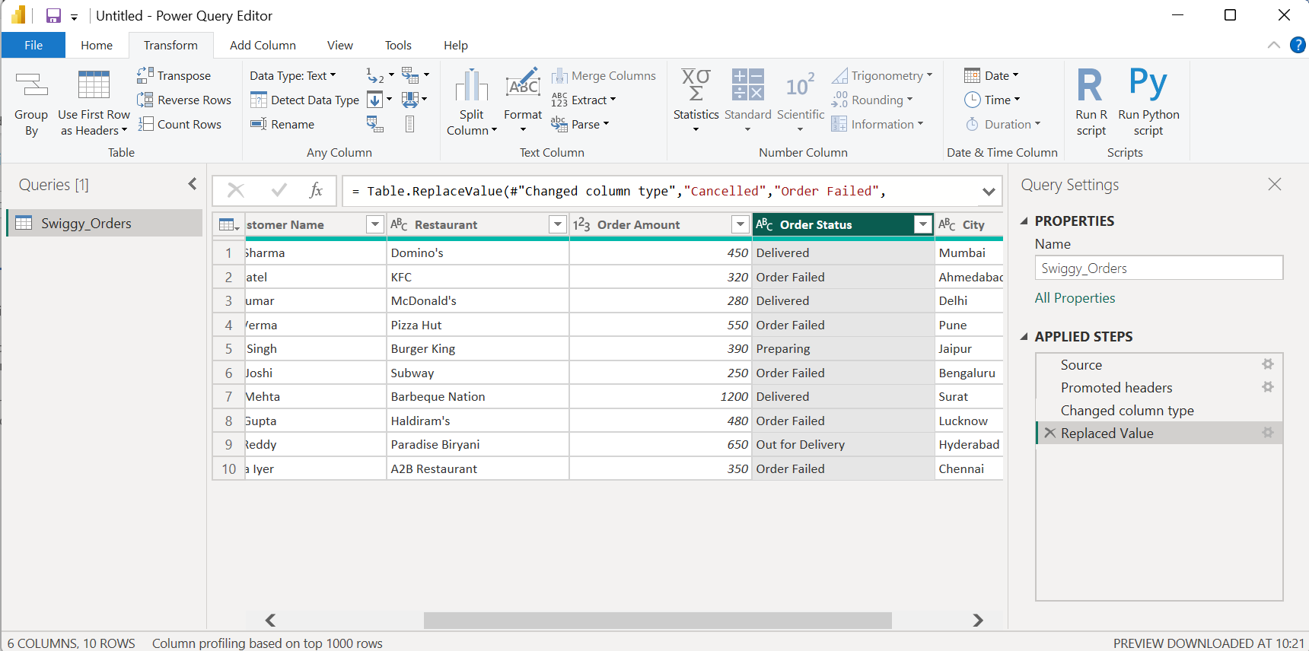

- Imported the Swiggy Orders dataset into Power BI and opened it in Power Query Editor. Selected the Order Status column and used the Replace Values feature to replace all instances of "Cancelled" with "Order Failed". Verified the changes and loaded the cleaned dataset into Power BI using Close & Apply.
- Change the data type of the 'Order Amount' column from Text to Decimal Number in a Paytm transaction table in Power BI, and verify that the column now supports numerical calculations.

- Before changing datatype:
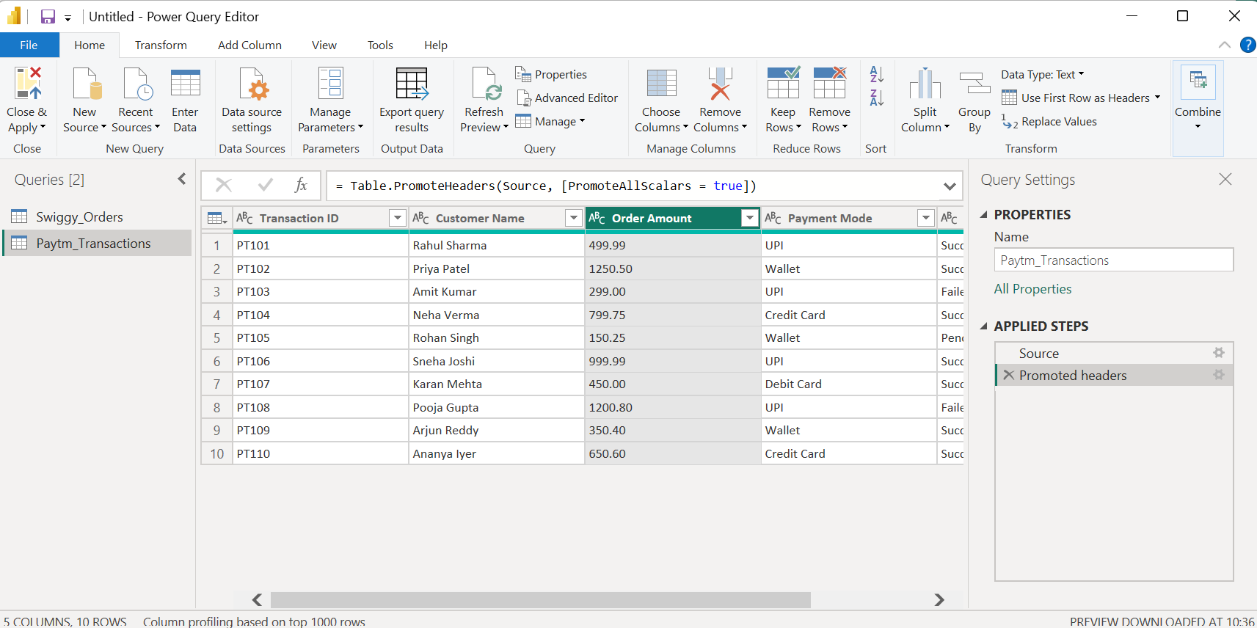

- After changing datatype:
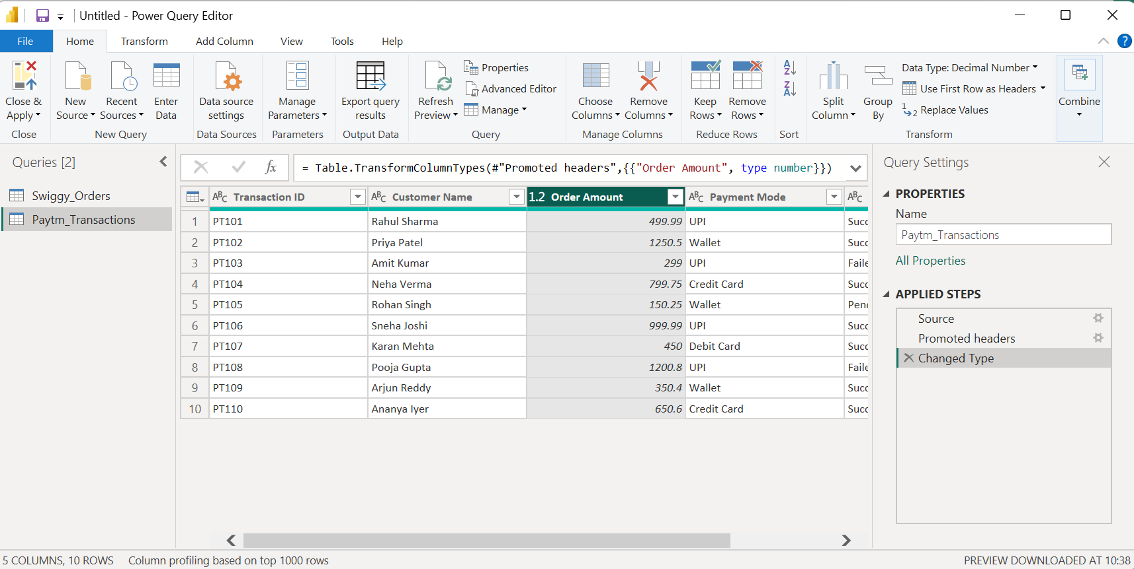

- Table visual showing sum, average, min.
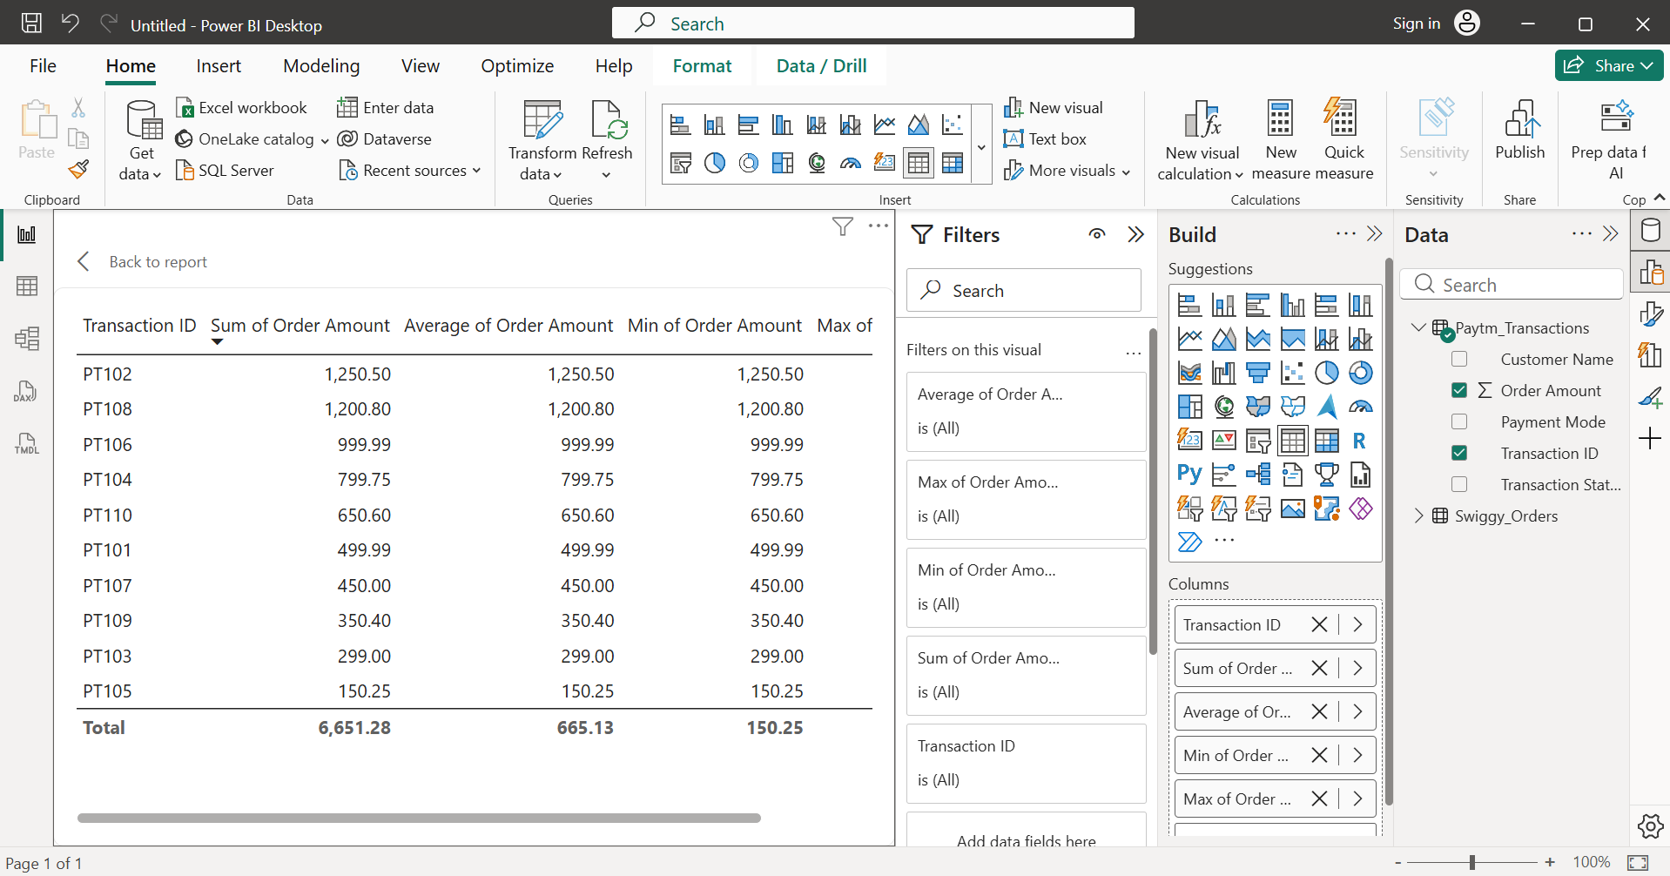

- Imported the Paytm transaction dataset into Power BI and opened it in Power Query Editor. Selected the Order Amount column and changed its data type from Text to Decimal Number using the Data Type option. After loading the data into Power BI, I added the column to a Table visual. The available summarization options included Sum, Average, Minimum, and Maximum, confirming that Power BI recognized the column as a numeric field and that it supports numerical calculations.

- In a Movie Ticket Booking dataset (like BookMyShow), use the 'Fill Down' operation in Power BI to fill missing 'Movie Name' values based on the previous row's value.<br><br><em><strong>Hint:</strong> Blank rows for 'Movie Name' should inherit the name from the last non-blank entry above.</em>

- Dummy dataset with missing ‘Movie Name’ values:
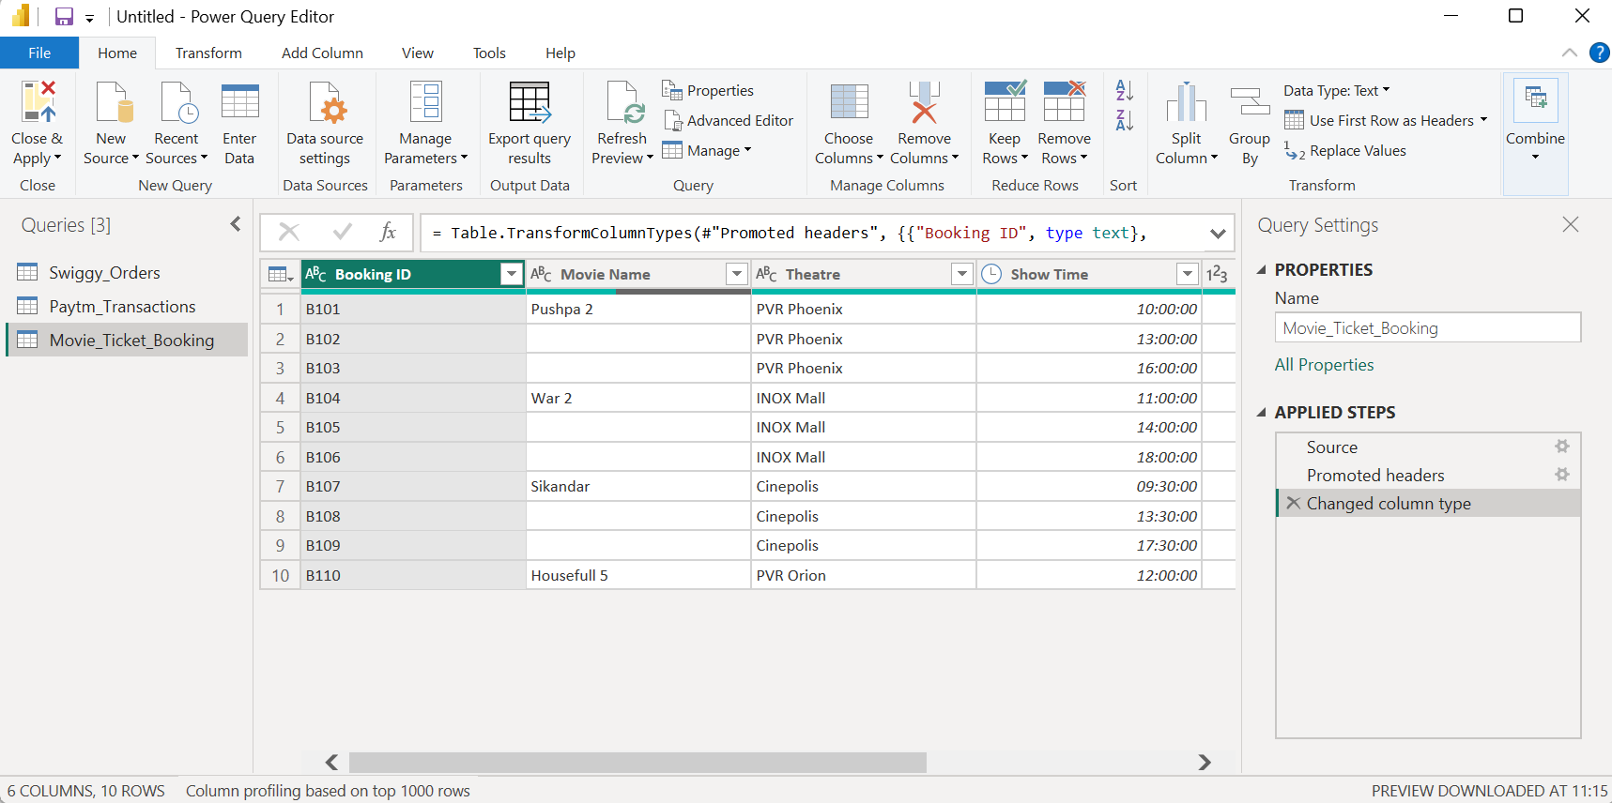
- After applying Fill -> Down:
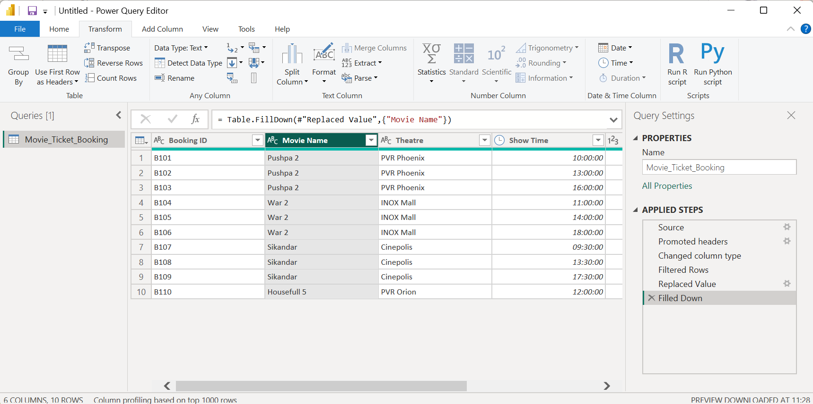

- Imported the Movie Ticket Booking dataset into Power BI and opened it in Power Query Editor. Selected the Movie Name column and used Transform → Fill → Down to populate blank values with the last non-blank movie name above them. This ensured that all booking records contained the correct movie name before loading the cleaned data into Power BI using Close & Apply.

