- Open Power BI Desktop and import a CSV file containing monthly step count data (columns: Month, Steps) for a year, then create a Line Chart visual to show the trend of steps over the months.

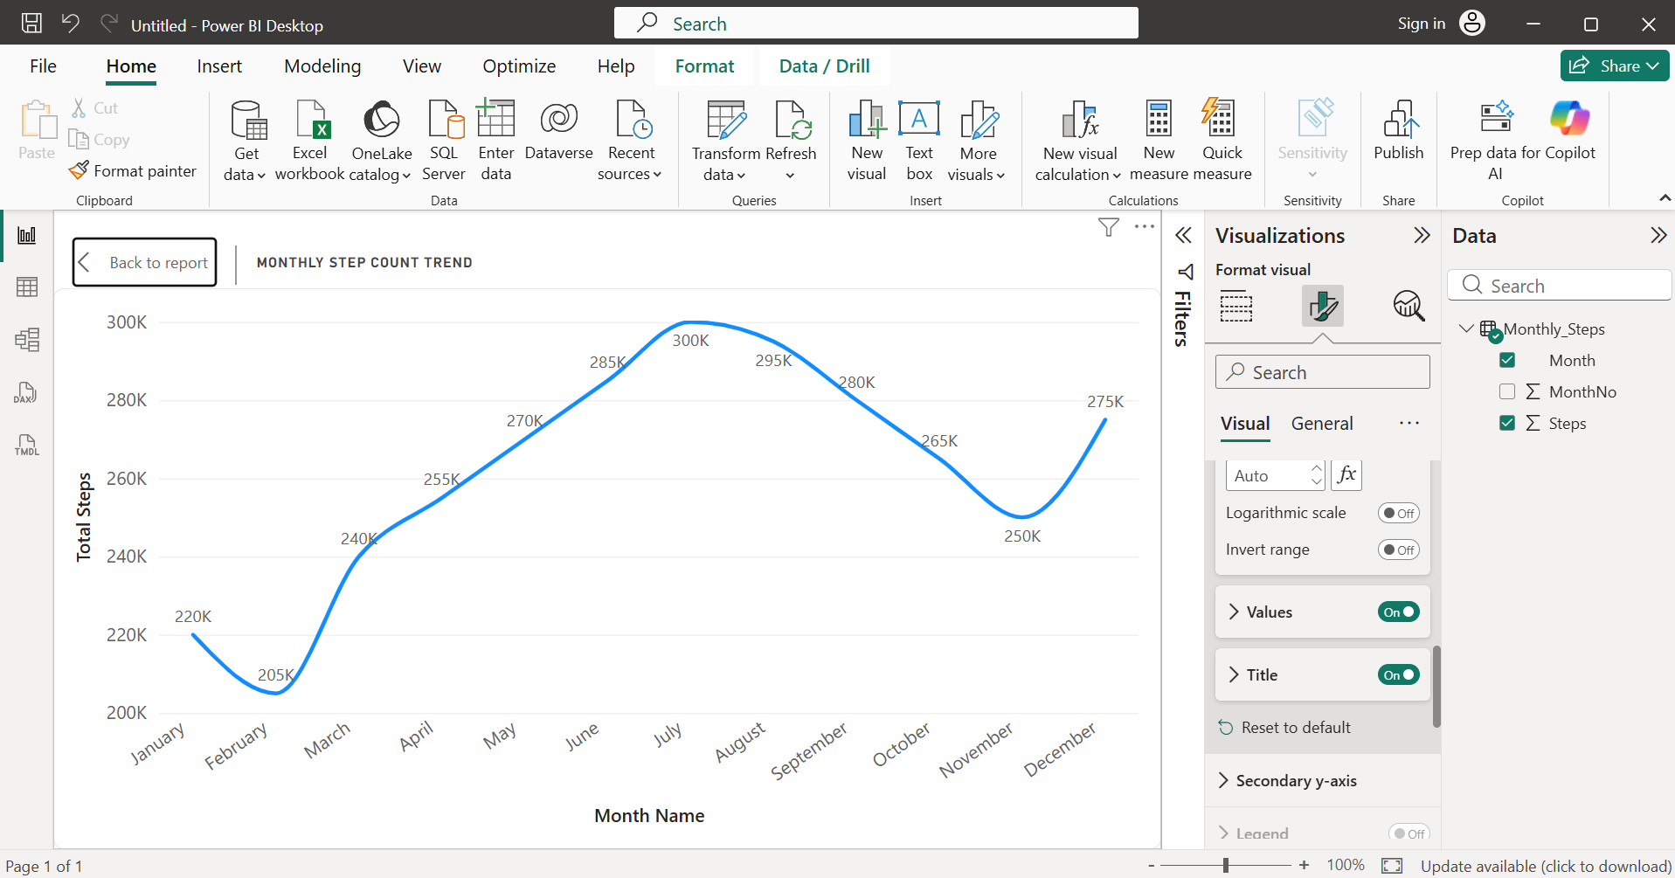
- Imported the Monthly_Steps.csv file into Power BI Desktop using Get Data -> Text/CSV. Created a Line Chart by placing Month on the X-axis and Steps on the Y-axis. Added the title "Monthly Step Count Trend" to visualize the monthly trend in step counts over one year.

- Using a sample dataset of your favourite food delivery app orders (columns: Restaurant, OrderCount), create a Pie Chart in Power BI to display the share of orders for each restaurant, and customize the legend to show percentage values.

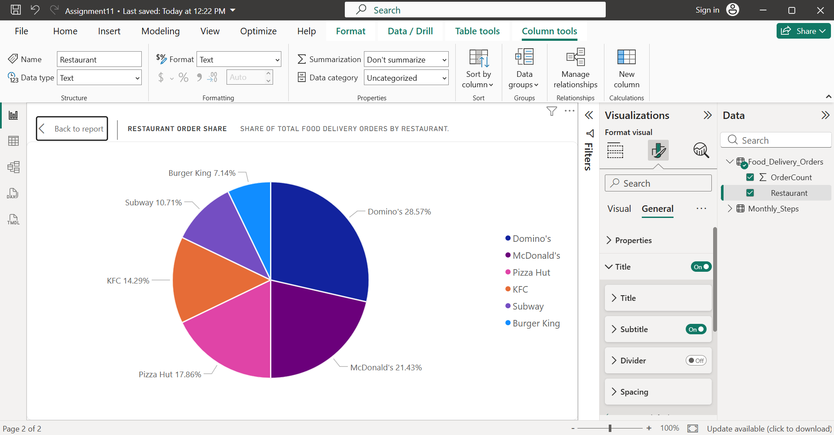
- Imported the Food_Delivery_Orders.csv dataset into Power BI Desktop. Created a Pie Chart by placing Restaurant in the Legend field and OrderCount in the Values field. Enabled Detail Labels and displayed Category, Percent of Total to show each restaurant's share of total orders. Added the title "Restaurant Order Share".

- Import a dataset with daily active user counts for three different social media apps (columns: Date, Instagram, WhatsApp, YouTube), and create an Area Chart in Power BI to visualize the usage patterns of all three apps over a two-week period.

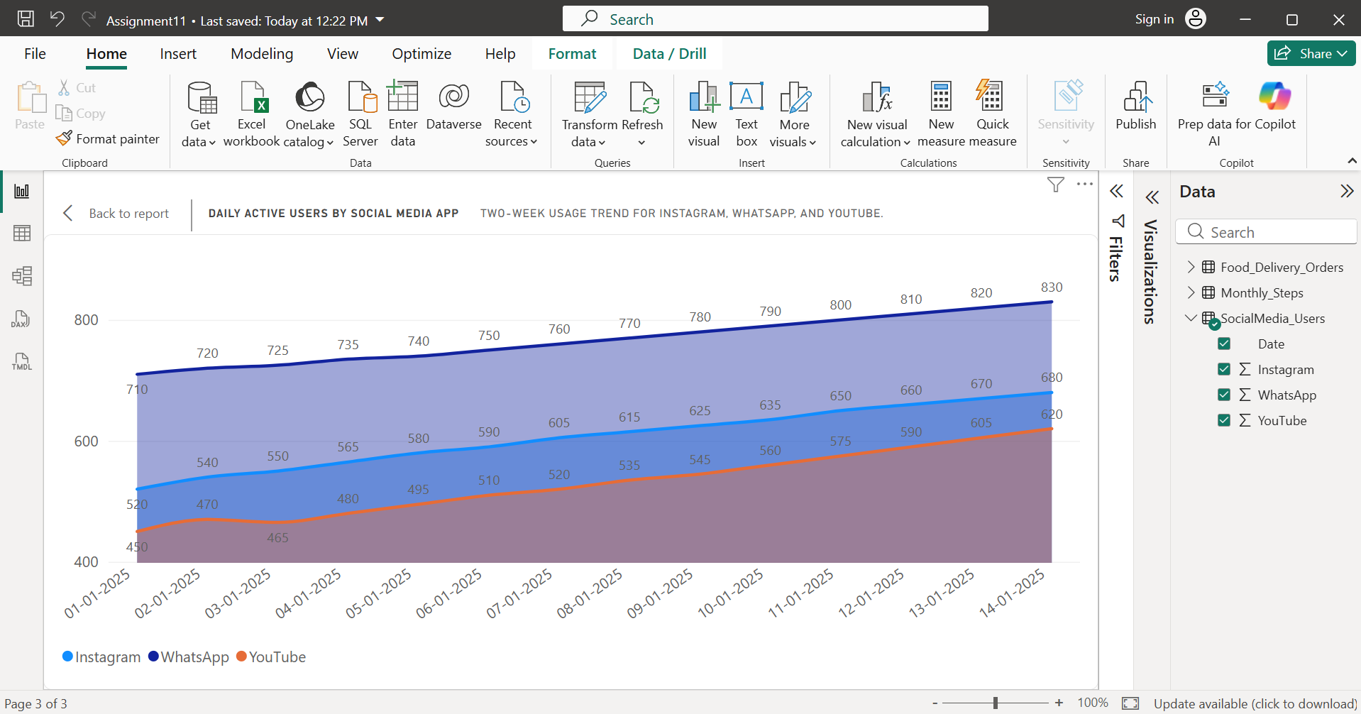
- Imported the SocialMedia_Users.csv dataset into Power BI Desktop. Created an Area Chart by placing Date on the X-axis and Instagram, WhatsApp, and YouTube on the Y-axis. Added the title "Daily Active Users by Social Media App" and enabled the legend to compare the usage patterns of all three apps over a two-week period.

- Build a Combo Chart in Power BI using a dataset of monthly Zomato orders (columns: Month, TotalOrders, AverageOrderValue), where TotalOrders is shown as columns and AverageOrderValue as a line on the same chart.<br><br><em><strong>Hint:</strong> Use the Combo Chart visual and assign the appropriate fields to column and line values.</em>

- Imported the Zomato_Orders.csv dataset into Power BI Desktop. Created a Line and Clustered Column Chart by placing Month on the X-axis, TotalOrders on the Column Y-axis, and AverageOrderValue on the Line Y-axis. Added the title "Monthly Zomato Orders and Average Order Value". This chart compares the monthly order volume with the average order value in a single visual.
- Chart is as shown below on next page:
