- In Power BI, create a table of your 5 most-used food delivery apps (like Zomato, Swiggy, Domino's, McDonald's, Pizza Hut) with a column for total orders placed. Use the SUM function to calculate the total number of orders across all apps and display it in a card visualization.

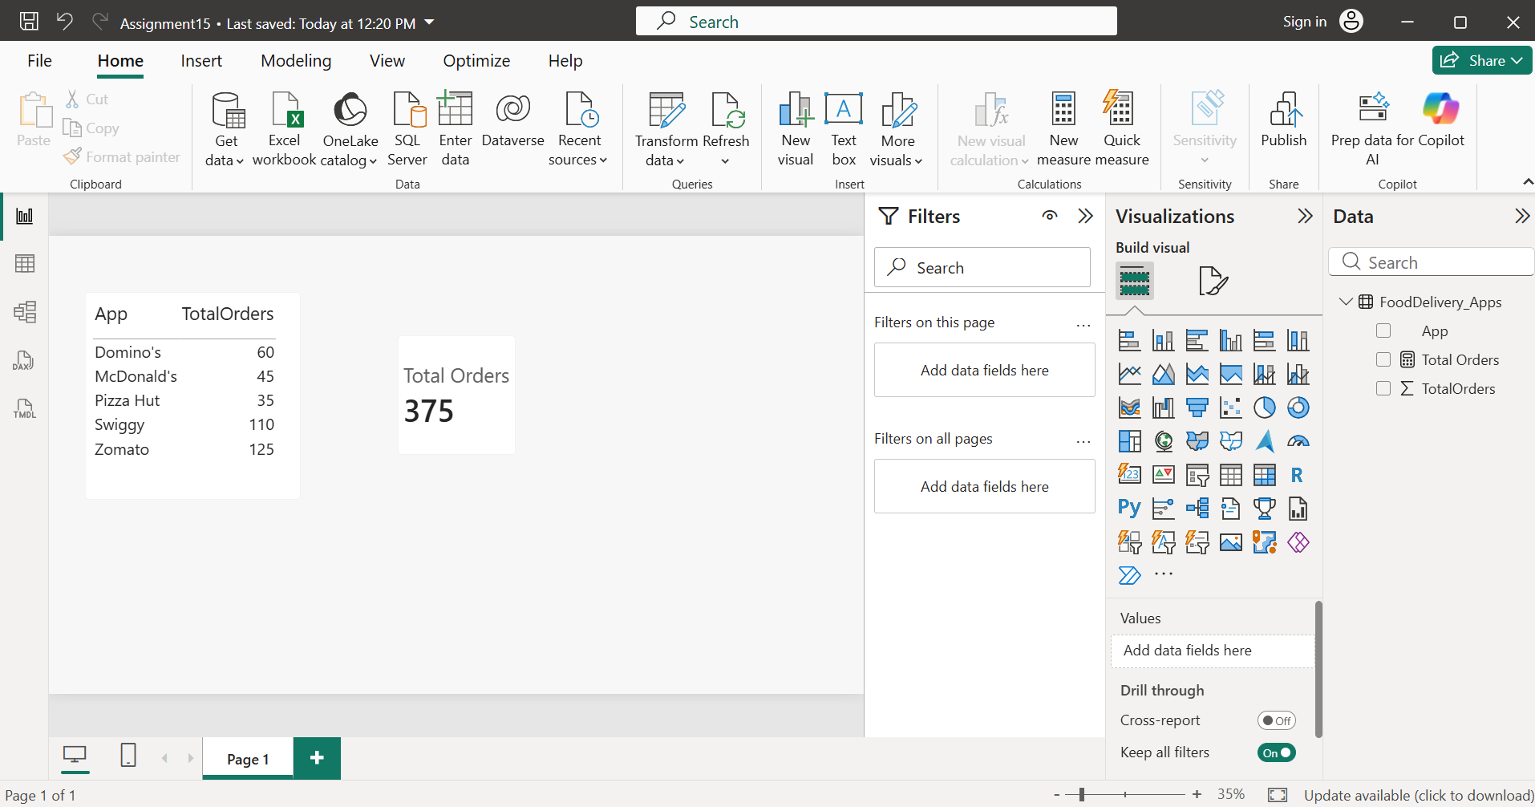
- Imported the FoodDelivery_Apps.csv dataset into Power BI Desktop. Created a DAX measure using:
Total Orders = SUM(FoodDelivery_Apps[TotalOrders])
- Displayed the data in a Table visual with App and TotalOrders, and used a Card visual to show the total number of orders across all five food delivery apps, which is 375.

- Add a new column to your Power BI table for 'Order Ratings' (random numbers between 1 and 5 for each app). Use the AVERAGE function to show the average rating across all apps in a separate card.

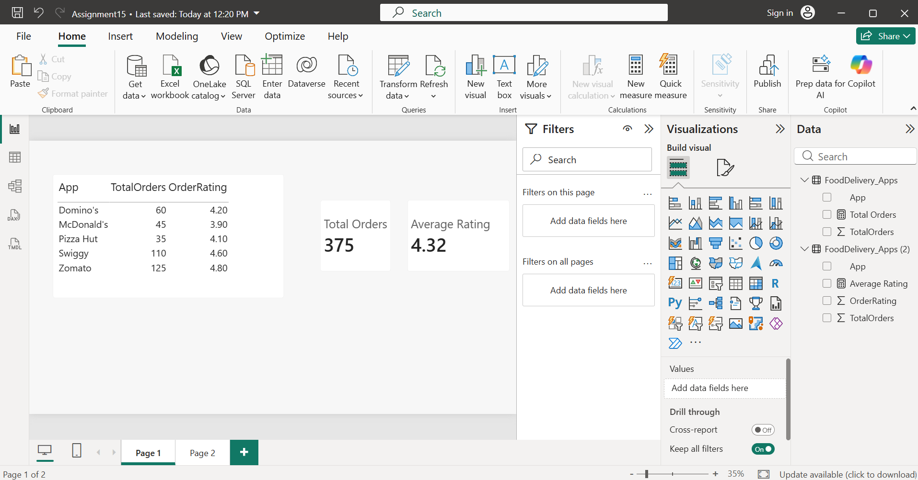
- Added a new column named OrderRating to the FoodDelivery_Apps dataset. Created a DAX measure using:
Average Rating = AVERAGE(FoodDelivery_Apps[OrderRating])
- Displayed the measure in a Card visual to show the average rating across all five food delivery apps. The calculated average rating is 4.32.

- Create a slicer in Power BI to filter your table by order ratings greater than 3. Use the COUNT and DISTINCTCOUNT functions to display the total number of orders and the count of unique apps with ratings above 3.

- Before filtering the table by order ratings greater than 3:
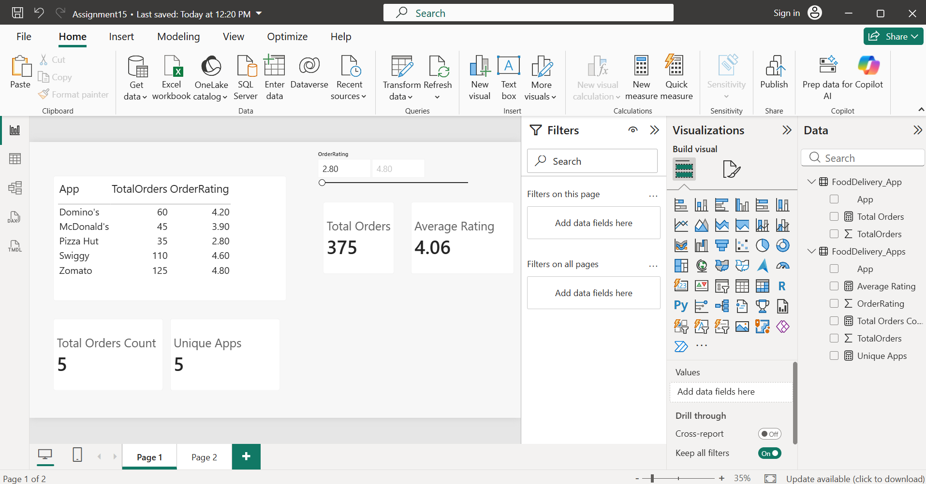

- After filtering the table by order ratings greater than 3:
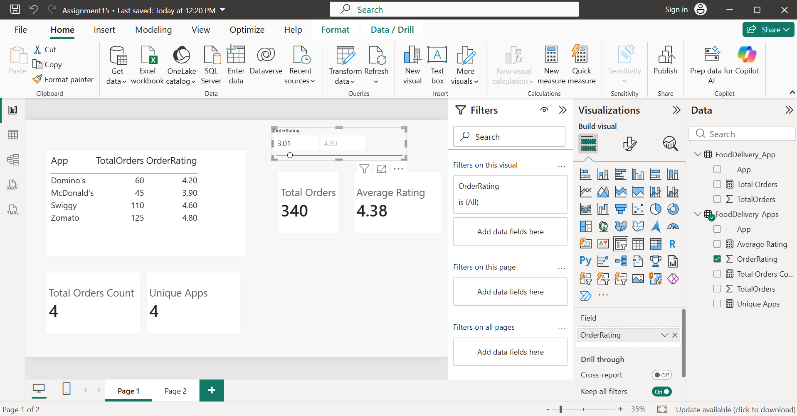

- Used the FoodDelivery_Apps dataset and created a slicer on the OrderRating field to filter apps with ratings greater than 3. Created two DAX measures:
Total Orders Count = COUNT(FoodDelivery_Apps[TotalOrders])
Unique Apps = DISTINCTCOUNT(FoodDelivery_Apps[App])
- Displayed both measures in Card visuals. After applying the filter, the cards show the number of order records and the number of unique apps with ratings above 3.

- Add a calculated column to your table that shows 'High Performer' if the app's order count is above the average, otherwise 'Regular', using the SWITCH function and logical operators (AND/OR). Display this new column in your table visualization.<br><br><em><strong>Hint:</strong> Use VAR to store the average and RETURN to output the label based on the condition.</em>

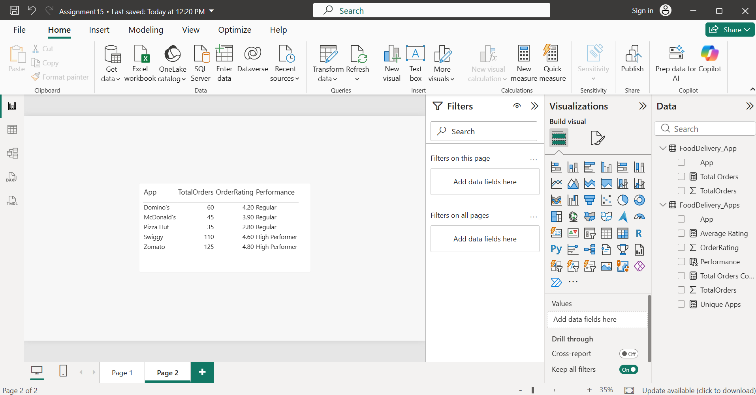
- Created a calculated column named Performance using VAR, RETURN, SWITCH, and the AND (&&) logical operator.

Performance =
VAR AvgOrders =
CALCULATE(
AVERAGE(FoodDelivery_Apps[TotalOrders]),
ALL(FoodDelivery_Apps)
)
RETURN
SWITCH(
TRUE(),
FoodDelivery_Apps[TotalOrders] > AvgOrders &&
FoodDelivery_Apps[OrderRating] > 3,
"High Performer",
"Regular"
)
- The new Performance column was added to a Table visual to classify each app as either High Performer or Regular based on its order count relative to the average and its rating.

- Use Power BI's DAX editor to write a measure that returns 'Top Choice' if an app has more than 100 orders and a rating above 4, otherwise 'Consider Alternatives'. Use AND, IF, and NOT functions in your logic.

- Created a DAX measure using IF, AND, and NOT:
App Status =
IF(
AND(
MAX(FoodDelivery_Apps[TotalOrders]) > 100,
NOT(MAX(FoodDelivery_Apps[OrderRating]) <= 4)
),
"Top Choice",
"Consider Alternatives"
)

- The measure was added to a Table visual along with the app name, total orders, and rating. It returns "Top Choice" for apps with more than 100 orders and a rating above 4, and "Consider Alternatives" for all other apps.

