- Apply a custom color theme to a Power BI report that matches the branding of your favorite IPL team, including logo placement and color palette.

- Opened the existing IPL Matches report in Power BI.
- Applied the Solar theme from the View tab.
- Added the Chennai Super Kings (CSK) logo using Insert → Image.
- Added the title "Chennai Super Kings Match Performance Dashboard".
- Used the theme colors consistently across charts and visuals to match the team's branding.
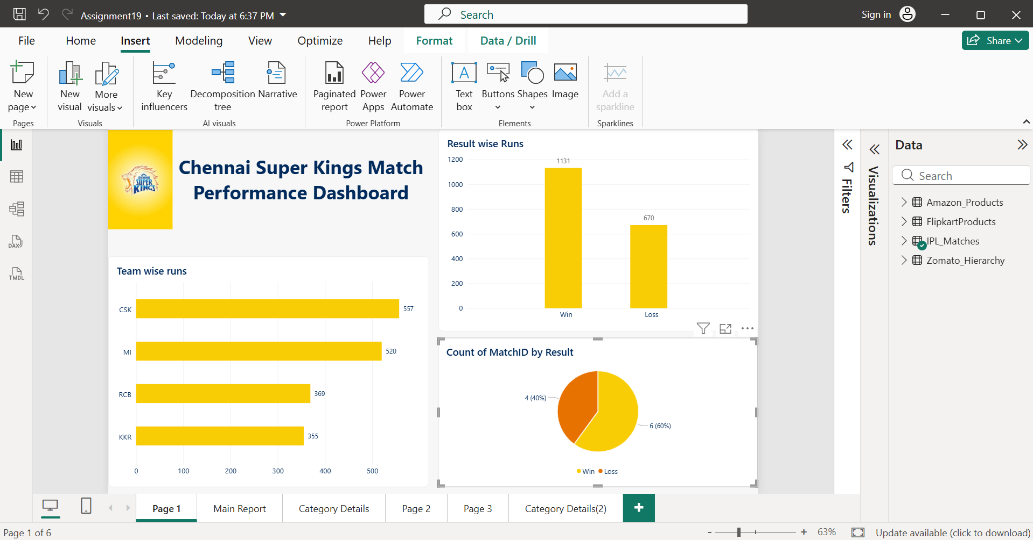

- Design a Flipkart-style sales dashboard in Power BI using gridlines for alignment, and arrange visuals (bar chart, pie chart, KPI card) to create a clean, balanced layout.

- Created a new report page.
- Enabled Gridlines from the View tab.
- Added a dashboard title.
- Created a KPI Card showing Total Sales.
- Added a Bar Chart showing Sales by Category.
- Added a Pie Chart showing Product Distribution by Category.
- Used the gridlines to align and arrange the visuals neatly.
- Designed a clean, balanced dashboard inspired by Flipkart.
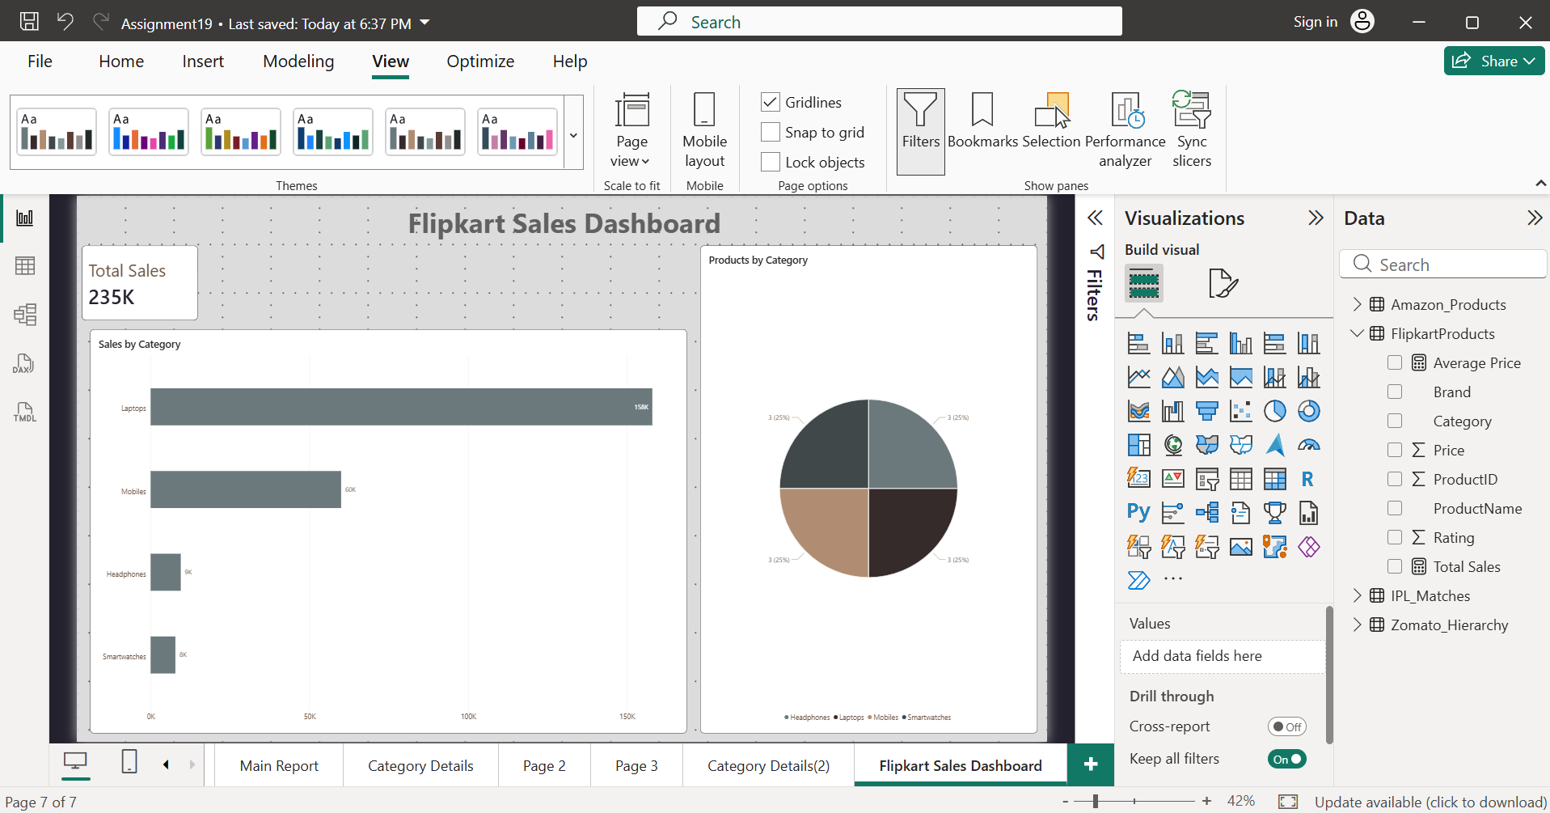
- Set up Row Level Security (RLS) in a Power BI report so that only sales data for a specific city (e.g., Ahmedabad) is visible to users from that city.<br><br><em><strong>Hint:</strong> Use the 'Manage Roles' feature to define your rule and test it using 'View as Role'.</em>

- Imported the City Sales dataset into Power BI.
- Created a Table visual displaying City, Product, and Sales.
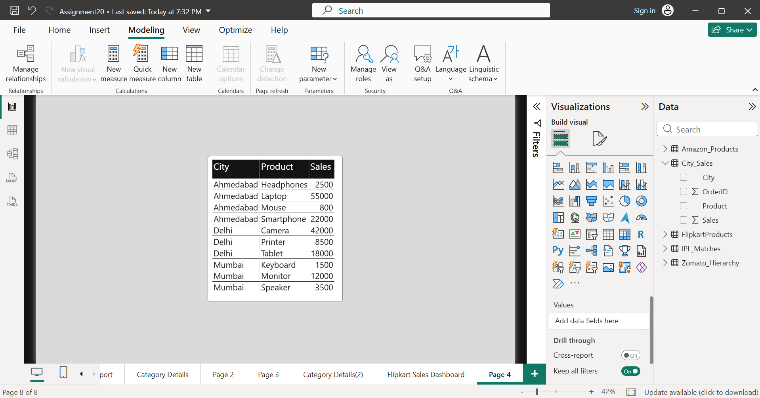
- Opened Modeling → Manage Roles.
- Created a role named Ahmedabad_User.
- Added the filter rule:
- [City] = "Ahmedabad"
- Saved the role.
- Used Modeling → View as to test the role.
- Verified that only Ahmedabad sales data was visible.
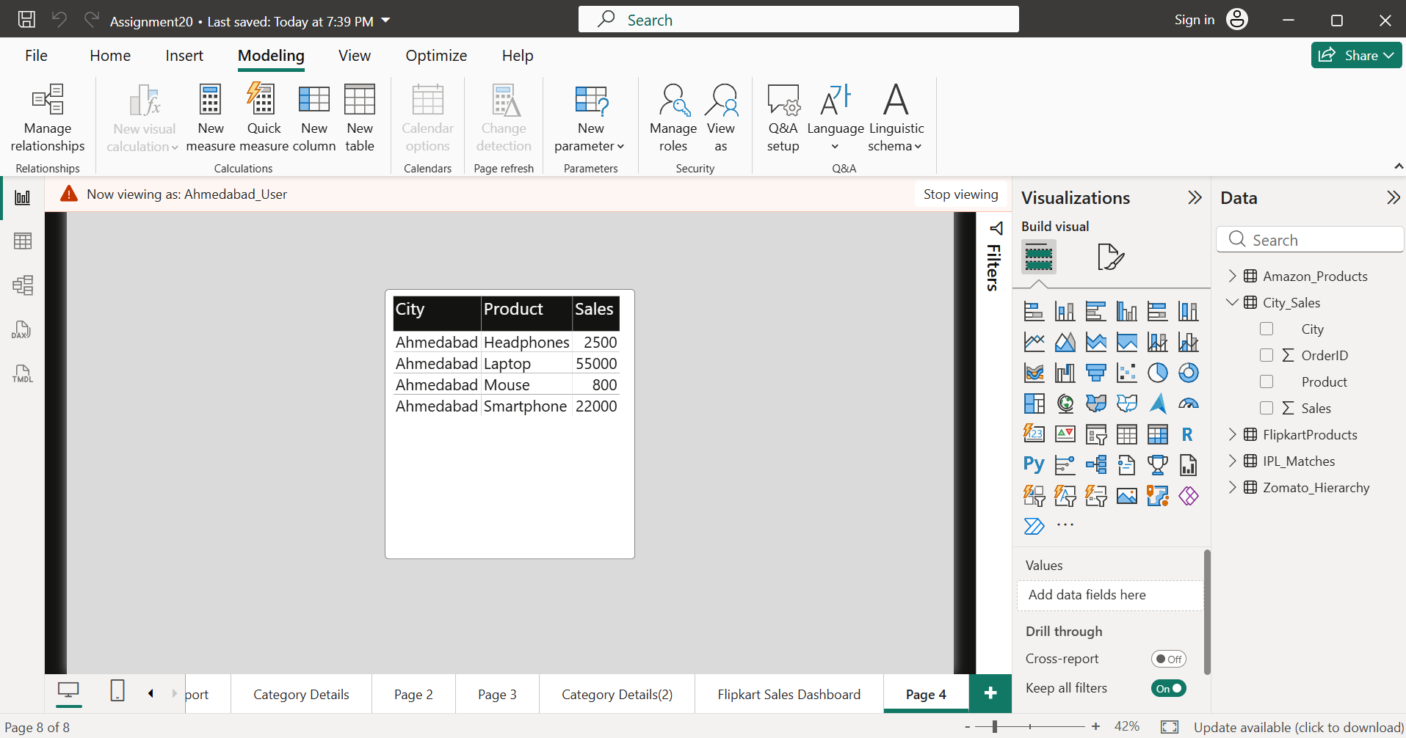
- Row Level Security (RLS) is a Power BI feature that restricts data access based on user roles. It ensures that users can only view the rows of data they are authorized to see.

- Publish your customized Power BI report to the Power BI Service and share it with a classmate using their email address.<br><br><em><strong>Constraint:</strong> Ensure the report is accessible and viewable by the recipient.</em>

- Note: I completed the Power BI report in Power BI Desktop. I was unable to publish it to the Power BI Service because the application required a work or school Microsoft account, and I only have a personal Microsoft account.

- Align all visuals in your Power BI report using the alignment tools so that the dashboard looks professional and organized, similar to the clean layouts found in apps like Zomato or Spotify.

- Opened the Healthcare Dashboard in Power BI.
- Selected multiple visuals using the Ctrl key.
- Used the Align tools to align the visuals.
- Adjusted spacing between visuals for consistency.
- Verified that KPI cards, charts, and slicers were neatly arranged.
- Created a clean, professional dashboard similar to modern applications like Zomato or Spotify.
