- In Power BI Desktop, import a sample dataset of IPL cricket matches and create a bar chart showing total runs by each team. Enable drill-down so that clicking on a team reveals runs by individual players from that team.

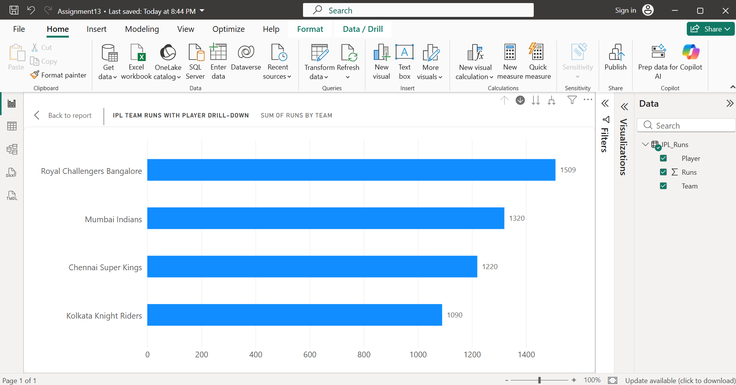
- Enabled drill down and selected team “Royal Challengers Bangalore” to see the runs scored by its each team member- Virat Kohli, Faf du Plessis, Glenn Maxwell.
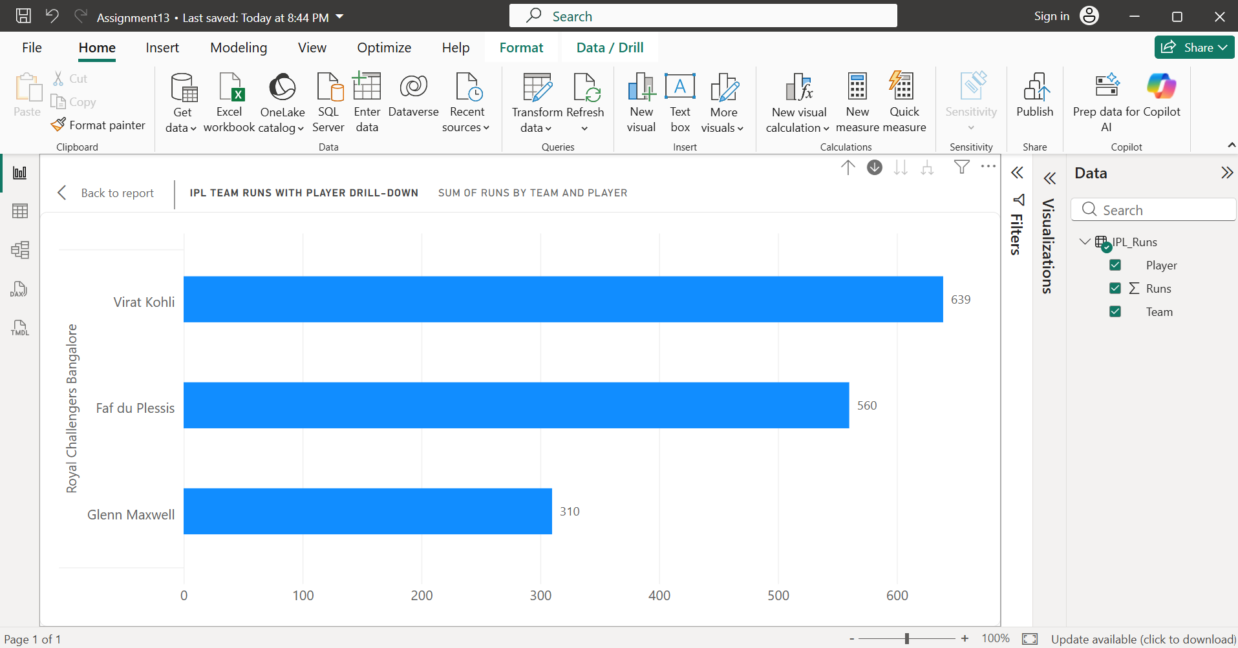
- Then selected Drill up to go back and clicked on team “Chennai Super Kings” to see runs scored by Ruturaj Gaikwad, Shivam Dube, MS Dhoni.
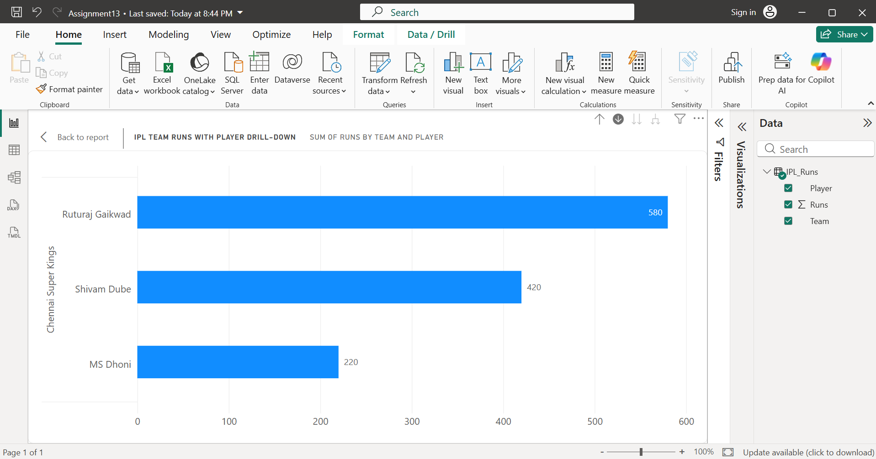
- Similarly, we can see the runs scored by players of another team too.
- Thus, for this question I imported the IPL_Runs.csv dataset into Power BI Desktop. Created a Clustered Bar Chart by placing Team and Player (as a hierarchy) on the Y-axis and Runs on the X-axis. Enabled Drill Down so that selecting a team displays the runs scored by individual players. This allows users to analyse team performance at both the team and player levels.

- Create a hierarchy in Power BI using a dataset of movies (for example: Genre > Year > Movie Title). Build a visual that lets users drill through these levels to see box office collections at each stage.<br><br><em><strong>Hint:</strong> Use the 'Manage Hierarchy' option in the Fields pane to set up your levels.</em>

- Right-clicked on Genre and created Genre Hierarchy. Added Year and Movie Title to it.
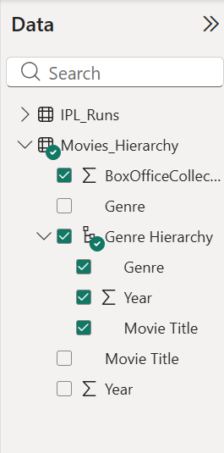
- At the first level, the chart displays total box office collection by genre in crores.
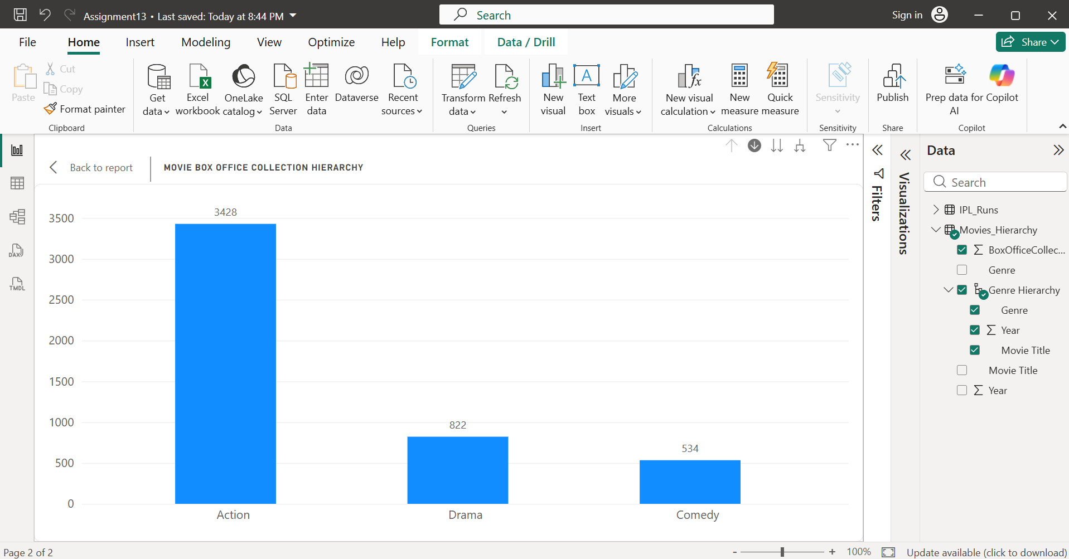
- After drilling down at level 2 under action we have:
  - Action
    - 2022
    - 2023
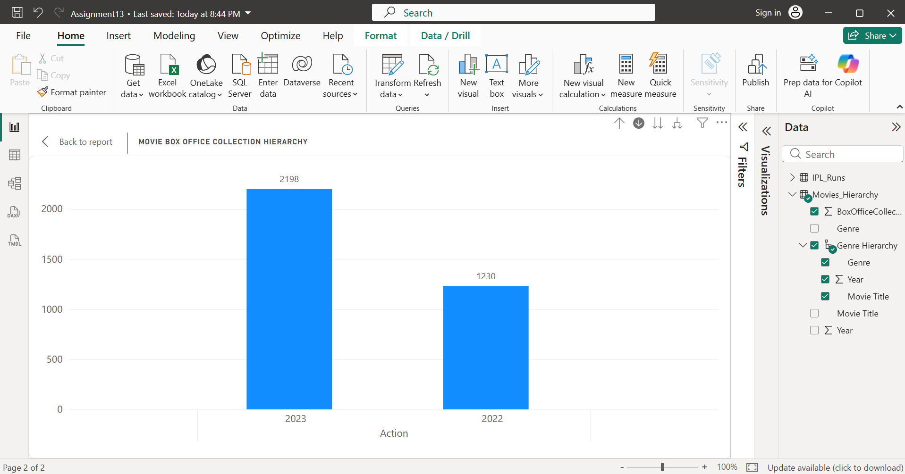
- At level 3 drill down under 2022 we have,
  - KGF Chapter 2 → ₹1230 Cr
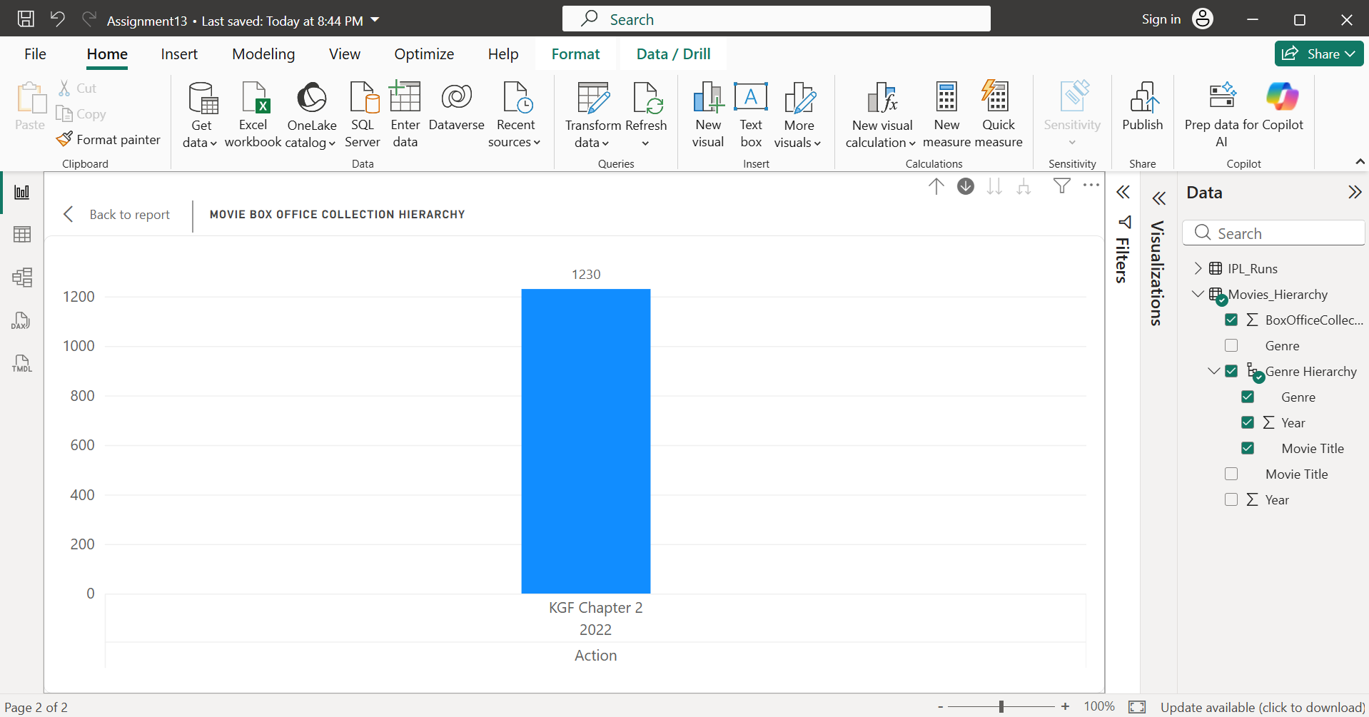
- Similarly, at level 3 when we drill down under 2023, we can see
  - Jawan → ₹1148 Cr
  - Pathaan → ₹1050 Cr
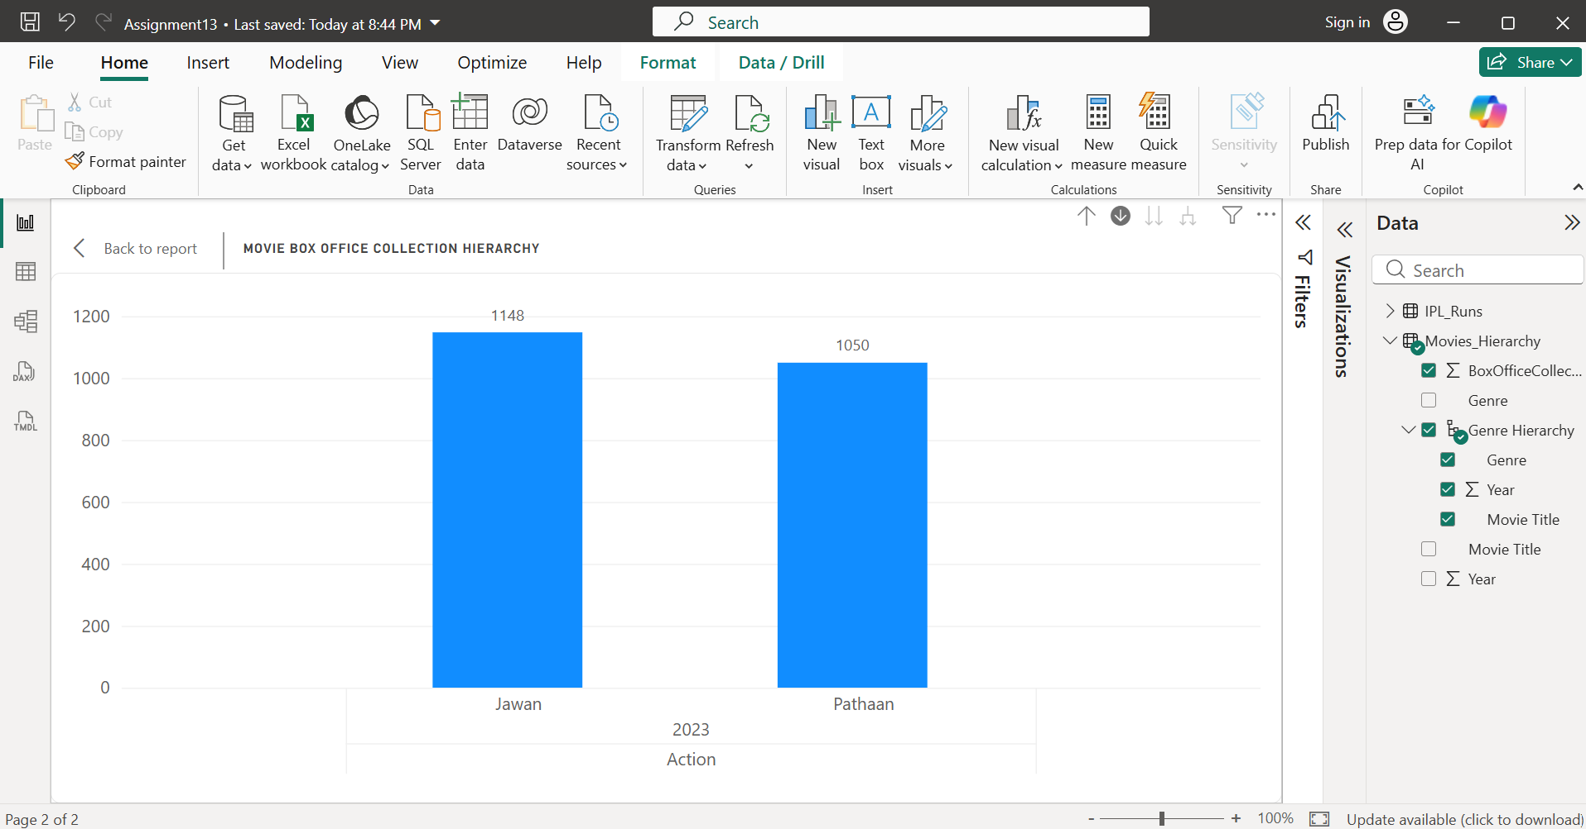
- In the same way, we can drill into Drama and Comedy.
- Imported the Movies_Hierarchy.csv dataset into Power BI Desktop. Created a hierarchy with Genre -> Year -> Movie Title using the Create Hierarchy option in the Fields pane. Built a Clustered Column Chart by placing the hierarchy on the X-axis and BoxOfficeCollection (₹ Crore) on the Y-axis. Enabled Drill Down to allow users to navigate from genre to year and finally to individual movie collections.

- Apply conditional formatting to a table visual displaying restaurant ratings (like Zomato) so that ratings above 4.5 appear in green, between 3 and 4.5 in yellow, and below 3 in red.

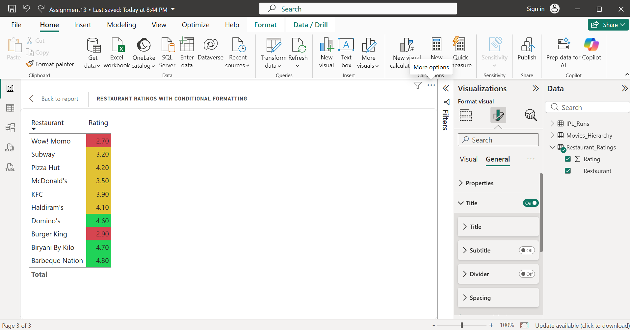
- Imported the Restaurant_Ratings.csv dataset into Power BI Desktop and created a Table visual with Restaurant and Rating fields. Applied Conditional Formatting to the Rating column using Rules:
  - Green for ratings above 4.5
  - Yellow for ratings between 3 and 4.5
  - Red for ratings below 3
- This formatting makes it easy to quickly identify highly rated, average-rated, and low-rated restaurants.

- Go to the Power BI Marketplace and add a custom visual of your choice (for example, a 'Word Cloud' or 'Bullet Chart'). Use it to visualize the most frequently ordered food items from a Swiggy-style order dataset.<br><br><em><strong>Hint:</strong> After importing, drag the visual onto your report and assign the relevant field.</em>

- Note: I was unable to complete this task because downloading custom visuals from the Power BI Marketplace requires a work or school Microsoft account. I only have a personal account, so I could not sign in to access the Marketplace. If access were available, I would have added the Word Cloud visual, imported a Swiggy food order dataset, and used Food Item as the Category and Order Count as the Values field to display the most frequently ordered food items.

- Use ChatGPT to help you write a DAX formula that calculates the average delivery time per city from a Flipkart orders dataset, then apply this measure to a visual in your Power BI report.<br><br><em><strong>Hint:</strong> Paste your ChatGPT prompt and the generated DAX formula in your submission.</em>

- ChatGPT Prompt:
  - Write a DAX measure in Power BI to calculate the average delivery time per city from a Flipkart orders dataset containing the columns City and DeliveryTime (Days).
- Generated DAX Formula:
Average Delivery Time =
AVERAGE(Flipkart_Delivery[DeliveryTime (Days)])

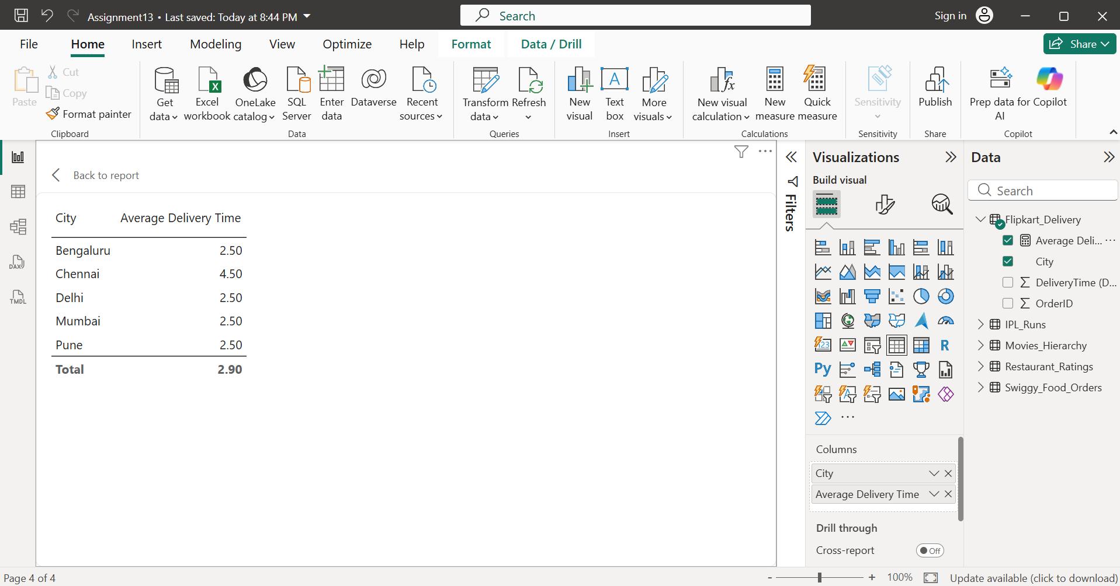
- Imported the Flipkart_Delivery.csv dataset into Power BI Desktop. Created the Average Delivery Time measure using the DAX formula above. Built a Table visual with City and Average Delivery Time to display the average delivery time for each city. This allows easy comparison of delivery performance across different cities.

