- In Power BI, use the FILTER() function to create a measure that counts the number of products in a Flipkart-style sales dataset where the rating is greater than 4.

- Created the following DAX measure using the FILTER() function:

Products with Rating > 4 =
COUNTROWS(
FILTER(
F_Sales,
F_Sales[Rating] > 4
)
)

- In a given dataset, this function counts the no. of products where the rating is greater than 4.
- Imported F_Sales.csv file and used a card visual to show the count of products where rating is greater than 4.
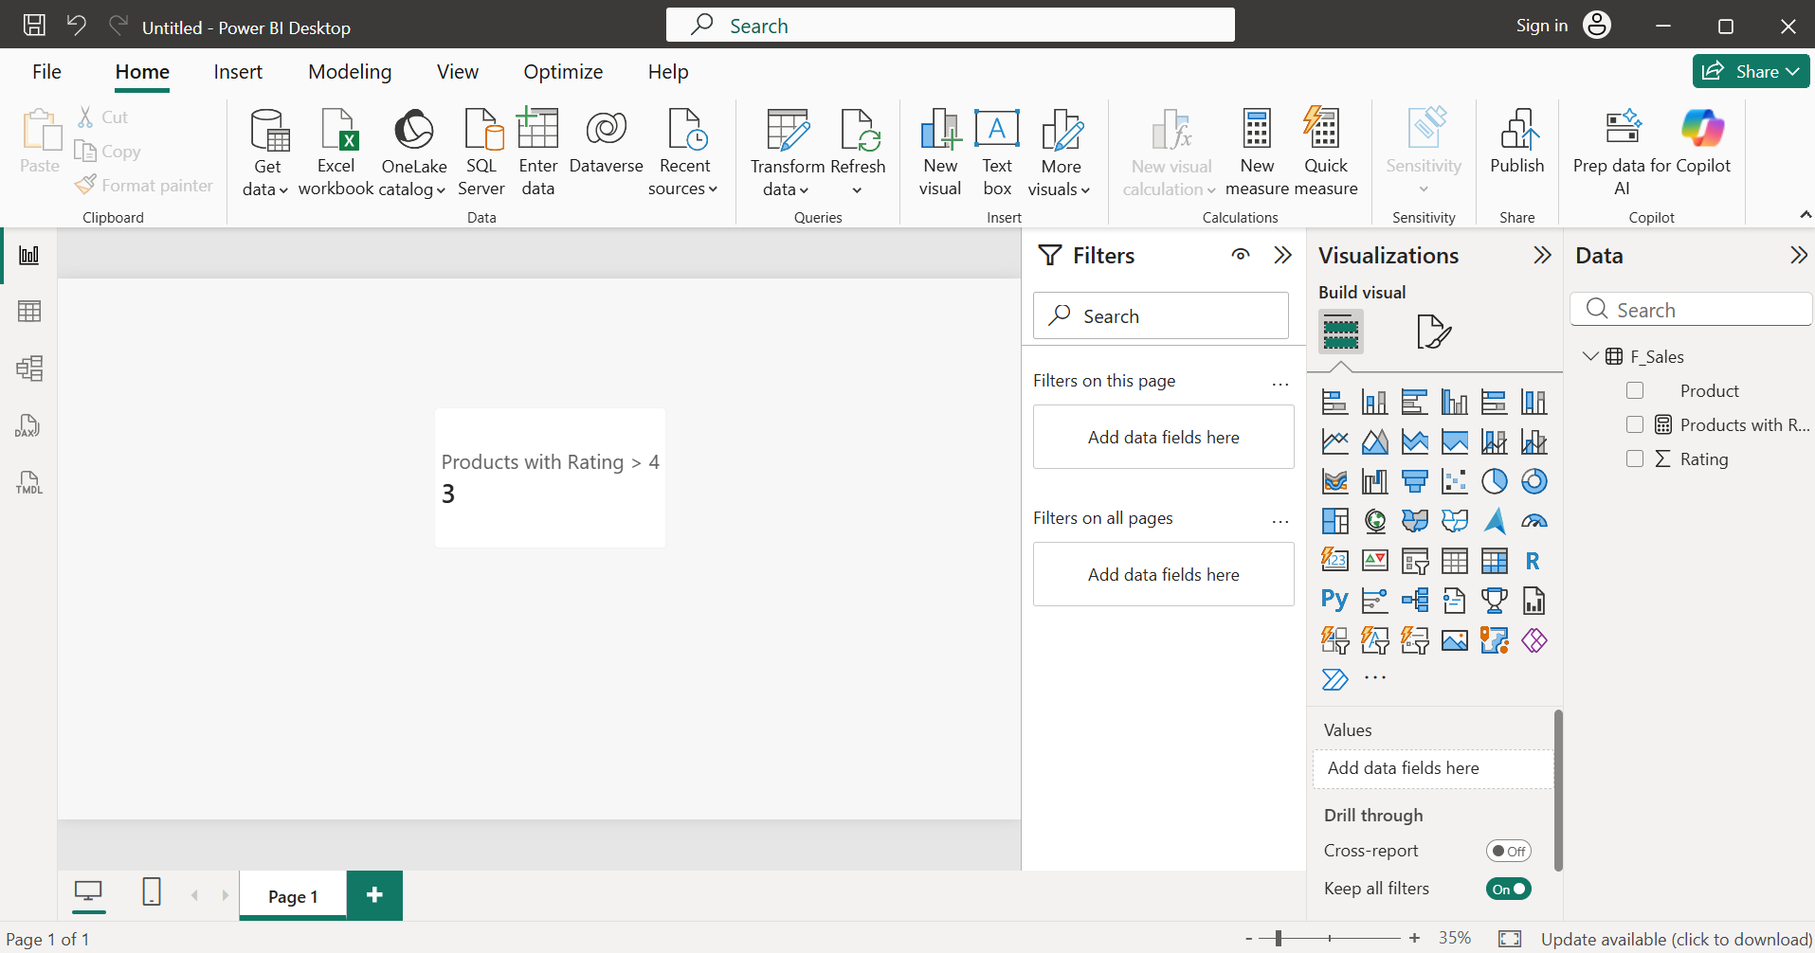

- Build a calculated measure using CALCULATE() and ALL() to show the overall average order value for all users in a Zomato orders dataset, ignoring any filters on city or cuisine.

- Imported file ZomatoOrders.csv
- Created two measures:
  - Average Order Value
Average Order Value = AVERAGE(ZomatoOrders[OrderValue])
  - Overall Average Order Value
Overall Average Order Value =
CALCULATE(
AVERAGE(ZomatoOrders[OrderValue]),
ALL(ZomatoOrders[City], ZomatoOrders[Cuisine])
)
- Added both measures on two separate card visuals
- Created two slicers, one for city another for cuisine
- Note that on filtering city and cuisine the value of ‘Average Order Value’ changes while the value of ‘Overall Average Order Value’ remains constant.
- This is because
  - CALCULATE() - Changes how the calculation is evaluated. Think of it as: "Calculate this measure, but under the conditions I give."
  - ALL() - Removes filters. It means ignore every filter applied on City and Cuisine.
- Screenshot with filter applied:
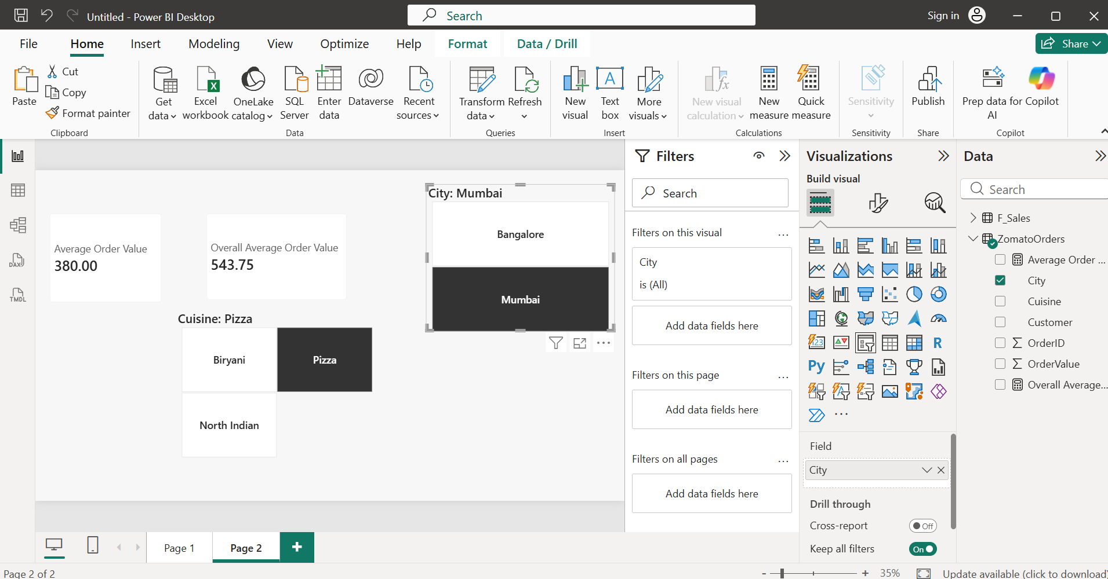

- Screenshot without filter applied:
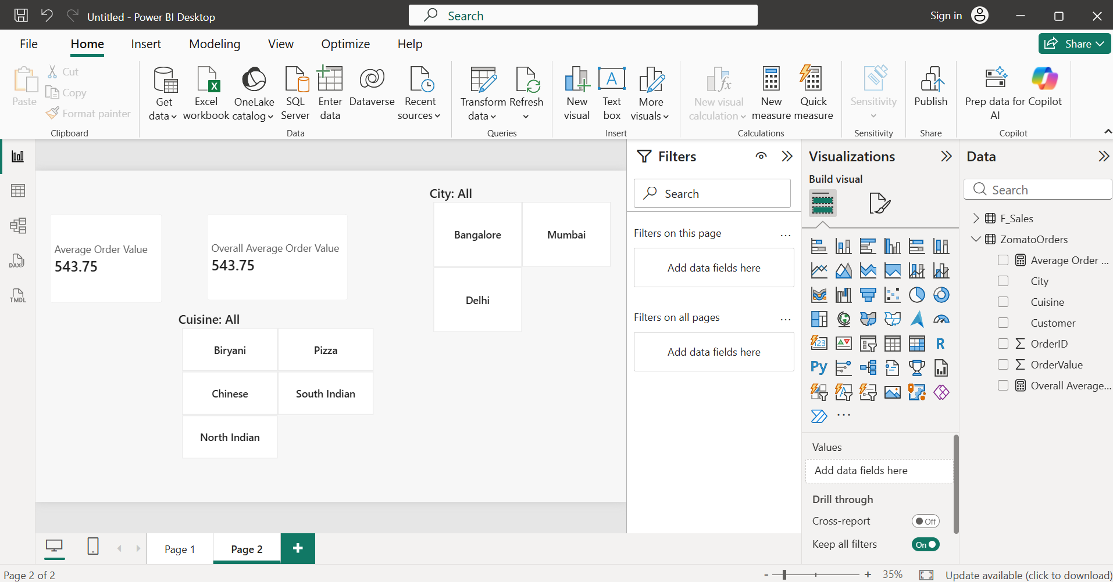

- Create a RANKX measure that ranks movies by total box office collection in a BookMyShow-style dataset and displays the rank next to each movie title.

- Imported file ‘Movies.csv’
- Created two measures
  - Total Box Office
Total Box Office = SUM(Movies[BoxOfficeCollection])
  - Movie Rank
Movie Rank =
RANKX(
ALL(Movies[MovieTitle]),
[Total Box Office],
,
DESC,
DENSE
)
- The RANKX() function is used to assign a rank to each movie based on its total box office collection. By using ALL(MovieTitle), Power BI evaluates the ranking across all movie titles, and DESC ensures that the movie with the highest collection receives Rank 1. The DENSE option provides consecutive ranking when there are ties.
- Inserted a table visual and displayed rank of movies in it.
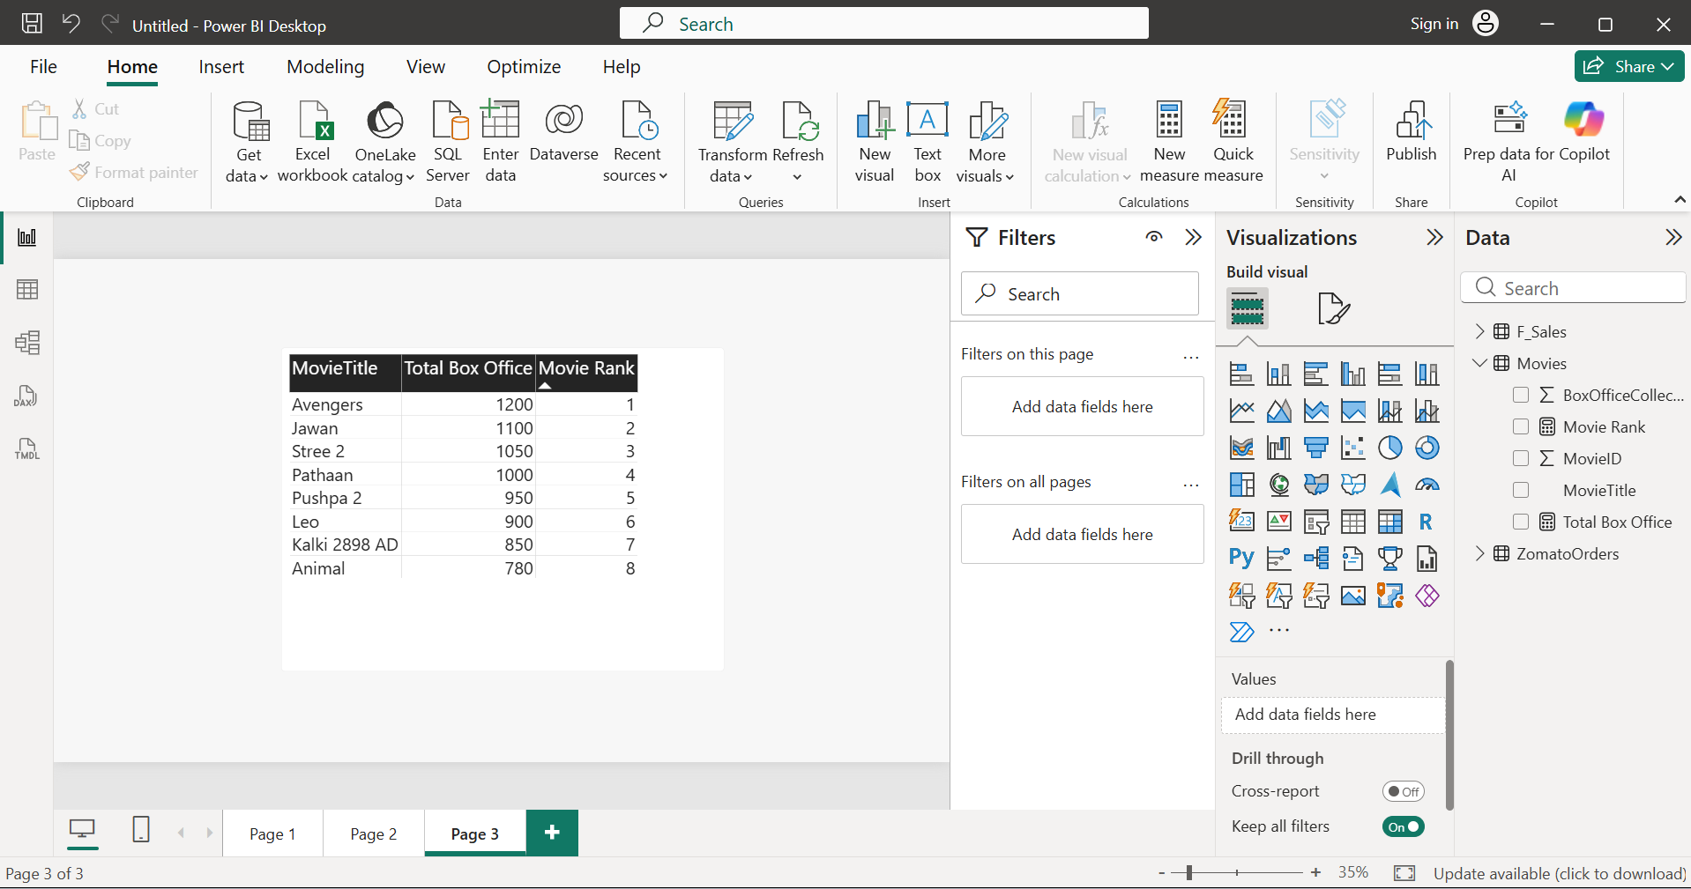

- Use the SUMX() function to calculate the total value of items in a Myntra shopping cart table, where each item has a quantity and price column.<br><br><em><strong>Hint:</strong> SUMX() lets you multiply quantity by price for each row and then sum the results.</em>

- Created ‘ShoppingCart’ table using Home -> Enter Data
- Created measure, Total Cart Value
Total Cart Value =
SUMX(
ShoppingCart,
ShoppingCart[Quantity] * ShoppingCart[Price]
)
- SUMX() iterates through each row of the ShoppingCart table.
- For every row, it calculates Quantity × Price.
- It then adds all the calculated values together.
- The measure returns the total value of all items in the shopping cart.
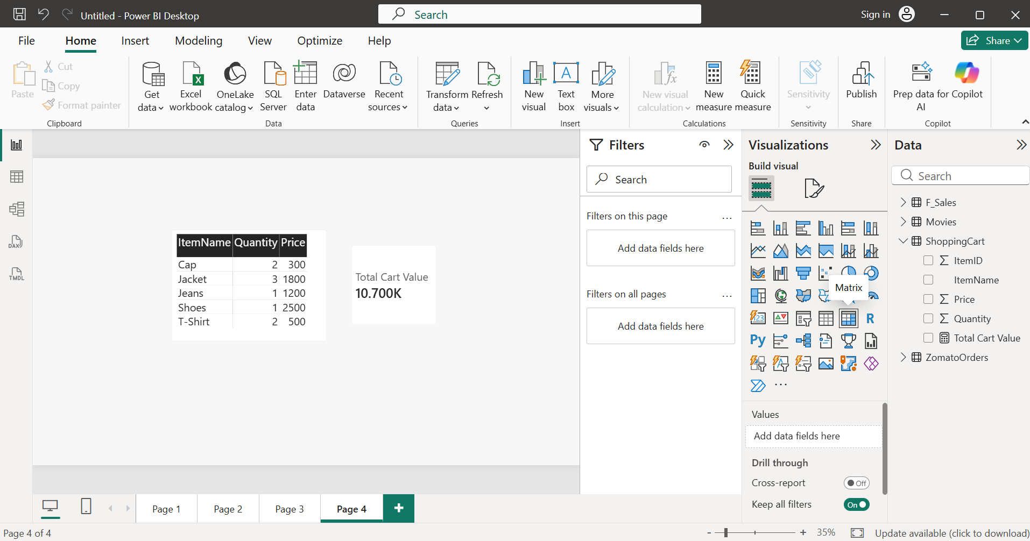

- With AVERAGEX(), build a measure that calculates the average rating per restaurant in a restaurant reviews table, and display it in a table visual in Power BI.

- Imported file “RestaurantReviews.csv”
- Created measure, Average Rating:
Average Rating =
AVERAGEX(
RestaurantReviews,
RestaurantReviews[Rating]
)
- AVERAGEX() iterates through each row of the RestaurantReviews table.
- It evaluates the Rating column for every review.
- It then calculates the average of those ratings.
- When used in a table visual with the Restaurant field, it displays the average rating for each restaurant.
- The same is shown in screenshot on next page.
