- Open Microsoft Excel or Google Sheets, create a column named 'Order Amount', and enter 20 random numbers between 100 and 1000 to simulate Zomato order values for a day.

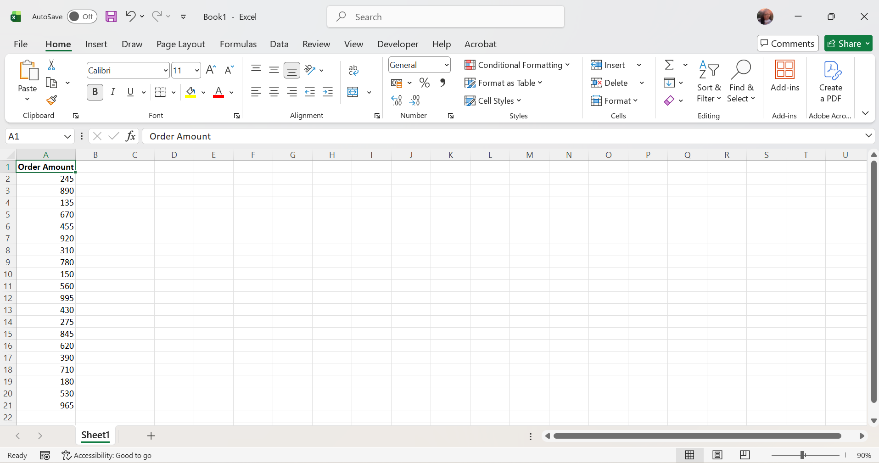

- A column named "Order Amount" was created, and 20 random order values between ₹100 and ₹1000 were entered successfully.

- From your 'Order Amount' data, calculate the mean, median, and mode using Excel or Sheets functions (AVERAGE, MEDIAN, MODE) and write the results below your data.

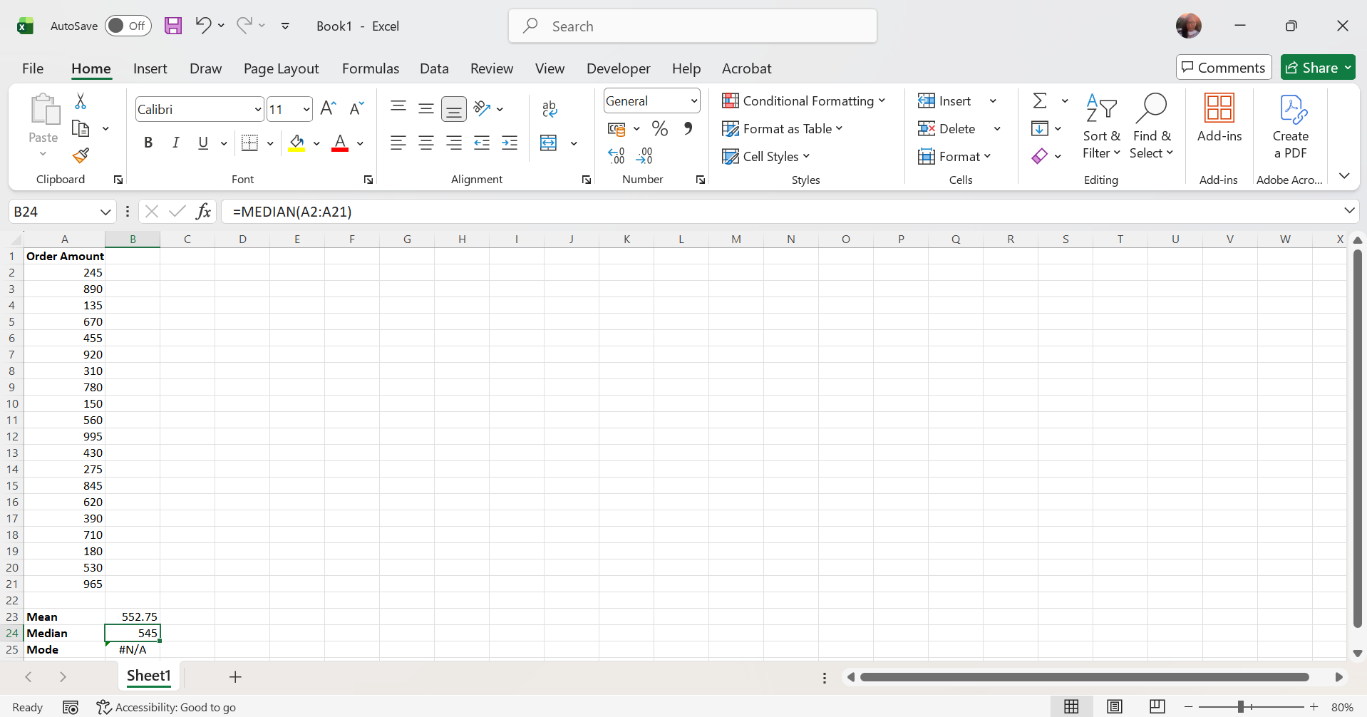
- A mode is the value that appears most frequently. In my dataset, every number appears only once, so there is no mode. Excel displays #N/A, which is the correct result.
- Conclusion: Hence, the average (mean) order amount is ₹552.75, the median order amount is ₹545, and there is no mode because no order amount is repeated.
- Select the first 5 values from your 'Order Amount' column as a sample. Calculate the sample mean and compare it to the population mean you found earlier. <br><br><em><strong>Hint:</strong> Use the AVERAGE function for both calculations and observe the difference between sample and population means.</em>
- Population = All 20 order amounts.
- Sample = Only the first 5 order amounts.
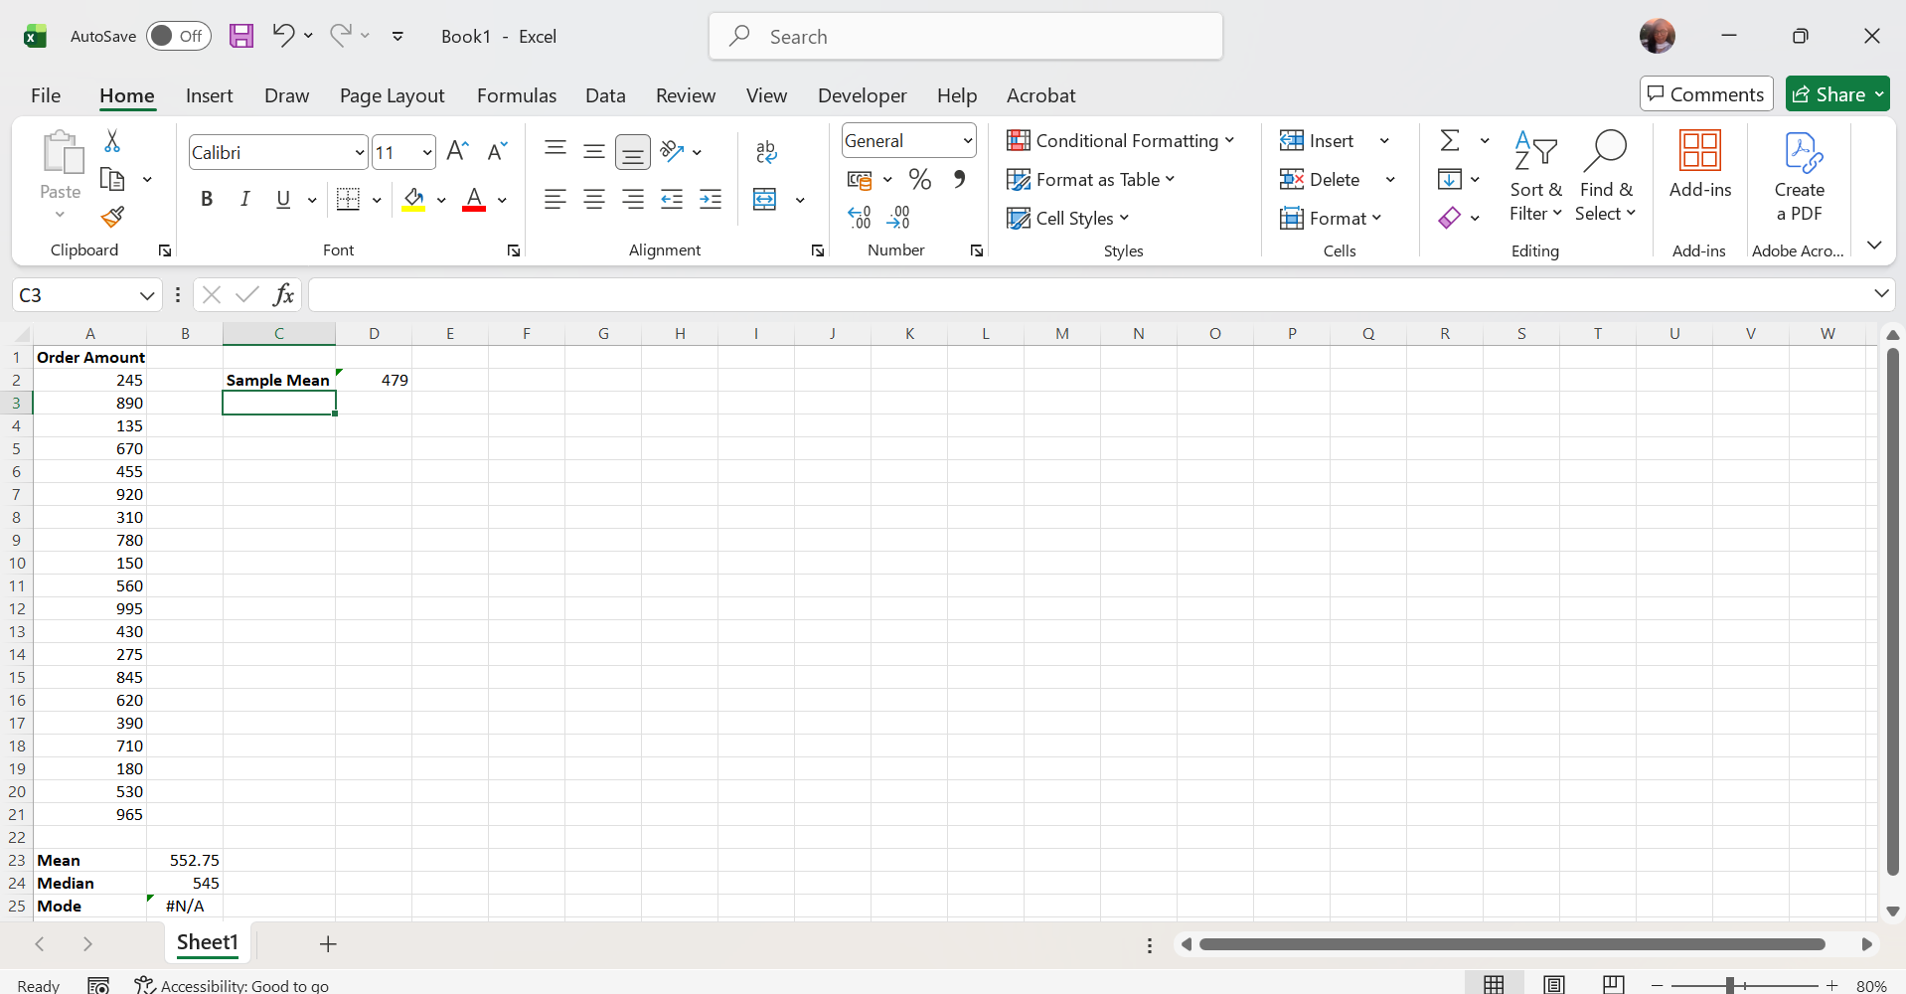

Measure | Value
Sample Mean (first 5 values) | 479
Population Mean (all 20 values) | 552.75

- The sample mean (479) is lower than the population mean (552.75).
- This is because the sample contains only 5 values and does not perfectly represent all 20 order amounts.
- Conclusion: The sample mean is 479, while the population mean is 552.75. They are different because the sample includes only the first five order amounts, whereas the population includes all twenty values. This shows that a sample may not exactly represent the entire population.

- Write a short paragraph explaining the difference between 'population' and 'sample' using your Zomato order data as an example. Mention which one is more practical to use for a food delivery company and why.
- Population refers to the complete set of data, while a sample is only a part of that data. In this assignment, all 20 Zomato order amounts represent the population, whereas the first 5 order amounts represent the sample. The population gives complete information, but collecting and analysing all data can take more time and effort. For a food delivery company like Zomato, using a sample is more practical because it is faster, less expensive, and still provides useful insights for making business decisions.

