Cloud front (CDN) :

It is used to make any website quickly/fastly browsable from any region.
It is a Content delivery network.

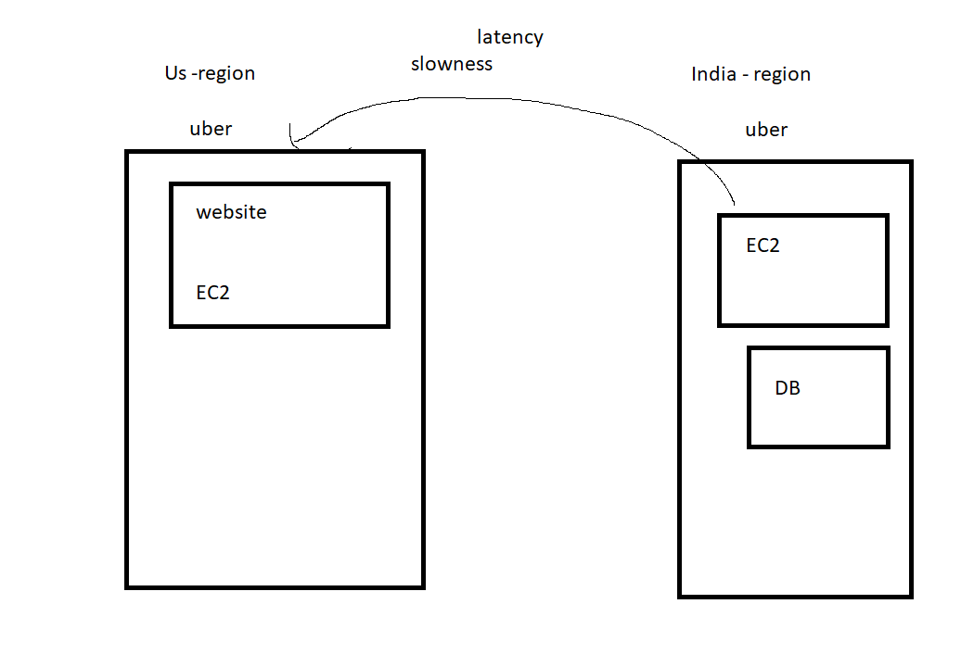

Steps :
- create 2 ec2 instances
- add them in the load balancer
- first test with LB. mark the speed
- Add the load balancer to cloud front
- second test with cloud front. check the latest speed

#!/bin/bash
sudo yum install httpd -y
sudo wget https://www.free-css.com/assets/files/free-css-templates/download/page272/evolve.zip
sudo unzip evolve.zip
sudo cp -rf evolve/* /var/www/html
sudo systemctl restart httpd
sudo systemctl enable httpd

ping dom link:

https://tools.pingdom.com/

Test result:
LB - 1.43 s

cloud front - 491 ms

