Route53 -

AWS DNS service

DNS - Domain Name service

DNS port number - 53

- What are the Records in DNS:
- A record - Converts IP to Name (forward lookup)
- PTR record - converts Name to IP (reverse lookup)
- Cname - Converts Name to Name
- NS record - Name server - used to identify your dns in a network
- SOA - Start of Authority - authority for the DNS
- Mx record - Mail server record

- Purchase a DNS and attach it to an EC2 instance through route53:
- public DNS - exposing your product globally
- private DNS - internal names for server identification
- free nom.com : https://www.freenom.com/en/index.html?lang=en
- Steps:
- create a DNS is freenom (lenintech.tk)
- create a web instance
- create a hosted zone in route53 with the same name created in freenom (lenintech.tk)
- copy the NS records from route53 to freenom name servers
- create a record in route 53 and add the ec2 instance public as A record.

- Add a Load balancer to Route53:
- create a LB
- and attach it to route53 using alias and in method 2 we can use cname.

- Sub domains:
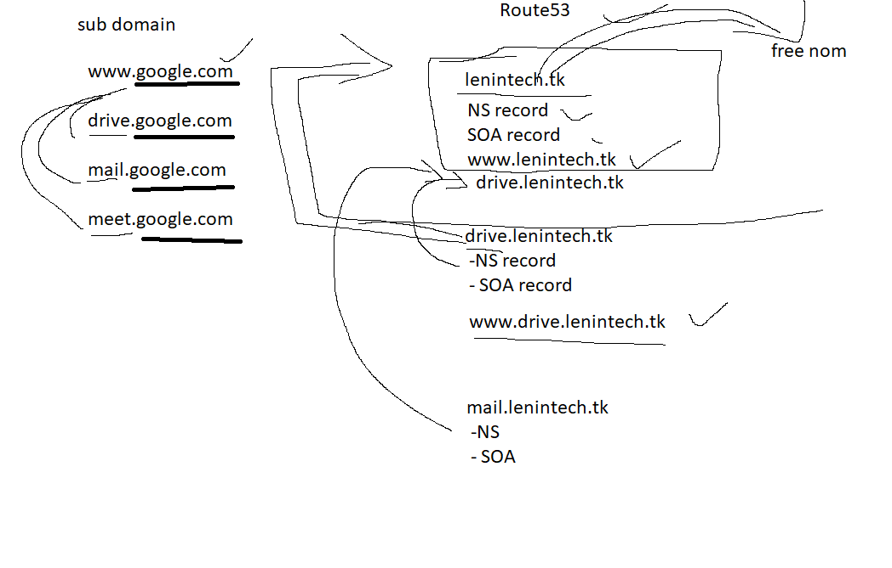
- Private DNS:
FQDN - Fully Qualified Domain Name

DNS - package
bind-utils

hostname web1.tcs.com
vi /etc/hosts
ip web1.tcs.com web1

Internal DNS tool :
Power DNS

https://www.howtoforge.com/how-to-install-powerdns-and-poweradmin-on-centos-7/

External DNS tool:
free nom
go daddy
NS1

- Routing policies
- simple policy - do as it is mentioned in the records
- weighted - giving weightage to different LBs
- latency - If one site LB is slow , the connection will be shifted to other LB
- failover - If one site LB is down, the connection will be shifted to other LB
- geo location - choosing specific country
- multi value answer - adding multiple IPs

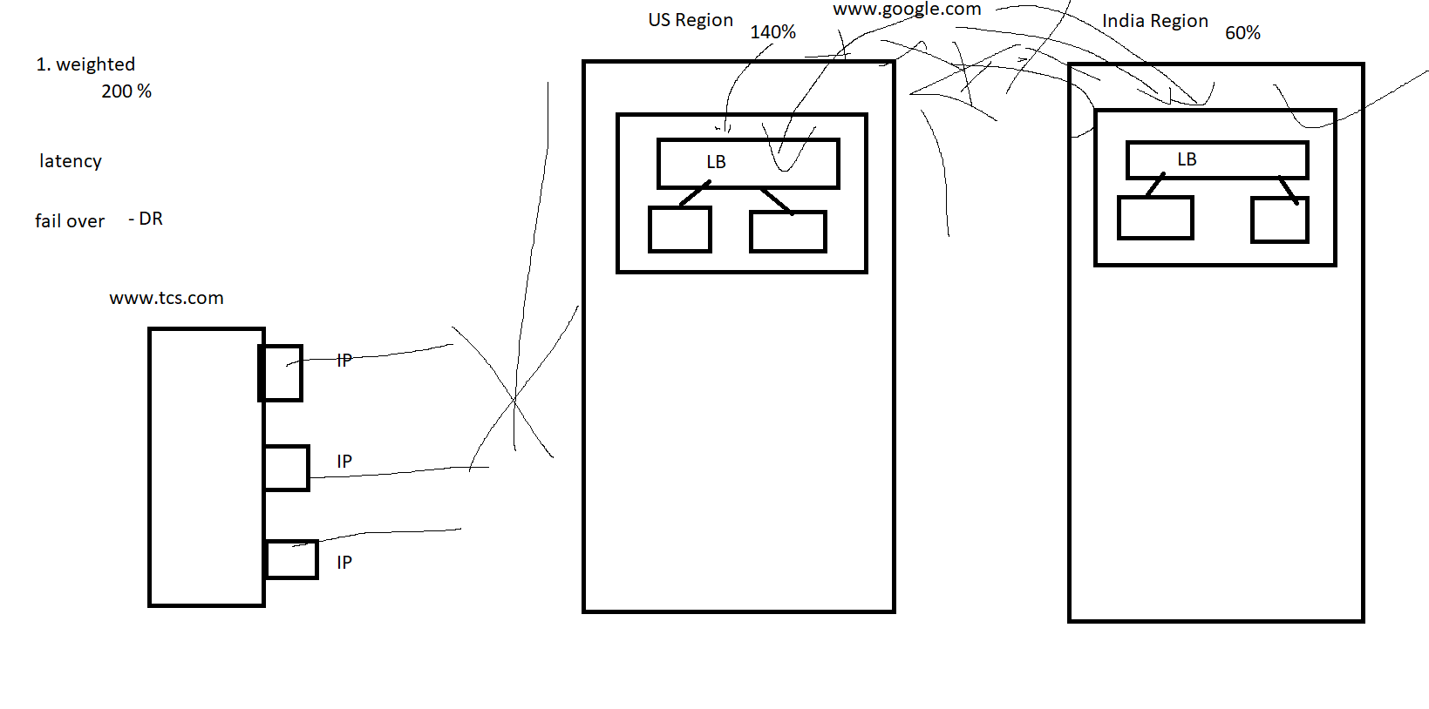

- remaining records
SRV - service record (www.google.com:81) 81 www.google.com
AAAA - IP6
SPF - sender policy frame work
NAPTR - Name authority Pointer - VOIP - IP phone
TXT - to verify email sender
CAA - certificate

