RDS - Relational Database service - PAAS based DB engine

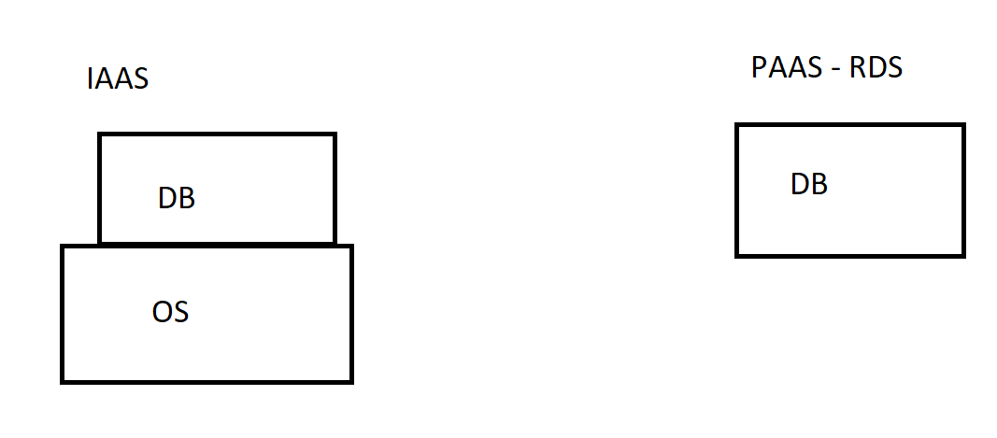
RDS is a relation database engine which supports the below bases:
- Mysql
- Postgre SQL
- Maria DB
- Amazon aurora
- MS-SQL
- Oracle

Topic 1: Create a Database and connect it.

- add the mysql port in existing Security group and attach this group to the new instance!

- #mysql -h dbgroup.cfcpfm2bhmtb.us-west-2.rds.amazonaws.com -u root -p
- > show databases;

Topic 2: Read replica

- creating a read only replica to other regions!

