Multi Az

Multi Az provides a back up for a RDS DB, if primary DB is down the secondary DB will comes to active state.

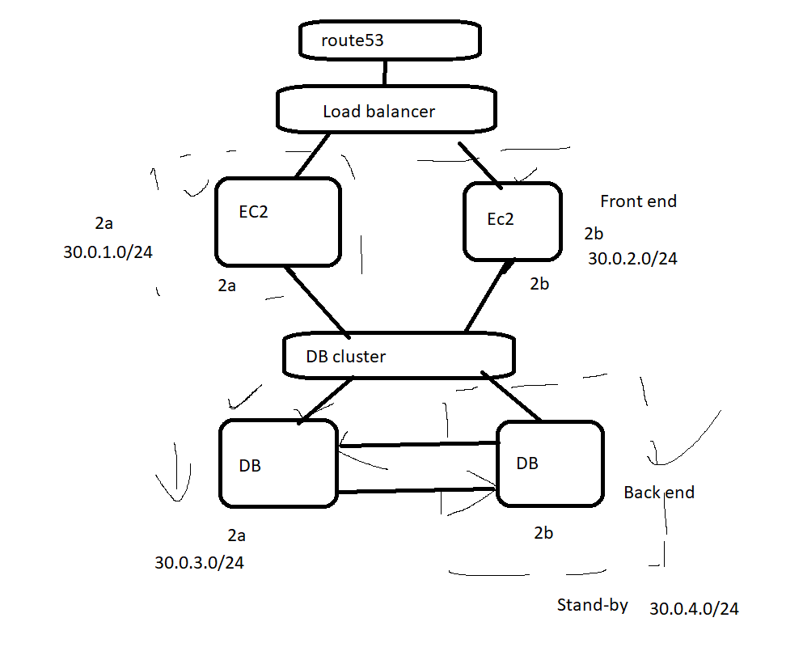

Steps :
- create a VPC (30.0.0.0/20)
- create 4 subnets
- 2a - web1 - internet - (30.0.1.0/24)
- 2b - web2 - internet - (30.0.2.0/24)
- 2a - db1 - no internet - (30.0.3.0/24)
- 2b - db2 - no internet - (30.0.4.0/24)
- create IGW
- create Route table and associate web1 and web2 for internet
- create a subnet group to separate the DB instances to create in DB subnets alone.
- create a security group and add the mysql/aurora port since it is a new VPC.
- create a aurora DB with mutli AZ enabled
- create 2 web instance and install LAMP setup

amazon-linux-extras install -y lamp-mariadb10.2-php7.2 php7.2
yum install -y httpd mariadb-server
systemctl start httpd
systemctl enable httpd
yum list installed httpd mariadb-server php-mysqlnd
cd /var/www/html

- create tables by connecting cluster DB. using mysql -h <cluster> -u root -p

show databases;
use phpschema;
show tables;
here paste the tables commands from website
select * from users;

- test it

