Monitoring :
Monitoring is a service which collects the information about all the server performance and sends the alert to users to solve the performance issues.

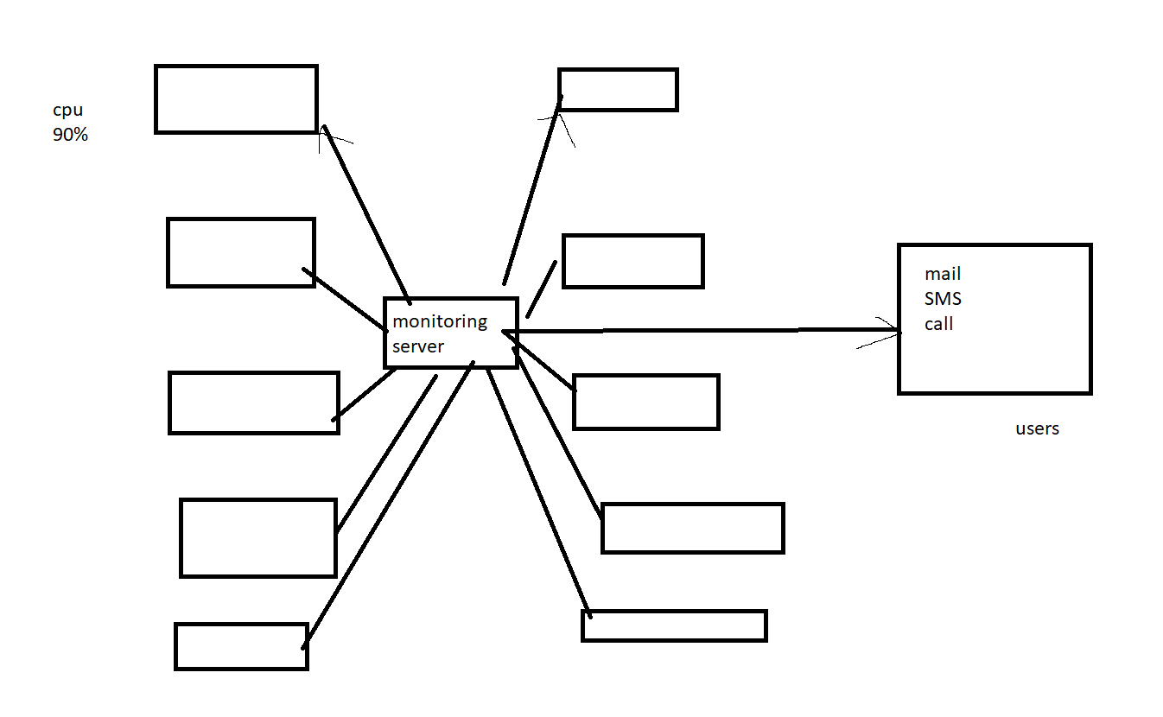

AWS - Monitoring tool:

Cloud watch
- Alarms - take cares of thresholds - Cpu, RAM, disk performance (with values)
- event bridge - monitors the event - power on, off, terminate, stop (without values)

Cloud Trail:
- All events

3rd party monitoring tool:
- Prometheus - metrics collector
- Grafana - metrics viewer
- Alert manager - sends notification

SNS - Simple notification service
- It sends us the mail using SNS

