AWS Migration

Vmware to AWS migration

Understanding Vmware:

ESXi
- Esxi is an OS which creates multiple OS in a single machine

Vsphere client / web client
- It is a controller for ESXI and Vcenter, by using this we will get the option to create the VM

Vcenter / VCSA
- It is a manager and which is used to add multiple ESXi, if one ESXI failed the machines associated with that ESXi will be moved to other ESXi

To create any new Vm in ESXi, first upload the VM.iso in the ESXI data store (local storage)
Refer my excel too :

Preparing the Machines to be migrated :

- username
- allow sudo access to the user (to connect in AWS after the Migration)
useradd raja
passwd raja
-

vi /etc/sudoers

below root give the following entry:
raja ALL=(ALL) ALL

ALL = all servers
ALL = all users
ALL = all commands

init 0 - shut down

upload the exported ova to S3

S3 - AMI

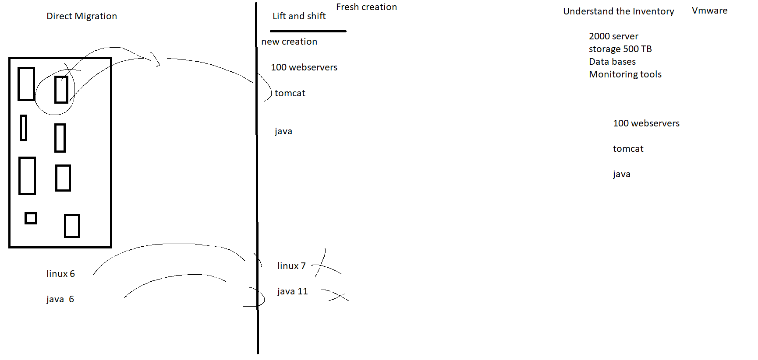

minimum requirement :

Laptop
8 GB RAM
i5 processor
500 GB

SMS - Server Migration Service

AWS Multiple VM migration:

DB Migration :
- Oracle Data guard
- SCT - Schema Conversion tool
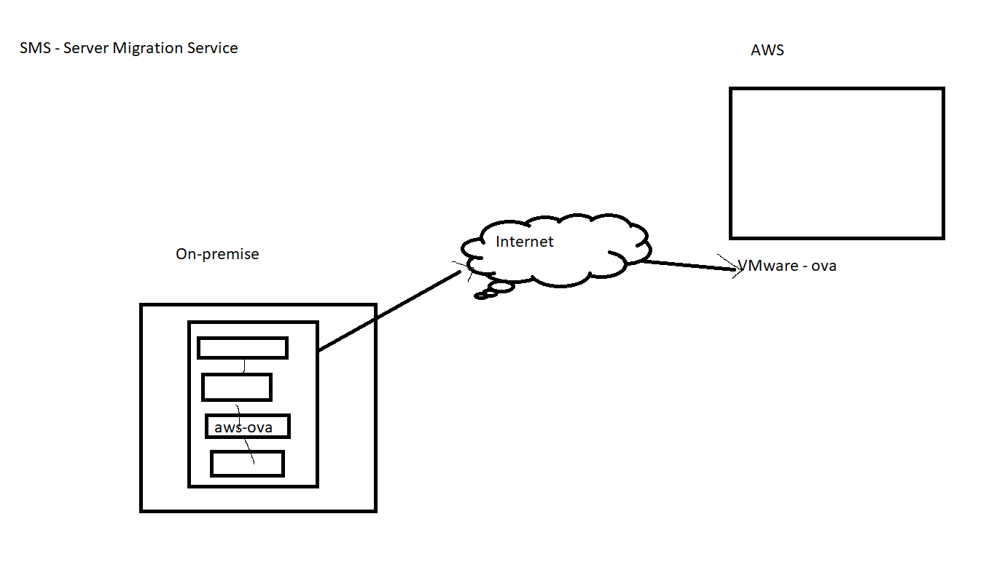
DB migration:

