S3 - Simple Storage service

- unstructured data
- internet
- object storage
- eg: logs, images, videos, static website content

s3 commands :

list:
aws s3 ls s3://weekdaymrg

copy:
aws s3 cp s3://weekdaymrg/containers.json /tmp

upload :
aws s3 cp java1 s3://weekdaymrg

sync:
aws s3 sync /python/ s3://weekdaymrg/python

bulk remove with matching name pattern:
aws s3 rm s3://weekdaymrg/python/ --recursive --exclude "*" --include "yaml*"

To check the OS details :

cat /etc/*release*

S3 Storage Class:

Standard
Intelligent-Tiering
Standard-IA
One Zone-IA
Glacier Instant Retrieval
Glacier Flexible Retrieval
Glacier Deep Archive
Reduced redundancy

Versioning:

This feature is used to maintain multiple versions in s3 , so that if current version of file is having any issue we can revert back it to previous version.

index.htm
-index.html.v1

overwrite
upload the files in same name, so that it will maintain the version.

Static website hosting:

we can maintain static website in s3 using this service

step1:
create the bucket with the domain name (www.ravitech.com), then only it will reflect in route53.
2:
upload index.html file and test it.

Permission mgmt:

https://docs.aws.amazon.com/AmazonS3/latest/userguide/example-bucket-policies.html

terraform codes:

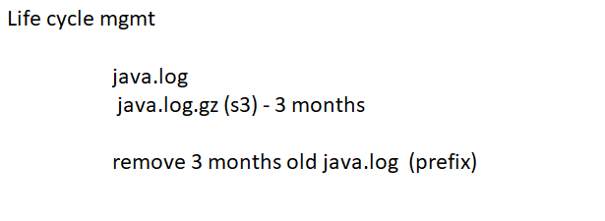
By using life cycle management, we can remove old files from s3 to maintain the cost.

S3 replication :

maintaining a s3 object backup is replication which will in be sync.

same region bucket
different region bucket
different account

