Docker

Docker is an open source tool which creates multiple virtual applications in a single Operating system as containers.

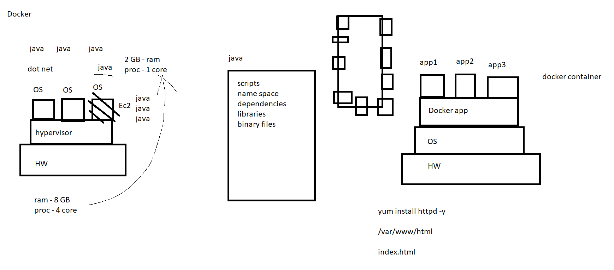

Steps:
- yum install docker -y
- mkdir /docker1
- cd /docker1
- vi Dockerfile

FROM ubuntu:16.04
# Install dependencies
RUN apt-get update
RUN apt-get -y install apache2
# Install apache and write hello world message
RUN echo 'Hey this Sundar web test for Docker!' > /var/www/html/index.html
# Configure apache
RUN echo '. /etc/apache2/envvars' > /root/run_apache.sh
RUN echo 'mkdir -p /var/run/apache2' >> /root/run_apache.sh
RUN echo 'mkdir -p /var/lock/apache2' >> /root/run_apache.sh
RUN echo '/usr/sbin/apache2 -D FOREGROUND' >> /root/run_apache.sh
RUN chmod 755 /root/run_apache.sh
EXPOSE 80
CMD /root/run_apache.sh

docker build -t web1:v1 .

docker image

docker run -it -d –name webserver -p 8080:80 web1:v1
(note: -it = internative terminal -to ready for one terminal
-d =detach
--name =giving one name)

docker ps

(Note: Docker stats – this command used to see the how many space is using for this docker file, Usually , they have set the limit and all, but we have to recheck tell clearly)

Refer my AWS Docs for other codes

Ports unused link:
https://en.wikipedia.org/wiki/List_of_TCP_and_UDP_port_numbers

AWS ECS:
- upload the docker image in ECR(Elastic Container repository)
- create the tasks with image (add container) - port mapping
- create a cluster for instance details
- click the cluster and create a service to add the tasks and cluster
refer my aws-docs - LB services
- Test the output ip:9090

AWS ECS Steps :
Install AWS cli if it is not available
And aws configure
$(aws ecr get-login --no-include-email --region us-west-2)
aws ecr create-repository --repository-name weekday
docker tag prasaddoc1:v1 <awsaccountid>.dkr.ecr.<region>.amazonaws.com/test-repository:latest
docker tag web1:v1 401231317770.dkr.ecr.us-west-2.amazonaws.com/web1:latest
docker push 401231317770.dkr.ecr.us-west-2.amazonaws.com/web1:latest

host port :8080 or whatever
container : 80

