- Types of Cloud :
- Public cloud
- Private cloud
- Hybrid cloud

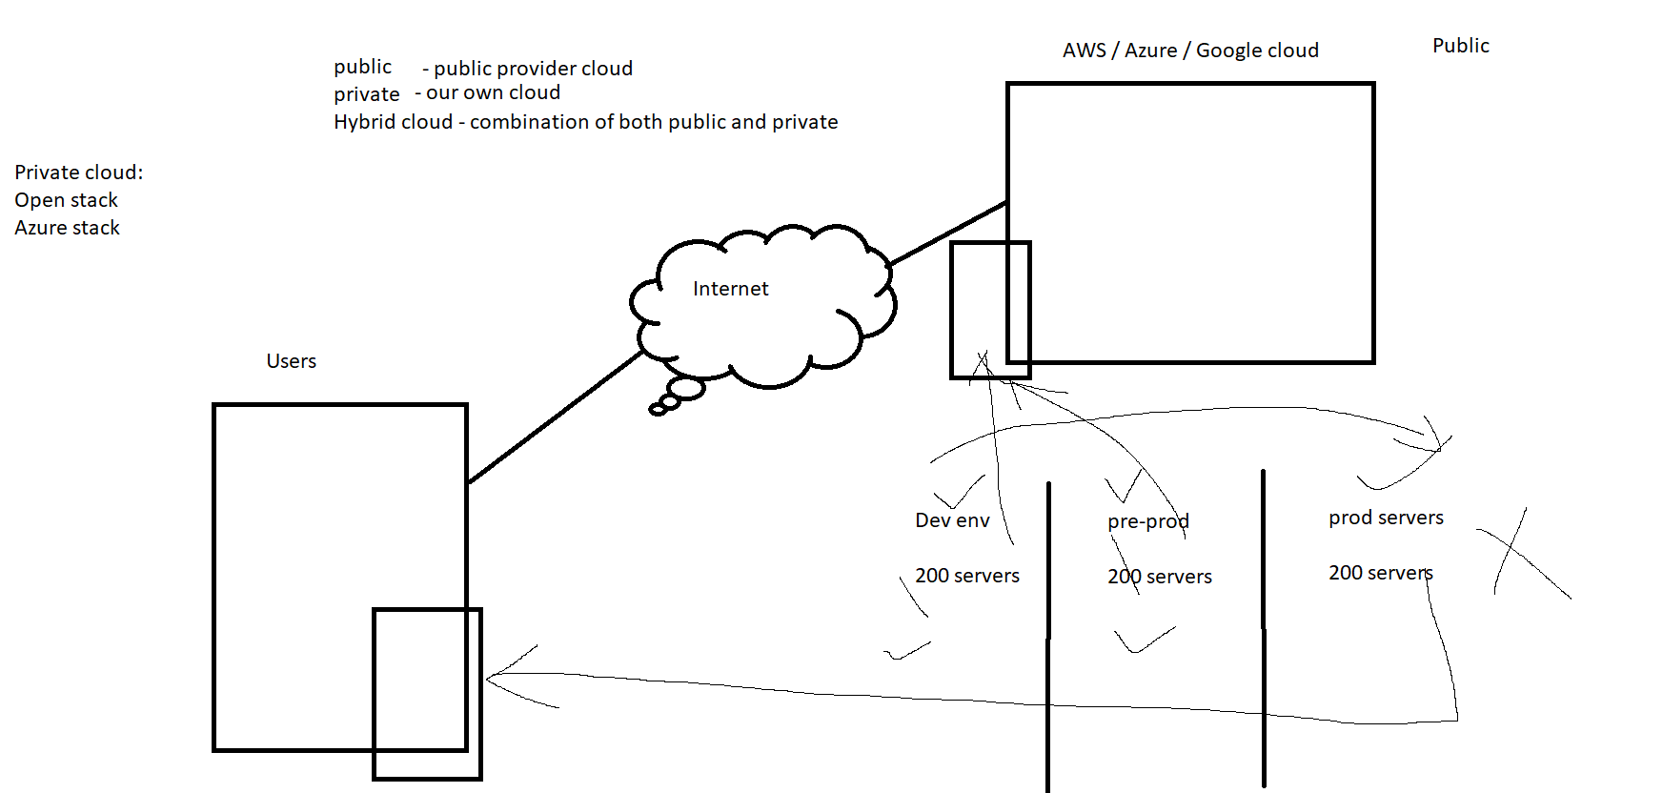

2. Services of Cloud :
- IAAS - Infra as a service
- PAAS - Platform as a service
- SAAS - Software as a service

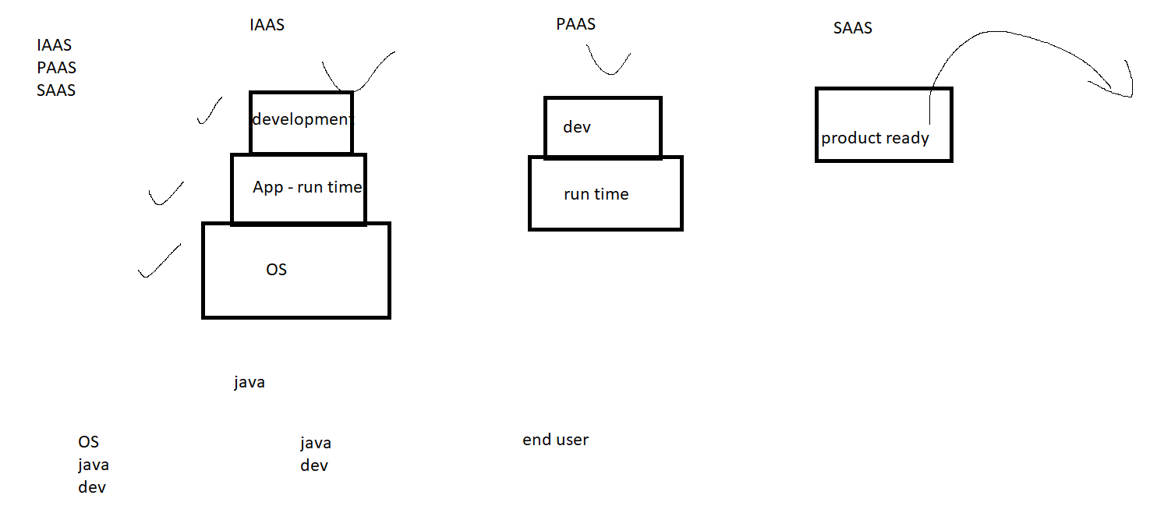

3. AWS console options :

- Billing
- Services
- Support center
- Regions
- AWS pricing calculator

Chapter 1 - EC2 - Elastic Compute cloud

EC2 - OS - VM

- Linux server
- Create a website in the Linux server

Linux server
Linux is a open source OS

Steps to build an EC2 -
- Search ec2 in service
- Launch instance
- Choose Amazon linux AMI image
- Choose the type of Ram and processor
- Choose no of instances to be created
- Choose the storage
- Add the tags
- Select the required ports in security group (ssh, http, All-icmp)
- Create a key pair and download it
- Instance MobaXterm software to connect the AWS linux server
- https://mobaxterm.mobatek.net/download-home-edition.html

- Then connect it and install java

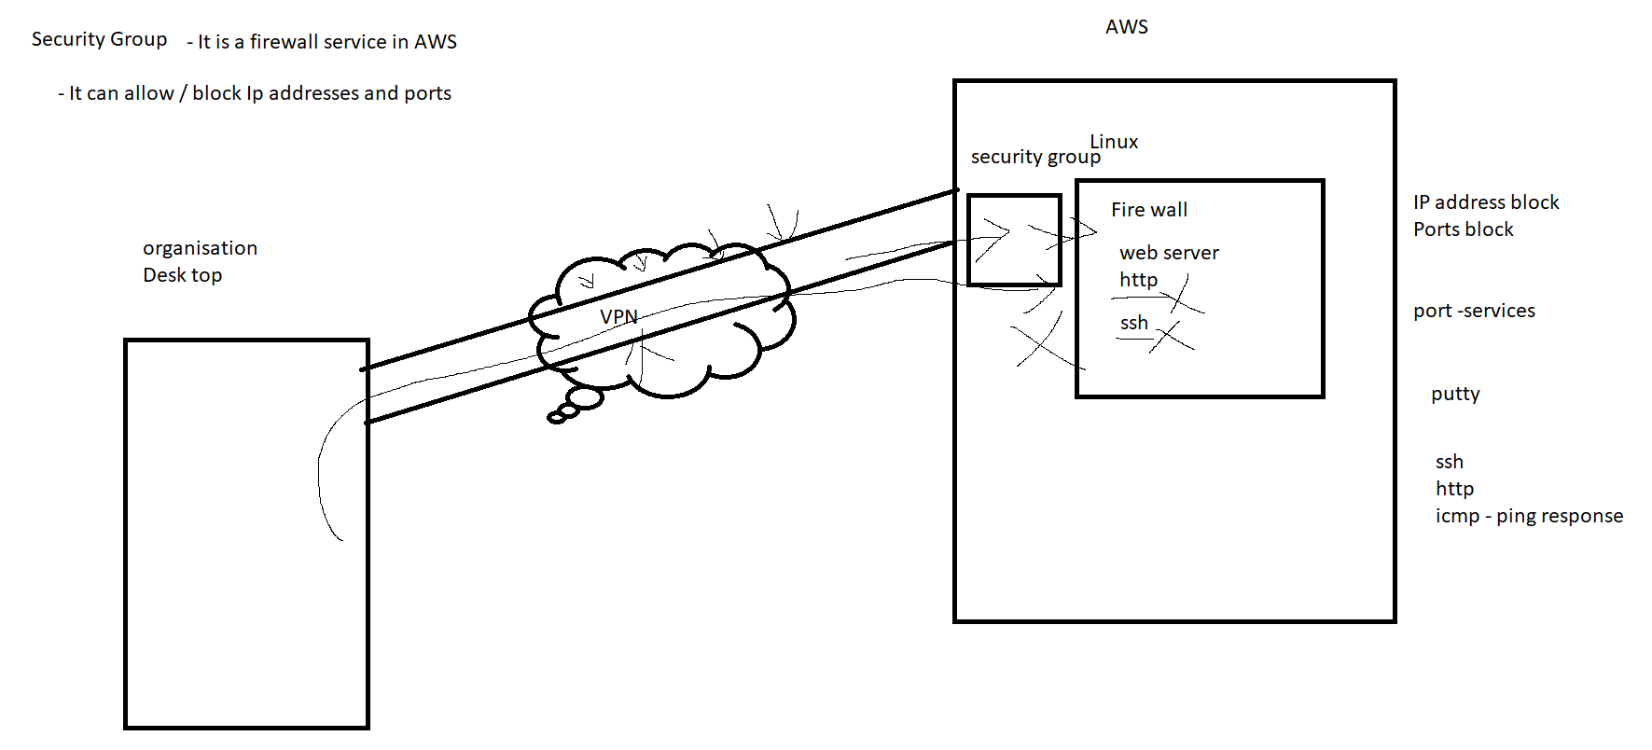

5. Create a HTML website
yum install httpd //(web hosting software in Linux / Apache)
cd /var/www/html
vi index.html
Add some content or html page
systemctl restart httpd
systemctl enable httpd

