3_EC2-part2

- Create a windows instance and create a website in it

Linux:
Yum install httpd
Cd /var/www/html
Vi index.html
Systemctl restart httpd
Systemctl enable httpd

windows:
Server manager
- Webster (IIS)
c:/inetpub/wwwroot/default.html

Esc dd
Esc i
Right click Paste
Esc :wq1

Types of Instance:

- Ondemand
- We can create and remove the instance whenever we want or required is on demand -100 rs
- Reserved instance
- We can reserve long run servers in reserved instance option - 70 rs
- Spot instance
- They are a kind of bedding instance - 30 rs
- Scheduled instance
- We can schedule and build an instance
- Dedicated host
- We will get our own hardware but we will not get the aws services
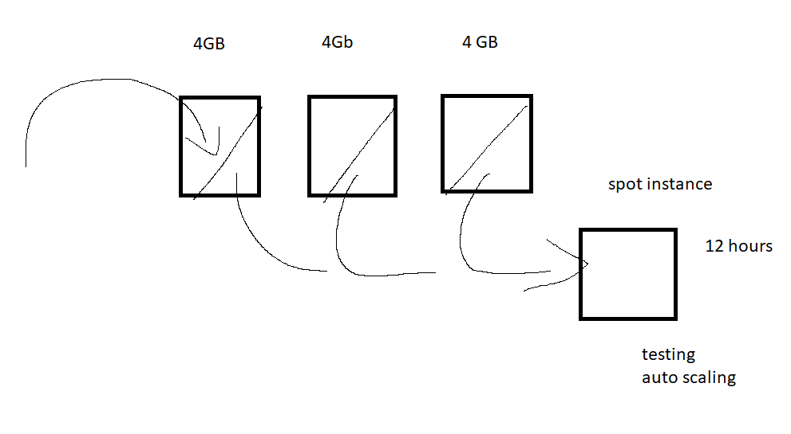

4. How to change RAM and Processor in existing EC2 instance

https://aws.amazon.com/ec2/instance-types/?trkCampaign=acq_paid_search_brand&sc_channel=PS&sc_campaign=acquisition_BEN&sc_publisher=Google&sc_category=Cloud%20Computing&sc_country=BEN&sc_geo=EMEA&sc_outcome=acq&sc_detail=ec2%20instance%20types&sc_content={ad%20group}&sc_matchtype=e&sc_segment=536392709935&sc_medium=ACQ-P|PS-GO|Brand|Desktop|SU|Cloud%20Computing|EC2|BEN|EN|Sitelink&s_kwcid=AL!4422!3!536392709935!e!!g!!ec2%20instance%20types&ef_id=Cj0KCQjw5JSLBhCxARIsAHgO2Sc__l_kfiBoQIvtqcD9pPZ-PQ83Gjkv27L49GqRNBxjjWJCH5UqbGIaAjpPEALw_wcB:G:s&s_kwcid=AL!4422!3!536392709935!e!!g!!ec2%20instance%20types

