*AMI - Amazon Machine Image

Example :
100 servers
- Linux
- Java
- Python
- Folders
- Files

In AMi - we can create or install all the common services in 1 EC2 instance then create an AMI from that instance.

Then if we create an instance from that AMI we will get the software and common files and folders

AMI : AMI is a master copy of an EC2 instance with common software, files and folders available in it

2. Migrate AMI to other region

Right click the AMI and copy AMI to other region

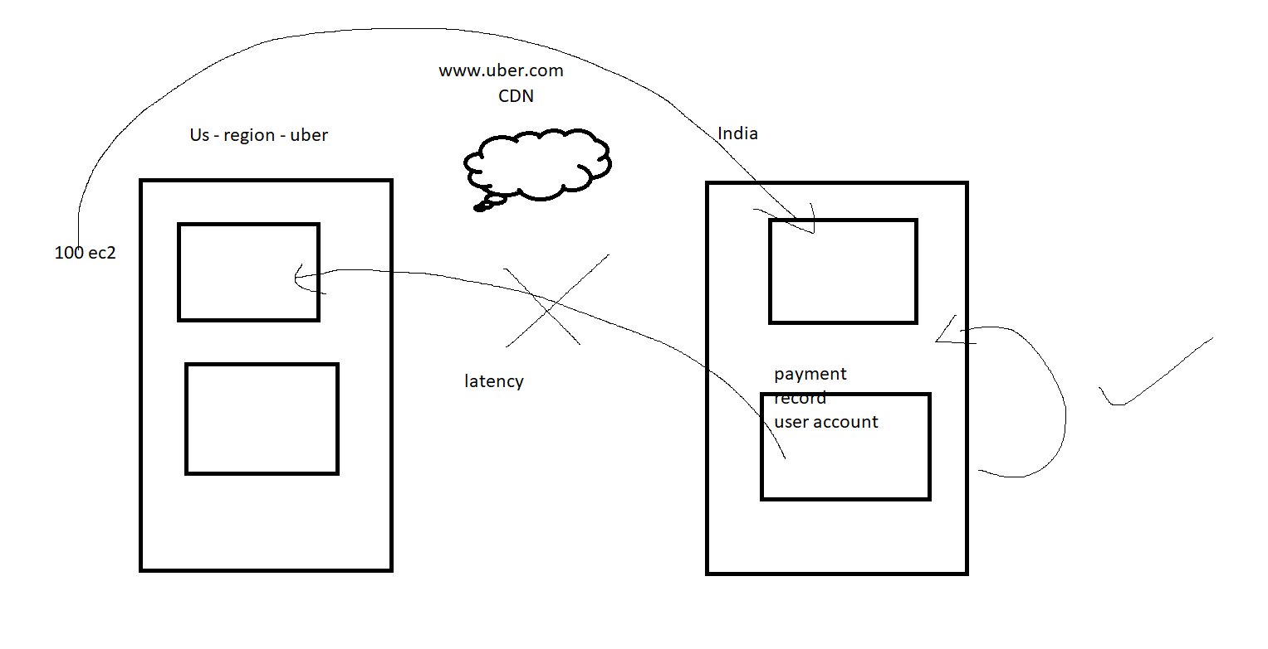

EC2, AMI

Chapter 2 - Storage

EBS - Elastic block storage
EFS - Elastic file storage
S3 - simple storage service
Glacier - Archival storage

EBS-
- It is a type of block storage
- Use case : OS and critical datas
- Example: D , E , F drive (Linux java, D, python)
- We can attach EBS (us-west-2a) to a single zone EC2 (us-west-2b) instance.

EFS-
- We can share the datas across Availability zone using EFS
- It will support only a single region
- It works on the principle of NFS
- Port - 2049 (NFS)

S3 -
- It is a type of Object storage
- Images,videos, logs
- It will work only with the internet
- It shares storage to all the regions

Glacier -

SSD - 1 TB - 1000 rs (rough examples)
HDD - 1 TB - 700
Magnetic - 1 TB - 400

- It stores old datas for auditing purpose

