Chapter 3 - Networking

class full IP
class less IP

N - constant
H - variable

Class full IP :

- class A : 1 - 126 - N.H.H.H - 126. 254x254x254 - 1 crore IPS
- class B : 128 - 191 - N.N.H.H - 172.16. 254x254 - 65000 IPS
- class C : 192 - 223 - N.N.N.H - 192.168.1 254 - 254 IPS
---------------------------------------
- class D : 224 - 239
- class E : 240 - 254

2. 254
- 8 8 8 8 = 32
- 2^0+2^1+2^2+3+4+5+6+7
1+2+4+8+16+32+64+128 = 255

3. 0 - network bit (whole network)
127 - loop back address
255 - broad cast

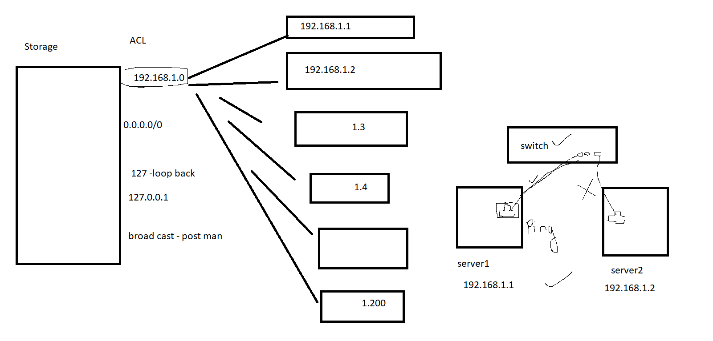

4. Switch - Switch allows same network to communicate with each other

5 . Router - Router allows different network to communicate with each other

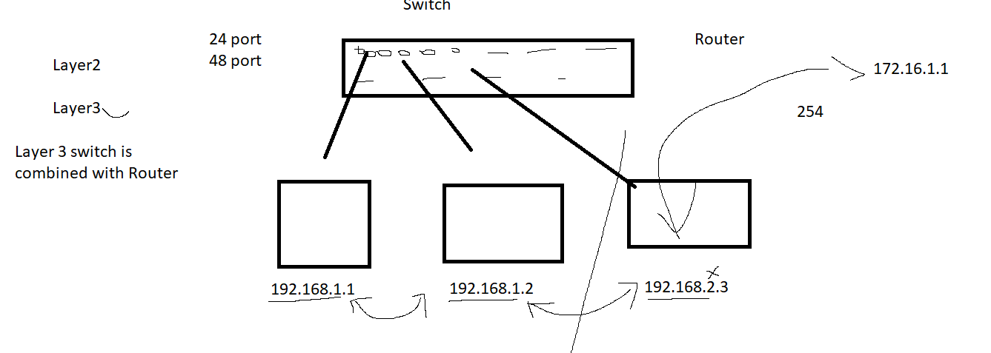

6. Subnetting

https://www.subnet-calculator.com/

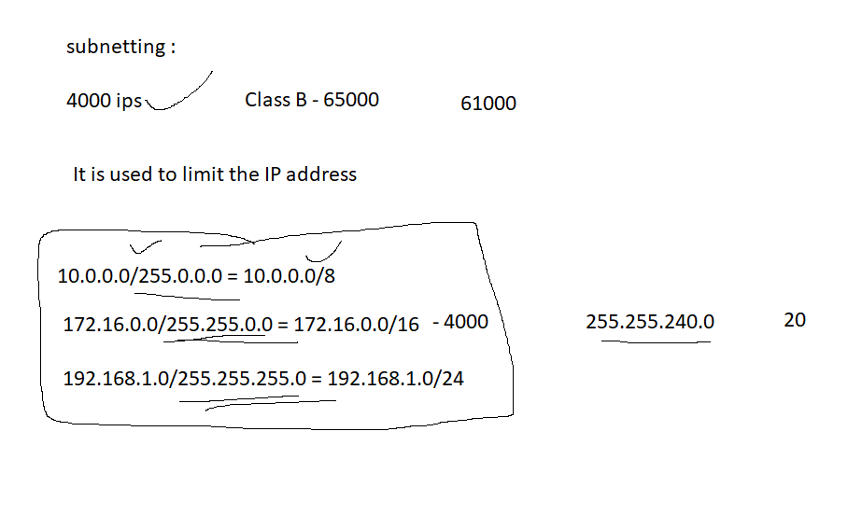

VLAN :

It is used to divide the switch

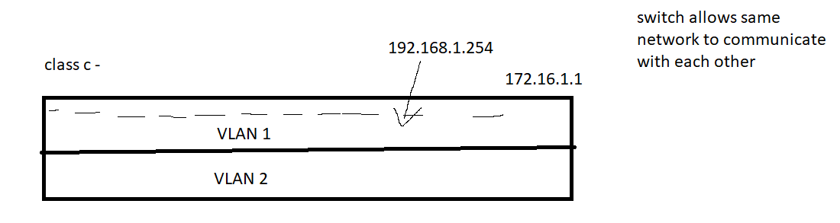

Class less IPS:

