AWS Networking:

ec2 - It is a OS service in AWS , we can choose any OS we want in AWS
ami - It is a master copy of an ec2 instance with common software installed on it!

ebs - It is a block storage and works in a single Availability zone
efs - It is shared storage and works in a single region which is available for all the zones in that region
s3 - It is an object storage and we can use this S3 across all the regions
glacier - It is a archival storage to maintain company’s legacy datas (auditing etc)

AWS Networking:

VPC
subnet
IGW
Route table

CIDR - Classless Inter domain routing

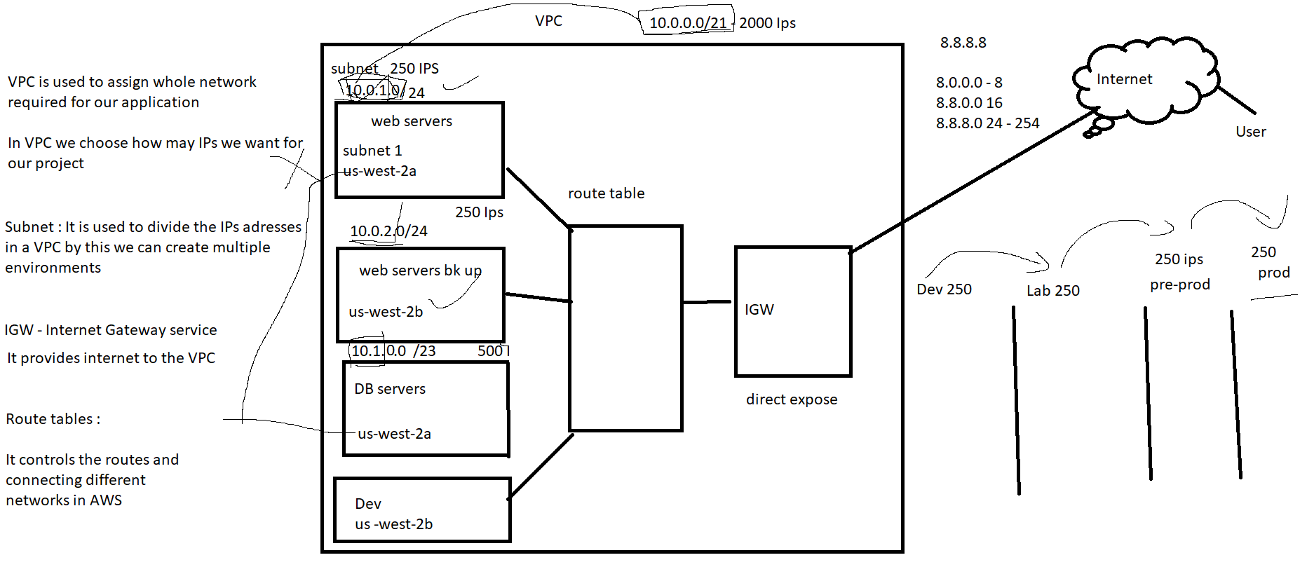

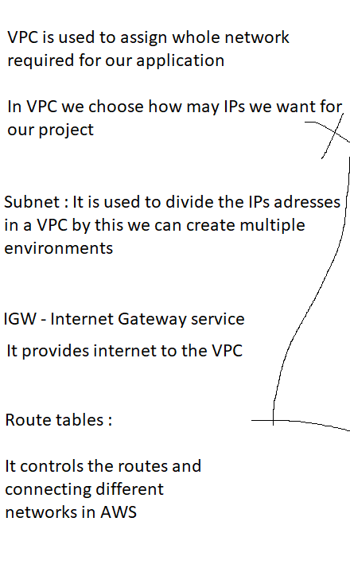

VPC - 5 VPCs for 1 region

Nat gate way

It is used to provide secured internet connecting to the private subnets!

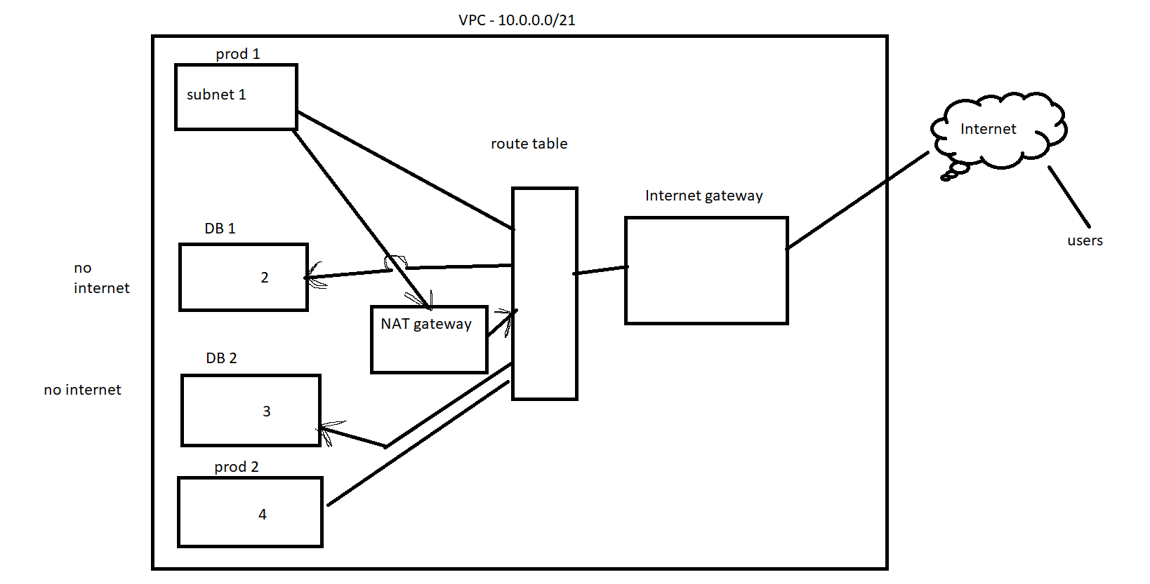

Steps :

- create a NAT gateway from the public (internet) subnet
- Add the Nat gateway to a new route table
- then connect the DB subnet to that route table

End point :

It enables internet for a particular AWS service

- create End point
- choose s3 gateway service in endpoint and add the DB route table directly
- test it
- aws configure
- apply credentials from your account
- aws s3 ls

Elastic IP :
It is a permanent public IP for AWS

