VPC Peering

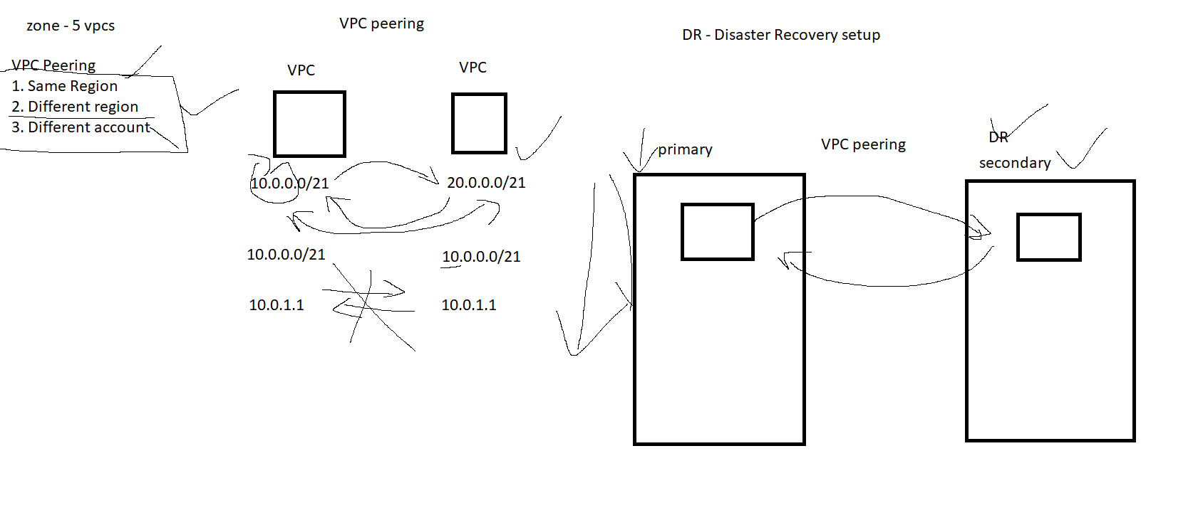

step 1: enable VPC peering in both regions

step 2 : add the different IPs in Route table

VPC Flow log

packet capturing tool

wire shark - example

1- VPC
2- subnet
3. EC2

step 1:
- create cloud watch log group (Cloud watch - AWS monitoring service)
- attach it to the VPC flow log
- allow flow log permission in IAM

Additional adapters

- adding additional NIC card to the EC2 instance
- while creating the NIC interface please choose the correct subnet!

VPN

- Virtual Private Network

types of VPN
- Open VPN
- Site to Site
- Direct connect

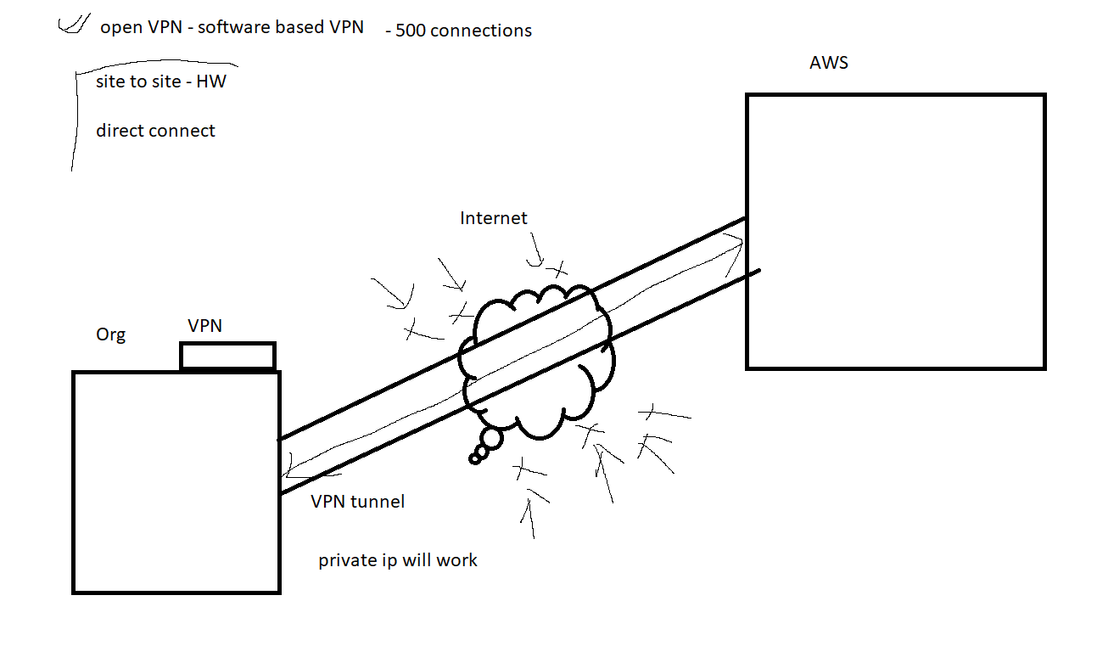

steps :
- create a openvpn ami from aws market place
- use : “openvpnas” as the user username

