Load balancers :
- It is used to share the Load across different servers

Types of Load balancers:

- Classic Load balancer (Layer 4 and Layer 7)
Layer 4 - Network layer (tcp/udp) - skype, teams
Layer 7 - Application layer (http/https) - facebook, flipkar, google

- Application Load balancer
Layer 7
http / https

- Network Load balancer
Layer 4

- Gateway load balancer

ALB

This is yuva garments

<a href="http://test-alb-1790286988.us-west-2.elb.amazonaws.com/men/index.html">men!</a>
<a href="http://test-alb-1790286988.us-west-2.elb.amazonaws.com/women/index.html">women!</a>

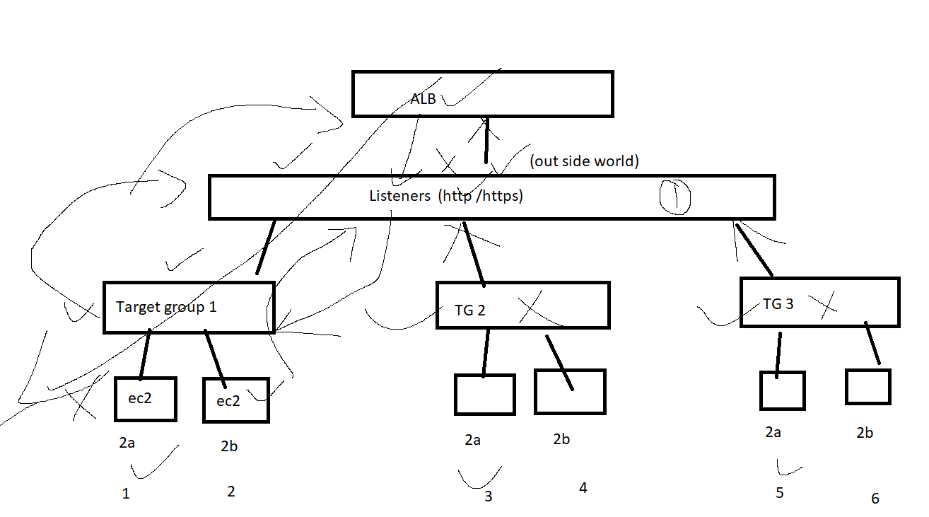

steps :

- create 6 ec2 instances

2 - 2a and 2b - main server
2 - 2a and 2b - men
2 - 2a and 2b - women

- create ALB

- while creating add the TG-1 and add main servers

- create other 2 TGs separately and attach it to the existing Listeners with path option

