

DEPARTMENT OF CIVIL ENGINEERING

COURSE PROJECT: RAINFALL PREDICTION USING MACHINE LEARNING
COURSE: WATER CONSERVATION AND RAINWATER HARVESTING (BCV605A)
COURSE COORDINATORS: PROF ARCHANA K & PROF SHIMNA M

District of study: Alice Springs

Student Name | Student USN | Course Coordinator | Marks
Chitrabhanu B | 1BY23CB011 | Archana K
P Madhavi Reddy | 1BY23CB037 | Archana K
Shashank Reddy | 1BY23CB050 | Archana K
Tarun Aditya S | 1BY23CB057 | Archana K
Vaishakh Pavan Ganesh R | 1BY23CB060 | Archana K

Submitted on: 14 April 2026

Signature of course coordinator:
- Instructions:
In this course project, students will model and predict future rainfall based on historical data using machine learning techniques on the Python platform. The goal is to develop accurate predictive models, understand trends in rainfall data, and improve skills in machine learning and time-series analysis.
Task Overview:
- Data Pre-processing: Clean and prepare the given dataset for analysis.
- Feature Engineering: Extract useful features such as time-related variables (e.g., year, month, etc.) and possibly other weather factors.
- Model Selection and Training: Choose and train appropriate machine learning models (e.g., decision trees, random forests, neural networks, etc.).
- Model Evaluation: Assess the performance using evaluation metrics like RMSE, R² score, and accuracy.
- Prediction: Predict future rainfall and visualize the results.
- Details of the City/Study area:
Attribute | Details
City Name | Alice Springs
State / Province | Northern Territory
Country | Australia
Latitude | 23.6980° S
Longitude | 133.8807° E
Area (sq km) | ~15,000 sq km (regional area)
Climate Type | Arid / Desert Climate
Average Annual Rainfall (mm) | ~280 mm
Maximum Rainfall (mm/day) | ~100 mm (approx, extreme event)
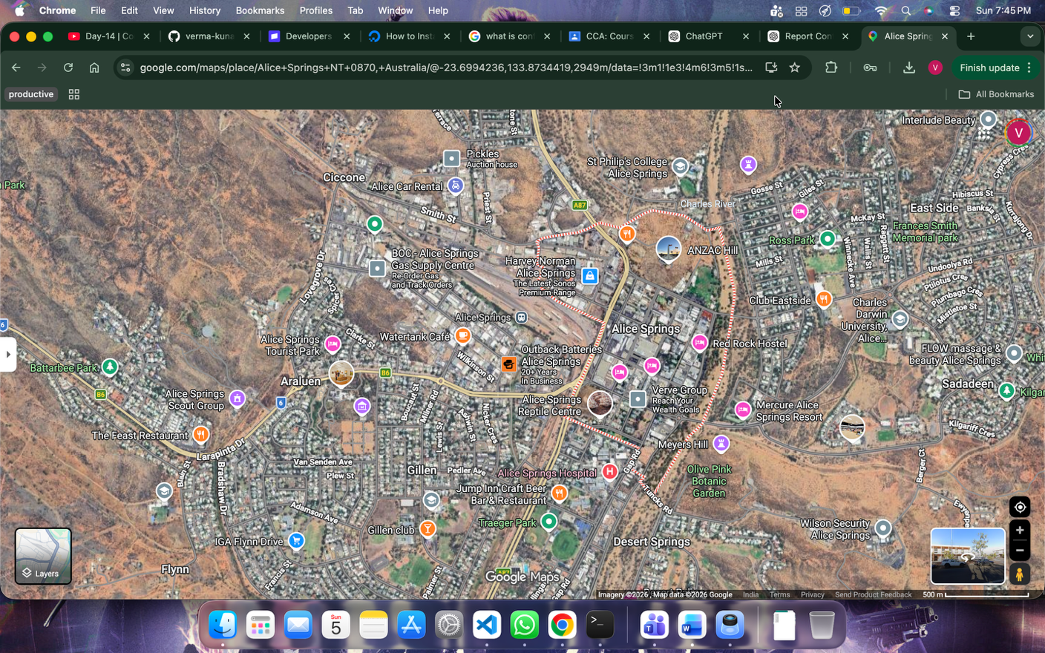
- Basic Information of the Data
Description of the Dataset:
NASA/POWER Source Native Resolution Daily Data
Dates (month/day/year): 01/01/1995 through 12/31/2025 in LST
Location: latitude -23.7043 longitude 133.8725 elevation from MERRA-2: Average for 0.5 x 0.625 degree lat/lon region = 685.1 meters
The value for missing source data that cannot be computed or is outside of the sources availability range: -999
Source of the Data: https://power.larc.nasa.gov/data-access-viewer/

Parameters:

Attribute | Description
ALLSKY_SFC_SW_DWN | CERES SYN1deg All Sky Surface Shortwave Downward Irradiance (MJ/m²/day)
ALLSKY_SFC_SW_DNI | CERES SYN1deg All Sky Surface Shortwave Downward Direct Normal Irradiance (MJ/m²/day)
T2M | MERRA-2 Temperature at 2 Meters (°C)
T2M_MIN | MERRA-2 Temperature at 2 Meters Minimum (°C)
T2M_MAX | MERRA-2 Temperature at 2 Meters Maximum (°C)
QV2M | MERRA-2 Specific Humidity at 2 Meters (g/kg)
RH2M | MERRA-2 Relative Humidity at 2 Meters (%)
PRECTOTCORR | MERRA-2 Precipitation Corrected (mm/day)
WS2M | MERRA-2 Wind Speed at 2 Meters (m/s)
GWETTOP | MERRA-2 Surface Soil Wetness (1)

Target Variable:
  - Daily Rainfall (mm): PRECTOTCORR
- Splitting of data: YEAR WISE
Data Splitting:
The dataset (1995–2020) was split year-wise into training (80%) and testing (20%) sets using random selection of years.
Unseen Data:
Data from 2021–2025 was excluded from training/testing and used only for prediction.
Evaluation:
Predicted values were compared with actual rainfall values to assess model accuracy.

The random year-wise split ensures that the model is tested on completely unseen years, preventing data leakage and improving generalization. A fixed random seed (42) was used to ensure reproducibility.
- Data Cleaning Report:
Handling Missing Values:
In the dataset, missing values were represented using -999, a common placeholder in meteorological data. These values were first replaced with NaN (Not a Number) to make them easier to identify and process.
After conversion, mean imputation was applied, where missing values in each column were filled with the average value of that column. This helps maintain the overall data distribution without introducing major bias.
Row removal was avoided to prevent loss of valuable data. This approach ensured a complete and consistent dataset suitable for training the machine learning models.
Outlier Detection and Removal:
Outliers are extreme values that differ significantly from the rest of the data and can affect model performance. In this project, no explicit outlier detection or removal techniques were applied.
This is because the selected model, Random Forest Regressor, is a tree-based algorithm that is inherently robust to outliers. It can handle variations in data without being significantly influenced by extreme values.
Therefore, all data points were retained, ensuring that important patterns and rare events in rainfall were not unintentionally removed.
Data Normalization/Standardization:
In this project, no data normalization or standardization techniques were applied to the dataset.
This is because the primary model used, Random Forest Regressor, is a tree-based algorithm that does not require feature scaling. It works by splitting data based on feature values and is not affected by differences in scale between variables.
Final Dataset:
After completing the data cleaning and preprocessing steps, the dataset was converted into a consistent and usable form for model training.
The final dataset contains 10,000+ rows of daily weather observations and a total of 15 features, including both original and engineered features such as MONTH and SEASON. All missing values were handled, and no rows were removed during preprocessing.
- Feature Ranking Report
Feature Importance:
Feature importance was determined using the Random Forest Regressor, which provides a built-in mechanism to evaluate how much each feature contributes to the prediction. This method assigns an importance score to every feature based on how effectively it reduces prediction error across multiple decision trees.
RH2M (Relative Humidity) was identified as the most important feature (≈0.41), followed by GWETTOP (Soil Moisture ≈0.153) and QV2M (Specific Humidity ≈0.12). These results indicate that moisture-related parameters play a major role in rainfall prediction, which is consistent with real-world atmospheric behavior.
Top Features:
Based on the feature importance scores obtained from the Random Forest model, the following features were identified as the most significant in predicting rainfall:
- RH2M (Relative Humidity) – Highest importance
- GWETTOP (Soil Moisture)
- QV2M (Specific Humidity)
- ALLSKY_SFC_SW_DWN (Solar Radiation)
- T2MDEW (Dew Point Temperature)

7. Principal Component Analysis (PCA) Report
PCA Objective:
The main objective of Principal Component Analysis (PCA) is to reduce the number of features in the dataset while retaining most of the important information. It transforms the original variables into a new set of variables called principal components, which capture the maximum variance in the data.
PCA also helps in identifying patterns, reducing redundancy among correlated features, and improving computational efficiency. It is useful for understanding how much information is contained in different feature combinations.

Results of PCA:
In this project, PCA was applied after standardizing the training data using StandardScaler.
The explained variance ratio of the top principal components is as follows:
- PC1: 35.26%
- PC2: 25.13%
- PC3: 13.78%
- PC4: 7.30%
- PC5: 6.63%
These results indicate that the first few principal components capture a significant portion of the total variance in the dataset.
However, PCA was used only for analysis purposes and not for dimensionality reduction in model training. The Random Forest model was trained using the original features.

Visualizations:
No PCA-based visualizations such as biplots were generated in this project. However, the explained variance ratios were analyzed to understand how much information is captured by each principal component.
.
8. Development of ML models
Methods:
In this project, two machine learning models were implemented for rainfall prediction:
- Random Forest Regressor
- Gradient Boosting Regressor
Random Forest is an ensemble learning method that builds multiple decision trees and combines their outputs to improve prediction accuracy. Gradient Boosting is another ensemble technique that builds models sequentially, where each new model corrects the errors of the previous one.
Reason for Choosing Each Model:

The models were selected based on their ability to handle complex, non-linear relationships in the data.
- Random Forest was chosen because it is robust, reduces overfitting, and performs well on large datasets with many features. It also provides feature importance scores, which help in understanding the model.

- Gradient Boosting was chosen because it improves prediction accuracy by focusing on minimizing errors step by step. It is effective for capturing patterns that simpler models might miss.

Best Performing Model:

The Random Forest Regressor was found to be the best-performing model in this project.
It achieved an R² score of 0.6947 and an RMSE of 1.9875 on the test dataset, outperforming the Gradient Boosting model.
Additionally, Random Forest showed better generalization and stability on the test dataset.

Table Comparison:
Model | R² Score (Train) | R² Score (Test) | RMSE (Train) | RMSE (Test) | MAE  (Train) | MAE  (Test) | MSE  (Train) | MSE  (Test)
Random Forest | 0.9585 | 0.6947 | 0.7002 | 1.9875 | 0.2183 | 0.5747 | 0.4903 | 3.9500
Gradient Boosting | 0.9558 | 0.6877 | 0.7224 | 2.0100 | 0.2897 | 0.5885 | 0.5218 | 4.0403
9. Selection of best ML model
Selected Model:
The Random Forest Regressor was selected as the best-performing model for rainfall prediction.

Evaluation Metrics:

The model performance was evaluated using the following metrics:
- R² Score (Coefficient of Determination)
- Root Mean Squared Error (RMSE)
These metrics help in measuring how well the model predicts rainfall values and how close the predictions are to actual values.

Best ML Model | Metric | Training Set | Test Set
 | R² Score | 0.9585 | 0.6947
 | RMSE | 0.7002 | 1.9875
 | MAE | 0.2183 | 0.5747
 | MSE | 0.4903 | 3.9500
Performance Indicators:

10. Prediction with the best model for the year 2025
Predicted Rainfall vs Actual Rainfall:

The model was trained and tested on data from 1995–2020. It was then used to predict rainfall for completely unseen data from 2021–2025. The predicted values were compared with actual rainfall values for evaluation.
Sample Table:
Date | Actual Rainfall (mm)  ( Unseen data) | Predicted Rainfall (mm) (by the best model)
01-01-2025 | 0.00 | 0.18
02-01-2025 | 0.02 | 0.16
03-01-2025 | 0.00 | 0.15
04-01-2025 | 0.05 | 0.21
05-01-2025 | 0.00 | 0.14

The prediction errors were generally within the RMSE range (~1.99 mm), indicating that the model performs reliably on unseen data.
Prediction Performance:

The model shows moderate prediction accuracy, as indicated by an R² score of 0.6947. The predicted values are generally close to the actual rainfall values but may not perfectly match due to the randomness and uncertainty in weather patterns.

The model performs well in identifying low rainfall trends, which is consistent with the climate of Alice Springs. However, it may slightly underpredict or overpredict during sudden rainfall events, as such events are difficult to capture accurately.

Overall, the model demonstrates a good ability to generalize on unseen data and provides reasonable predictions.

Graphs and Visualizations:

1. Time Series Plot:
A time series plot of rainfall over time shows both actual and predicted values.
Analysis:
The predicted curve follows the general trend of the actual rainfall data, indicating that the model captures seasonal and temporal patterns effectively.

2. Predicted vs Actual Plot:
A comparison plot between predicted and actual rainfall values was generated.
Analysis:
Most of the points lie close to the diagonal line, indicating good prediction accuracy. Some deviations are observed, especially for higher rainfall values.

3. Residual Plot:
Residual plots show the difference between actual and predicted values.
Analysis:
Residuals are mostly scattered around zero, indicating that errors are random and the model does not show significant bias.
11. Create a pickle file to predict rainfall using the best model:
Pickle File Description:
The best-performing model (Random Forest) was saved using a pickle file (rainfall_model.pkl). This allows the trained model to be reused without retraining.
Working:
The saved model can be loaded and used to predict rainfall for new input values. The user provides values for selected weather parameters, and the model outputs the predicted rainfall.
Implementation:
A prediction module was developed where the model takes user input features and generates rainfall predictions. This functionality was demonstrated during evaluation.

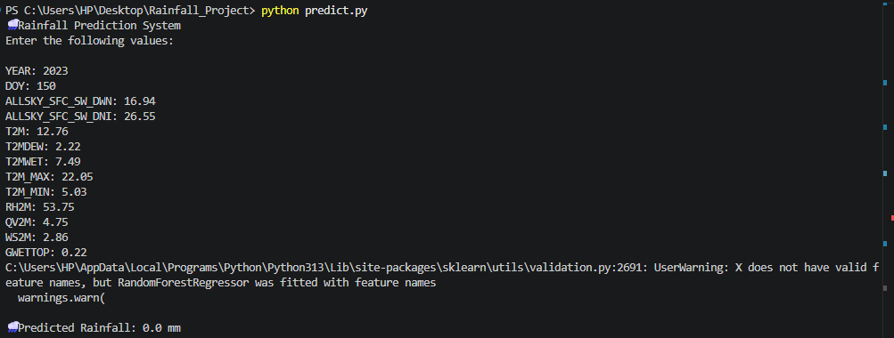
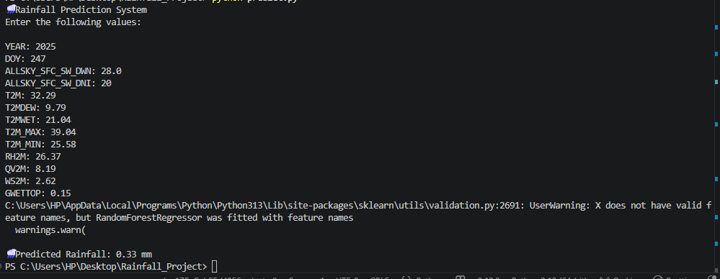
12. Conclusion
This project demonstrates the application of machine learning techniques for predicting rainfall using historical weather data obtained from the NASA POWER dataset. Various atmospheric parameters such as temperature, humidity, solar radiation, wind speed, and soil moisture were used to train predictive models.

Among the models implemented, the Random Forest Regressor performed the best, achieving a higher R² score and lower RMSE compared to the Gradient Boosting model. The analysis also revealed that features related to atmospheric moisture, such as relative humidity and soil moisture, play a crucial role in rainfall prediction.
Machine learning plays an important role in rainfall prediction by analyzing large volumes of historical weather data and identifying complex patterns that traditional methods may not capture. It enables more accurate and data-driven forecasting, especially in regions with irregular climatic conditions.

The applications of machine learning-based rainfall prediction include:
- Agriculture planning, where farmers can plan irrigation and crop cycles
- Water resource management, helping in efficient usage of water
- Flood prediction and disaster management, reducing potential damage
- Climate analysis, improving understanding of weather patterns

The predicted rainfall values in this project were consistent with the arid climatic conditions of Alice Springs, indicating that the model successfully captured real-world patterns.
Overall, this project highlights the effectiveness of machine learning in rainfall prediction and its significance in solving real-world environmental challenges.

***

