RAG Project
Doubts, Answers & Reference Guide
Built with: Python, LangChain, ChromaDB, HuggingFace Embeddings, OpenRouter

1. What is RAG?
RAG stands for Retrieval-Augmented Generation. It is a technique where instead of asking an AI model a question directly from its training data, you first retrieve relevant pieces of text from your own documents, then pass those pieces along with your question to the AI so it answers based on your content specifically.

2. Folder Structure
RAG/
documents/ <- put your PDFs here
chroma_db/ <- auto-created, do not touch
index.py <- run once to index documents
query.py <- run every time to ask questions
.env <- stores your API key

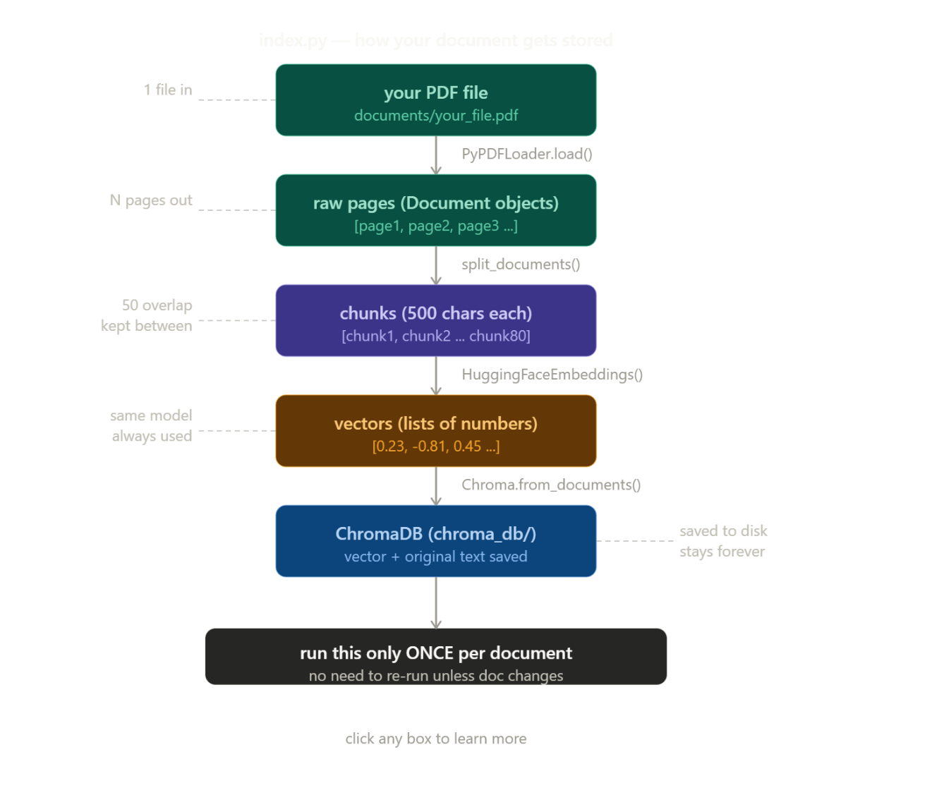

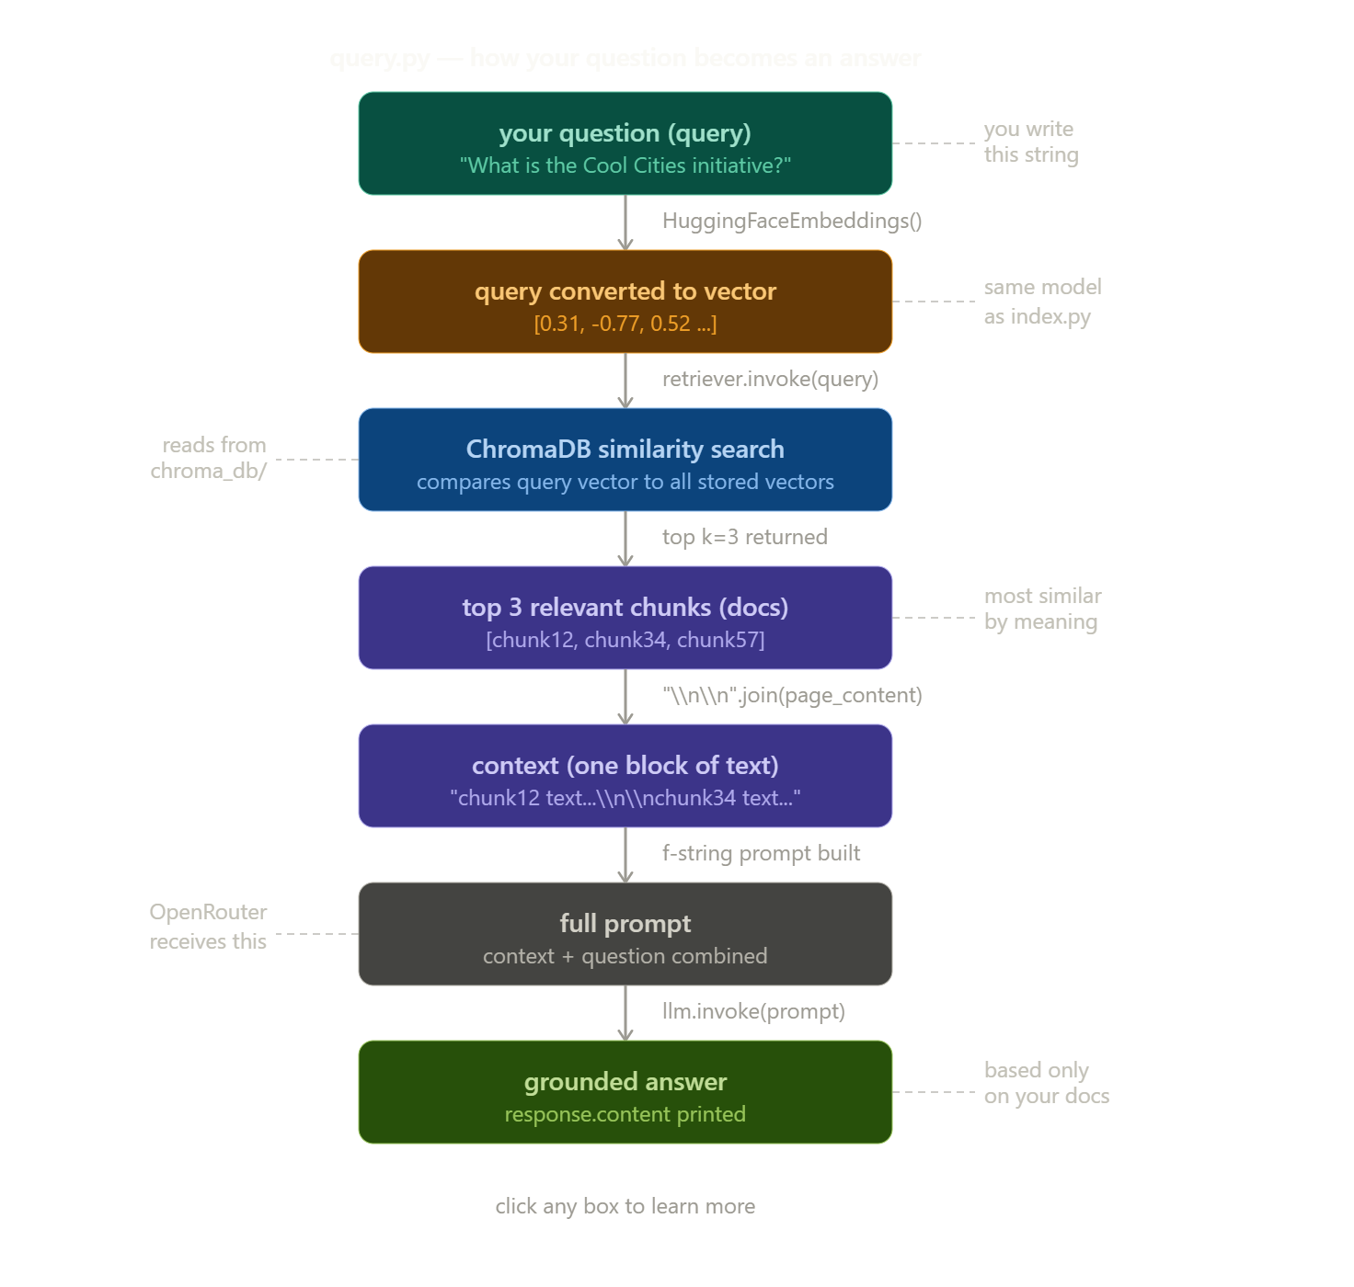

3. Installation Commands
Run these in the VS Code terminal (Ctrl + ` to open terminal):

pip install chromadb sentence-transformers langchain langchain-community openai pypdf python-dotenv langchain-text-splitters langchain-openai langchain-huggingface

4. All Doubts & Answers

Setup & Installation

Q: What if pip is not recognized?
A: Try: python -m pip install <package names> instead of just pip install. This directly tells Python to use its own pip.

Understanding the Code
Q: What are the import lines at the top doing?
A: They are like opening your toolbox before starting work. Each line brings in a specific tool you installed. PyPDFLoader reads PDFs, RecursiveCharacterTextSplitter cuts text into chunks, Chroma talks to ChromaDB, and HuggingFaceEmbeddings converts text into vectors.

Q: What is doc.page_content — is it a Python command?
A: No, it is a LangChain-specific attribute. When LangChain loads your document and splits it into chunks, each chunk is stored as a Document object with two built-in attributes: doc.page_content (the actual text of the chunk) and doc.metadata (extra info like page number and source filename). It only works on LangChain Document objects.

Q: Could we just put docs directly into the prompt instead of cleaning it?
A: Technically a smart LLM could parse it, but you should not. The raw docs list includes Document(page_content=..., metadata={...}) wrapper text which wastes tokens (costs money), takes up context window space, and occasionally confuses the LLM. Cleaning it to plain text costs 1 line of code and guarantees reliability.

Q: Is the prompt block necessary?
A: Yes, it is one of the most important parts. Without it, the LLM receives only your question with no context from your documents, making the whole RAG pointless. The prompt glues the retrieved chunks and your question together into one structured message: Use this context: {context}. Answer this question: {query}.

Embeddings & Models
Q: Why is the embedding model name (all-MiniLM-L6-v2) not being changed like the LLM model name?
A: They serve completely different jobs. The LLM (OpenRouter model) reads your question and writes the answer. The embedding model converts text into numbers (vectors) for similarity search. The embedding model must be identical in both index.py and query.py — if you indexed with one model and search with another, the numbers won't match and search will fail completely.
Can I use a single LLM for both selecting chunks and answering?
This is a very common misconception. You can use a single provider (like OpenAI), but you are actually using two completely different models under the hood.
AI models are trained for specific tasks:
- The Embedding Model (The Selector): This model is trained purely to read text and translate its "meaning" into a massive array of numbers. It does not know how to talk or generate text. (e.g., OpenAI's text-embedding-3-small).
- The Generative Model (The Answerer): This model takes text, predicts the next logical word, and generates sentences. (e.g., OpenAI's gpt-4o).

ChromaDB
Q: What is ChromaDB — is it a language or a file format?
A: Neither. It is a database — a program that runs on your computer and stores data in an organized way so it can be searched quickly. It is a Python library that creates a folder (chroma_db/) on your computer and manages files inside it. Unlike regular databases that search by exact match, ChromaDB is built for vector similarity search — finding text that means something similar to your query.

Q: What does ChromaDB actually store inside?
A: It stores both the vectors (lists of numbers) AND the original chunk text. Inside chroma_db/ you will see a chroma.sqlite3 file (standard database format used by Chrome browser and WhatsApp too) and binary files with the actual vectors. When you search, it compares vector numbers and returns the matching original text.

PDF Support
Q: Will it work for PDFs that contain images of text (scanned documents)?
A: No, not directly. PyPDFLoader can only read actual text. For image-based PDFs you need OCR. Install pytesseract and pdf2image, install Tesseract separately (from github.com/UB-Mannheim/tesseract/wiki on Windows), then use UnstructuredPDFLoader instead of PyPDFLoader. For beginners, start with a normal text-based PDF first, then tackle OCR later.

API & Internet
Q: Can I use OpenRouter API key instead of OpenAI?
A: Yes. In .env set OPENAI_API_KEY to your OpenRouter key. In query.py use ChatOpenAI with base_url="https://openrouter.ai/api/v1" and add default_headers with HTTP-Referer and X-Title. Change model_name to any model from openrouter.ai/models. Everything else stays the same.

Q: Do we need internet for all this to work?
A: Partially. ChromaDB runs 100% locally. The embedding model only needs internet once on first download (about 80MB), then it is cached on your computer forever. OpenRouter needs internet every time you run query.py to generate answers. index.py after the first run works offline. query.py always needs internet.

GPU & Hardware
Q: Will RTX 3050 work for running local LLMs (Ollama)?
A: Yes but with limitations. RTX 3050 Laptop has 4GB VRAM and can run small models like llama3.2:3b or phi3-mini. RTX 3050 Desktop has 8GB VRAM and can run better models like llama3.1:8b or mistral:7b. However, the free models on OpenRouter are much larger and smarter than what fits in 4-8GB VRAM. Recommendation: stick with OpenRouter while learning, set up Ollama later.

Q: How did developers figure all this out before AI assistants existed?
A: They relied on official documentation websites, Stack Overflow (a site where developers post errors and others answer), GitHub issues (where library changes are discussed), trial and error, and community forums. What takes minutes with AI help used to take a full day of reading and failing. AI did not create this knowledge — it compressed all the existing documentation and Stack Overflow answers into a conversational format.

5. Quick Command Reference

Run order (every time):
- First time only: python index.py
- Every time you ask questions: python query.py

If you change your document:
- Delete the chroma_db/ folder
- Run python index.py again
- Then run python query.py

If you change the embedding model:
- Delete chroma_db/ folder
- Re-run index.py before query.py

