**WEB DEVELOPMENT PROJECT - FRONT END**

**TEAM MEMBERS**

**CHITRA MOGER 01FB15ECS081**

**NAVYASHREE S 01FB15ECS182**

**SHRAVANTHI R 01FB15ECS219**

**INTRODUCTION**

When designing web and mobile apps, we aren’t fully delivering experiences that allow the user to control the interface in a way that makes sense to them. We talk about delighting the user and having empathy, but more often than not, we tend to miss the mark and deliver a frustrating experience. It's time that we consider giving the user more control with how they prefer the interface to function. Designers are missing the opportunity to create configurable options for users.

**USER INTERFACE**

User Interface (UI) Design focuses on anticipating what users might need to do and ensuring that the interface has elements that are easy to access, understand, and use to facilitate those actions. To design an efficient UI, everything stems from knowing your users, including understanding their goals, skills, preferences, and tendencies. Once we know about our user, we should make sure to consider few qualities in our design such as keeping an interface simple, consistent, purposeful in page layout, strategic use color and texture, etc.

To provide users well interactive UI with configurable options, we used concept the “Configurable User Interface” in our webpage design.

**CONFIGURABLE USER INTERFACE**

A configurable interface is designed for the user to have the ability to modify the way the software or app looks and works. It can also include the option to choose what data is displayed within each panel.

Configurable interfaces can also be used in web applications, though most web apps don’t offer these in apps today because they are very hard to design, develop and test.

As far as now, our design allows user to rearrange the position of the tiles (information windows/grids) according to his/her priorities or area of interests on the information provided. And the preferences or changes made by him/her were saved and same is displayed from next-onwards. The user is allowed to change the

We achieved this configurable UI with the help of a “Metro-style Menu”.

**CREATING A METRO-STYLE MENU**

The call **METRO** style is the new style interface of Microsoft applications can be seen, for example, in Windows Phone 7 and Windows 8. The main menu of these applications has a simple format, based on the tiles, usually two different sizes.

An example of this menu can be seen in the following figure.

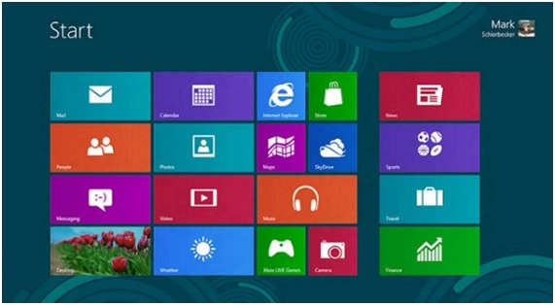

To develop this menu, divide the lines in the central region in which we insert the tiles. In this design, will not be developed more complex features like scrolling or moving tiles, we developed a simple UI that can be customized by the user. The tiles are of two types: normal and wide (as seen in the image above) and the colors will be given later with the addition of CSS classes.

**LANGUAGES USED**

* HTML
* CSS
* JAVA SCRIPT

We do not need to attach the lines of code for making the site configurable. Since SCSS / Sass is compiled at build-time, it would be an expensive and time-consuming process to compile the Sass with each request for the configurable UI (run-time). Ideally you want the base portions of the UI served from a master CSS file, a file that would be cached and typically unaltered.  
Then serve an extra CSS file or inline-style for the user-configured aspects.

**SNAPSHOTS**

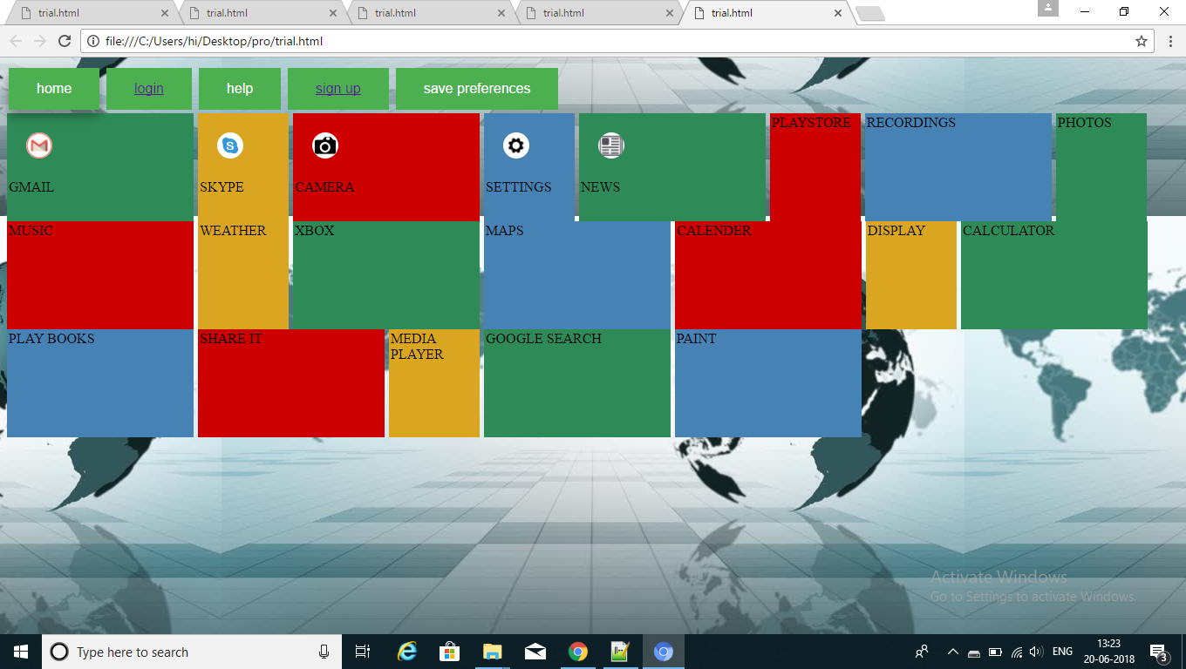

LOGIN PAGE

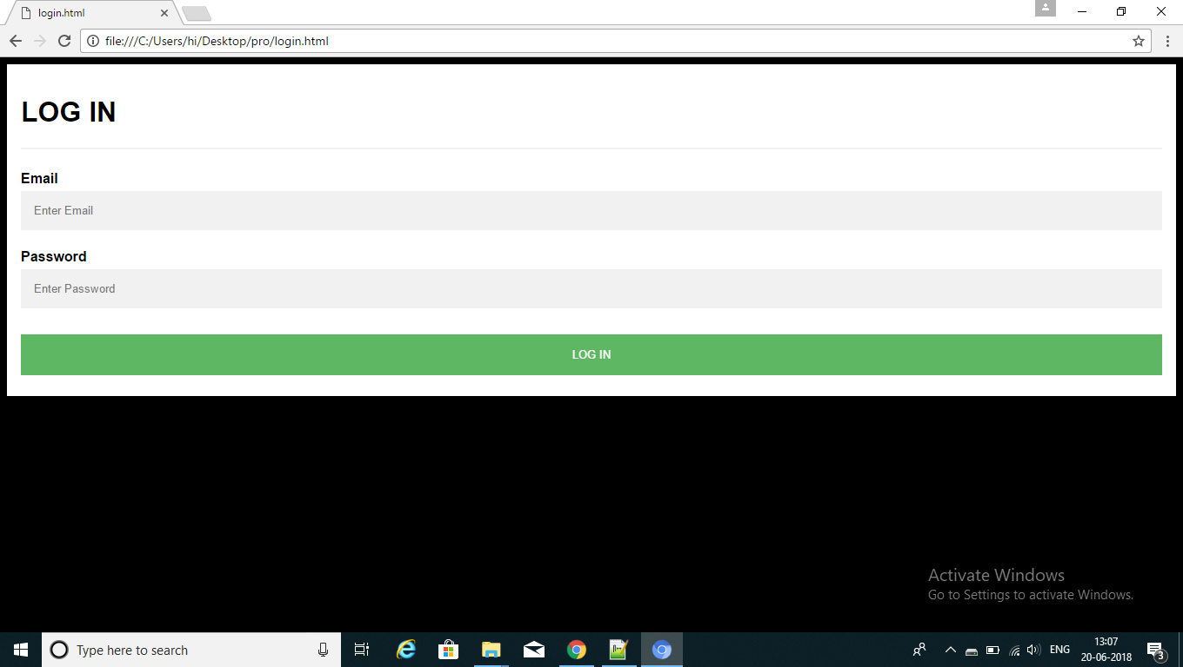

SIGN UP PAGE

