**DSC-650-Week-08-Mukherjee**

**Author : CHitramoy MUkherjee**

**Date : 02/01/2024**

**Exercise 1:** Create a Solr collection named ‘mynewcollection’.

Screenshot showing ‘mynewcollection’ in the Solr Web Interface.

**Exercise 2:** Verify that ‘mynewcollection’ has been successfully created.

Access Solr’s Web Interface at http://localhost:8983/solr/ and check for ‘mynewcollection’ under the “Core Selector” dropdown.

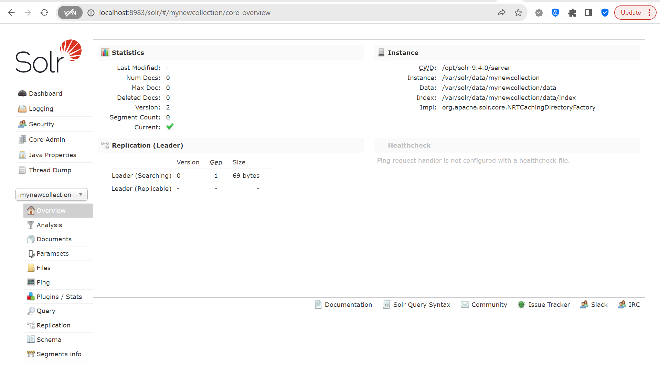

**Exercise 3:** Let’s add the generated data to our collection.

Screenshot showing successful data ingestion messages in the terminal.

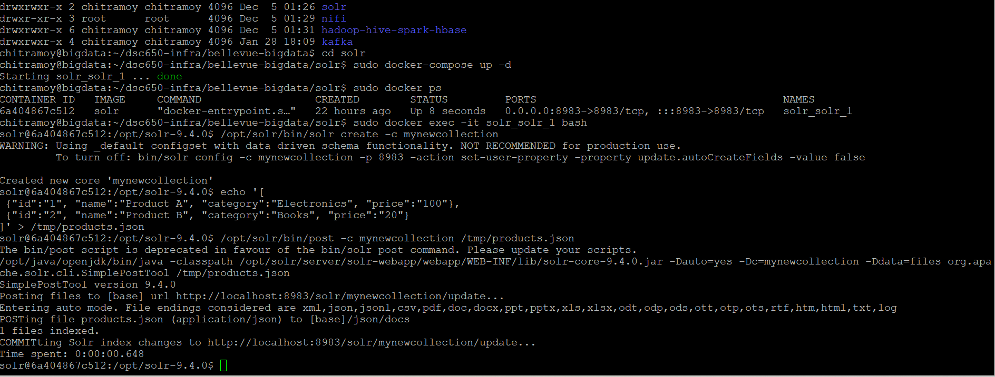

**Exercise 4:** Use Solr’s query interface to retrieve all documents from ‘mynewcollection’. curl "<http://localhost:8983/solr/mynewcollection/select?q=>*:*"

**Exercise 5:** Query for products in the ‘Electronics’ category. curl "http://localhost:8983/solr/mynewcollection/select?q=category:Electronics"

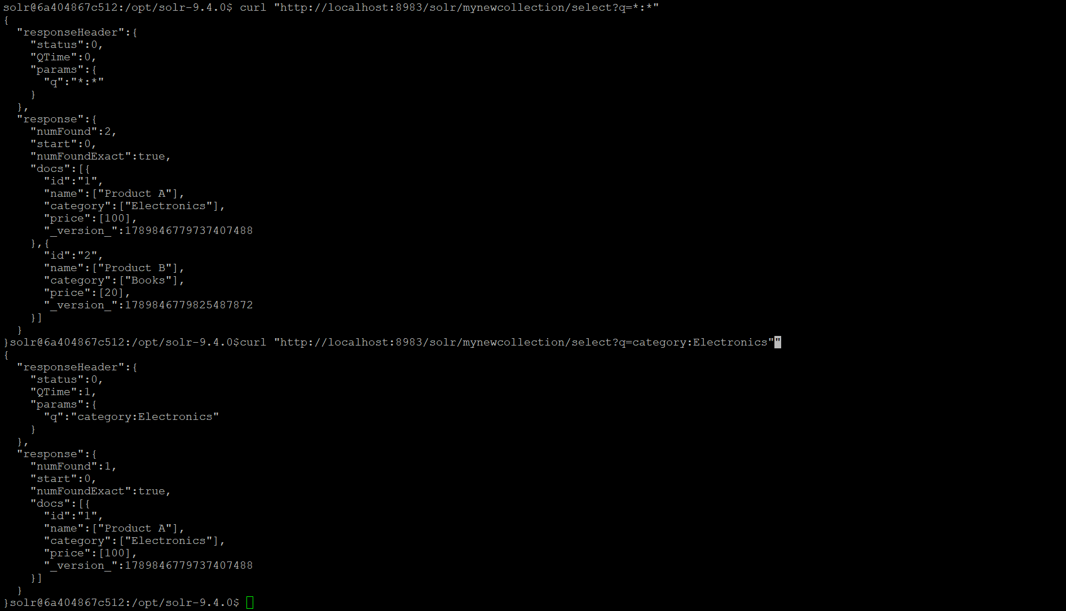

**Exercise 6**: Try a faceted search to count the number of products in each category.

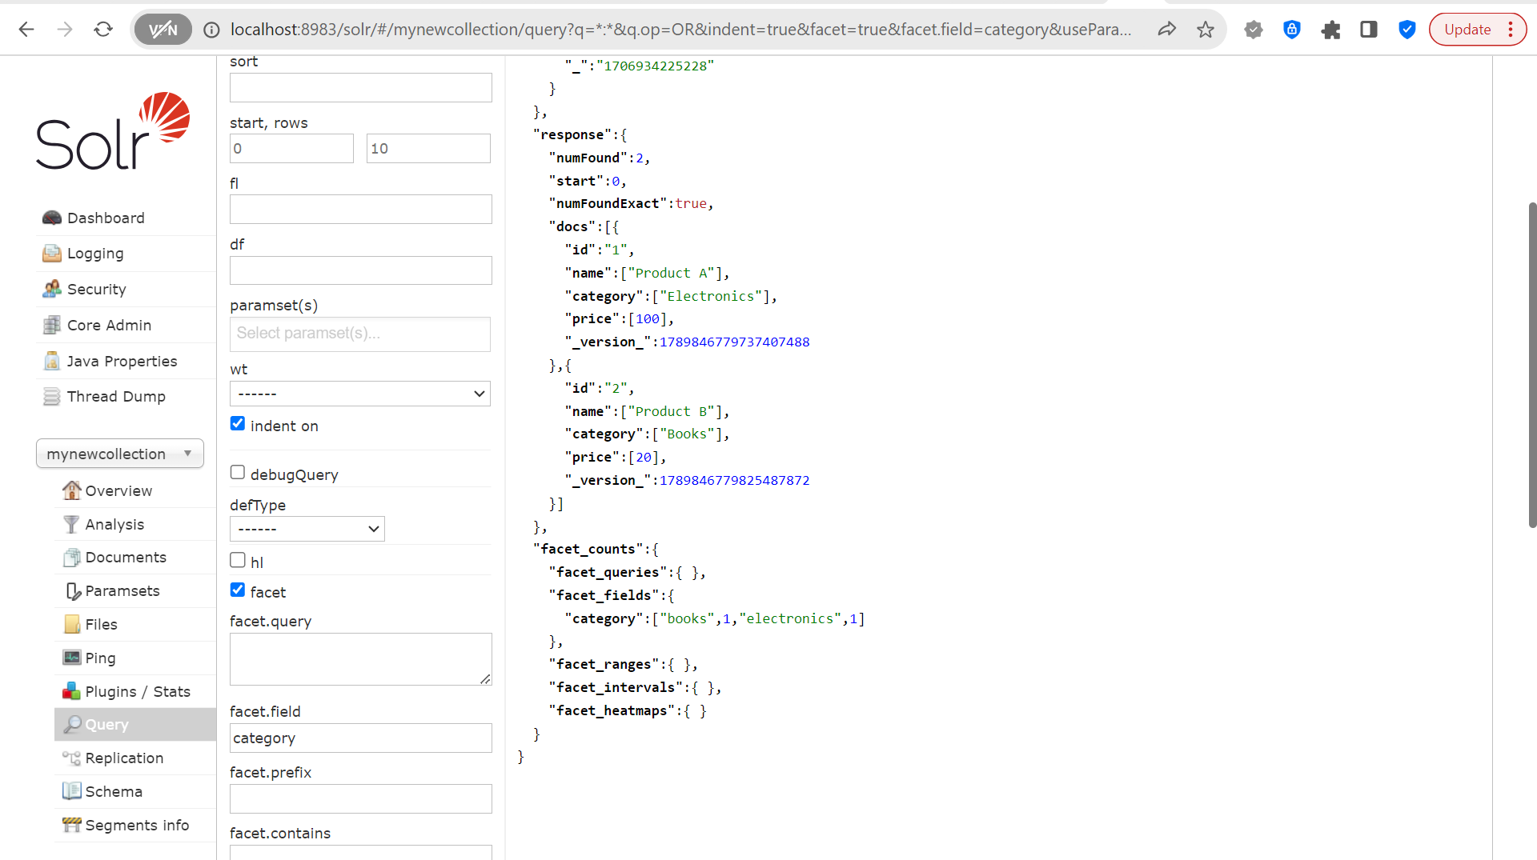

Select name, category where price less than 25.

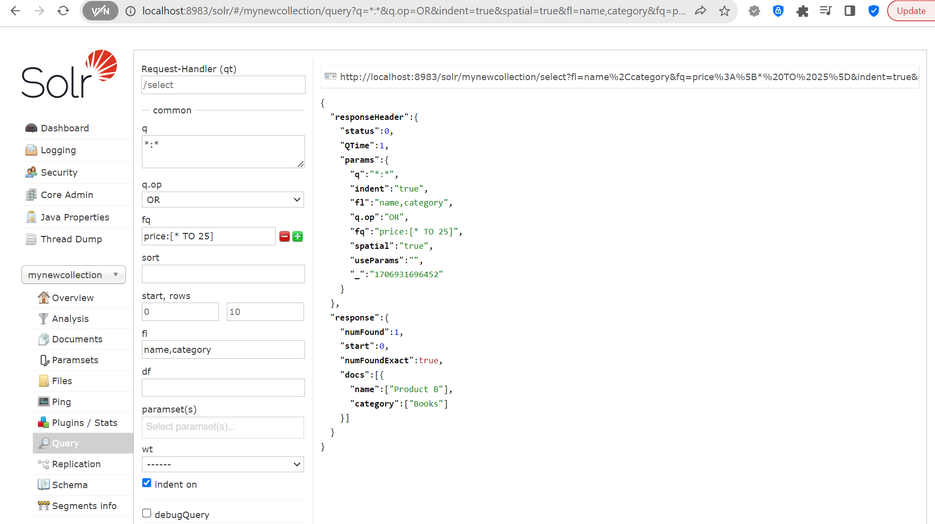

Display data in xml format.

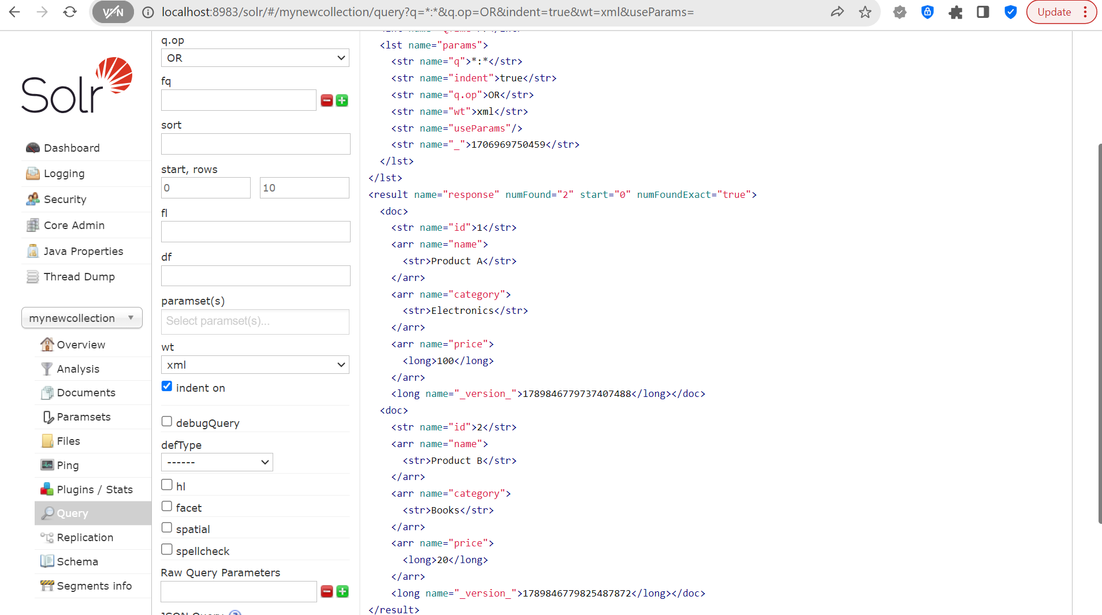

Select category, price for name:"Product B" and xml output.

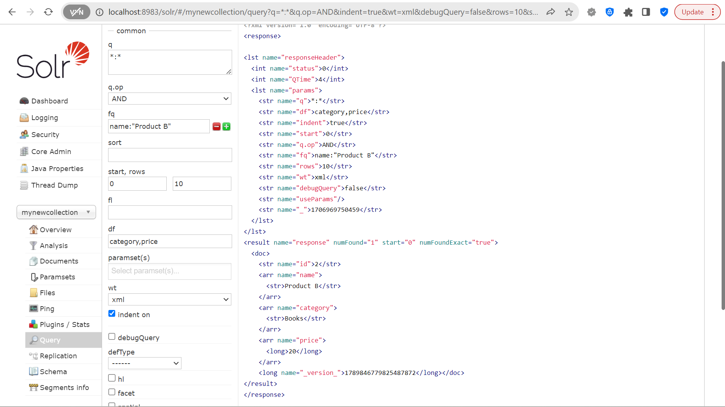

Create a new collection in Solr mynewcollection_1.



Verify that ‘mynewcollection_1’ has been successfully created

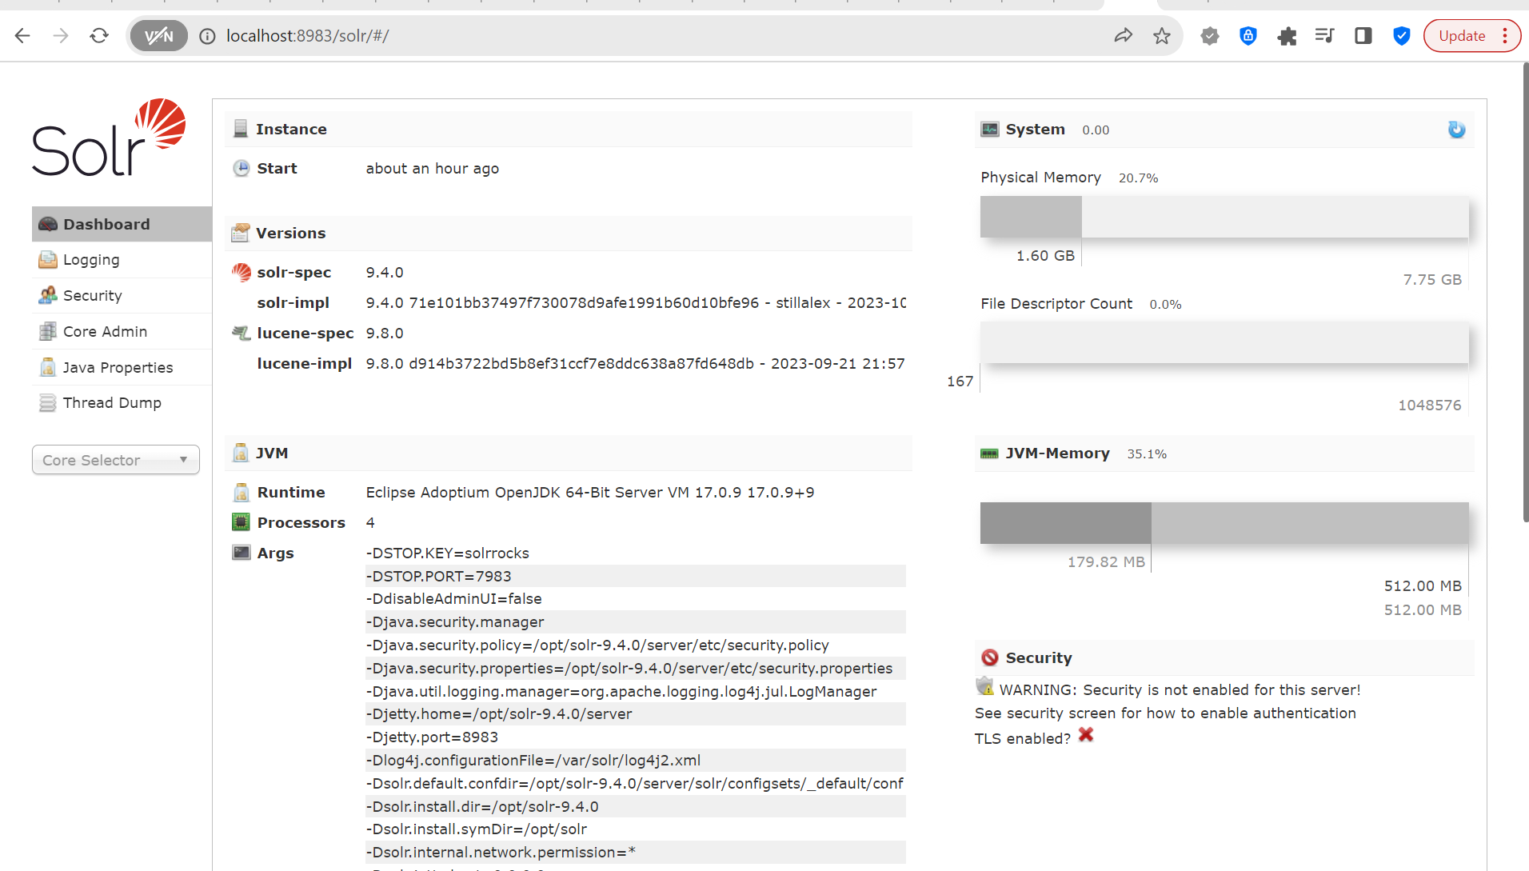

Generate JSON data and add it to mycollection_1.

Structure of result.json file

echo '[

{"student_id":"1", "name":"John", "Grade":"A", "Result":"Pass"},

{"student_id":"2", "name":"Ron", "Grade":"A+", "Result":"Pass"},

{"student_id":"3", "name":"Andrew", "Grade":"B", "Result":"Pass"},

{"student_id":"4", "name":"Sophia", "Grade":"B", "Result":"Pass"},

{"student_id":"5", "name":"Jason", "Grade":"F", "Result":"Fail"},

{"student_id":"6", "name":"Mady", "Grade":"A", "Result":"Pass"},

{"student_id":"7", "name":"Grayson", "Grade":"F", "Result":"Fail"}

]' > /tmp/result.json

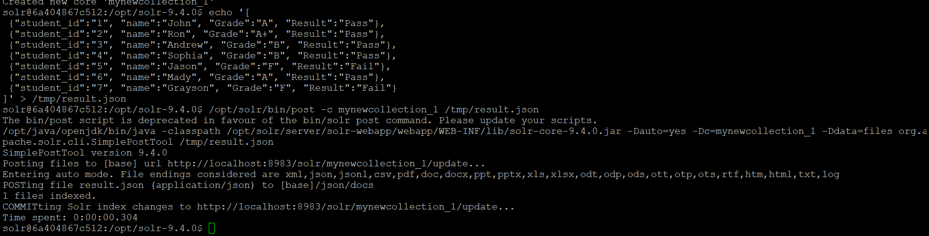

Query your collection from command line and web interface :

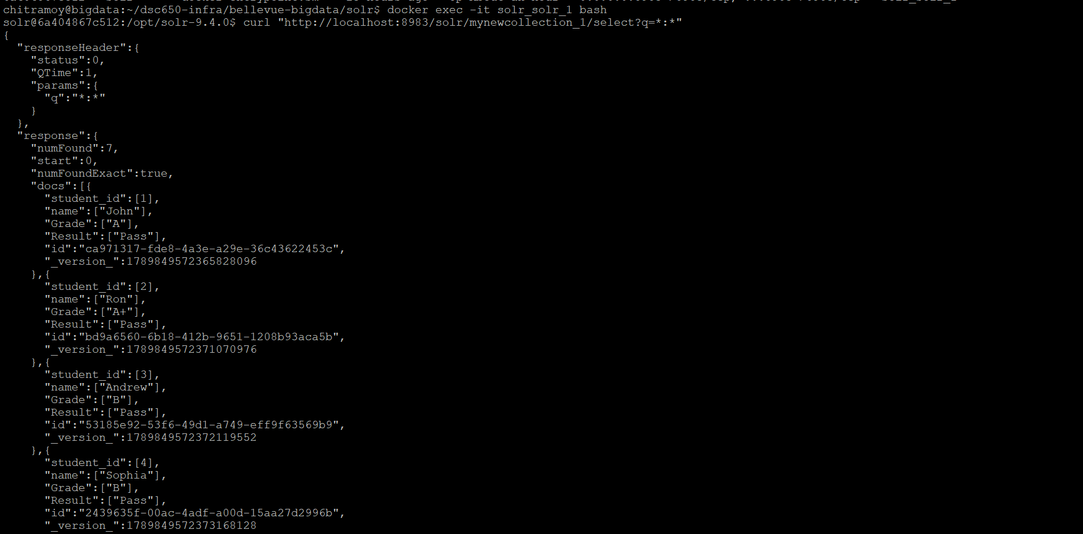

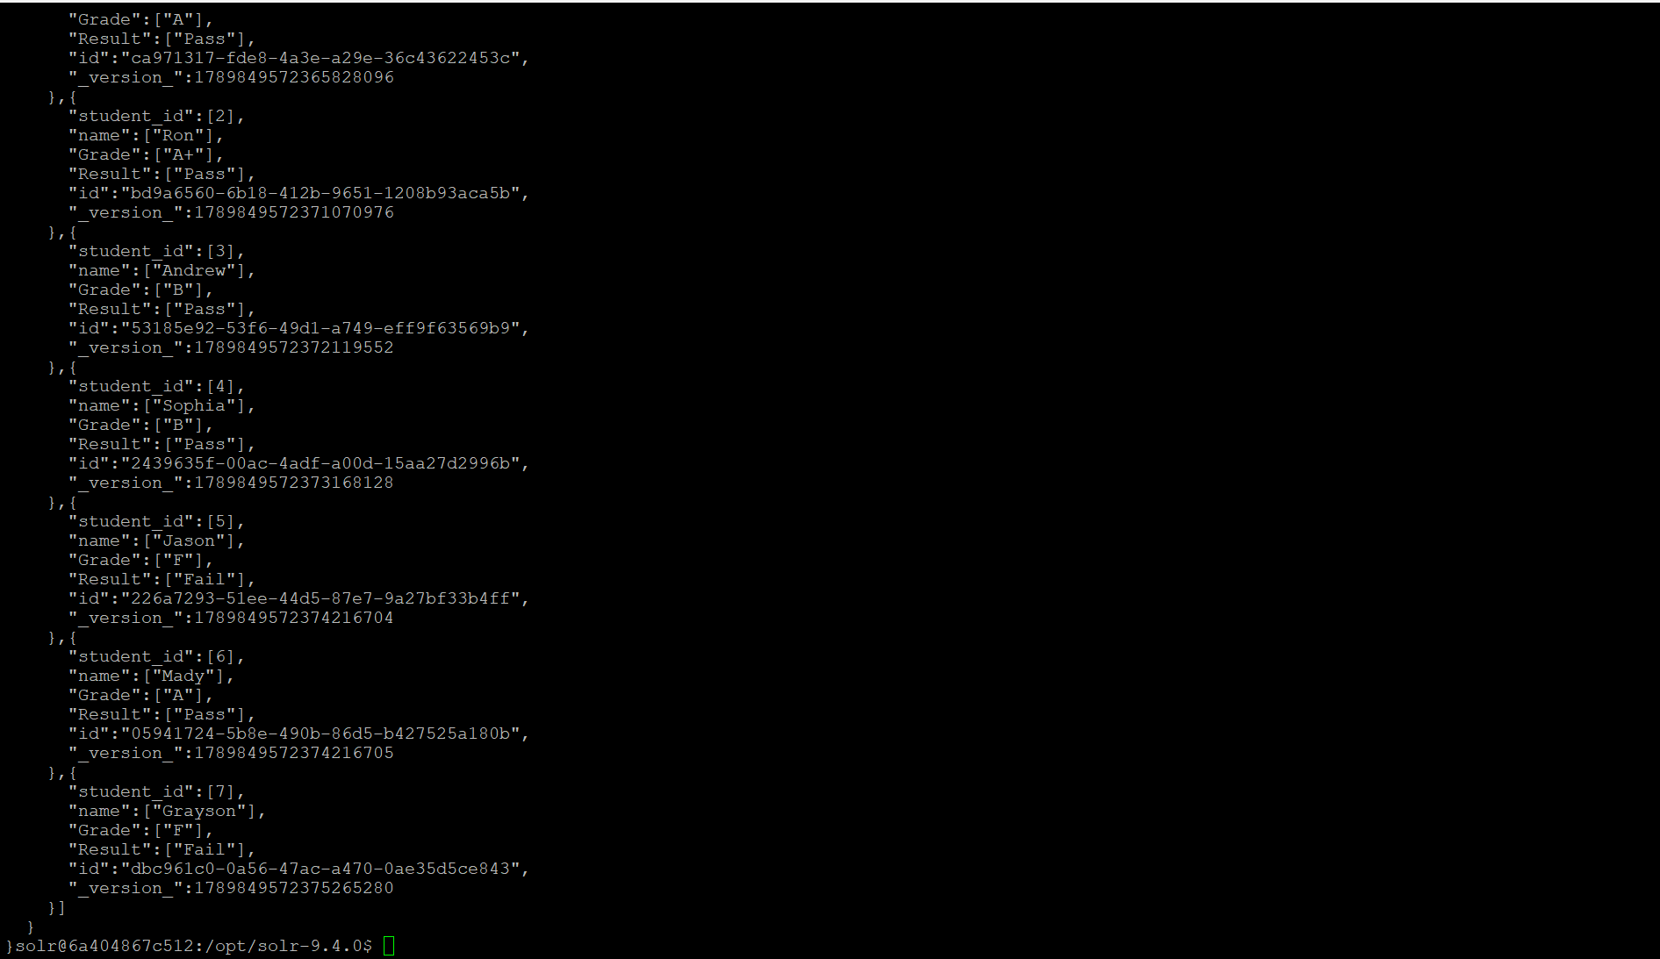

Query your collection from command line and web interface :

Select where name is Ron and select * where Garde = ‘B’.

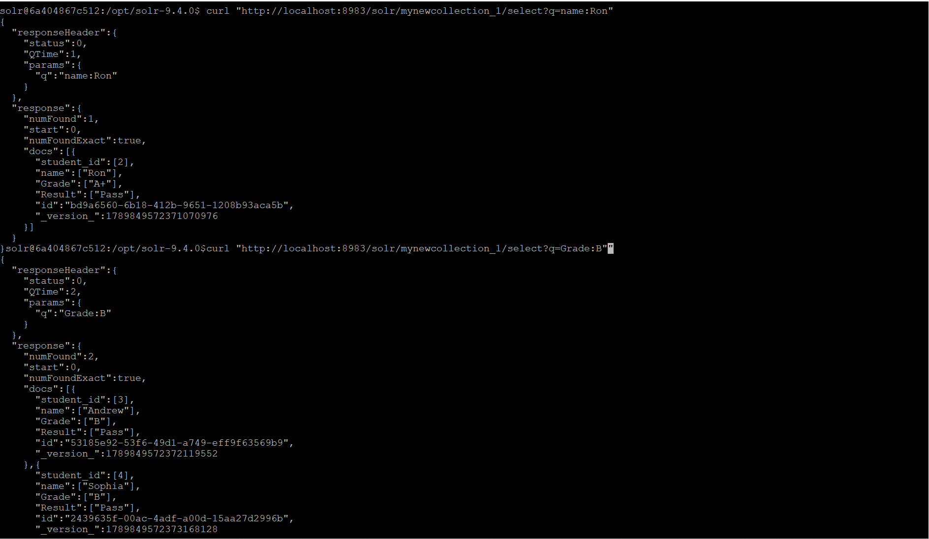

Query your collection from web interface:

Select name, Grade, Result from mynewcollection_1 where Result:”Pass” and extract in csv format.

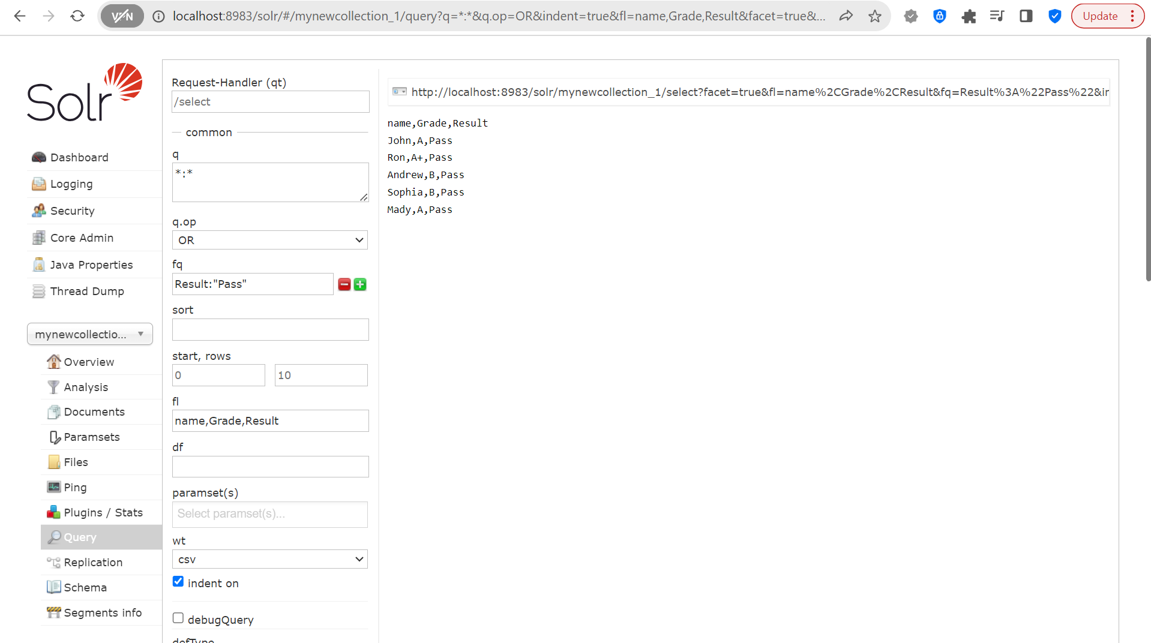

Select name, Grade, Result from mynewcollection_1 where Grade = ‘A’ and extract in python format (df).

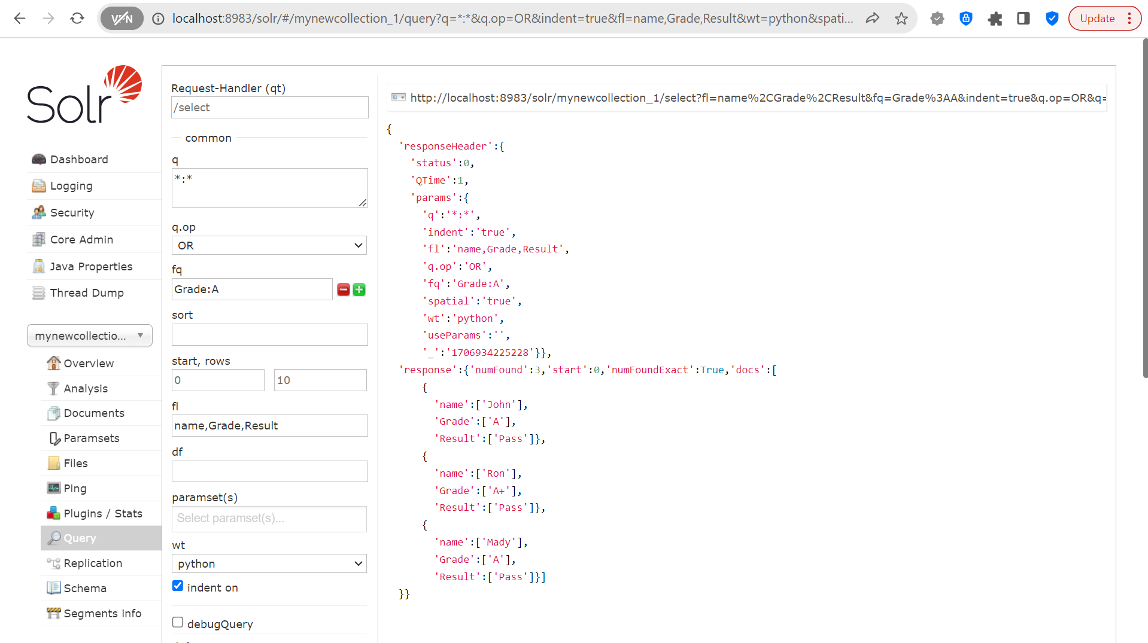

Grade wise count from from mynewcollection_1.

