DSC-650-week-09-Mukherjee

Author : Chitramoy Mukherjee

Date : 02/08/2024

**Screenshot confirming successful access to the NiFi UI.**

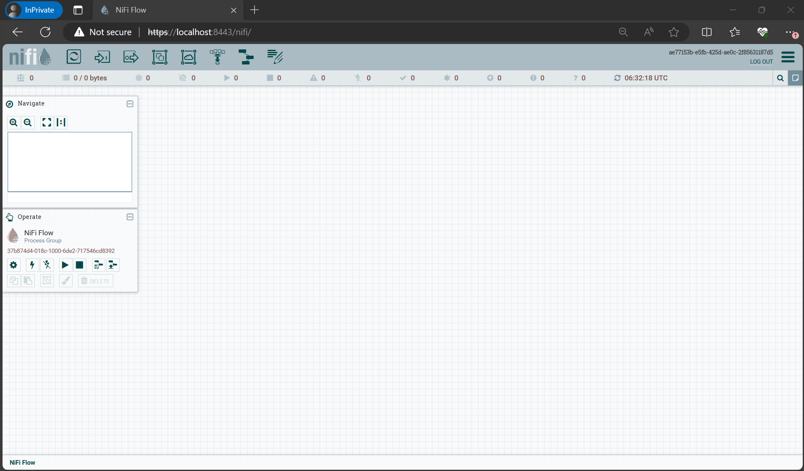

**Exercise 1:** Drag and drop the “Processor Group” icon onto the canvas. Name this processor group “My First NiFi Flow”.

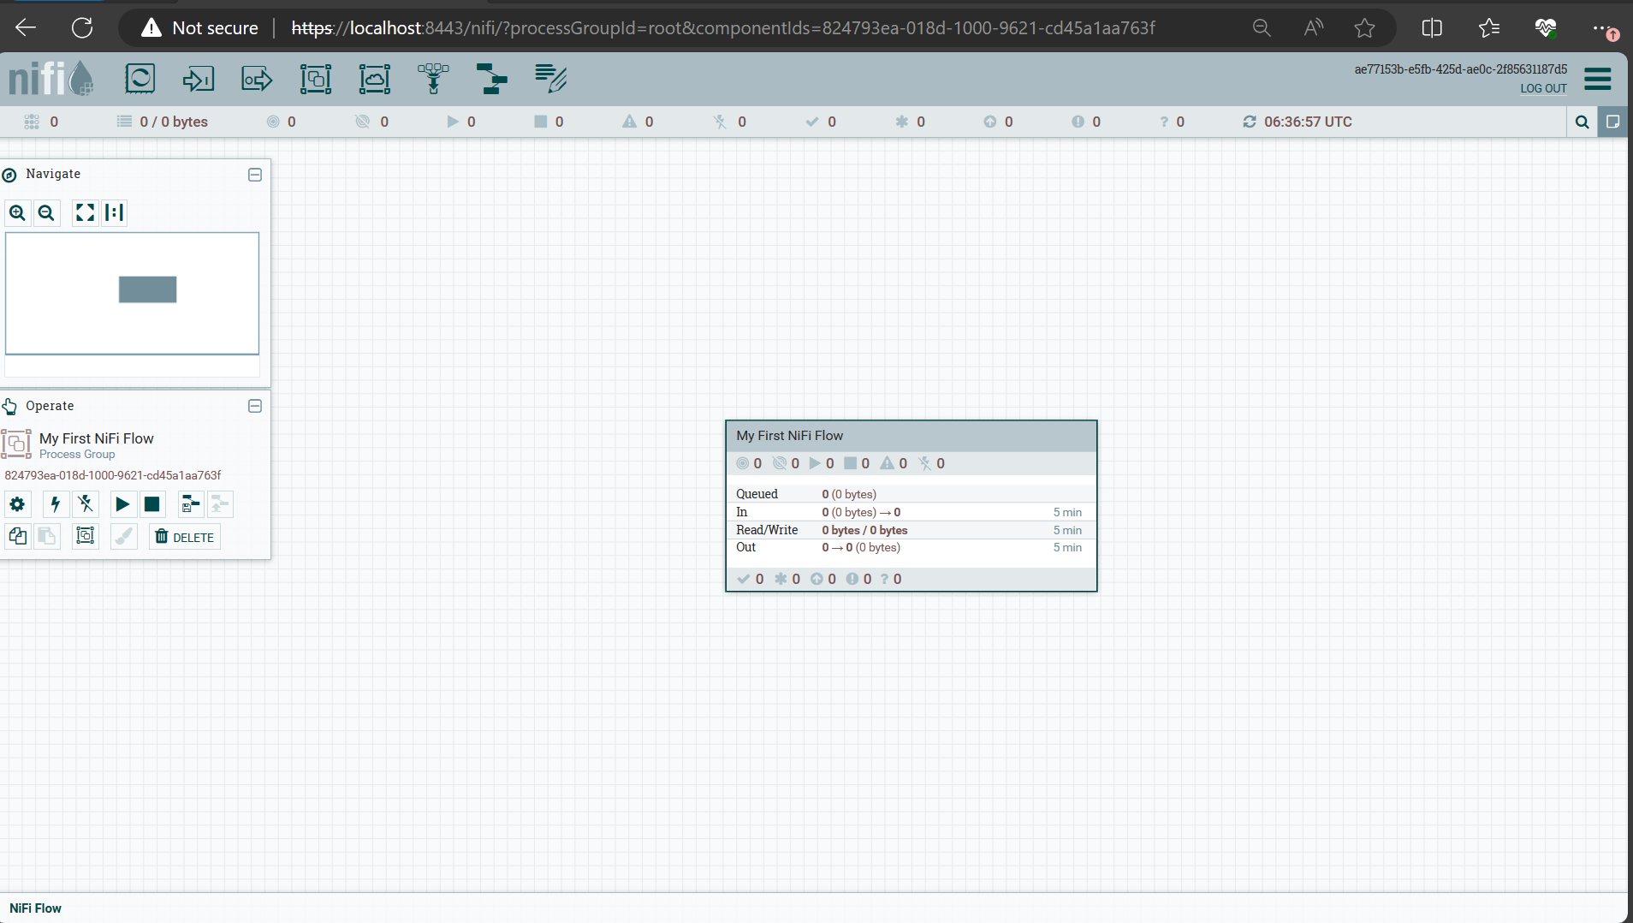

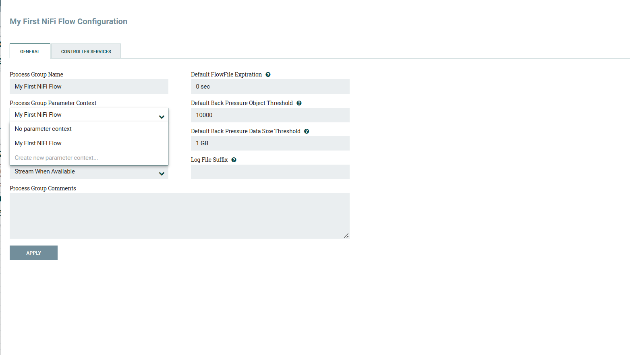

**Exercise 2:** Create a Parameter Context for your new processor group. Define a parameter (e.g., File_Size) that will determine the size of the files generated in the next step

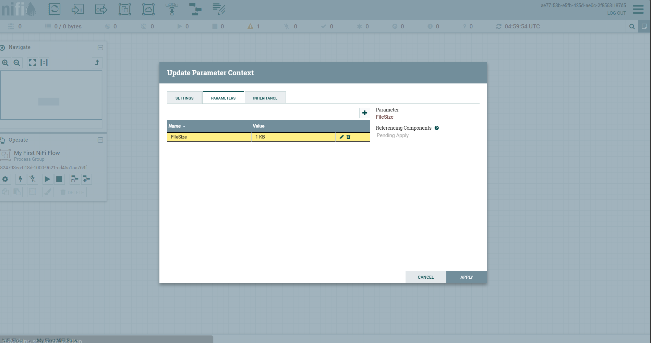

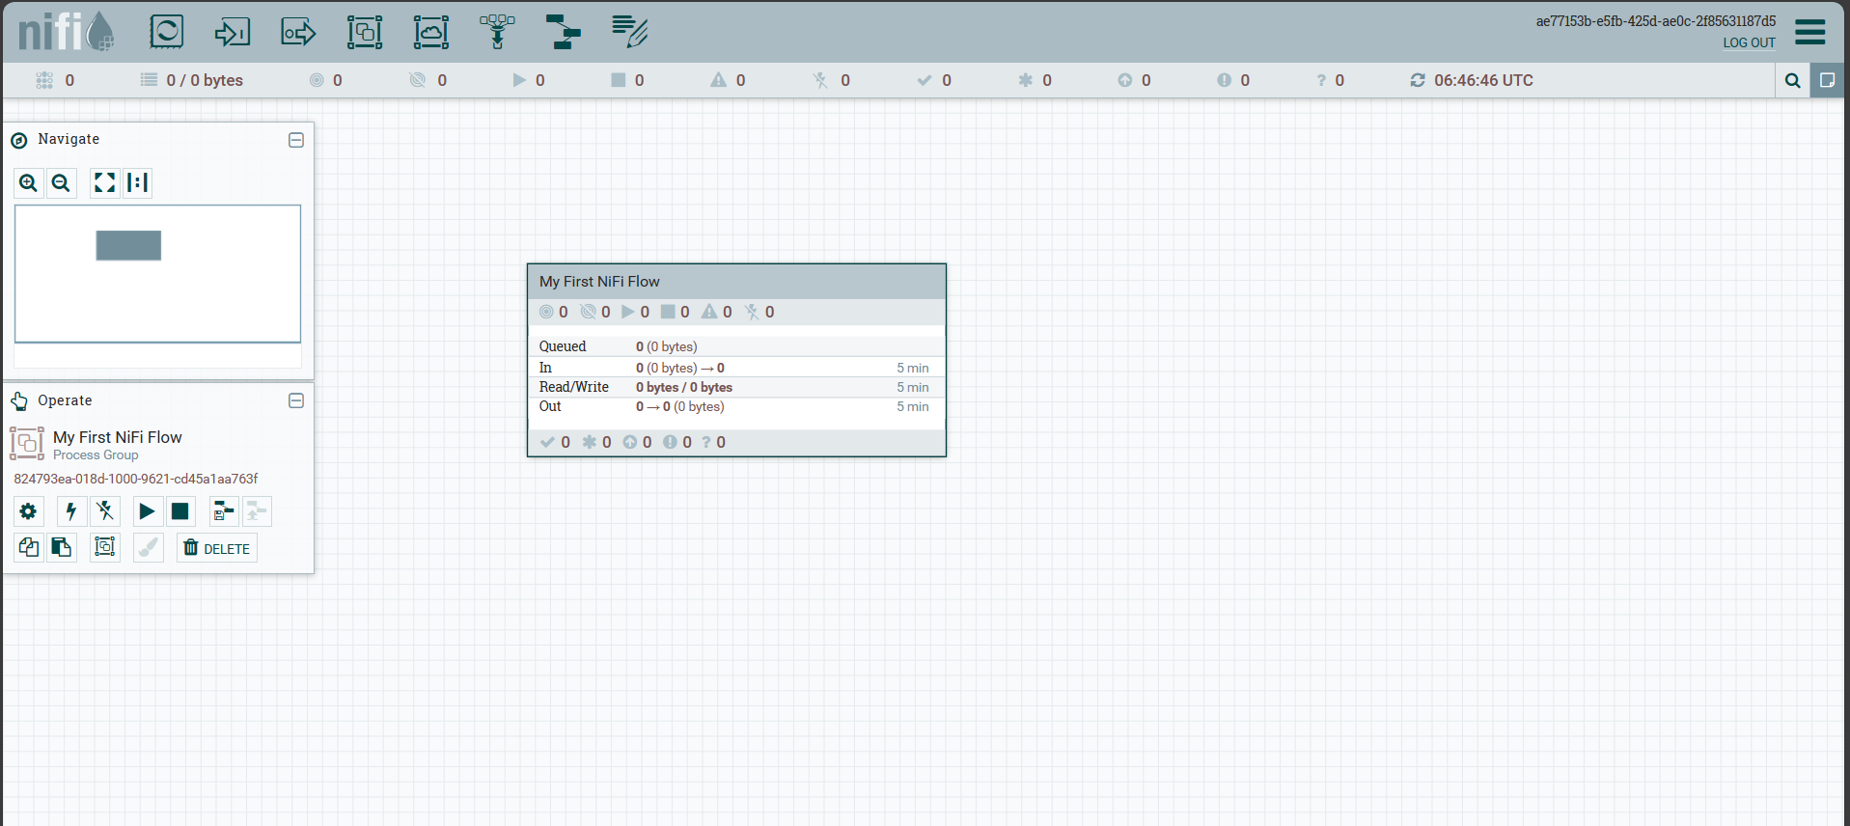

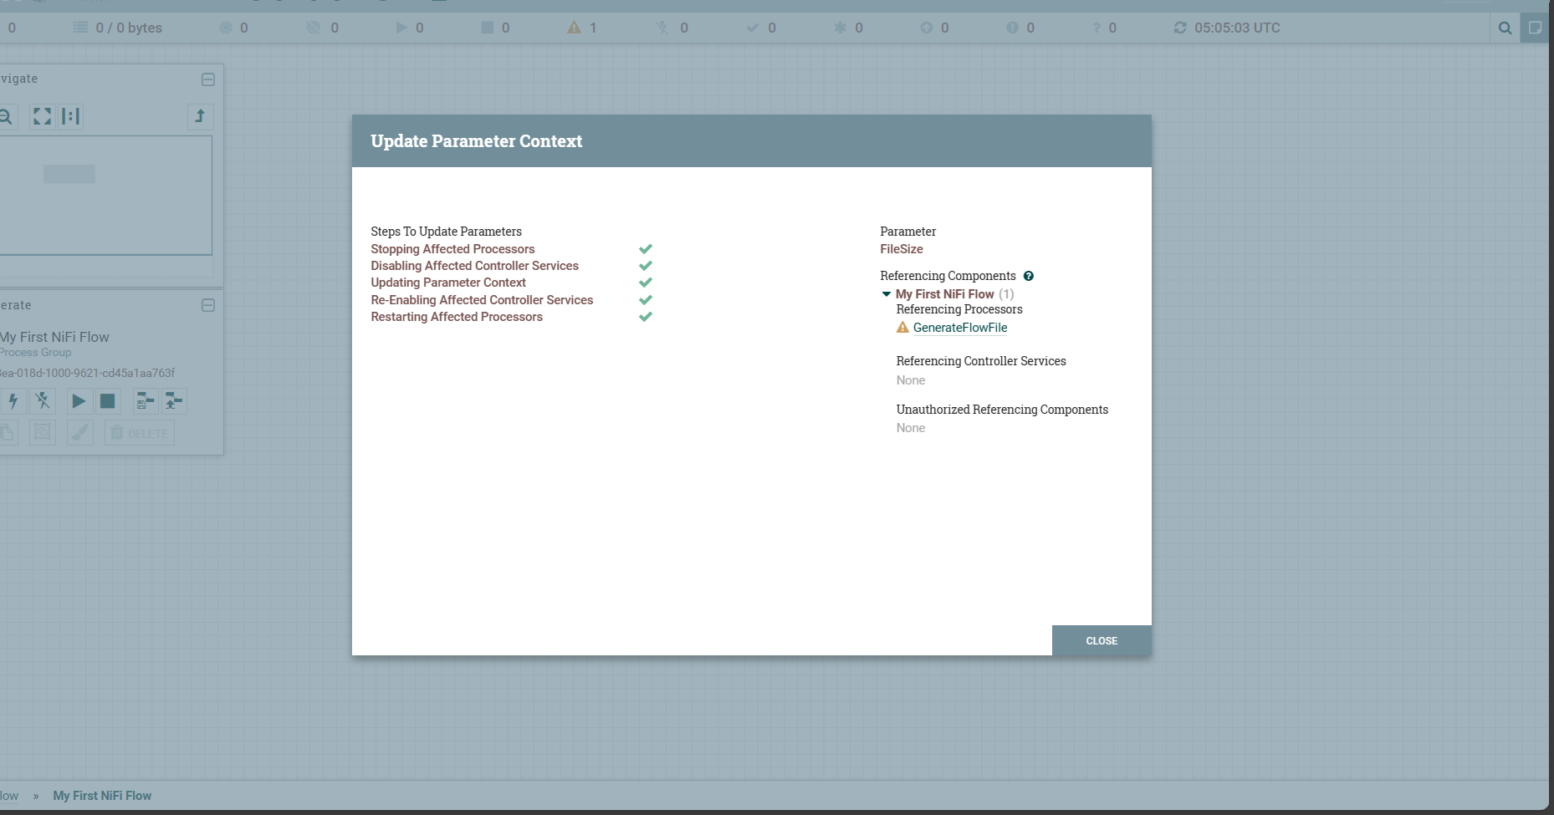

Screenshot of the simple flow (GenerateFlowFile to LogAttribute).

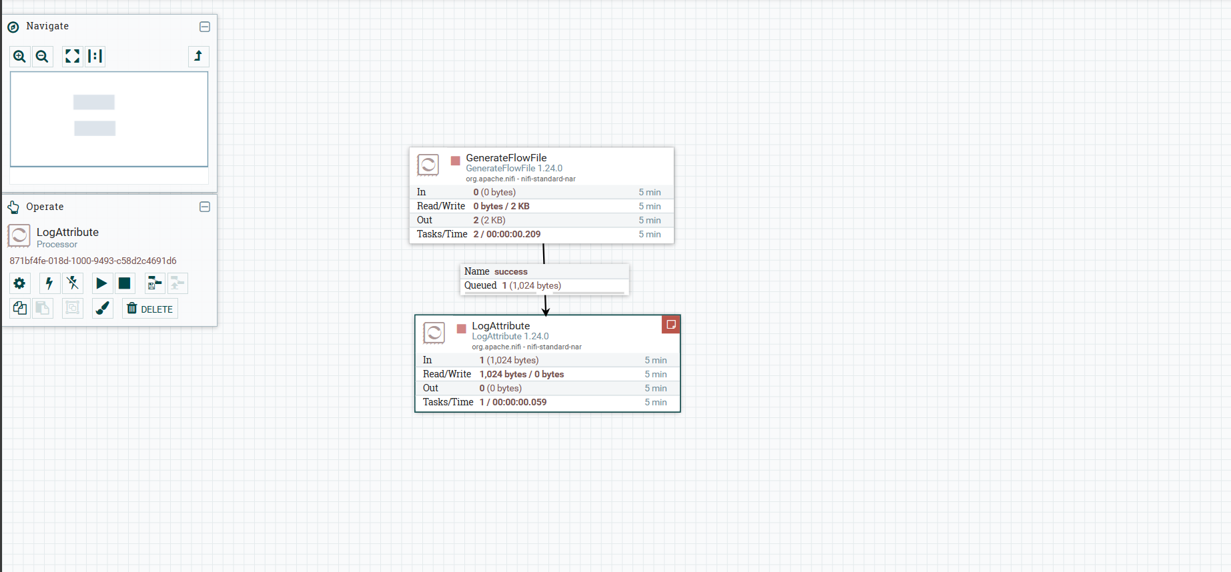

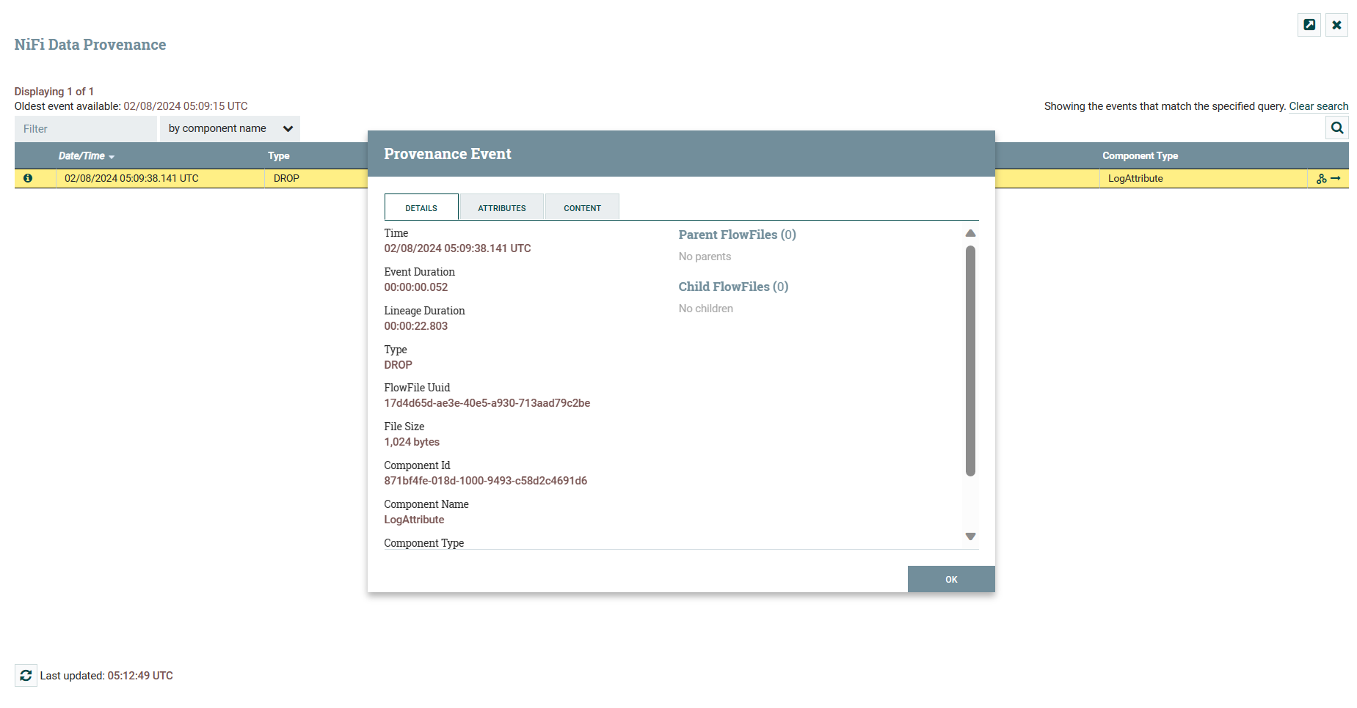

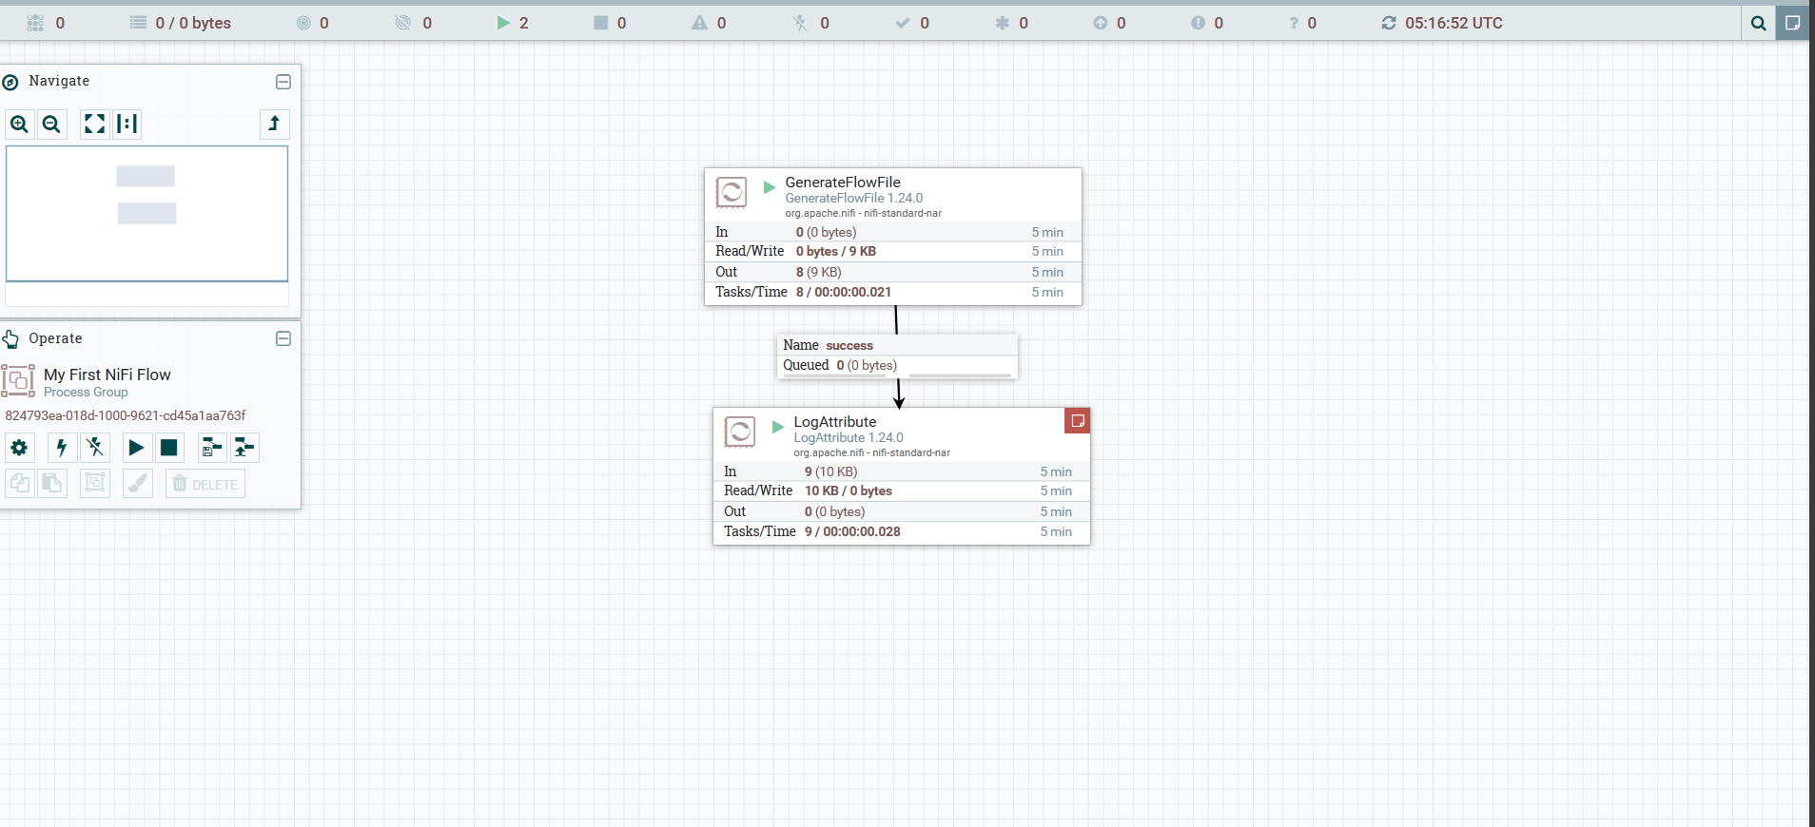

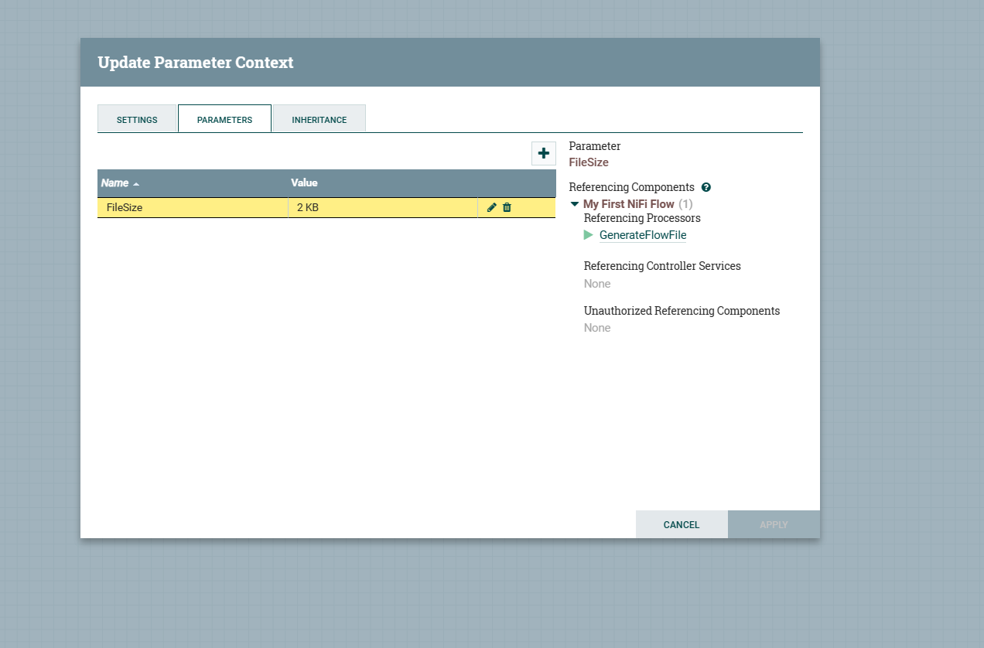

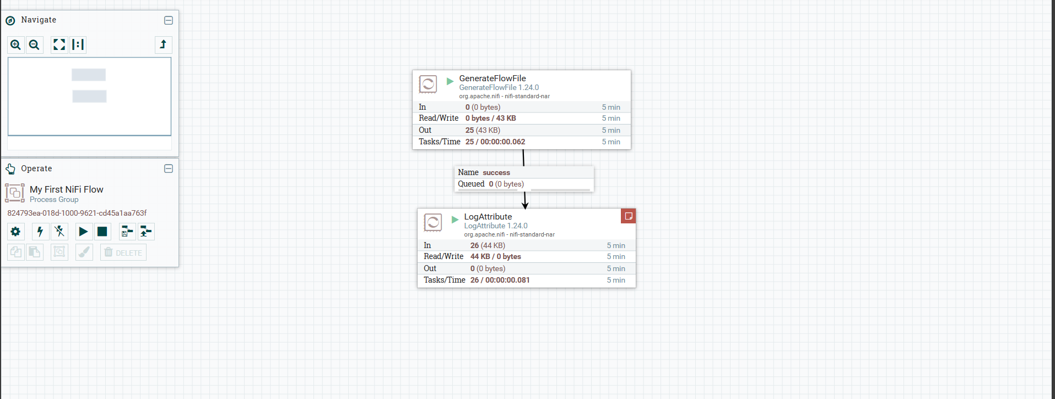

**Screenshot confirming the successful creation of the syslog collection.**

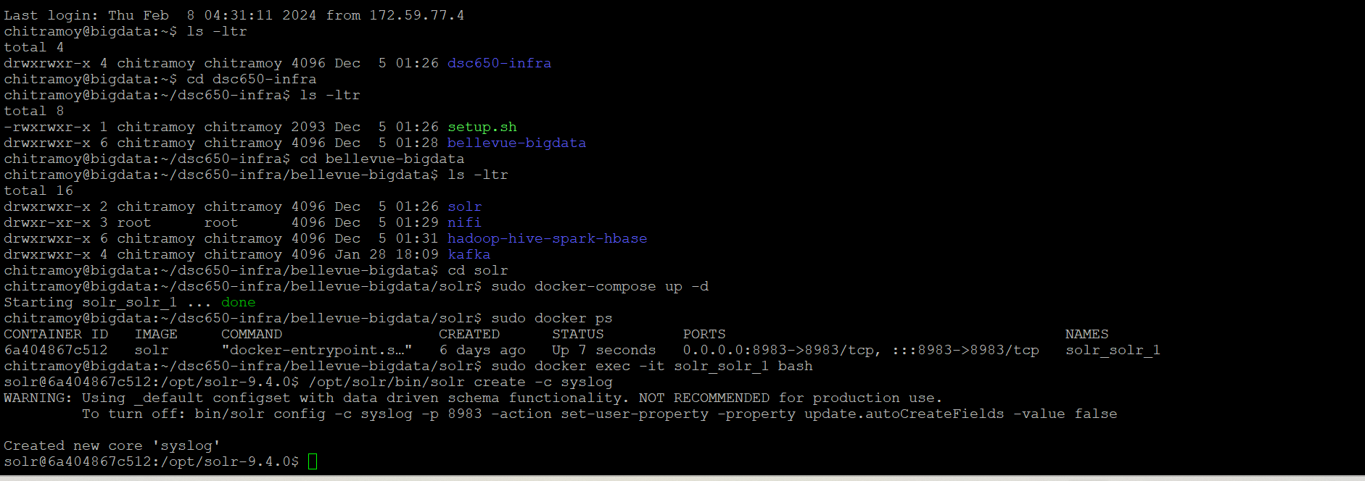

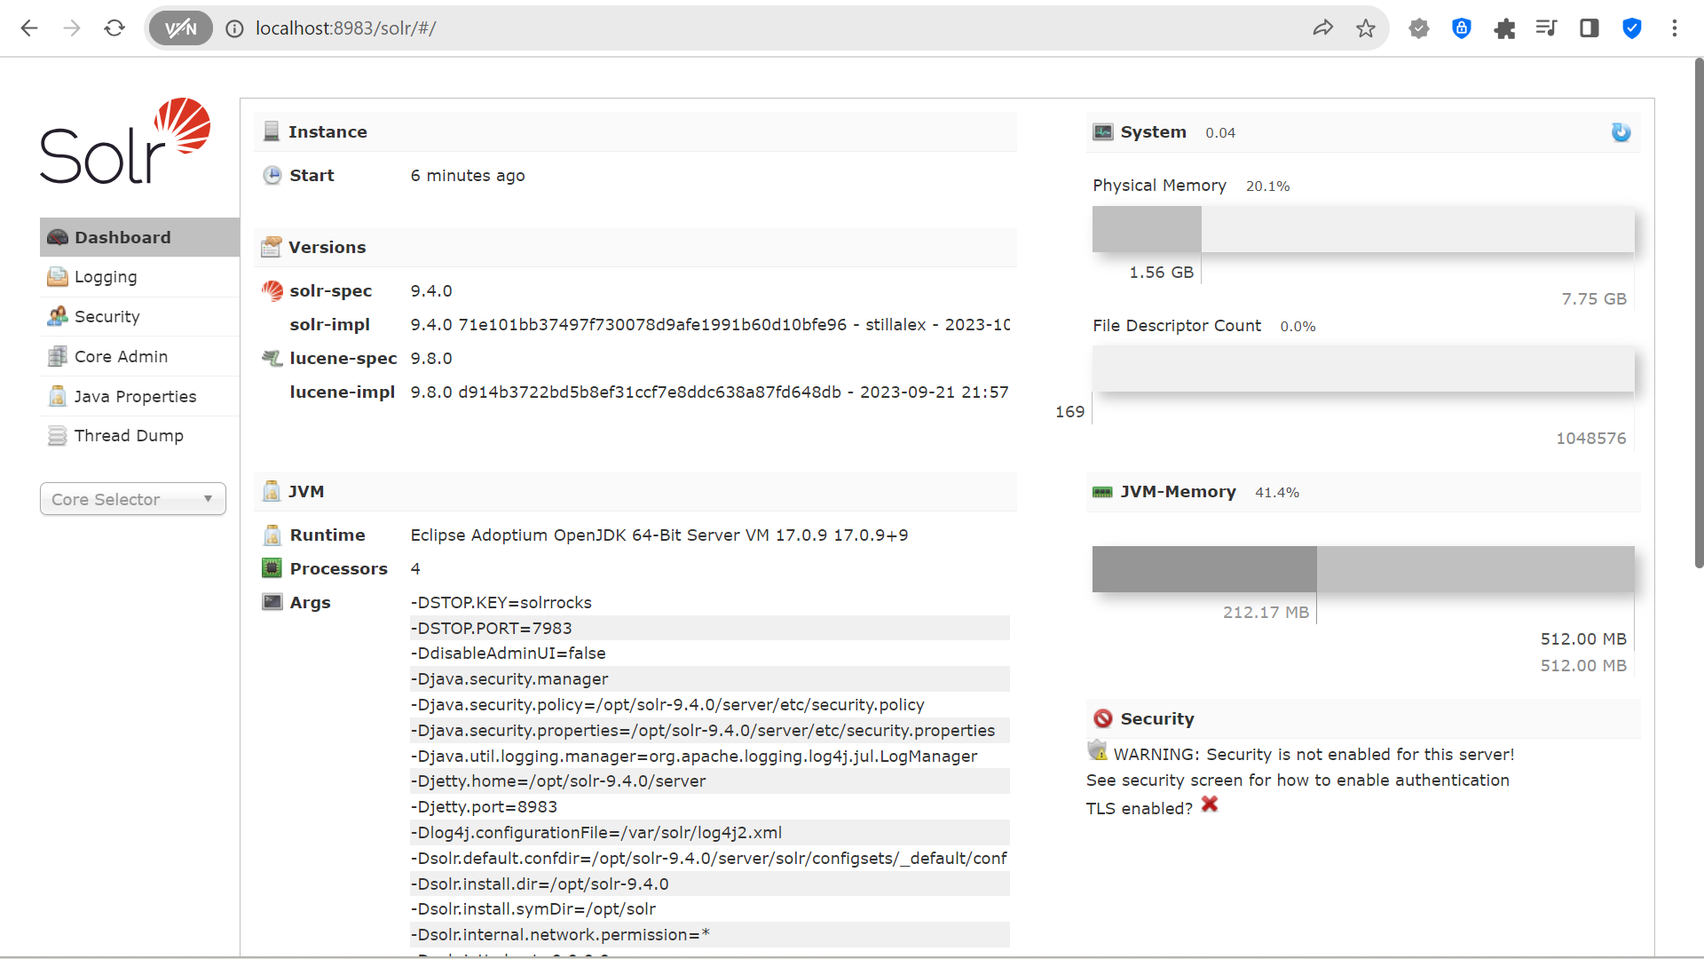

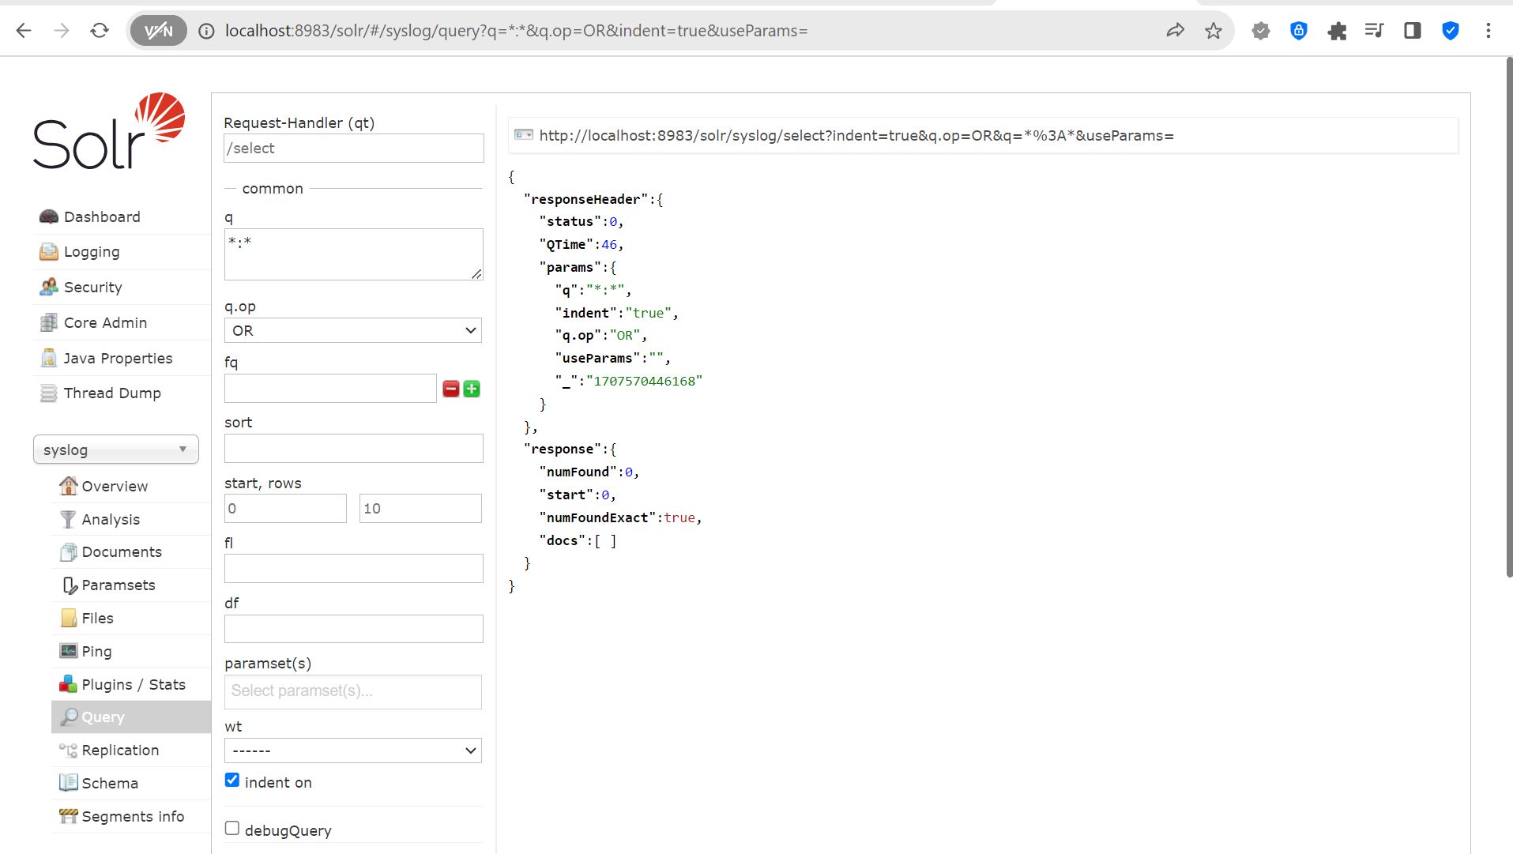

**Screenshot of the advanced NiFi flow processing and sending data to Solr.**

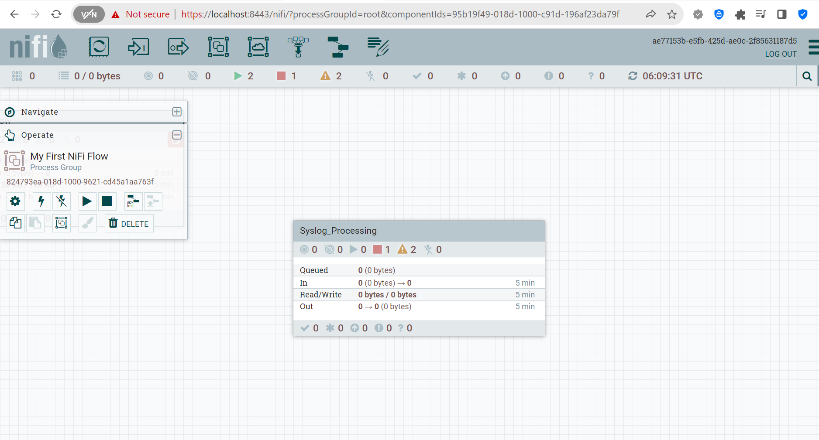

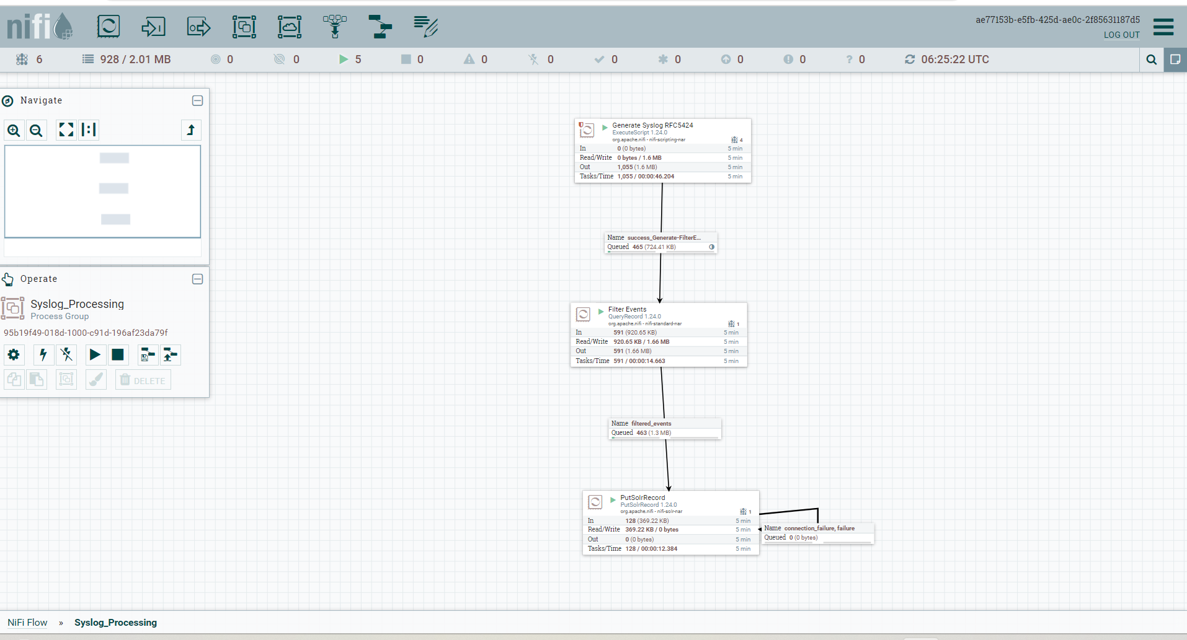

Select severity, timestamp, structuredData_SDID_iut, structuredData_SDID_eventSource where procid='4340' from solr Web Interface.

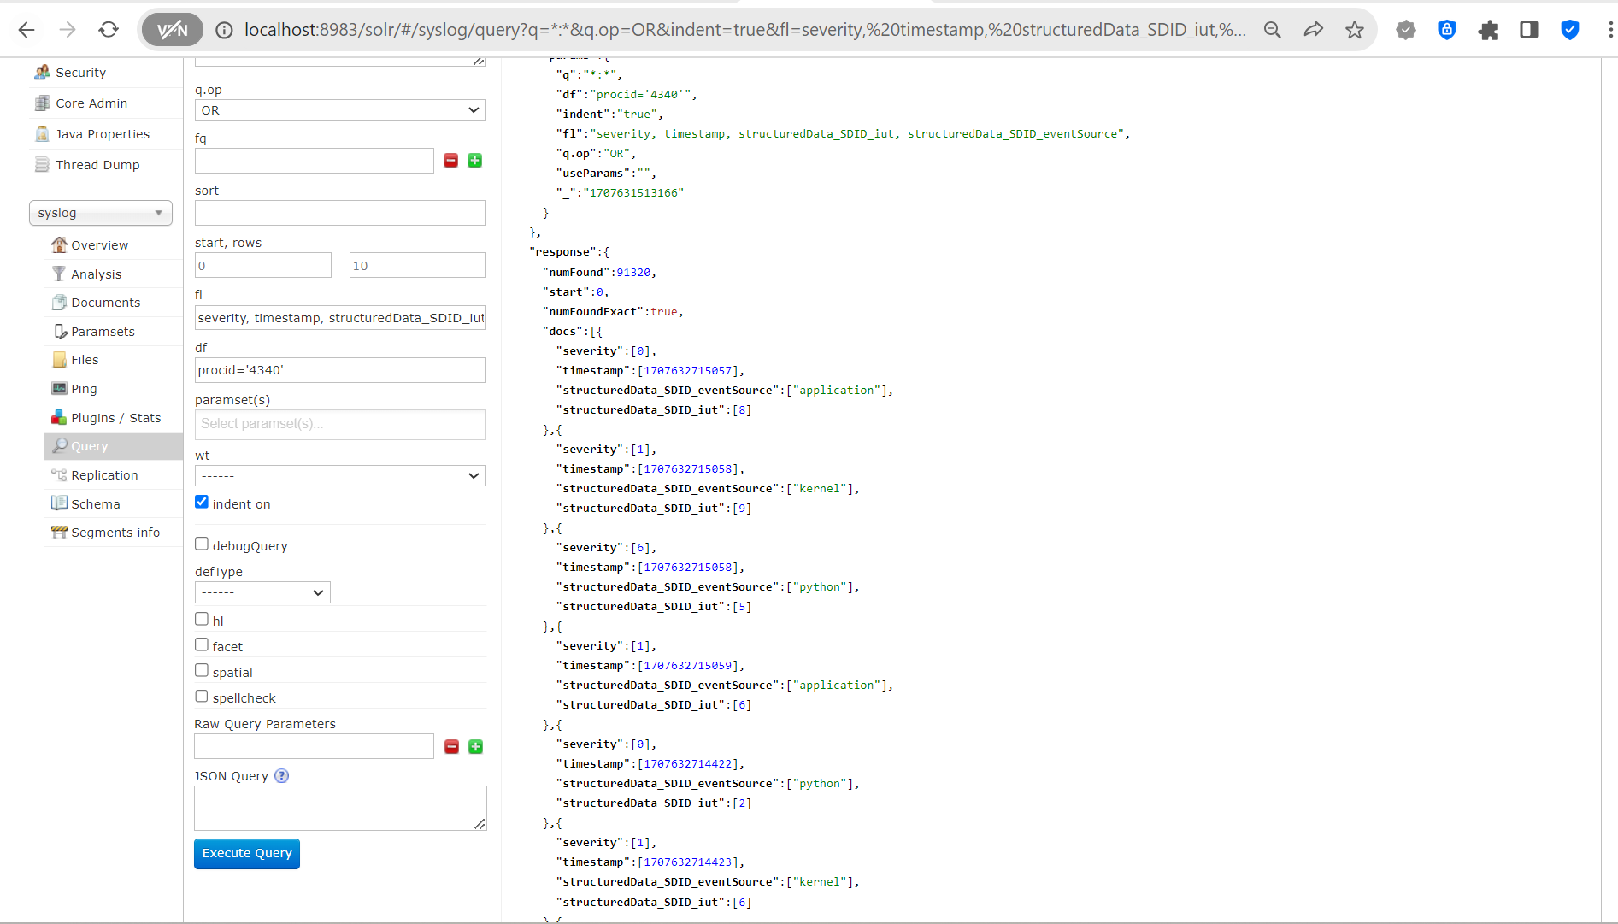

Count based on priority is solr Web Interface on syslog data.

