**Web Design for Everybody Capstone Project (Portfolio)**

* developed a professional-quality web portfolio.
* Designed the website from scratch.
* Built HTML structure.
* Added CSS style.
* Added Responsive for screens less than 500px;
* Added JavaScript Interactivity.
* Validated On w3 Validator.

**Build With:**

* HTML5
* CSS3
* JavaScript
* jQuery

**Freehand design sketches for the Portfolio**

** This is a design for Desktop screen

[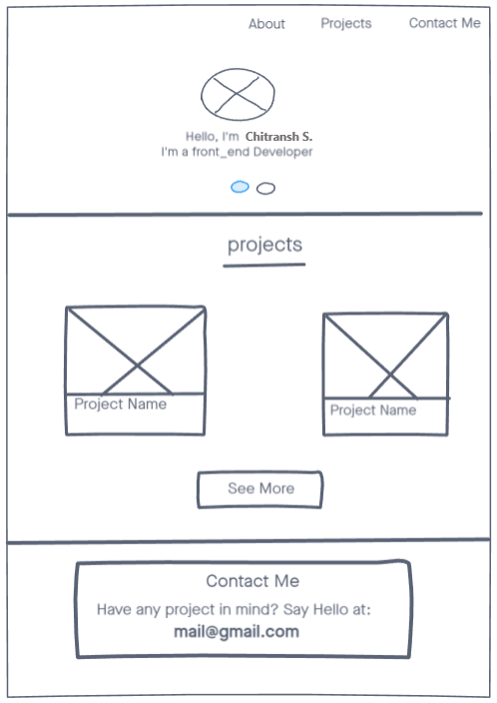](https://github.com/NohaaAa/Coursera-Web-Design-for-Everybody-Capstone-Project/blob/master/Designs/Desktop%20view.png)

** This is a design for Mobile screen

[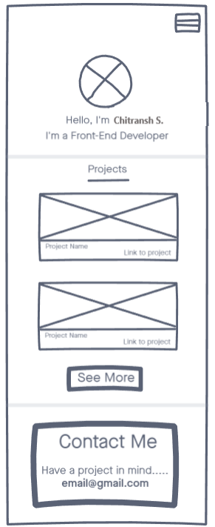](https://github.com/NohaaAa/Coursera-Web-Design-for-Everybody-Capstone-Project/blob/master/Designs/mobile%20view.png)

**w3 Validation for index.html**

[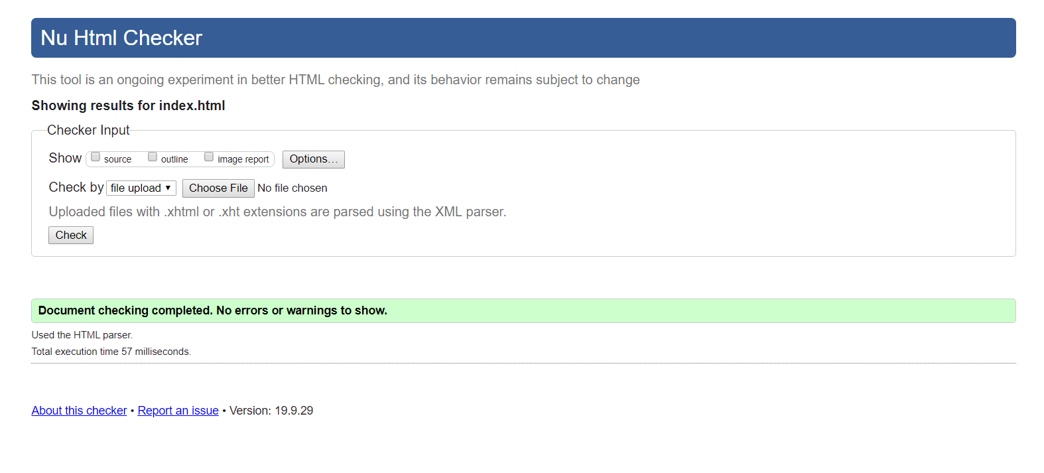](https://github.com/NohaaAa/Coursera-Web-Design-for-Everybody-Capstone-Project/blob/master/Validations/w3-validator.png)

### Portfolio Demo

