Create a CI/CD pipeline using jenkinsfile ( No Freestyle project ) to build, test and deploy docker containers from a private repository

Login to your jenkins server add create a pipeline project

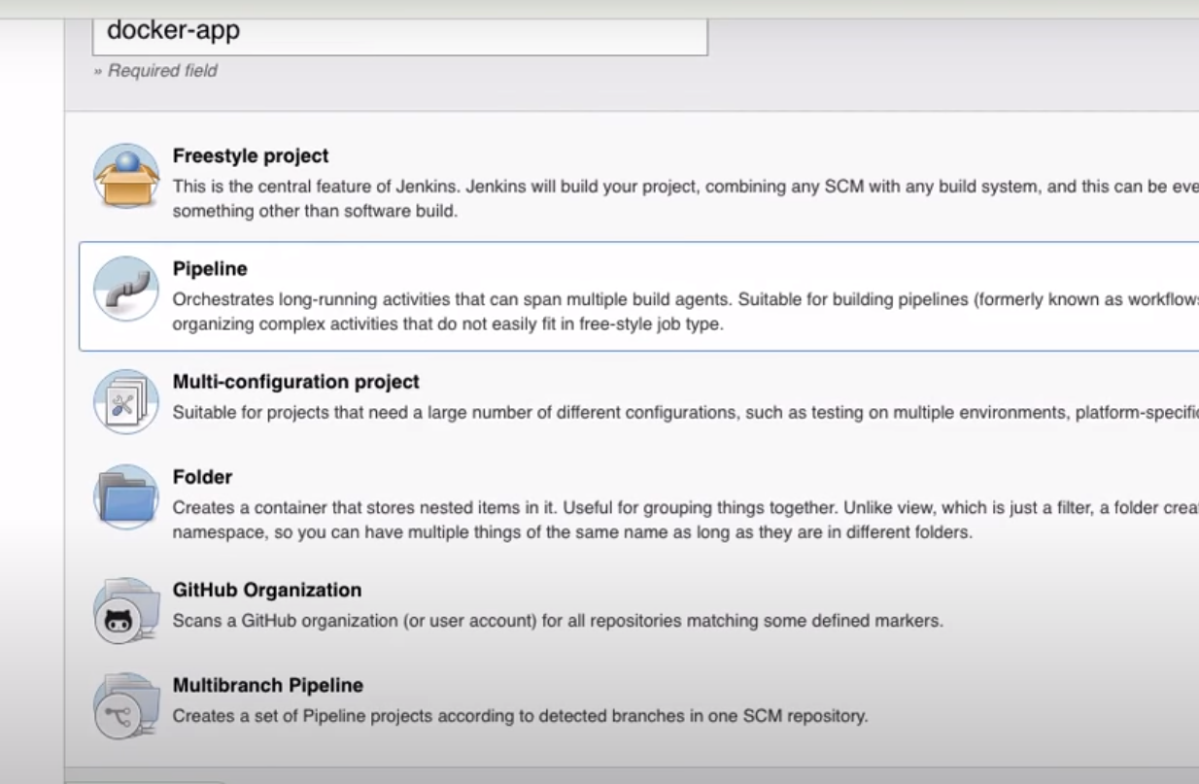

First give the github repo Use Syntax generator to write the Jenkinsfile and install maven

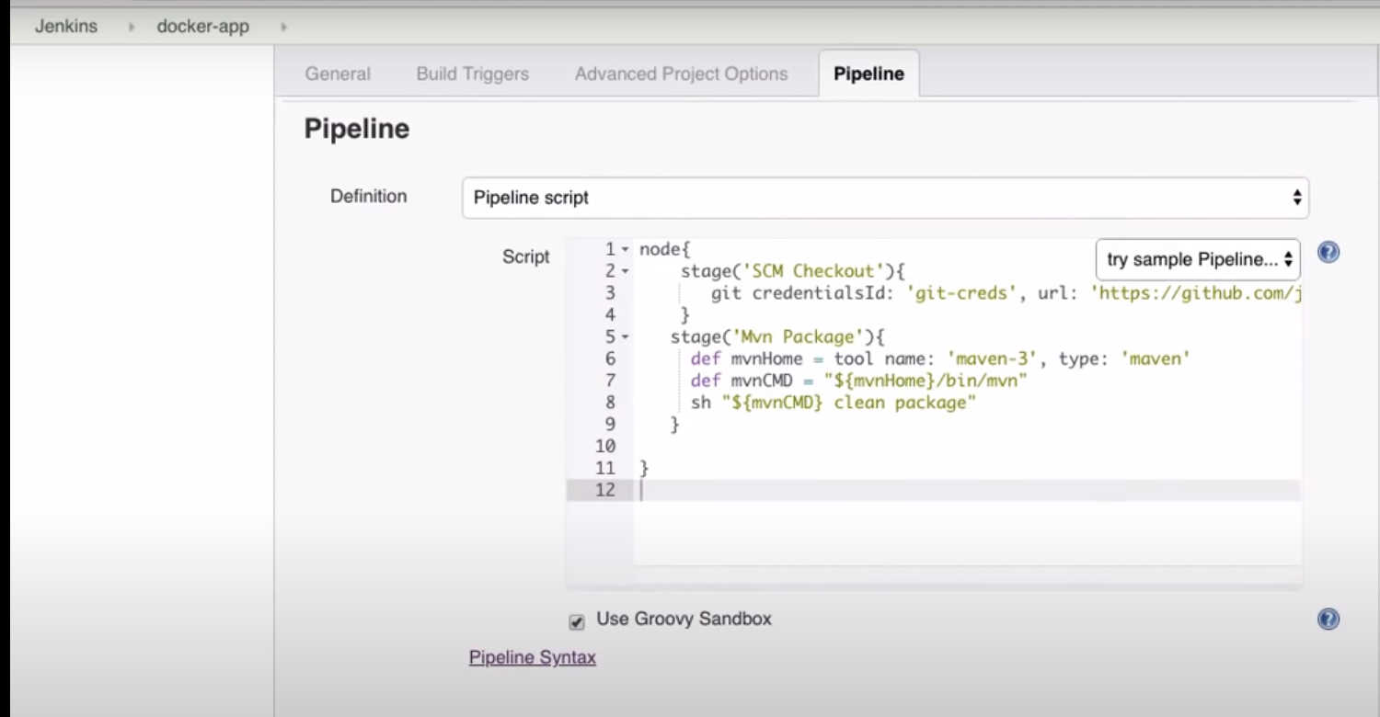

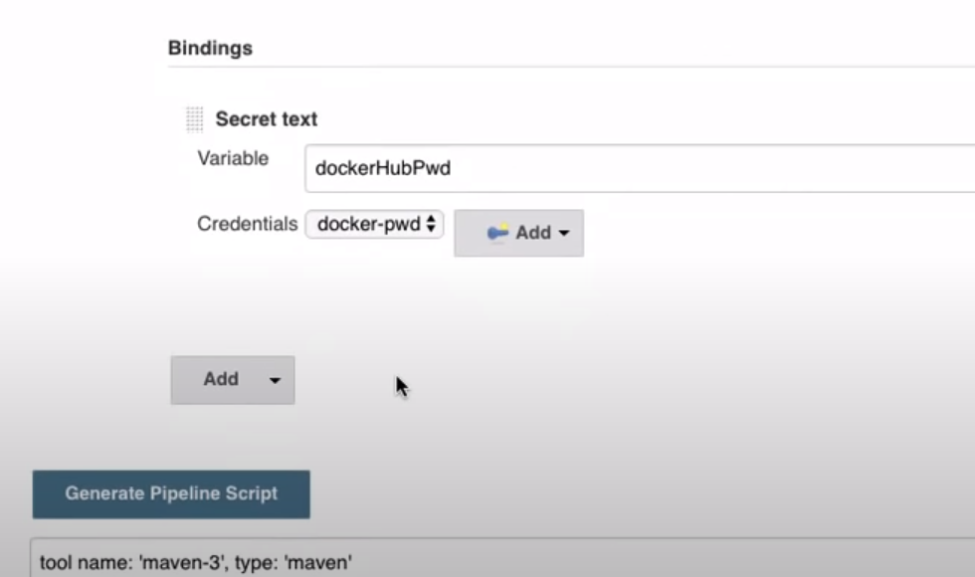

Then create a stage for docker hub and push your image to the docker hub

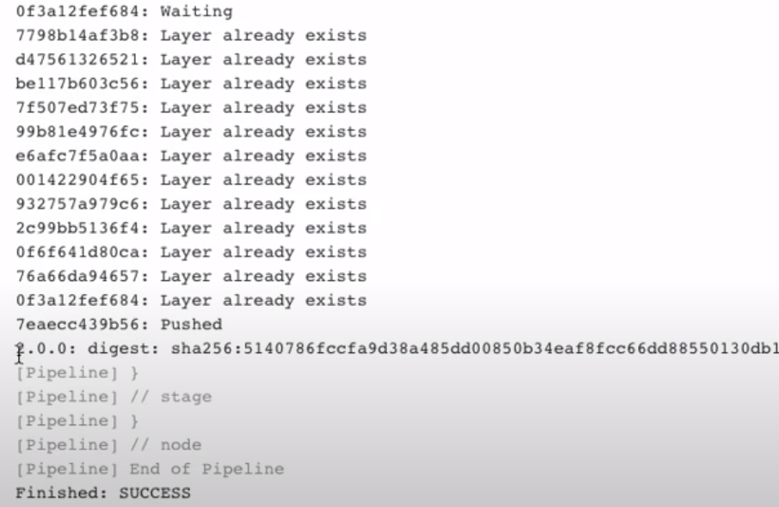

All these steps are mentioned into the Jenkinsfile.

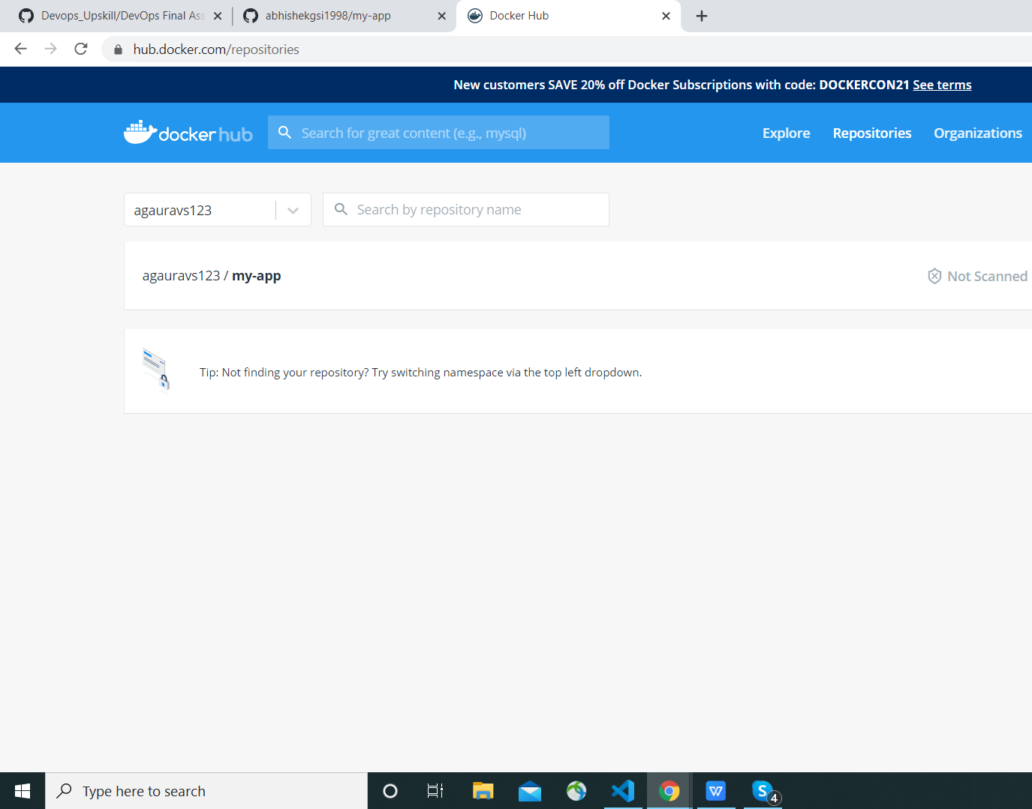

I want to run my application on another server for that follow the steps

For that install ssh Agent from the plugins

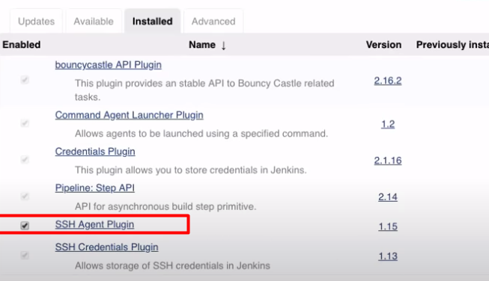

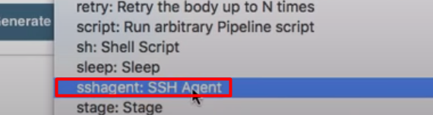

Then it will be shown in pipeline syntax generator.

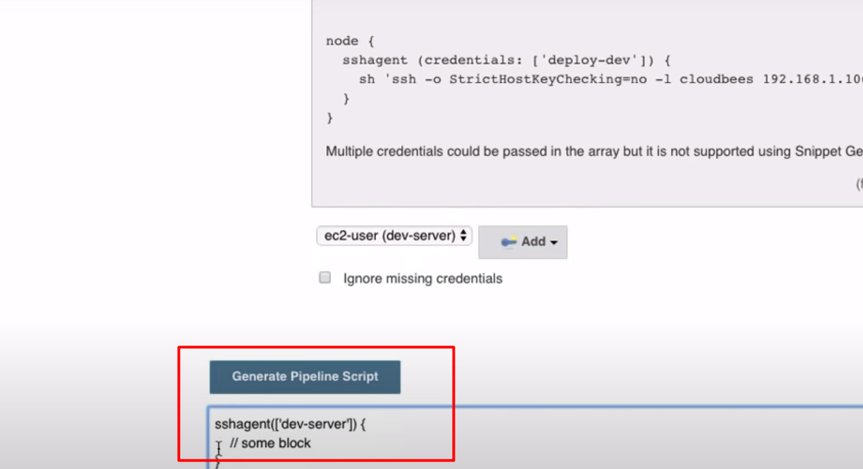

Now change the confioguration and run the pipeline again.

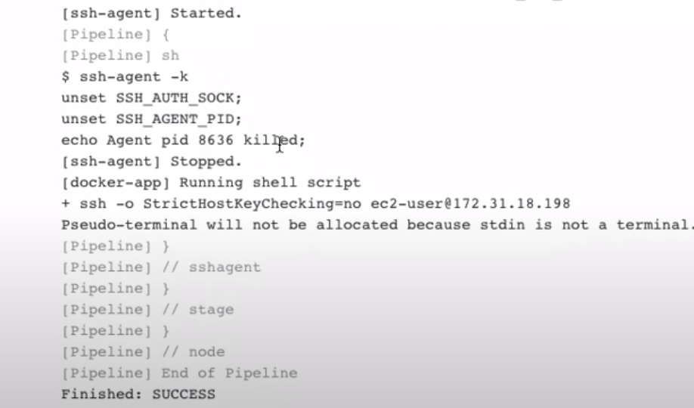

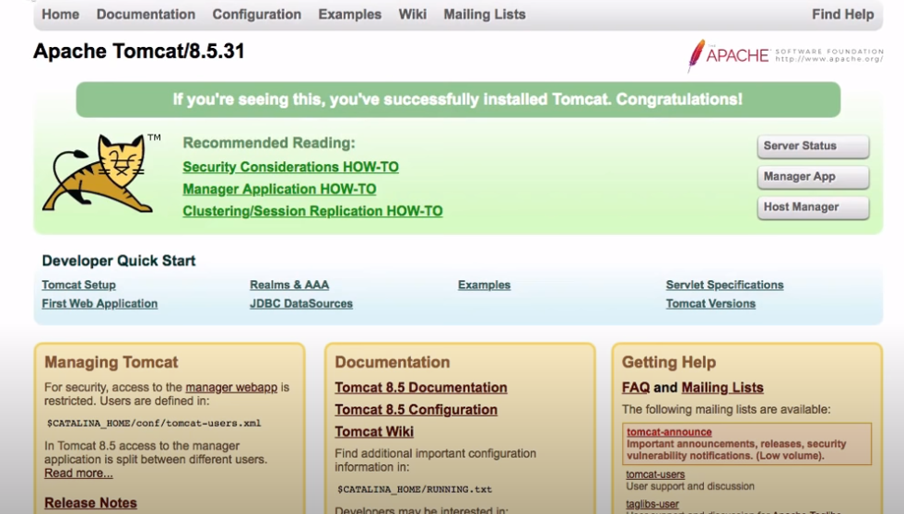

For detailed information of the stages involved please see the jenkinsfile attached to it.