1.Replicate s3 bucket from one bucket to another bucket of different accounts

Policy attached to source bucket(3pillar) of Source account:
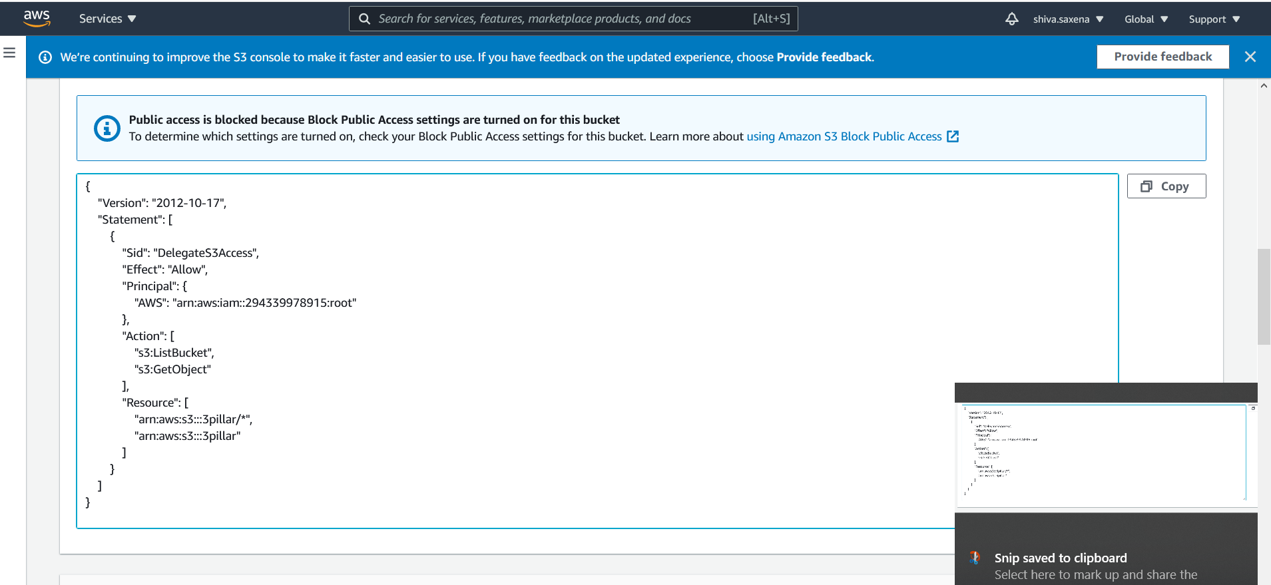
Policy attached to IAM user(3pillar) of Destination account:

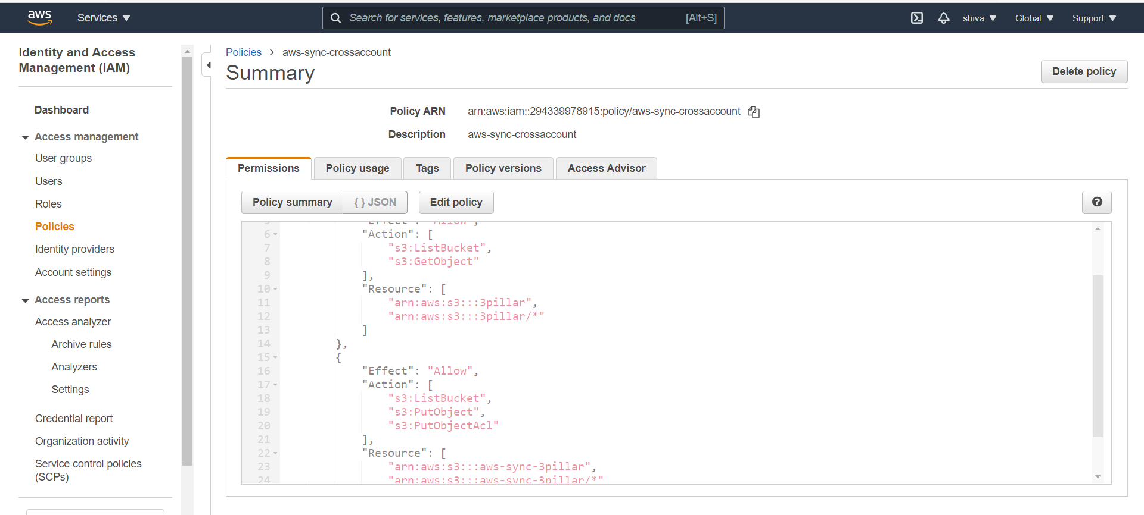
Source bucket(3pillar) data:
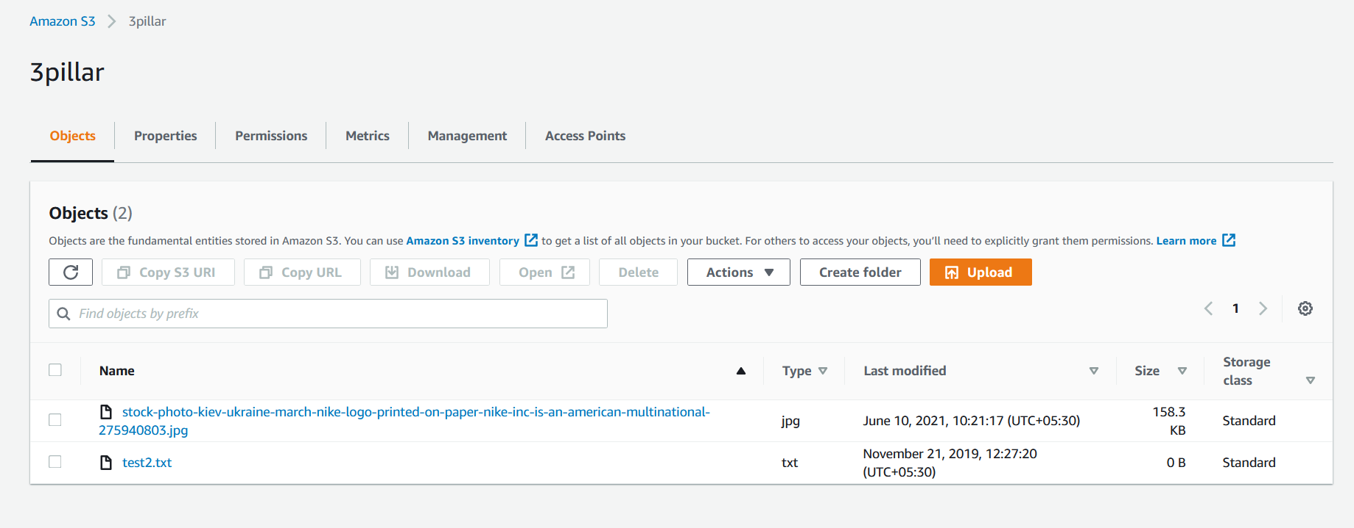
After configuring AWS CLI, following command run from user 3pillar cli :
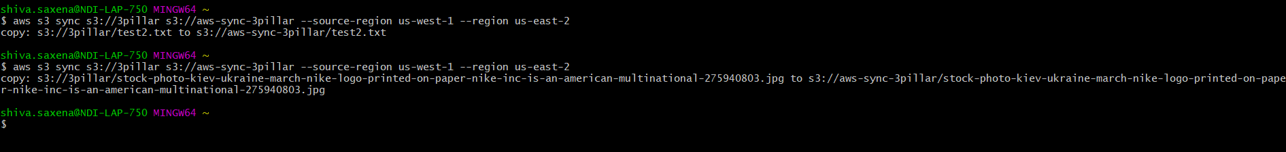
Destination bucket(aws-sync-3pillar):

