Cloudfront distribution created
S3 policy-
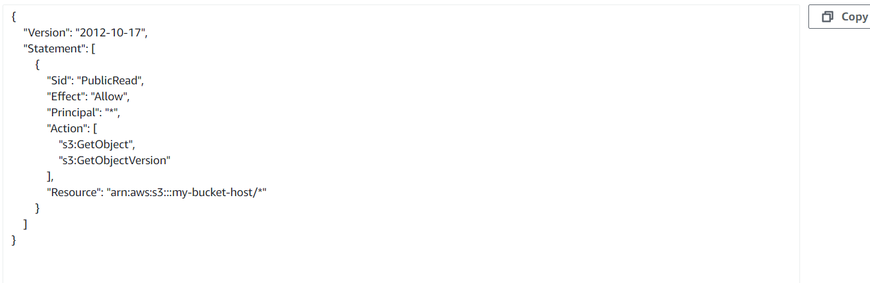
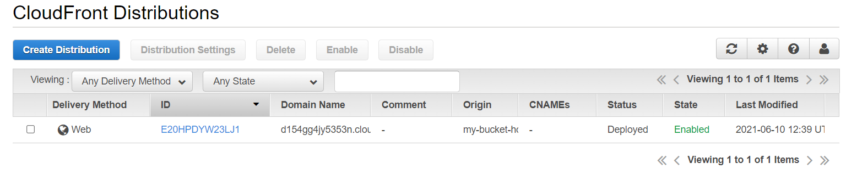
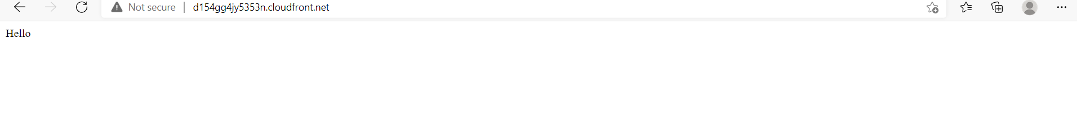

New record set in Route53 for primary and secondary failover in routing policy.

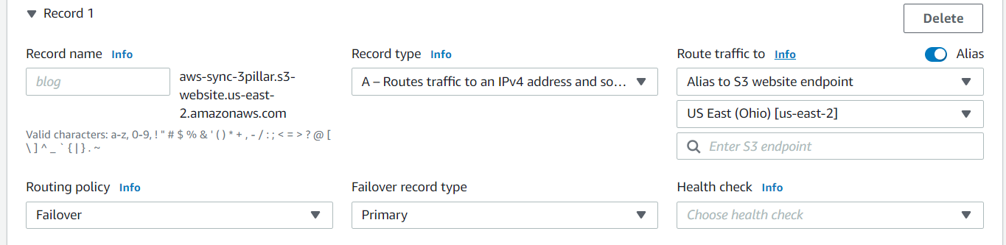
Couldn't finish this due to time constraint.

