Q1 Create a VPC through terraform with 4 subnets and use CIDR that consists of minimum IPs. ( Networking basics, Terraform )

For Authentication :-Used An EC2 Role with Administrator Access for Terrform credentials Authentication .

CIDR used for minimum Ips :-
VPC- 10.0.0.0/26
Subnet 1- 10.0.0.0/28 ( Available 11 IPs)
Subnet 2- 10.0.0.16/28 (Available 11 IPs)
Subnet 3- 10.0.0.32/28 (Available 11 IPs)
Subnet 4- 10.0.0.48/28 (Available 11 IPs)

Directory Structure :
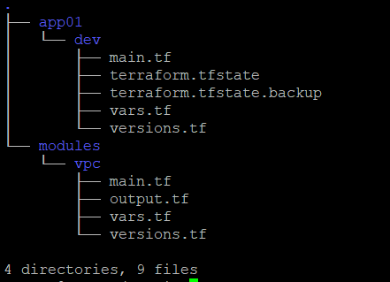

Codes :-
Attached in another folder named Q1CodeForVPCusingTerraform
Also over this link (https://github.com/HemantTomar/Q1CodeForVPCusingTerraform.git)

Result :-
git clone :
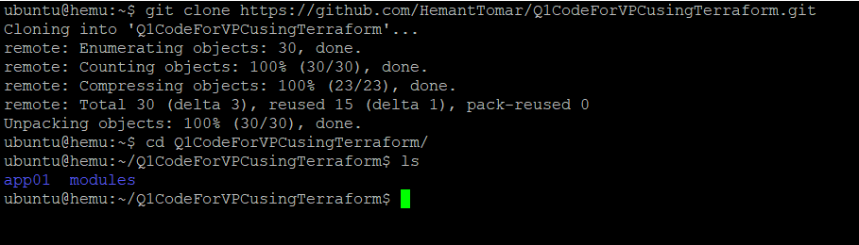
terraform init :

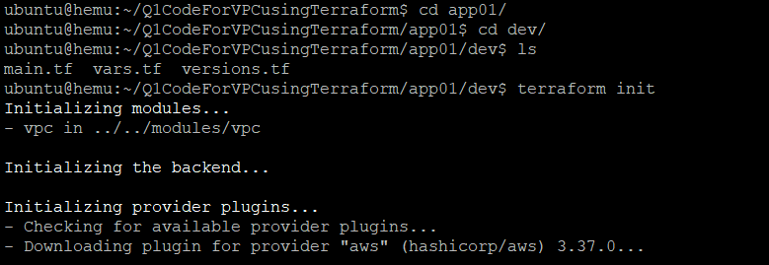
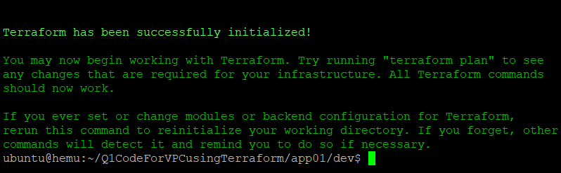
terraform apply :
