Q2 Create a CI/CD pipeline using jenkinsfile ( No Freestyle project ) to build, test and deploy docker containers from a private repository. ( CI/CD , Git )

Solution: Os used -Ubuntu
Pre installed – Java,Jenkins,Docker
Note : Before running this do run these command to not get error from docker security
sudo chmod 666 /var/run/docker.sock
sudo apt remove golang-docker-credential-helpers
Code for Jenkinsfile:
node{
stage('SCM Checkout'){
git credentialsId: 'git-cred', url: 'https://github.com/HemantTomar/Q2JenkinsPipeline.git'
}
stage('Build Docker Image'){
sh 'docker build -t hemu14/my-app:2.0.0 .'
}
stage('Testing Docker Image Build')
{
sh 'docker ps'
}
stage('Push Docker Image'){
withCredentials([string(credentialsId: 'docker-pwd', variable: 'dockerHubPwd')]) {
sh "docker login -u hemu14 -p $dockerHubPwd"
}
sh 'docker push hemu14/my-app:2.0.0'
}
}
Code for Dockerfile:
FROM ubuntu:latest
MAINTAINER Hemant Kumar
RUN apt-get update
RUN apt-get install -y python python3-pip
RUN pip install Flask
ADD hello.py /home/hello.py
WORKDIR /home
Code for hello.py:
#! /usr/local/bin/python3
print('Hello, world!')

Step1: Creating Pipeline------Q2JenkinsDockerBuild

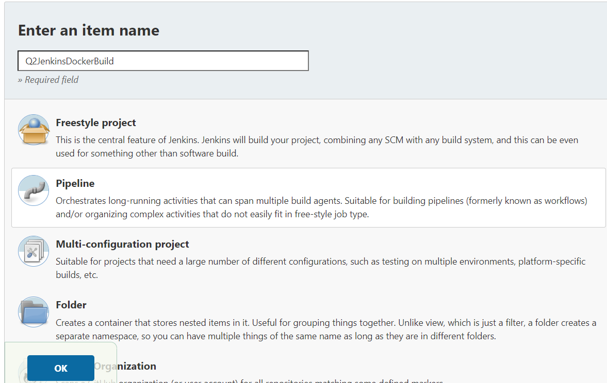

Step2 : Created Private Git Repository------- Q2JenkinsPipeline
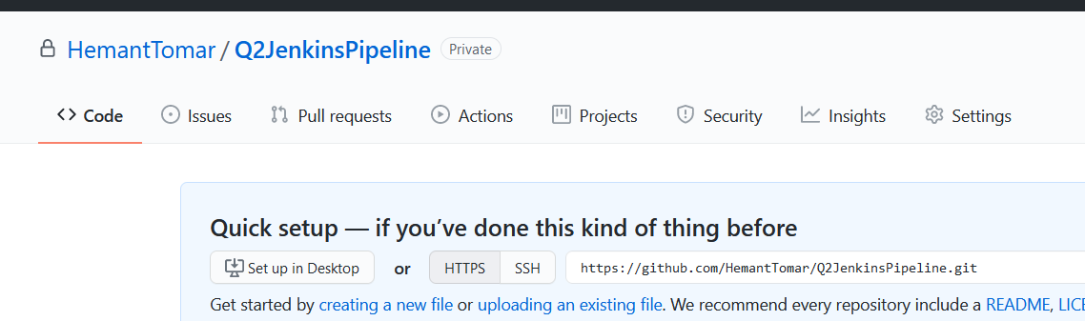

Step3: Adding Github Repository Credentials to Pipeline
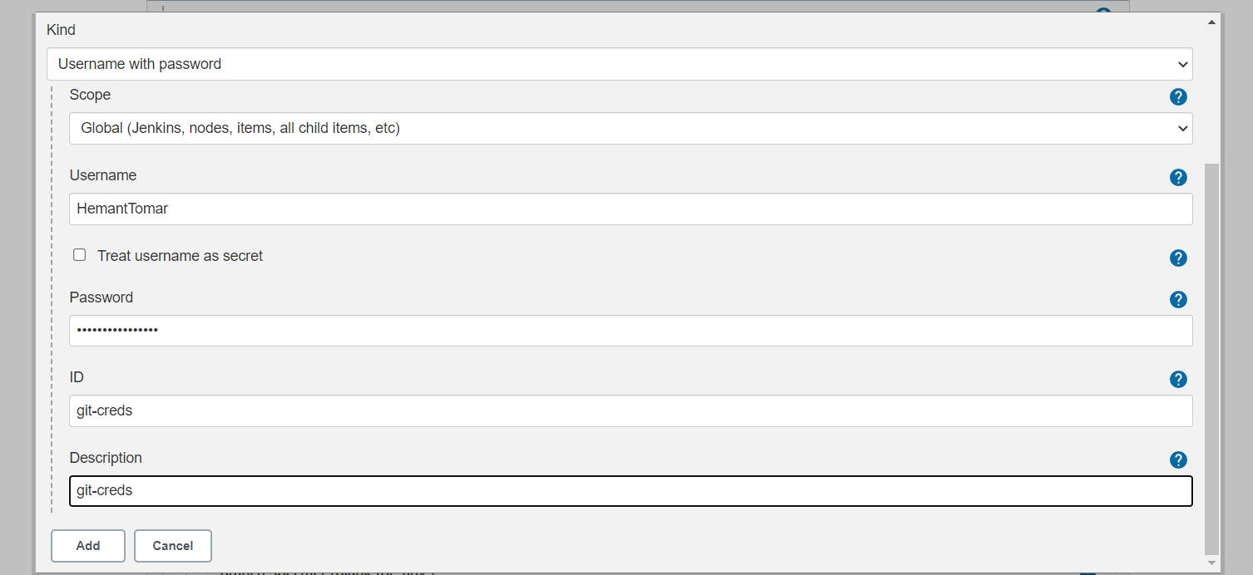

Step 4: Pipeline script from SCM ----- added git repository

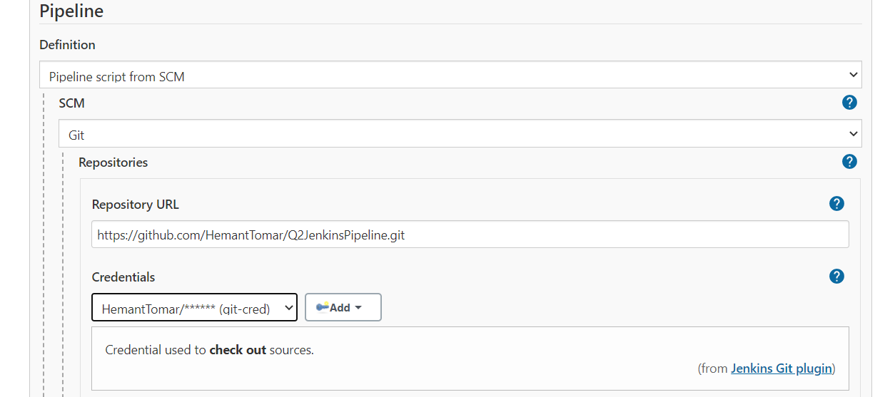

Step 5: Making Pipeline syntax for Docker Hub credentials
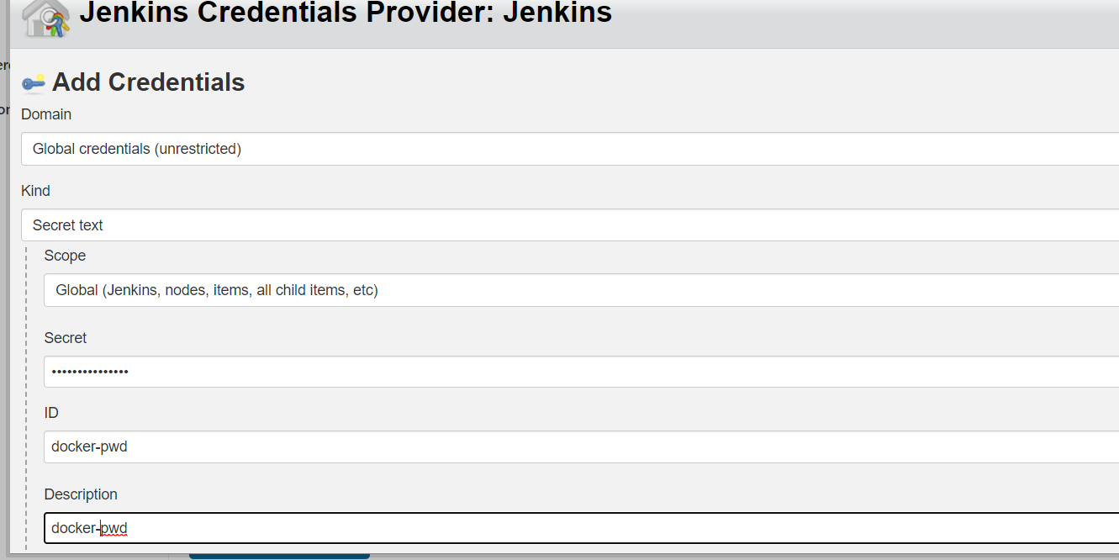

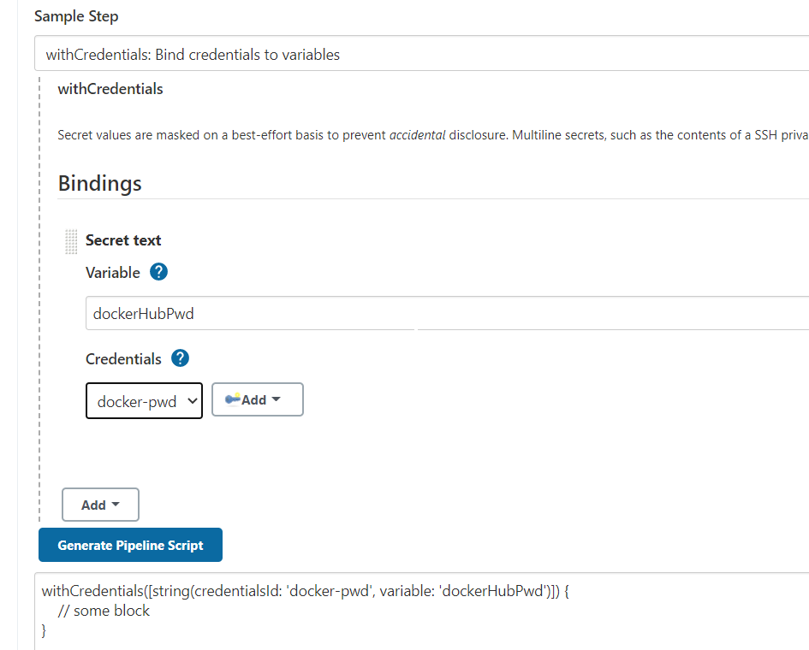

step 6: Added Jenkinsfile ,Dockerfile and hello.py file to Private Git Repository

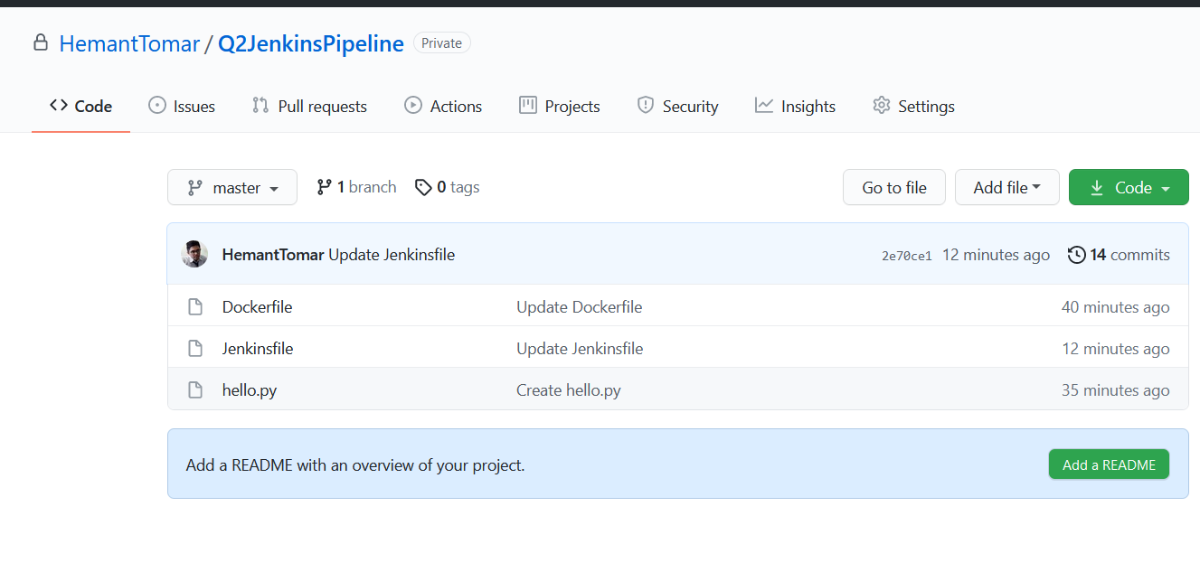
step 7: Build Successful

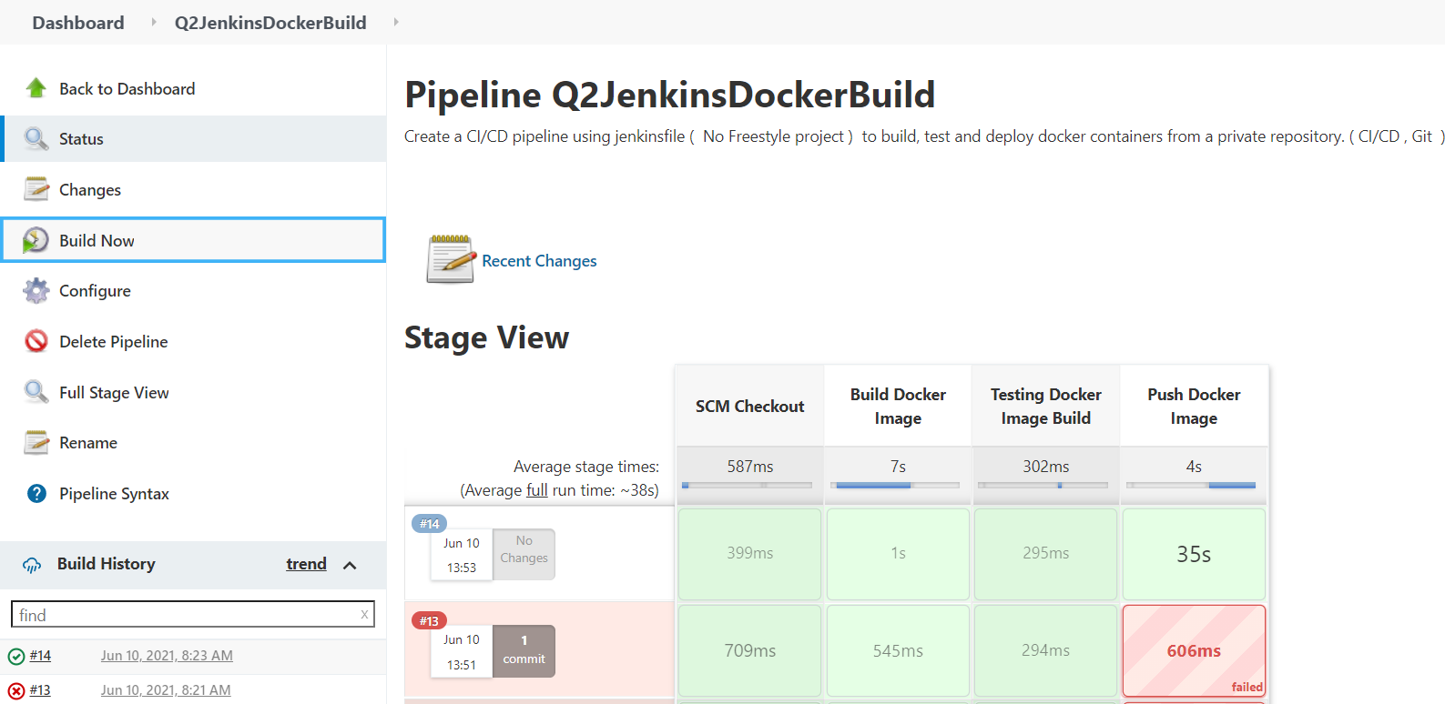

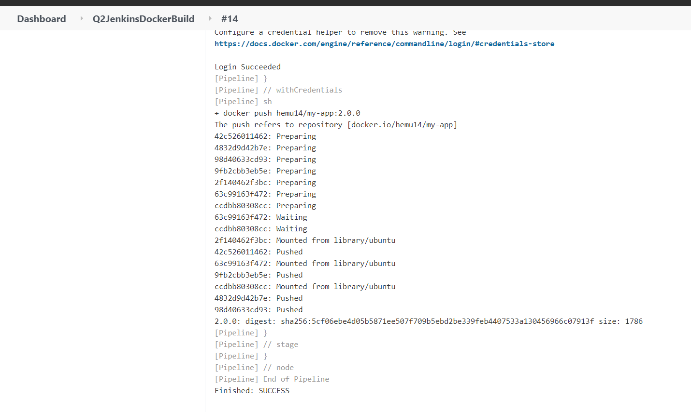
Step 8: Pushed Docker Image Verified .

