Q4 .Create cloudfront for a failover website with s3 bucket and route53. ( DNS , CDN , S3 replication )

Solution.

Step1 . Created S3 Bucket to host static website :

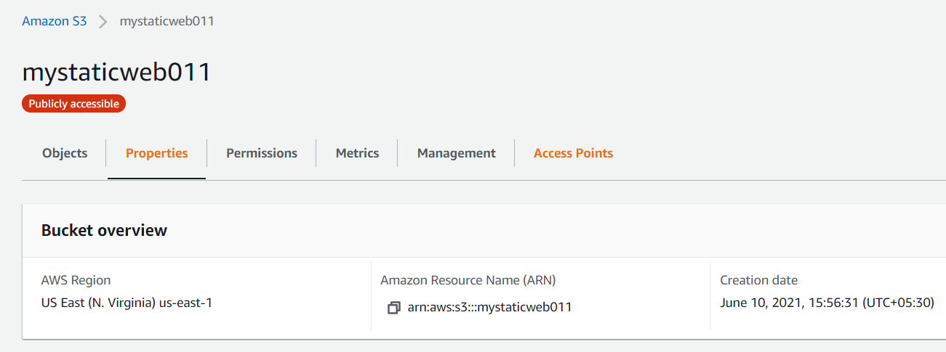

step2: Uploaded objects to this bucket :

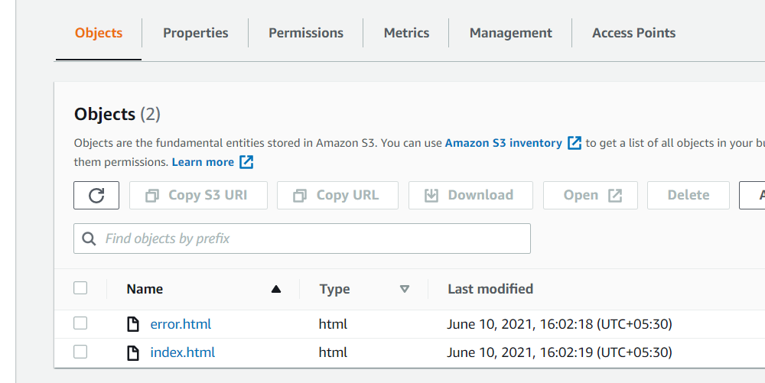

step3 : Verify static website hosted:

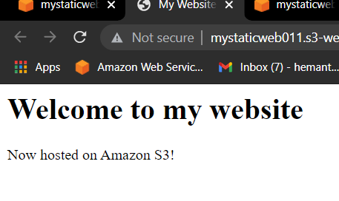
step 4 : Created two cloudfront distribution :

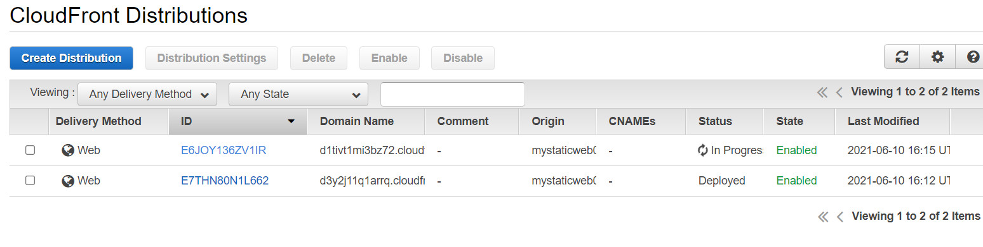
step 5 : created two Route53 record:(used cloudfront domain names)

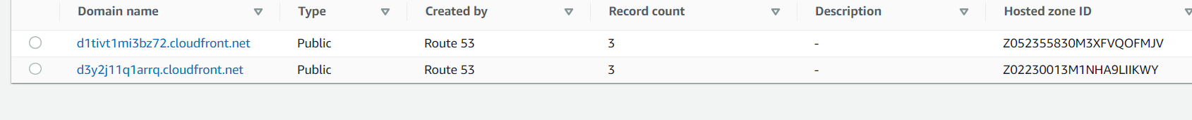

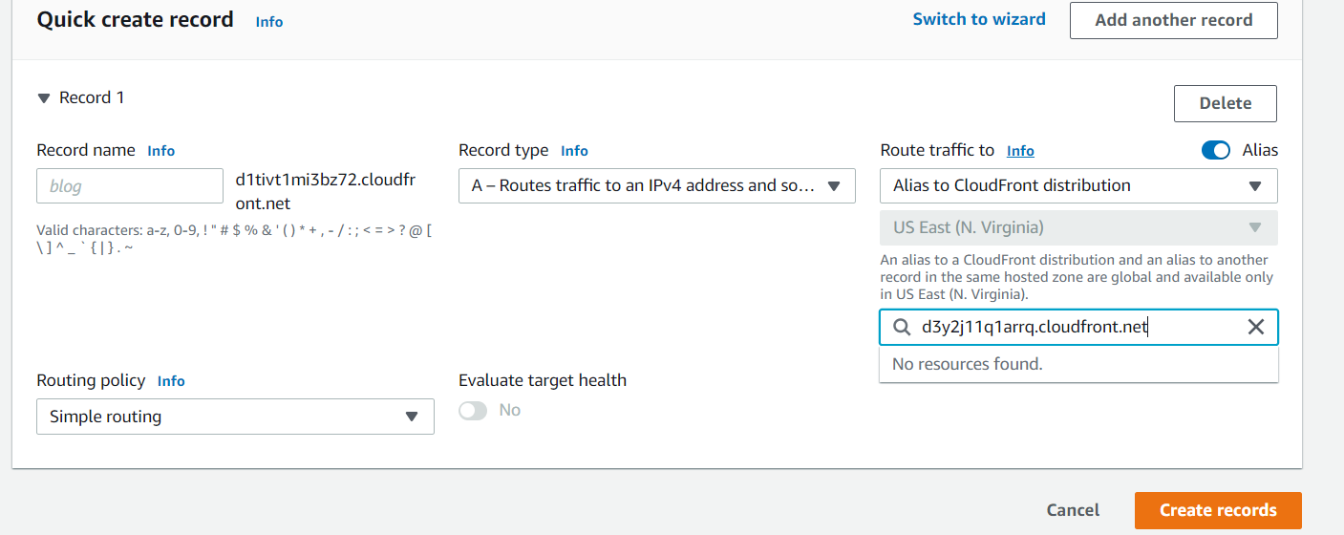

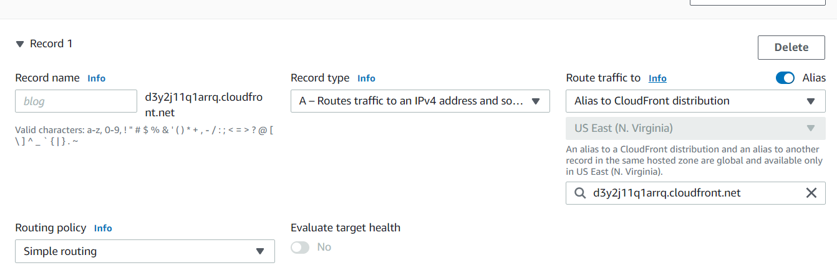

step6 : verifying results from two cloudfront distribution:
