A Design Procedure for Sintered Copper Flat Heat Pipes

Nitish Tripathi1*, Prafulla P. Shevkar1, Chitransh Atre1 and Baburaj A. Puthenveettil1

**1** Department of Applied Mechanics, IIT Madras, Chennai-600036, India

* nitishkumartripathi7@gmail.com

# ABSTRACT

In this paper we obtain the design parameters such as the length of the heat pipe, the porosity and the maximum heat flux for flat heat pipe. The length of the heat pipe is obtained for different values of maximum heat flux for various values of the porosity and the mean pore size of the sintered porous media. We determine numerically the optimum mean pore diameter required to avoid dry-out conditions at a given heat flux. The maximum heat flux first increases and then decreases with increasing the mean pore radius. The dependence of maximum heat flux on porosity is also studied for different pressure values inside the cavity. We also study the effect of acceleration due to gravity and find that the value of g strongly affects maximum heat flux.

**Keywords**: Heat pipe, porosity, mean pore radius, dry-out, g-factor.

# INTRODUCTION

Thermal ground plane (TGP) or flat heat pipe is a device which is used to manage the heat transfer as it absorbs the heat from a heated source at one end and sinks the heat at the other end [4]. The heat pipes are being designed for passive thermal management, wherein heat transfer is required to be coupled with adiabatic region between the evaporator and condenser sections [5]. Since more heat generation may affect the working of devices properly, so it becomes necessary to keep the working temperature below the maximum limit which can be done using flat heat pipe. It has many applications e.g. in cooling the electronic devices, heat exchangers, spacecraft cooling, engines and automobile industries and solar energy devices [7]. TGP is very thin and small in size having high thermal conductivity. Therefore, due to compact size and good thermal performance, it is highly used for electronic chip cooling [8].

A rectangular copper cavity enclose the sintered porous media, which is fixed in the cavity bottom by fixing with the help of epoxy from front and rear side of the cavity such that the pores were not blocked. The porous media used in the heat pipe is based on Copper powder sintered. The porosity depend upon the sintering process [10]. The space above the surface of the sintered porous media in the cavity top wall forms the vapor region [6]. The degassed liquid (water) will be filled in the porous media of the cavity through the hole on the top plate of the cavity that hole can be sealed after the liquid filled by the help of melting the solder preform based on lead free Sn96.5Ag3.5 solder by the induction heater [14]. Heat absorbed from the hot chip by the fluid evaporates it to form vapor in the evaporator side [12]. This vapor will move to the condenser region of the chamber, where it condenses on the porous media and returns through the porous media to the evaporator region by capillary action of motion [7-8]. The following design calculations were done for a flat heat pipe with porous media made from sintered copper powder enclosed. The geometry considered is shown in figure 1.

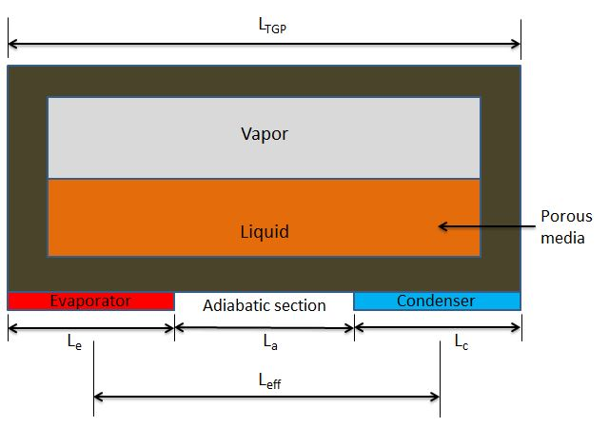

**Figure 1:** **Schematic of the heat pipe.**

# LITERATURE REVIEW AND OBJECTIVE

For a heat pipe to work appropriately without dry out, the net capillary pressure difference between evaporator and condenser region ($ΔP_{c}$) must be greater than the sum of pressure losses in the system. In the limiting case of dry out [6],

|  |  |
| --- | --- |
| $ΔP_{c}=ΔP_{l}+ΔP_{v}+ΔP_{b}$, | (1) |

Where, $ΔP_{l}$ is the pressure drop due to viscous resistance in the liquid, $ΔP_{v}$ is the pressure drop due to viscous resistance in the vapour and $ΔP_{b}$ is the hydro static pressure head. The capillary pressure $\left(ΔP_{c}\right)$ is given by the Young-Laplace equation,

|  |  |  |
| --- | --- | --- |
| $$ΔP_{c}=C_{1}\frac{2σ}{r_{p}}$$ |  | (2) |

where $C_{1}=0.5$, an empirical constant for sintered copper porous media dependent on the contact angle and the standard deviation of pore diameter [2], $σ=$ the surface tension of water in $(N/m)$ at ${100}^{∘}C$ and $r_{p}=$ the mean wick pore radius $d_{p}=2r_{p},r_{p}=5.80$ $μm$.

Since the Reynolds number of the fluid flow through the sintered media is small, $ΔP_{l}$ in (1) is approximated by Hagen-Poiseuille equation,

|  |
| --- |
|  |
| $ΔP_{1}=\frac{\overset{˙}{m}μ_{l}L_{\text{eff }}}{Kρ_{l}A_{\text{wick }}}$. | (3) |

Here, $μ_{l}=$ dynamic viscosity of the liquid, $L_{\text{eff }}=$ effective length of TGP, which is equal to $L_{a}+0.5\left(L_{e}+L_{c}\right.$) (see figure 1), $ρ_{l}=$ density of water $,A_{\text{wick }}=$ area of cross section of wick and $K$ is the permeability of the porous media. The permeability of the sintered porous media is given by the Chi equation [1],

|  |  |
| --- | --- |
| $K=\frac{r_{p}^{2}ε^{3}}{37.5(1-ε)^{2}}$, | (4) |

However, Ababneh M. T. et al., $2014[3]$ shows that an estimate based on Hagen-Poiseuille relation, for an array of channels of circular cross section pores,

$K=C_{2}\frac{d_{p}^{2}ε}{32},$ (5)

with $C_{2}=1.17$, gives a better estimate of permeability as a function of porosity $ε$. The porosity of sintered wick has a profound influence on the maximum heat transfer rate according to the working principle of heat pipe [15].

In (1) the pressure drop in the vapour chamber $\left(ΔP_{v}\right)$ is approximated by,

$ΔP_{v}=\frac{32μ_{v}L_{eff}\overset{˙}{m}}{d_{v}^{2}ρ_{v}A_{\text{vap }}}\text{, }$ (6)

assuming laminar flows. Here, $μ_{v}$ is the dynamic viscosity of water vapour at 1 bar, $d_{v}=4A_{\text{vap }}/2\left(W_{v}+H_{v}\right)$ is the hydraulic diameter of vapour channel, where $W_{v}$ and $H_{v}$ are the width and the height of the vapour chamber, $ρ_{v}=$ vapour density and $A_{\text{vap }}$ is the area of cross section of the vapour chamber. The body force/area $ΔP_{b}$ in (1) is considered as the static pressure head over the length of the heat pipe $L_{TGP}$, multiplied by a factor $g_{f}$ to take into account of the acceleration of the heat pipe.

$ΔP_{b}=ρ_{l}gL_{TGP}g_{f }$ (7)

Where, $L_{TGP}=L_{a}+L_{e}+L_{c}$.

We assume that all the heat supplied by the chip to the heat pipe is fully carried away by water vapor (which were already degassed before filling), which condenses at the condenser and flows back through the porous media to the evaporator end [9]. Then, the mass flow rate of liquid through the porous media $\overset{˙}{m}=Q_{HP}/h_{fg}$ where, $Q_{HP}$ is the heat flux supplied by the chip in watts and the latent heat of vaporisation of water $h_{fg}=2256400 J/Kg$. The width of the heat pipe is fixed at 20 mm due to the geometric constraints as per our  
requirement. The width of the heat pipe is fixed at 20 mm due to the geometric constraints as per our  
requirement. However, changes of width does not seriously impact the design since, as we  
verified, the flux per unit area remains constant for a given $L_{TGP}$ and ε for heat pipes of  
different widths equal to 10 mm, 20mm and 30 mm. Therefore, we fix the width of the cavity as W = 20 mm and the height of the porous media and vapour cavity as h = 0.5 mm and hv=2 mm; Then Avap=W.hv and Awick=W.h. We use the properties of water and water vapour, given in table 1. These properties were chosen at a pressure of $1 atm$ and temperature of ${100}^{∘}C$, assuming that the condenser is cooled so that the amount that evaporates at the evaporator and condenses at the condenser is the same so that the pressure remains the same as the saturation pressure at the ambient temperature. We could also consider that the evaporator temperature is ${140}^{∘}C$ and the condenser temperature ${60}^{∘}C$ so that the properties are evaluated at a mean temperature of ${100}^{∘}C$, the saturation temperature at $1 atm$. This assumption needs to be relaxed in future calculations where a temperature model is coupled to a pressure model. We however show later that calculation done at saturation pressure at vacuum does not change the following results drastically.

# RESULTS AND DISCUSSION

We then solve (1) to (7) for any one of the three unknown $Q_{HP}$, $ε$ and $L_{TGP}$ by fixing the other two for the dry out condition (1). Simulations were conducted with the values of properties and parameters shown in table 1 for $r_{p}=5.86, 20 \& 40$ $μm$.

|  |  |  |  |  |
| --- | --- | --- | --- | --- |
| $$μ_{l}( Pa.s)$$ | $$ρ_{l}\left(Kg/m^{3}\right)$$ | $$μ_{v}( Pa.s)$$ | $ρ_{v}$ $\left(Kg/m^{3}\right)$ | $$d_{v}(mm)$$ |
| $2.822×$ ${10}^{-4}$ | $$958.35$$ | $$1.2×{10}^{-5}$$ | $$0.590$$ | $$0.0036$$ |

Table 1: Input parameters during the study.

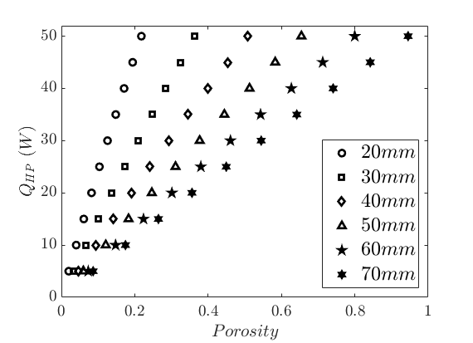

**Figure 2a: Variation of the dry out flux with porosities for various maximum possible lengths of TGP,**

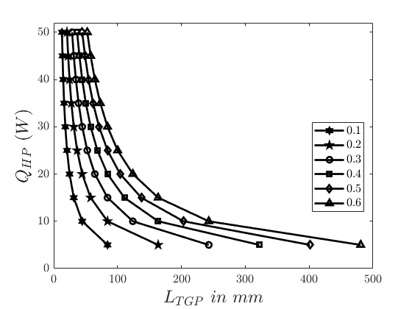

**Figure 2b: Variation of flux with maximum possible length of TGP for various porosities**

Figure 2 shows the design curves for a heat pipe with sintered porous media having $d_{p}$ =11.6 μm. Figure 3 gives the design curves for a heat pipes with sintered porous media of various mean pore diameters.

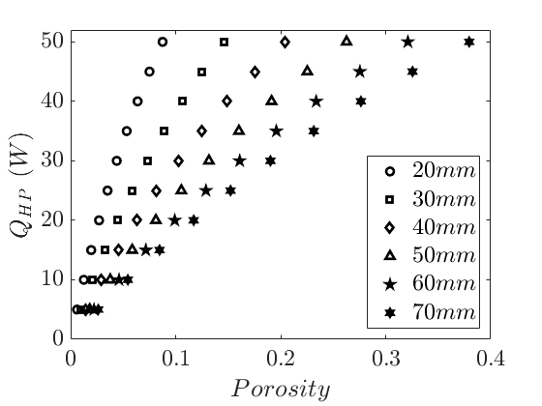

**Figure 3a: Variation of dry out flux with porosities for various maximum possible lengths of TGP at $d_{p}=40μm$**

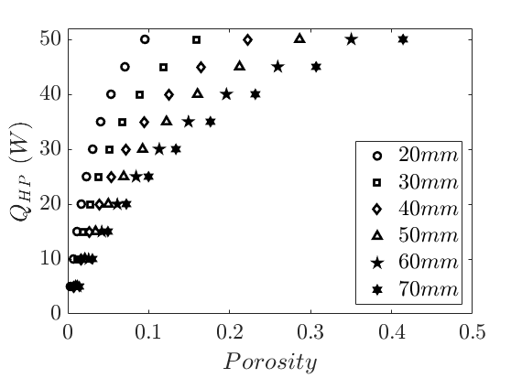

**Figure 3b: Variation of dry out flux with porosities for various maximum possible lengths of TGP at $d_{p}=80μm$**

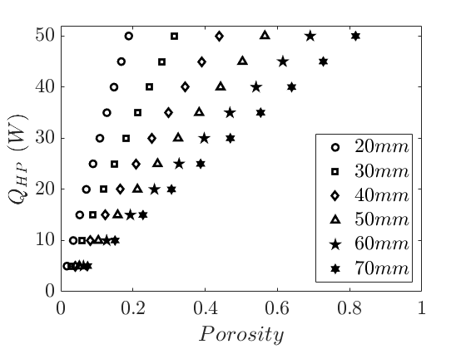

**Figure 4: Variation of flux with maximum possible length of TGP for various porosities with vacuum pressure $0.3$ Bar with the pore size having $d_{p}=11.60$ $μm$**

Figure 2b shows the limiting heat flux $Q_{HP}$ that would result in dry out for various $L_{\text{TGP }}$ when the porosities are changed over the range0.1< $ε$ <0.6. Figure $2\text{a}$ shows that for a $20 W$ heat removal over a distance of $3 cm$, the porous media with a mean pore diameter of $d_{p}=11.60μm$ needs to have a porosity of $0.15$ or more. Similar information can be obtained from the plot of $Q_{HP}$ vs $L_{\text{TGP }}$ for various $ε$ shown in figure~2b. Figure~2b shows that a heat pipe with $L_{\text{TGP }}=5 cm$ would need an $ε≥0.25$ to remove $20 W$ of heat without dry out.

We now study the effect of increasing the mean pore diameter. Figure 3 a shows that with increase in $d_{p}$ to $40μm$ for a given length of TGP $\left(L_{TGP}=30 mm\right)$, for a maximum heat flux $Q_{HP}=20 W$ without dry out, a much lower porosity of $ε≥0.045$ will work, similarly with $d_{p}=80μm$, $ε≥0.028$ in figure 3b.

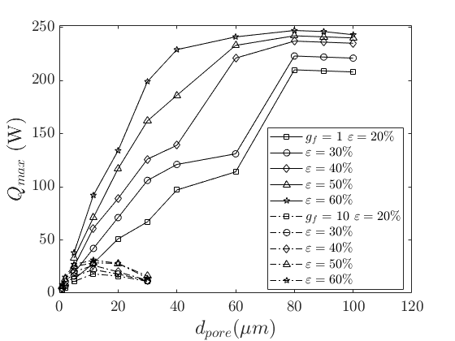**Figure 5: Maximum heat transferable for various pore diameters $\left(d_{p}\right)$ at different values of porosities $(ε)$ for a length of TGP $\left(L_{TGP}\right)=3 cm$, with $g_{f}=1$ and $10.$ The heights of vapour and porous regions are equal to 1 mm.**

Since the cavity is to be evacuated before filling, we now check the variation of the above design curves with pressure. Figure 4 shows the variation of dry out heat flux with porosity when the pressure inside the cavity is saturation vacuum pressure of $0.3$ bar. Figure 4 shows that for $L_{TGP}=30 mm$, for $Q_{HP}=20W,ε=0.12$ at $0.3$ bar while, $ε=0.13$ at 1 bar from figure $2 b$. This negligible variation in $ε$ of $8\%$ shows that the neglect of pressure variation in the design calculations to be reasonably correct.

During the evacuation process, the pressure inside the cavity will reach $0.3$ bar while an atmospheric pressure of 1 bar will result in the wall of the cavity to feel a pressure of $0.7$ bar from the outside [11]. To find whether the casing will collapse due to this force, we find the maximum deflection at the center of an edge supported plate by,

$δ_{max}=0.284La^{4}/Et^{3}\left(1.056(a/b)^{5}+1\right),$ (8)

where the load per unit area $(L)=42 N$, the shortest length $\left(a\right)=W=20 mm$, the longest length (b) $=L_{\text{TGP }}=30 mm$, the modulus of rigidity of copper $(E)=110$ GPa and thickness of the plate $(t)=1 mm$. From $\left(8\right),δ_{max}=0.015 μm$. Since $δ_{max}$ is very small, there will be negligible deflection at the centre of the plate and we expect the present casing to not collapse.

Figure 5 shows the maximum heat flux that can be removed by the TGP as a function of $d_{p}$ at different porosities for a given length $L_{TGP}=30 mm$, for $g_{f}=1$ and 10. The heat flux increases and then it decreases with increase in $d_{p}$ for a given $ε$, so that an optimum $d_{p}$ could be found out. Figure 5 shows that a mean pore diameter of 40 to $80μm$ will achieve a maximum heat transport of about $240 W$, avoiding dry-out at $g_{f}=1$ and $ε=20\%$. The heat flux is maximum for $g_{f}=10$ at $d_{p}=15μm$ and for $g_{f}=1$ at $d_{p}=80μm$.

# CONCLUSIONS

In this paper we obtained the design parameters to avoid dry out in a thin flat heat pipe. The walls of the heat pipe was chosen as 0.5 mm thick to reduce temperature drop across the walls, the design was tested to find negligible deflection for a pressure difference of 0.7 bar across the wall, which is expected to occur for saturation condition inside the heat pipe cavity. Balancing capillary pressure with the viscous pressure drop in the porous media and the vapour cavity, we obtain the dry out length for various heat fluxes and porosities. We find that at a pore size of $d_{p}$ = 11.6 $μm$, the dry out length $L_{TGP}$ is 3 cm when 20 W of heat flux is to be removed from the chip of area 5 x 5 sq. mm. The calculation done for 1 bar, however we show that doing the calculations at a saturation pressure of 0.3 bar does not change the obtained results significantly. For a length of 3 cm and a porosity of $ε$ = 0.045, the maximum heat flux increases as $d_{p}$ increases. Since the minimum $ε$ to avoid dry-out decreases with increase in $d_{p}$, for a given length of TGP and $Q_{max}$ (figure 5), larger pore sizes, as would occur in Cu foams [13], seems to be desirable. We also show that an increase in g results in a decrease in the maximum heat flux.

ACKNOWLEDGEMENTS

We gratefully acknowledge the financial support of DST, Government of India through their grants IMP/2018/001167. We acknowledge the support of Usha P Verma Sc ‘G’, Advanced Systems Laboratory (ASL), DRDO, and Astra Microwave Products Ltd.

NOMENCLATURE

|  |  |  |
| --- | --- | --- |
| $$L_{TGP}$$ | Length of the TGP | [m] |
| $$g_{f}$$ | Gravity Factor | -- |
| $$r_{p}$$ | Radius of the pore size | [m] |
| $$μ_{l}$$ | Dynamic viscosity of water | [Pa.s] |
| $$ρ_{l}$$ $$ε$$ $$μ_{v}$$ $$ρ_{v}$$ $$g$$ $${ A}_{\text{vap }}$$ $L_{a}$ $L_{e}$ $L_{c}$ $$H_{v}$$ $$W$$ | Density of water  Porosity  Dynamic viscosity of water  Density of vapour  Gravity  area of cross section of the vapour chamber  Length of adiabatic section  Length of evaporator section  Length of condenser section  Height of the vapour region  Width of wick | [kg/m3]  --  [Pa.s]  [kg/m3]  [m/s2]  [m2]  [m]  [m]  [m]  [m]  [m] |
|  | surface tension of water  Permeability | [N/m]  [m2] |

REFERENCES

1. Chi. S. W., Heat Pipe Theory and Practice. Series in thermal and fluids engineering. New York: McGraw-Hill, 1976.
2. De Bock HPJ, Varanasi K., Chamarthy P., Deng T., Kulkarni A., Rush BM, Russ BA, Weaver SE, Frank M. Gerner. "Experimental investigation of micro/nano heat pipe wick structures." In: Asme International Mechanical Engineering Congress and Exposition, Proceedings IMECE2008.67288 (2008), pp. 991-996.
3. Ababneh, M. T., Gerner, F. M., Pramod Chamarthy, De Bock, P., Chauhan, S., Deng, T. "Thermal-Fluid Modeling For High Thermal Conductivity Heat Pipe Thermal Ground Planes". In: Journal Of Thermophysics and Heat Transfer $28.2$ (2014).
4. Faghri A., Heat Pipe Science And Technology. Taylor & Francis, 1995
5. Jaipurkar T., Kant P., Khnadekar S., Paralikar S. and Bhattacharya B., Thermo-Mechanical Design and Characterization of Flexible Heat Pipes, Applied Thermal Engineering, Vol. 126, pp. 1199-1208, 2017.
6. Ababneh, M. T., Gerner, F. M., Hurd, D., De Bock, P., Chauhan, S., and Deng, T., “Charging Station of a Planar Miniature Thermal Ground Plane,” Proceedings of the ASME/JSME 2011 8th Thermal Engineering Joint Conference, Honolulu, HI, 2011.
7. Kenny, T., 2007, “A–Thermal Ground Plane (TGP),” DARPA, Solicitation No. BAA07- 36,1_darpa_baa07_36_tgp_final_for_posting_13apr07.pdf
8. Ababneh, M.T., Chauhan, S.S. Gerner, F. M., Hurd, D., De Bock, P., and Deng, T., Charging Station of a Planar Miniature Heat Pipe Thermal Ground Plane”. J. Heat Transfer 135, 021401, 2013.
9. Nam, Y., Sharratt, S., Cha, G.,and Ju, Y. S., “Characterization and Modeling of the Heat Transfer Performance of Nanostructured Cu Micropost Wicks” J. Heat Transfer, 2011, Vol. 133 / 10150
10. Hanlon, M.A., and Ma, H.B., “Evaporation heat transfer in sintered porous media,” J.Heat Transfer 34 (4), 2003, pp. 644–652
11. Tien, C., Majumdar, A., and Gerner, F., 1997, Microscale Energy Transport. Taylor & Francis, London.
12. Shirazy M.R.S., Fréchette L.G., A parametric investigation of operating limits in heat pipes using novel metal foams as wicks, ASME 2010 3rd Joint US-European Fluids Engineering Summer Meeting and 8th International Conference on Nanochannels, Microchannels, and Minichannels FEDSM2010-ICNMM2010, (2010).
13. Shirazy M.R.S., Fréchette L.G., Capillary and wetting properties of copper metal foams in the presence of evaporation and sintered walls, International Journal of Heat and Mass Transfer, Volume 58, Issues 1–2, 2013, Pages 282-291,
14. Dhillon N. S. and Pisano Albert P 2014 *J. Micromech. Microeng.* **24** 035021
15. CHEN Y. M., WU S. C., CHU C. I., Thermal performance of sintered miniature heat pipes [J]. Heat and Mass Transfer, 2001, 37(6): 611616.