# What is inherently wrong with the form ?

1. **Form Name**

* Form name is mentioned as “Account Information” but the form is related to payment/billing. The name could be misleading to the user. So, name should be “Payment Information” or “Billing Information” instead of “Account Information”.

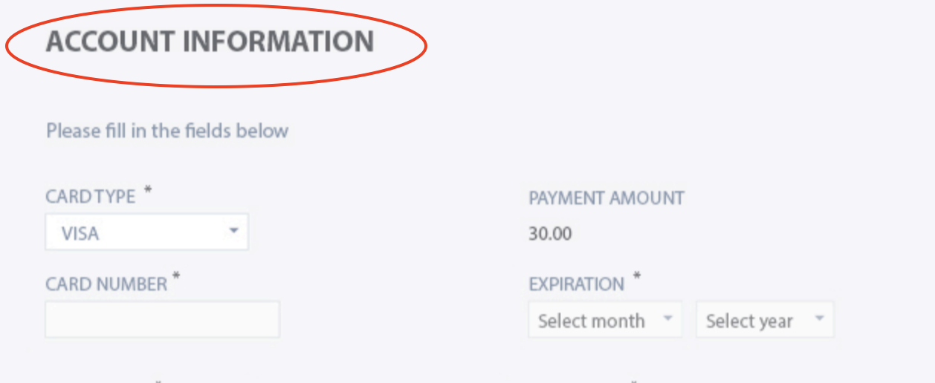

1. **Currency Information**

* Under the field “PAYMENT AMOUNT” just the amount is displayed without any currency details like EUR, INR etc. These days, it is quite common to pay from different cards with different currencies. So, it is very important for the user to know the currency.

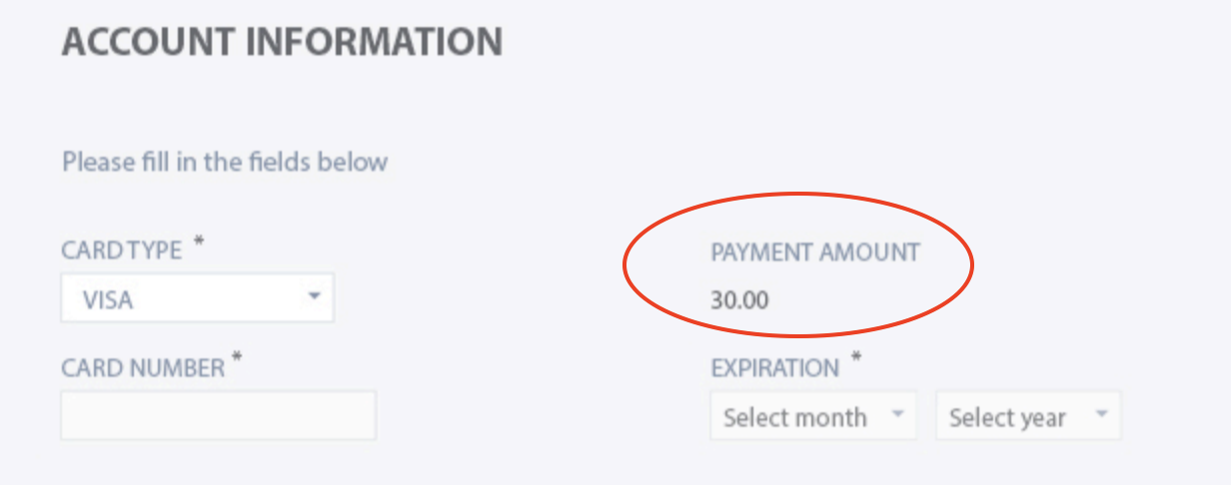

1. **Card Types – Symbols/Images**

* In the current modern world, there are so many options and card types to pay. For example, VISA, MASTER, AMEX, PAYPAL etc. So, it would be better to display the images to make it very clear to the user what to use.



1. **Missing CVV Field**

* Transaction will be successful only when CVV is provided. So, this field should be available in the form.

1. **Missing Country Field**

* Country should also be part of the address, as we are asking for other related fields like City, Postal Code and State. Also, in some countries, address is also considered to make the transaction. So, it is important to have country field in the payment form.

1. **Name On Card**

* Instead of First Name, Middle Name and Last Name, it would be good to have ‘Name On card’ as this will be very clear for the user, what to provide and would be useful in making the transaction. This would also clear the confusion for the user which one to enter in First Name and Last Name fields, in case of multiple words in name.

1. **Billing Address**

* “Billing Street Address” should be renamed to “Billing Address”.

1. **Expiration Date**

* Instead of just “Expiration”, it would be nice to have the field name as “Expiration Date”