DRAFT FOR ADVISOR REVIEW — 23 Oct 2026 — fine-tuning results (M1–M3) pending
Fine-Tuning Pretrained Models for Khmer Speech Recognition: A Leakage-Free Evaluation Protocol and Zero-Shot Baselines
Sem Chitra, Dr. Mao Makara
Data Science in Computer Science, Royal University of Phnom Penh, Cambodia

Abstract
Khmer remains under-resourced for automatic speech recognition (ASR), and published Khmer results are hard to compare because they use different test sets, text normalization and training data. We audit the full Digital Divide Data Khmer corpus (450,396 utterances, 1,073.9 h, 20 speakers) and find that every sentence is read by four different speakers, so a random split leaks test sentences into training. We define a split that holds out both speakers and every sentence they read, a documented Khmer text normalization protocol, and a space-insensitive character error rate (CER). Zero-shot, all three Whisper models fail on Khmer (CER ≥ 133%), looping on a repeated character or misidentifying the language, whereas the MMS-1B CTC model with its Khmer adapter reaches 9.7% CER on the held-out test set. These results set the baselines for controlled fine-tuning experiments on data quantity and Khmer-specific strategies.

1. Introduction
Large multilingual speech models such as Whisper [1] and MMS [3] cover Khmer, but their out-of-the-box accuracy on Khmer is poor. A 2026 study reports 103.19% CER for zero-shot Whisper-large-v3 on FLEURS Khmer and 25.99% after full fine-tuning [5]; on SEA-SpeechBench, even commercial speech models reach 13–30% CER [6]. Khmer is written without spaces between words, so word error rate depends on a segmentation choice, and CER is the more reliable metric.
A large Khmer corpus is now openly available [10], and community models have already been fine-tuned on it [11]. What is missing is a controlled, reproducible study: reported numbers use different test sets and normalization, and none that we found guards against the sentence leakage this corpus makes easy. This paper contributes:
- A full-corpus audit of the Digital Divide Data Khmer dataset that corrects several figures on its dataset card (Section 3).
- A split protocol that holds out both test speakers and every sentence they read, with automatic leakage checks (Section 4.1).
- A Khmer text normalization protocol derived from the character inventory of all 112,516 sentences (Section 4.2).
- Zero-shot baselines for two model families, Whisper (encoder-decoder) and MMS (CTC), including a diagnosis of Whisper's failure mode (Section 5).

2. Related Work
Early Khmer ASR built HMM-based broadcast-news recognizers and compared word and sub-word units because of the missing word boundaries [4]. Current work starts from multilingual pretrained models. Whisper is trained with weak supervision on about 680,000 hours of audio [1]; MMS covers 1,107 languages with language-specific adapters [3]; FLEURS provides about 12 hours per language for evaluation [2]. How many hours of a language a model saw in pre-training predicts whether self-supervised or weakly-supervised models adapt better [8].
For Khmer specifically, BuzzASR fine-tunes Whisper-large-v3 per language [5], and community model cards report 22.8% FLEURS CER for a Whisper-base model trained partly on the corpus we use [11] and 12.03% for an Omnilingual CTC model [12]. These numbers come from different test sets and normalization and are not directly comparable. A controlled Whisper fine-tuning study for Assamese [7] is the closest methodological template. We found no controlled study of modern pretrained models fine-tuned on Khmer.

3. Dataset and Audit
We use the Khmer ASR Cultural Dataset [10] (CC BY-SA 4.0) at a pinned revision. Because its dataset card is internally inconsistent, we audited all 4,447 parquet files by reading only their metadata columns, without downloading the audio. Table 1 compares the card with the audit.
Table 1. Dataset card versus our full-corpus audit.
Item | Dataset card | Our audit
Utterances | 450,396 | 450,396
Total audio | 727.94 h | 1,073.9 h
Speakers with audio | 12 | 20 (9 female, 11 male, aged 18–66)
Unique sentences | not stated | 112,516
Topics / subtopics | 61 / 1,749 | 70 / 2087
Sample rate | 16 kHz (feature metadata) | 16 kHz mono, except 71 files at 48 kHz

Clips have a median length of 8.06 s (5th–95th percentile 4.5–14.4 s). The key finding is that 112,487 of 112,516 sentences are read by exactly four different speakers, in groups of two female and two male readers. Speaker hours are also highly unbalanced (Figure 1): the three largest speakers hold 61% of the audio, while three speakers have only 16 clips each. Finally, one upload batch (71 files named *-of-00724) is stored at 48000 Hz although the dataset declares 16 kHz. Pipelines that decode the raw audio bytes without resampling feed these clips to a model at the wrong speed; we found this through near-total recognition failure on exactly these clips and resample all audio to 16 kHz.
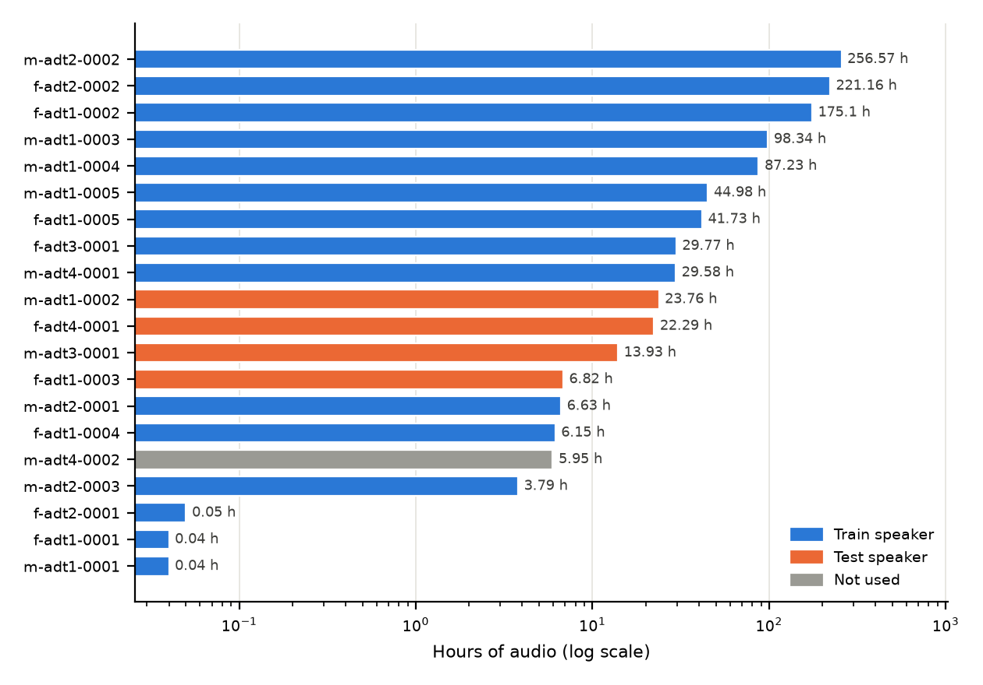
Figure 1. Hours of audio per speaker (log scale) and each speaker's role in the split. speaker m-adt4-0002 is not used because every sentence this speaker read was also read by a test speaker.

4. Methodology

4.1 Leakage-free split
Because each sentence is read four times, holding out speakers alone would still put test sentences into training. Our rule: test speakers never appear in training, and no sentence read by a test speaker appears in training. Training speakers' readings of those sentences form a second evaluation set of unseen sentences from known speakers. Validation holds out whole sentences for checkpoint selection. We compared four choices of test speakers and chose option D (two female and two male speakers aged 23–60), which keeps 872.0 h for training. We drop 673 clips with a missing duration, under 0.5 s, or over 30 s. Leakage checks run on every build. As a side effect, speaker m-adt4-0002 (5.95 h) drops out of training, because every sentence this speaker read was shared with a test speaker.
Table 2. Splits (option D, seed 42).
Split | Clips | Hours | Speakers | Purpose
Train | 376,255 | 872.0 | 15 | Fine-tuning
Validation | 1,288 | 3.0 | 12 | Checkpoint selection
Test | 3,712 | 10.0 | 4 | Unseen speakers and sentences
Test (seen speakers) | 1,891 | 5.0 | 10 | Unseen sentences, known speakers

4.2 Text normalization
We derived the rules from the inventory of all 190 distinct characters in the transcripts (Table 3). The same function normalizes training targets and both sides of every score. Primary CER also removes all spaces, because Khmer word spacing is optional and inconsistent; we report a space-sensitive CER as a secondary metric.
Table 3. Normalization rules and the sentences they affect.
Found in transcripts | Sentences | Rule
Zero-width characters | 6,233 | Remove
Punctuation (។ ៖ " « » ( ) , -) | — | Replace with a space (not spoken)
% & # @, symbols, repetition sign ៗ | — | Keep (read aloud)
Arabic / Khmer digits | 85 / 4,475 | Map Arabic to Khmer digits
Latin words | 1,642 | Keep, lowercased
Legacy order: subscript ro first / vowel before subscript / nikahit before u | 737 / 114 / 39 | Reorder to the standard order
Newlines / double spaces | 500 / 1,704 | Collapse whitespace

4.3 Models and setup
We evaluate two families without fine-tuning (M0): Whisper small, medium and large-v3-turbo, forced to transcribe Khmer, and MMS-1B-all with its Khmer adapter. All model revisions are pinned. Inference uses greedy decoding in fp16 on NVIDIA GeForce RTX 4060 Laptop GPU (8 GB). Whisper's zero-shot decoding repeats until the 440-token limit, which would take about 16 GPU-hours on the full test set; we therefore evaluate Whisper on a seeded sample of 100 test clips per speaker (400 clips) and MMS on the full test set. We report 95% bootstrap confidence intervals (1,000 resamples of clips).

5. Zero-Shot Results (M0)
Table 4. Zero-shot results on the test set (unseen speakers and sentences). CER ignores spaces; brackets give the 95% bootstrap interval.
Model | Family | Params (M) | Clips | CER [95% CI] | CER w/ spaces | RTF
MMS-1B-all (khm adapter) | CTC | 965 | 3,712 | 9.7% [9.5%–9.9%] | 11.6% | 0.007
Whisper medium | Encoder-decoder | 764 | 400 | 132.9% [129.7%–136.0%] | 150.5% | 0.706
Whisper small | Encoder-decoder | 242 | 400 | 136.3% [132.5%–140.0%] | 186.7% | 0.219
Whisper large-v3-turbo | Encoder-decoder | 809 | 400 | 177.1% [171.3%–183.0%] | 173.4% | 0.146

MMS-1B-all reaches 9.7% CER on the full test set (3,712 clips, 10.0 h). Its errors are mostly substitutions (5.0%) and deletions (2.9%), with 1.8% insertions. It runs at a real-time factor of 0.007. Per test speaker, CER ranges from 7.2% to 12.9%. Part of its error is structural: the released Khmer adapter's vocabulary has no symbol for the Khmer digits ៤, ៦, ៨ and ៩, so it can never output them.
All Whisper models exceed 100% CER, with 1,087 of 1,200 evaluated clips above 100%: decoding locks onto a repeated character until the token limit. This agrees with the 103.19% zero-shot CER reported for Whisper-large-v3 on FLEURS Khmer [5]. To find the cause, we ran 40 test clips (10 per speaker) through each Whisper model twice more (Table 5).
Table 5. Whisper diagnostics on 40 test clips: language detected when the language is not forced, and whether fp16 and fp32 decoding agree.
Model | Detected as Khmer | Detected as other | fp16 = fp32
Whisper small | 38 / 40 | vi 2 | 38 / 40
Whisper medium | 39 / 40 | vi 1 | 40 / 40
Whisper large-v3-turbo | 0 / 40 | vi 29, th 10, id 1 | 39 / 40

Numerical precision is not the cause: fp16 and fp32 decoding agree on almost every clip. Language identification separates the models: Whisper small and Whisper medium recognize the audio as Khmer yet still collapse into repetition when transcribing it, while Whisper large-v3-turbo mostly labels it as Vietnamese or Thai. Zero-shot Whisper therefore knows it hears Khmer but cannot write it, which is the gap fine-tuning has to close.

6. Planned Fine-Tuning Experiments
All experiments use the same locked test set and normalization, change one variable at a time, and select checkpoints on validation only.
- M1 — Fine-tune a pretrained model on the training split; compare with its M0 baseline (RQ1).
- S — Train on nested subsets (e.g. 10, 50, 100 h) to measure the effect of data quantity (RQ2).
- M2 — Add one Khmer-specific strategy (normalization, augmentation or fine-tuning method) (RQ3).
- M3 (optional) — Compare Whisper and MMS families after fine-tuning (RQ4).

7. Limitations
- The corpus has only 20 speakers and contains read cultural-domain speech; results may not transfer to spontaneous or other-domain speech.
- Whisper zero-shot results use a 400-clip sample; MMS uses the full test set.
- MMS-1B-all is licensed CC BY-NC 4.0, which restricts it to non-commercial research.
- Each configuration is a single run; we report bootstrap intervals over clips, not over training seeds.
- The split leaves 15 training speakers and excludes speaker m-adt4-0002, one of only 3 speakers aged 60 or over.
- The split option is provisional until approved; the test set will then be locked.

8. Conclusion
A full audit of the largest open Khmer speech corpus shows that its sentences are shared across speakers, which makes leakage-free evaluation essential. With a split that holds out speakers and sentences and a documented normalization protocol, zero-shot Whisper is unusable for Khmer while MMS with a Khmer adapter is already a strong starting point. The next step is controlled fine-tuning on the same protocol.
Reproducibility. Code, configurations and split manifests: github.com/chitrasem001/khmer-asr-research.

References
[1] A. Radford, J. W. Kim, T. Xu, G. Brockman, C. McLeavey, and I. Sutskever, “Robust speech recognition via large-scale weak supervision,” arXiv:2212.04356, 2022.
[2] A. Conneau, M. Ma, S. Khanuja, et al., “FLEURS: Few-shot learning evaluation of universal representations of speech,” arXiv:2205.12446, 2022.
[3] V. Pratap, A. Tjandra, B. Shi, et al., “Scaling speech technology to 1,000+ languages,” arXiv:2305.13516, 2023.
[4] S. Seng, S. Sam, L. Besacier, B. Bigi, and E. Castelli, “First broadcast news transcription system for Khmer language,” in Proc. LREC, 2008.
[5] S. Singh, A. Yadavalli, C. Arnett, and A. Warstadt, “BuzzASR: A swarm of 100+ monolingual speech recognition models,” in Findings of EMNLP, 2026. arXiv:2609.09554.
[6] J. Liao, W. Zhang, Z. Liu, et al., “SEA-SpeechBench: A large-scale multitask benchmark for speech understanding across Southeast Asia,” in Proc. EMNLP, 2026. arXiv:2609.09672.
[7] G. Das, D. Laskar, H. A. Ahmed, et al., “Robust Assamese speech recognition through controlled fine-tuning of Whisper models,” arXiv:2607.17164, 2026.
[8] A. Rouditchenko, S. Khurana, S. Thomas, et al., “Comparison of multilingual self-supervised and weakly-supervised speech pre-training for adaptation to unseen languages,” in Proc. Interspeech, 2023.
[9] H. Lovenia et al., “SEACrowd: A multilingual multimodal data hub and benchmark suite for Southeast Asian languages,” arXiv:2406.10118, 2024.
[10] Digital Divide Data, “Khmer ASR Cultural Dataset,” CC BY-SA 4.0, Hugging Face: Digital-Divide-Data/khmer-speech-dataset, revision e872b0c.
[11] sengtha, “whisper-base-khmer,” model card, Hugging Face, accessed Oct. 2026.
[12] Darayut, “Omnilingual-ASR-Khm,” model card, Hugging Face, accessed Oct. 2026.

