Coffee Shop Sales & Business Intelligence Dashboard
Degree of
Master of Computer Applications (MCA)

Submitted by
Register Number: 1RN24MC017

Under the Guidance of
Mupan Pruthvi Sir

RNS Institute of Technology
Bengaluru, Karnataka
Academic Year: 2024–2026

Certificate
This is to certify that the project report titled 'Coffee Shop Sales & Business Intelligence Dashboard' submitted by Register Number 1RN24MC017 in partial fulfillment for the award of the degree of Master of Computer Applications (MCA) of RNS Institute of Technology, Bengaluru, is a bonafide record of work carried out under my guidance and supervision.
Name: Mupan Pruthvi Sir

Acknowledgement
I express my sincere gratitude to my guide, Mupan Pruthvi Sir, for his valuable guidance and continuous support throughout this project.
I thank the faculty members of the Department of MCA, RNS Institute of Technology, for providing academic support.
I also extend my gratitude to my family and friends for their encouragement.

Declaration
I hereby declare that this project titled 'Coffee Shop Sales & Business Intelligence Dashboard' is an original work developed using Power BI and Python analytics for academic submission.

Abstract
This project develops a Business Intelligence dashboard to analyze Coffee Shop sales data. It integrates descriptive analytics, store comparison, product insights, and regression modeling to support strategic decision-making.

Table of Contents
1. Introduction
2. Research Methodology
3. Hypothesis Testing
4. Regression Model Analysis
5. Detailed Dashboard Explanations
6. Statistical Interpretation
7. Conclusion
8. References

1. Introduction

The Coffee Shop Dashboard transforms transactional data into actionable insights by applying Business Intelligence and data analytics techniques to retail sales data. In today’s competitive business environment, organizations must analyze large volumes of transactional information to identify revenue drivers, performance trends, and growth opportunities. This project focuses on converting raw sales data into meaningful visual insights that support strategic decision-making.
The dataset includes transaction details such as date, quantity sold, unit price, store location, and product category. Using Power BI, the dashboard presents key performance indicators (KPIs) such as Total Revenue, Total Transactions, Total Quantity Sold, and Average Order Value to evaluate overall business performance. These metrics provide a clear understanding of financial health and operational efficiency.
The dashboard further analyzes product contribution and store-level performance to identify high-performing categories and balanced operations across locations. Time-based sales trends help recognize peak-performing periods and assist in forecasting and resource planning. In addition, statistical techniques such as hypothesis testing and regression modeling are used to validate the relationship between quantity sold, pricing, and revenue generation.
Overall, the project demonstrates the effective use of Business Intelligence tools and statistical analysis to transform retail sales data into meaningful insights, supporting data-driven decision-making and performance optimization in a competitive market environment.

2. Research Methodology
Data Source: Transaction dataset including date, quantity, unit price, and store location.
Data Processing: Created Total Sales = Quantity × Unit Price.
Tools Used: Power BI and Python.
Techniques: KPI analysis, trend evaluation, correlation, and regression modeling.

3. Hypothesis Testing
H0: No significant relationship exists between quantity and revenue.
H1: Significant positive relationship exists between quantity and revenue.
Analysis supports rejection of H0.

4. Regression Model Analysis
Total Sales = β0 + β1(Quantity) + β2(Unit Price) + ε.
Both predictors positively influence revenue.

5. Detailed Dashboard Explanations
Dashboard 1: Sales Overview – KPIs and revenue distribution.
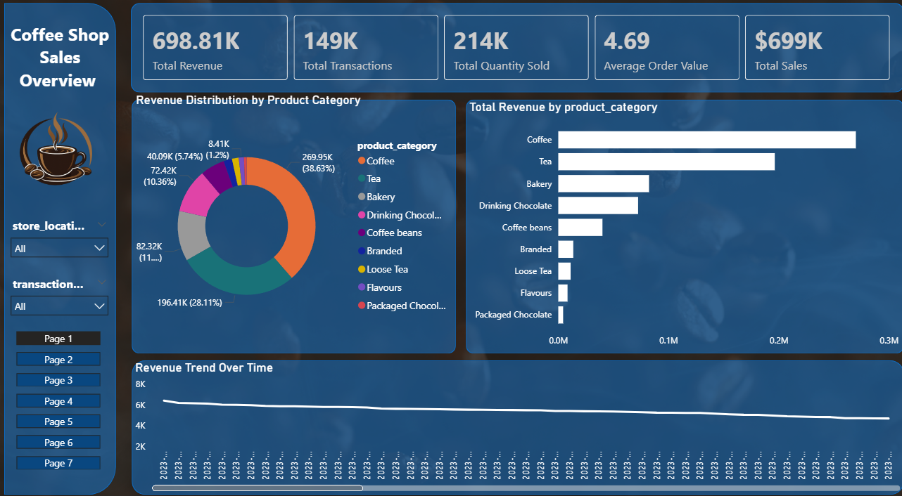
This page provides a high-level summary of overall business performance. Key Performance Indicators (KPIs) such as Total Revenue (698.81K), Total Transactions (149K), Total Quantity Sold (214K), Average Order Value (4.69), and Total Sales (699K) are displayed. The revenue distribution chart shows Coffee as the highest revenue-generating category, followed by Tea and Bakery. The revenue trend line visualizes daily performance, helping identify seasonal patterns and fluctuations.
Dashboard 2: Product Performance – Quantity and revenue by product.
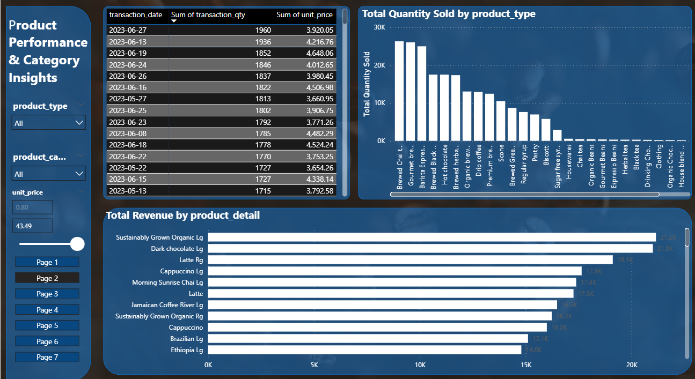
This section analyzes product-level performance. The dashboard displays transaction summaries by date, total quantity sold by product type, and revenue contribution by product detail. Top-performing products such as Sustainably Grown Organic and Dark Chocolate Latte generate the highest revenue. This page helps identify best-selling items and pricing performance across categories.
Dashboard 3: Time-Based Analysis – Performance by day and store.
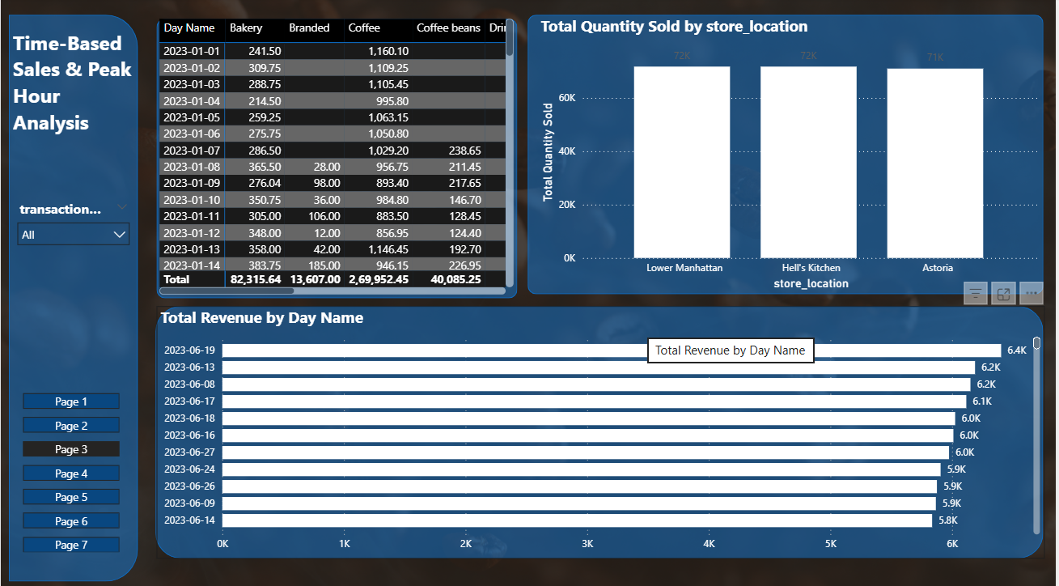
This page focuses on time-based revenue analysis. Sales data is broken down by day name and store location. The analysis identifies peak sales days and compares store-level quantity distribution. Lower Manhattan, Hell's Kitchen, and Astoria show balanced performance, with slight variations in quantity sold and revenue generated.

Dashboard 4: Store Comparison – Location-based revenue comparison.
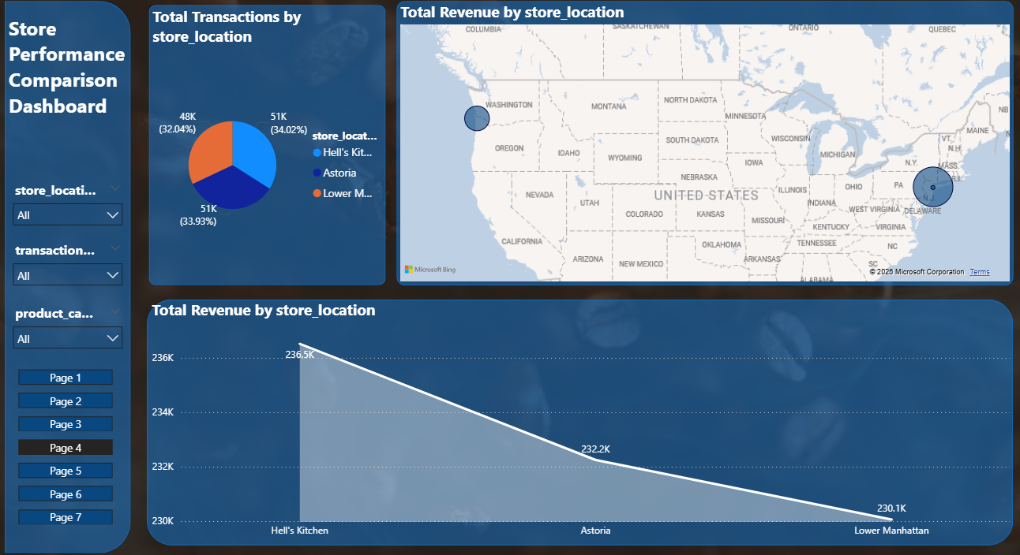
This page compares store-level performance using transaction distribution and geographical mapping. The pie chart highlights transaction share by store location. The map visual shows geographic revenue distribution, and the revenue comparison chart indicates Hell’s Kitchen as the highest revenue-generating store, followed by Astoria and Lower Manhattan.
Dashboard 5: Advanced Insights – Pricing and revenue trends.
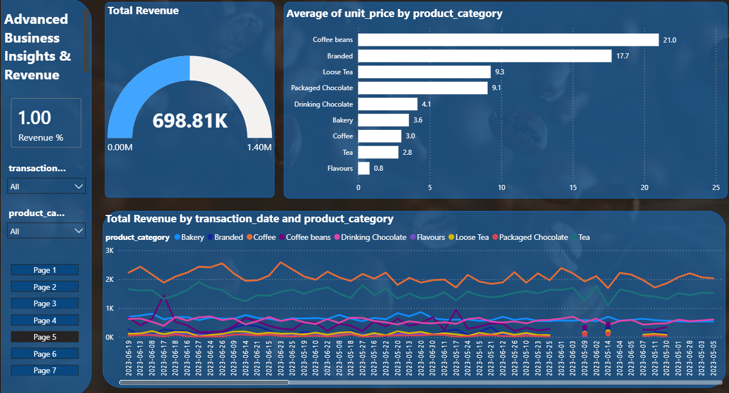
This page presents advanced analytical metrics including revenue gauge visualization and average unit price analysis by product category. Coffee Beans and Branded products show higher average prices, indicating premium positioning. The multi-line revenue trend chart displays category-wise revenue movement over time, supporting strategic pricing and inventory decisions.

Dashboard 6: Distribution Analysis – Pair plots and variability insights.
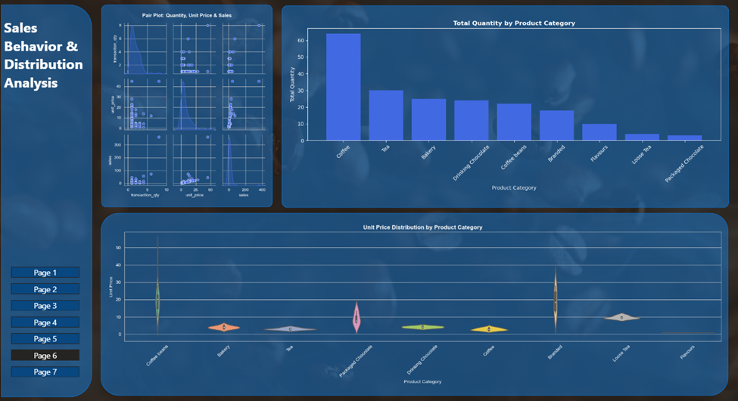
This page includes advanced statistical visuals such as Pair Plot, Quantity Distribution, and Unit Price Distribution using violin plots. The pair plot identifies relationships between transaction quantity, unit price, and total sales. The violin plot reveals pricing spread across categories, highlighting variability in Coffee Beans and Branded products.
Dashboard 7: Growth Insights – 3D analysis and cumulative growth.
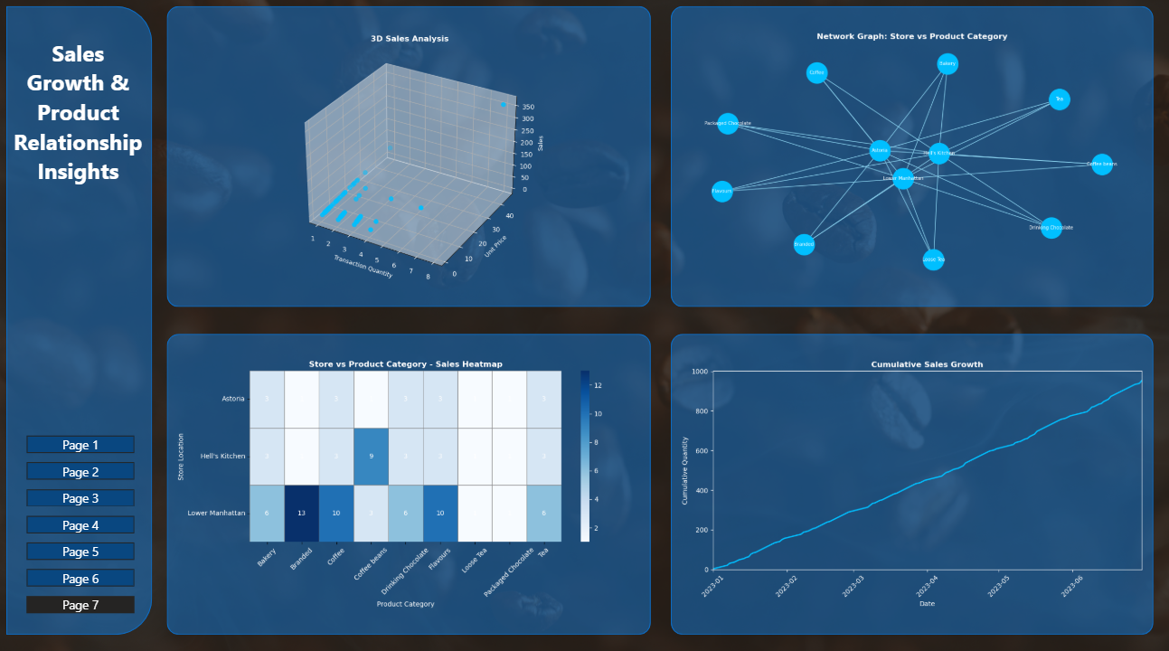
The final page provides advanced visual analytics including a 3D Sales Analysis, Network Graph, Heatmap, and Cumulative Sales Growth chart. The 3D chart demonstrates the relationship between transaction quantity, unit price, and total sales. The network graph visualizes connections between stores and product categories. The heatmap shows intensity of category performance across stores, and cumulative sales growth indicates steady upward revenue progression over time.

6. Statistical Interpretation

Coffee contributes the highest proportion of total revenue, indicating strong and consistent consumer demand within this category. Premium segments such as Coffee Beans and Branded products generate higher profit margins due to elevated unit pricing. Regression analysis confirms that both transaction quantity and unit price have a statistically significant positive impact on total revenue. These findings emphasize that sales volume and pricing strategy are the primary determinants of revenue growth and overall business performance.

7. Conclusion
The Coffee Shop Sales & Business Intelligence Dashboard project demonstrates the effective integration of Business Intelligence tools and statistical modeling techniques to analyze retail sales performance. The primary objective of transforming raw transactional data into structured and actionable insights has been successfully achieved through the application of descriptive analytics, comparative analysis, and inferential statistical validation. The dashboard provides a clear and comprehensive overview of business performance, supporting data-driven decision-making.
Key performance indicators such as Total Revenue, Total Transactions, Total Quantity Sold, and Average Order Value collectively reflect the organization’s financial health and operational efficiency. The analysis identifies the Coffee category as the dominant revenue contributor, accounting for approximately 38% of total sales, which highlights strong consumer demand and strategic importance within the product portfolio.
Product-level analysis reveals that premium categories, including Coffee Beans and Branded products, generate higher average unit prices and contribute significantly to profit margins. Variations in pricing across categories indicate opportunities for optimized pricing strategies. Store-level comparison across Lower Manhattan, Hell’s Kitchen, and Astoria shows balanced operational performance with minor revenue differences, suggesting consistent management practices while offering scope for localized marketing initiatives. Time-series analysis further supports business planning by identifying peak sales periods and stable growth patterns.
From a statistical perspective, hypothesis testing and multiple linear regression confirm that transaction quantity and unit price significantly influence total revenue. The regression model:
Total Sales = β₀ + β₁ (Quantity) + β₂ (Unit Price) + ε
demonstrates that both independent variables positively contribute to revenue variation. The rejection of the null hypothesis validates the statistical significance of these relationships and reinforces the importance of demand management and pricing strategies in retail performance optimization.
The inclusion of advanced visualizations such as 3D plots, heatmaps, network graphs, and cumulative growth analysis enhances the analytical depth of the study by enabling multidimensional insights into store performance and product relationships.

8. Future Enhancements
The current project lays a strong foundation for advanced business intelligence implementation. Future enhancements can include:
- Predictive Modeling & Machine Learning
Integration of machine learning algorithms such as Random Forest, XGBoost, or Neural Networks for sales forecasting and demand prediction.
- Real-Time Dashboard Integration
Connecting the dashboard to live databases for real-time monitoring of transactions and revenue.
- Profitability & Cost Analysis Module
Incorporating cost of goods sold (COGS), operational expenses, and net profit calculations for deeper financial analysis.
- Customer Analytics & CRM Integration
Integrating customer demographic data to analyze purchase behavior and improve customer retention strategies.
- Advanced Statistical Testing
Expanding analysis to include ANOVA tests, multivariate regression models, and elasticity modeling.
- Mobile & Cloud Deployment
Deploying the dashboard on cloud platforms for accessibility and scalability.
- AI-Based Recommendation Engine
Implementing AI-driven product recommendation systems to enhance cross-selling and up-selling strategies.

9. References
Field, A. (2018). Discovering statistics using IBM SPSS statistics (5th ed.). Sage Publications.
Healy, K. (2018). Data visualization: A practical introduction. Princeton University Press.
Microsoft Corporation. (2023). Power BI documentation. https://learn.microsoft.com/power-bi/
Wickham, H., & Grolemund, G. (2017). R for data science. O'Reilly Media.

