SimpliLearn Phase-2

Project Document

**Project Developer: Chitra Tambi**

**Project Name: Phase2-FlyAway-Project**

**API (Jar files):**

* **com.mysql.jdbc_5.51.5**
* **jstl-1.2**
* **stl-standard**
* **mysql-connector-java-5.0.8-bin-g**
* **servlet-api**

**CSS: style.css**

**JSP:**

* **index.jsp**
* **session_login.jsp**
* **session_logout.jsp**
* **session_dashboard.jsp**
* **flight_detail.jsp**
* **display_flight_detail.jsp**
* **registration_form_page.jsp**
* **review_details.jsp**
* **payment_reciept.jsp**
* **confirmation.jsp**

**Database: flyaway**

**Tables:**

* **flight**
* **login**
* **registration**

**Tables Description:**

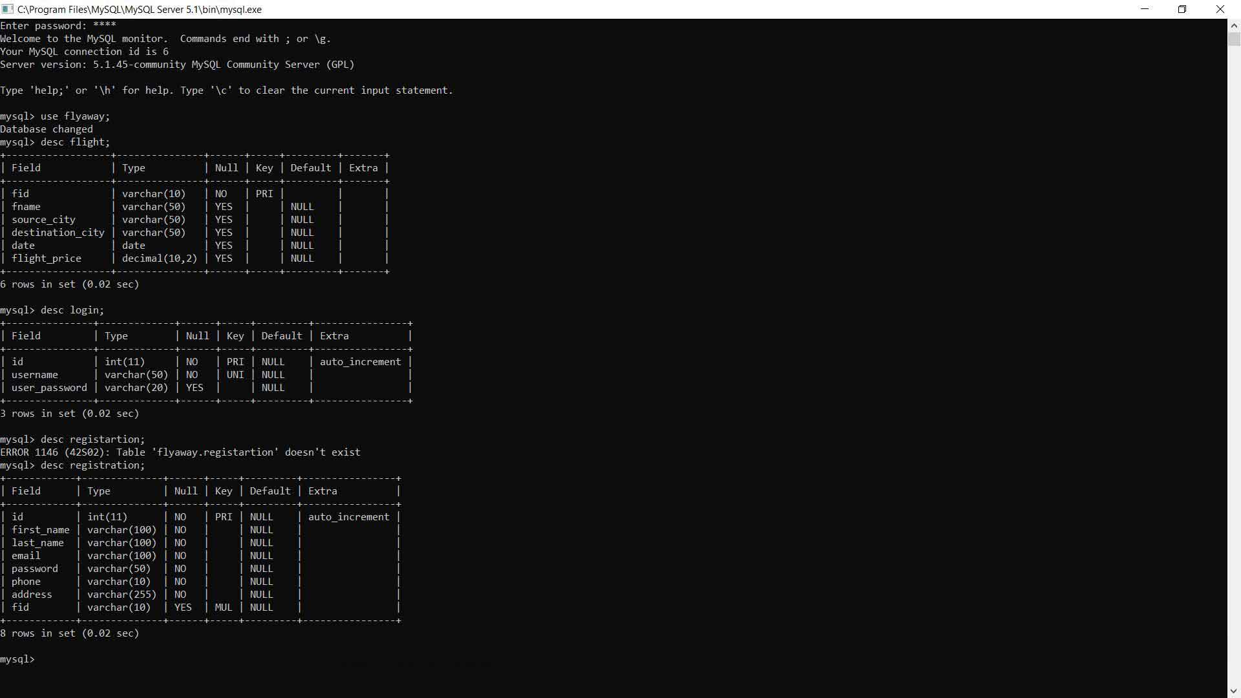

**Project detail:**

The project shows user a six webpages. Where user can

1. Login

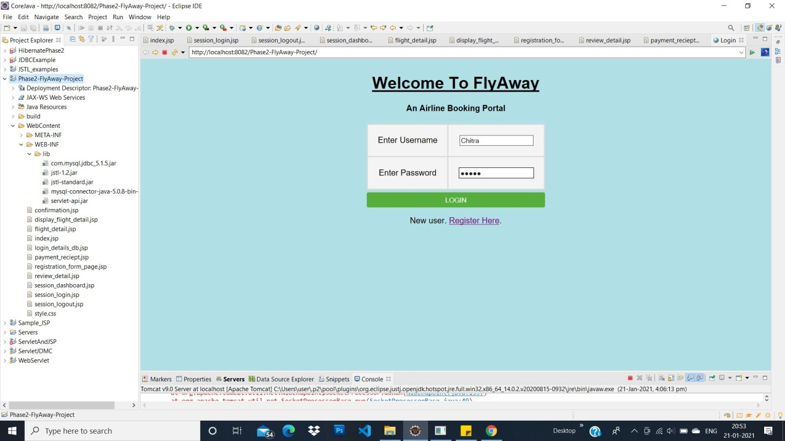

1. Search A Flight On Dashboard.

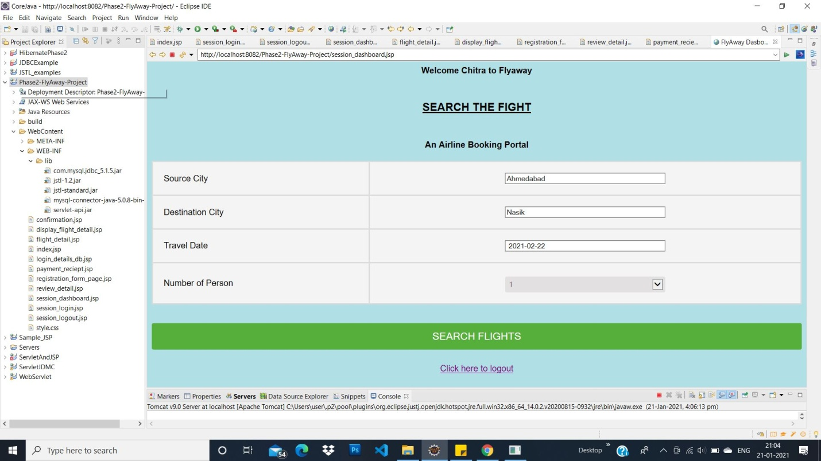

1. Flight List.

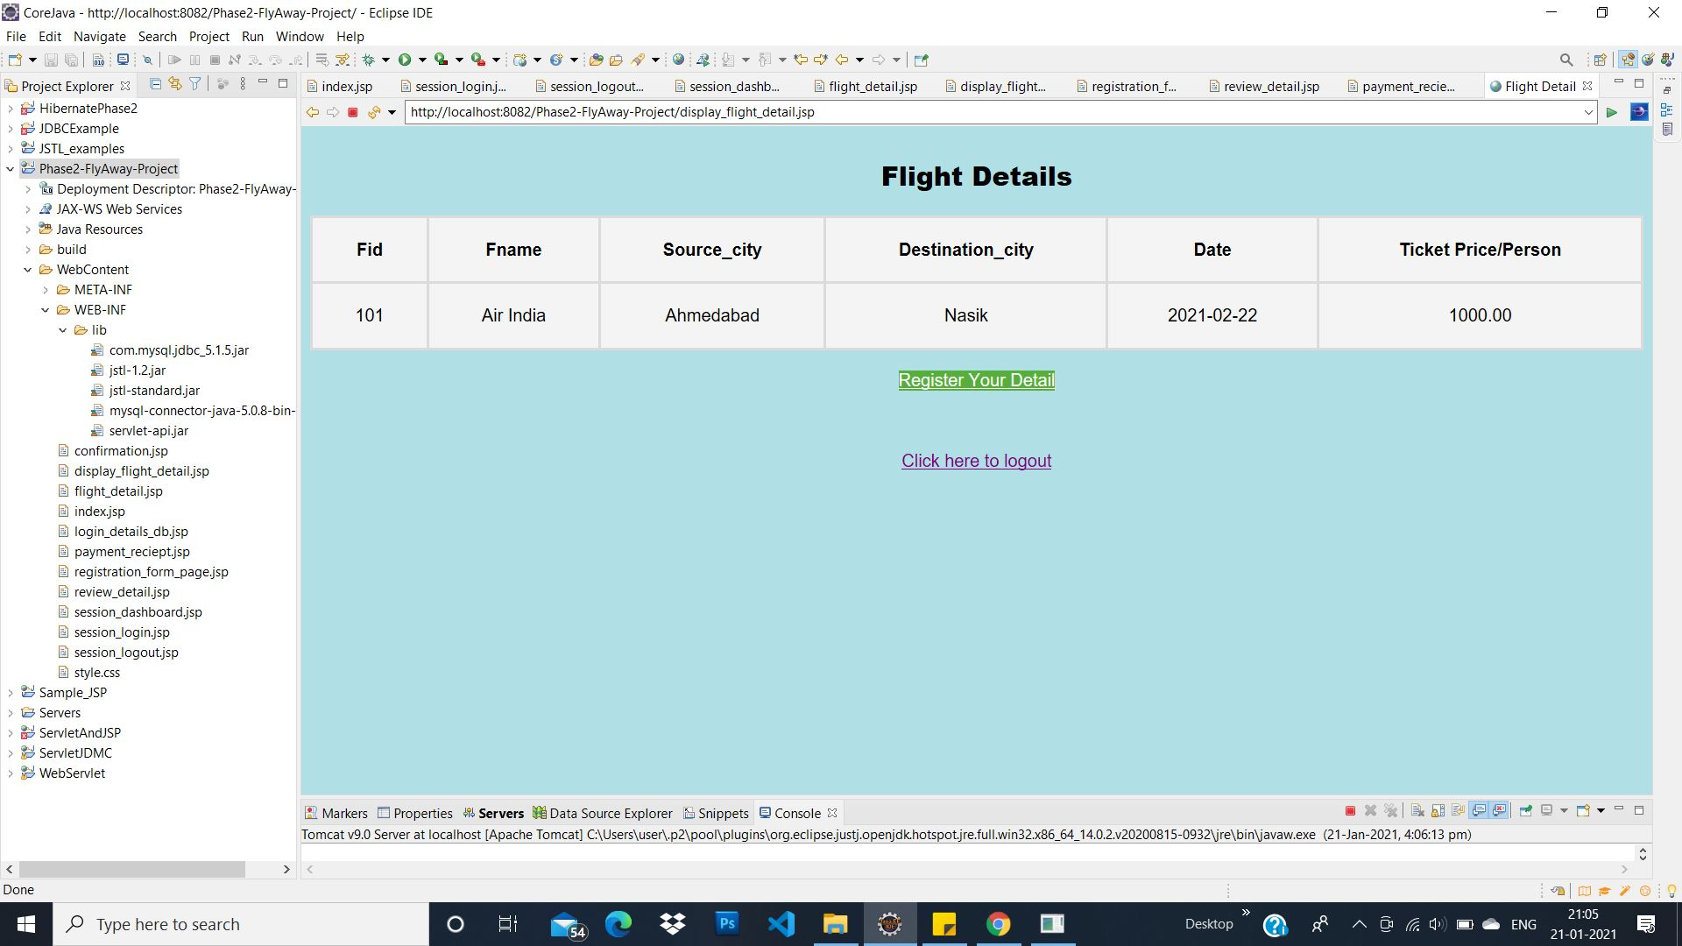

1. Registration Form.

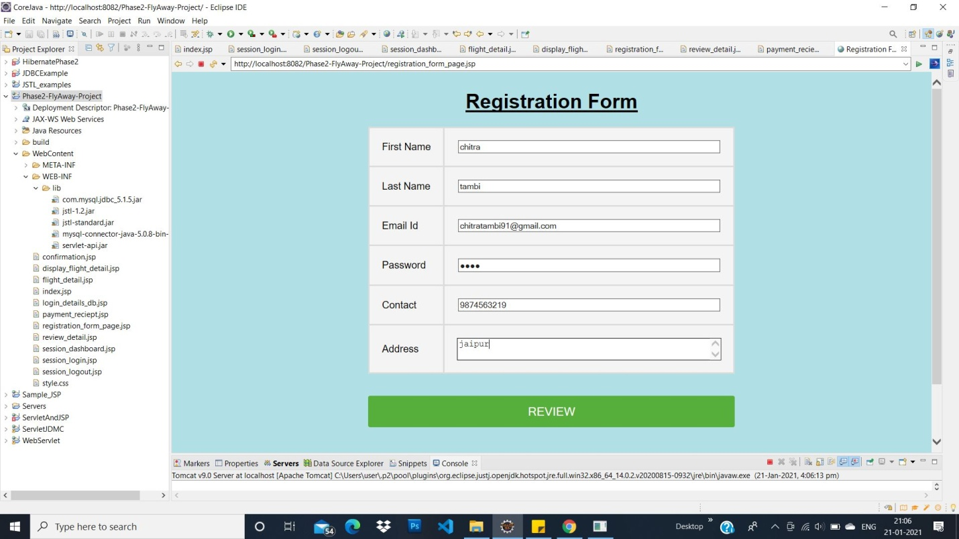

1. Review Details. 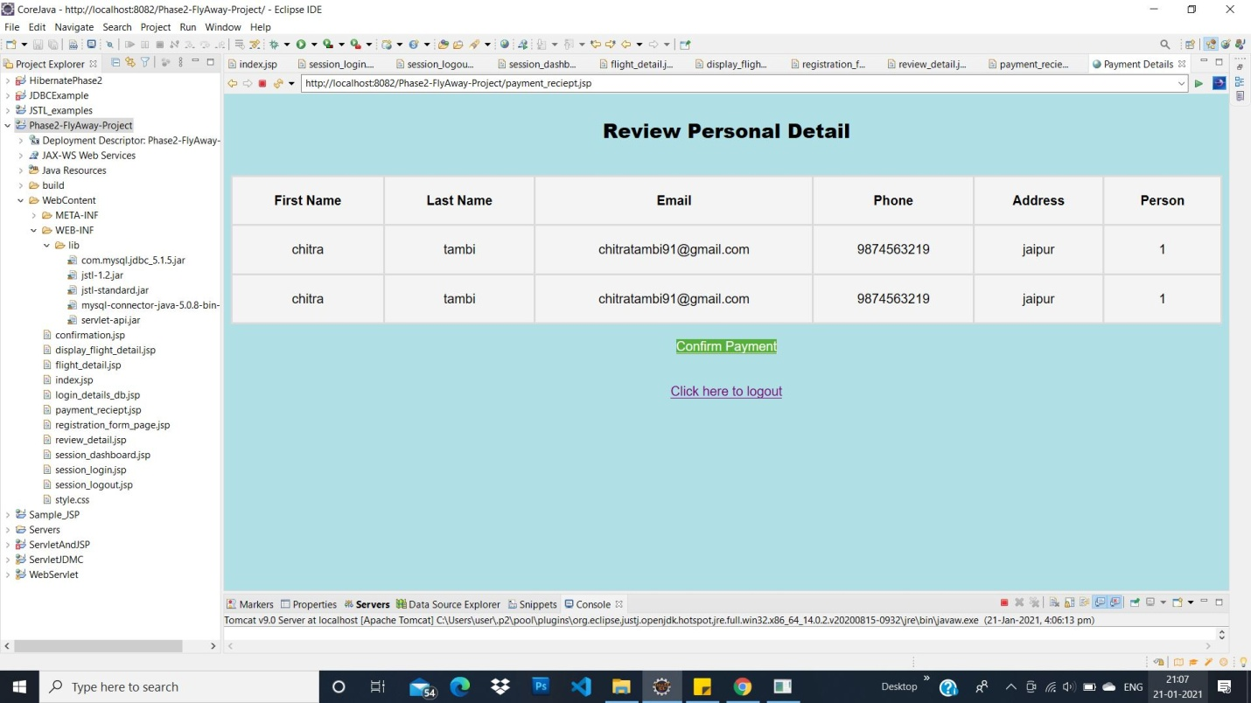
2. Confirmed Flight Ticket.

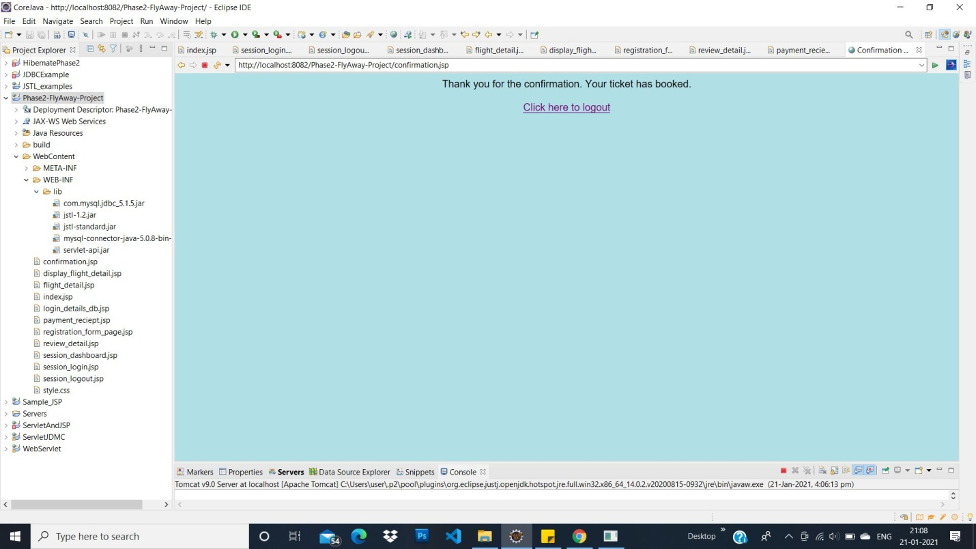

FlyAway is a ticket-booking portal that lets people book flights on the website. It is an airline booking portal named as FlyAway. Login Page (Starting from here) when somebody logins he will be sent to "Search Page". Search Page (2nd page after login. Here user search the flight)

* Source city
* Destination city
* Leave Date
* Number of persons

Flight Details Page (3rd Page after Search Page) based on the travel details entered on "Search Page", it will show the available flights with the per person ticket price. Register Page / Personal Details Page (4th Page after Flight Details Page) once a person selects a flight to book, they will be taken to a register page where they must fill in their personal details. Review Page: (this will come after Register Page) in this they are shown the flight details of the flight that they have booked and the payment is done via a dummy payment gateway. once user clicks on the" payment button" he will be shown a dummy payment page. Confirmation Page (this will come after Review Page) Shows message here" Thank you for the confirmation. Your ticket is booked".

**Github link**: <https://github.com/chitratambi/Phase2-FlyAway-Project.git>

**Technology used:**

* Eclipse: An IDE to code for the application
* MySQL: To create database, tables
* Apache Tomcat Server: To execute Java servlets and render web pages that use Java Server Page coding.
* Java: A programming language to develop the prototype
* Git: To connect and push files from the local system to GitHub
* Git Hub: To store the application code and track its versions
* Scrum: An efficient agile framework to deliver the product incrementally

**Concepts used:**

* HTML, CSS
* JSP
* SQL query
* Loops, Conditions
* Exception Handling

**Sprint detail:**

1. **Create Product Backlog:**

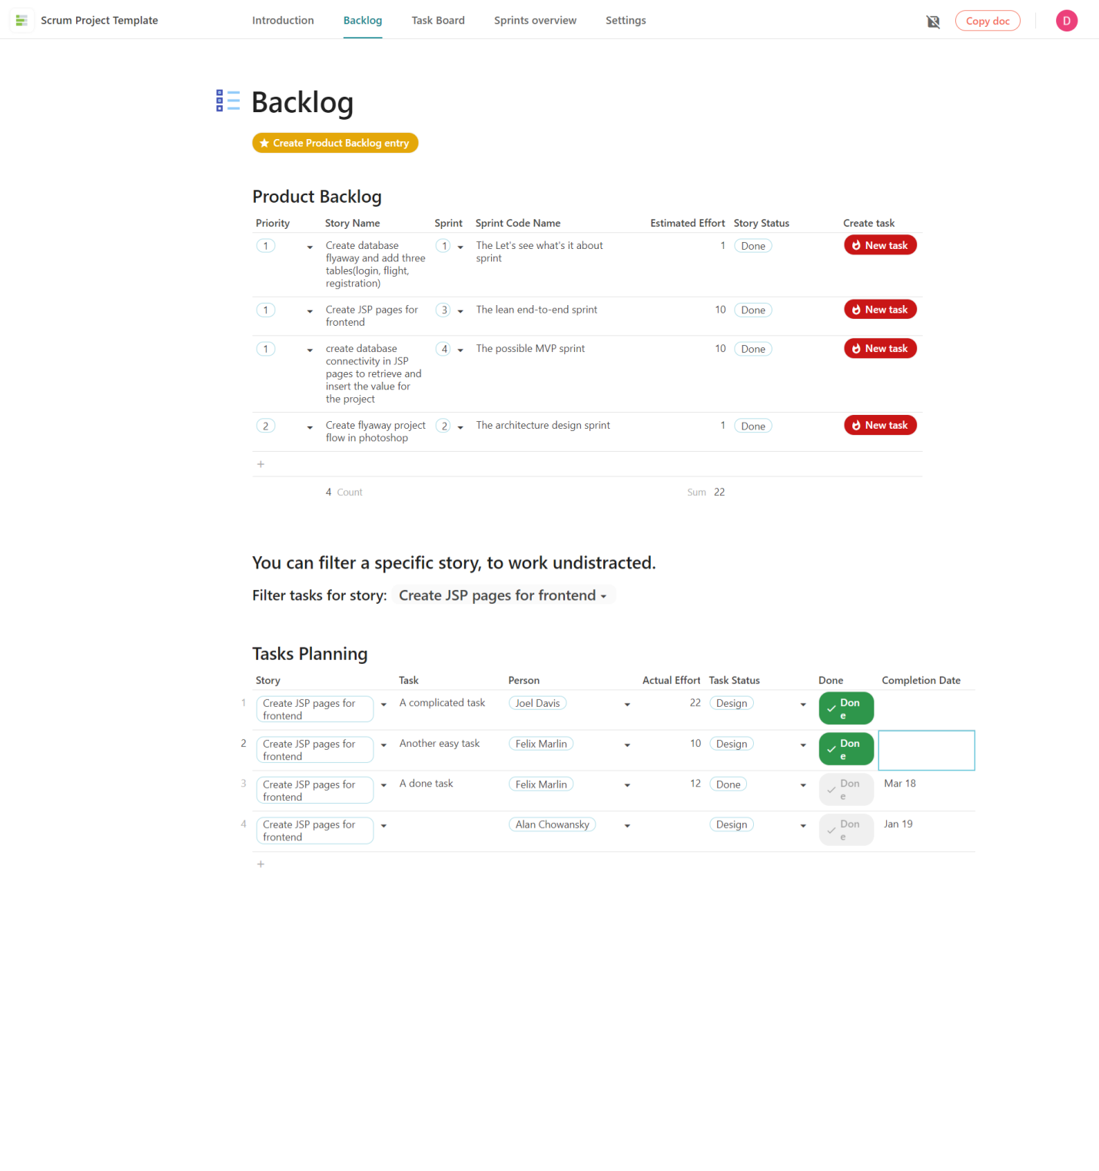

1. **Task Planning:**

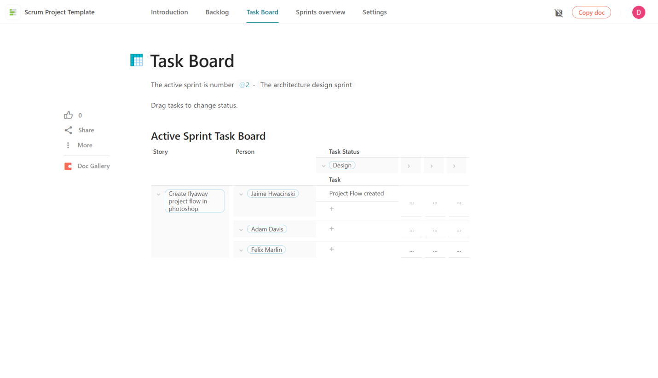

1. **Burndown chart:**

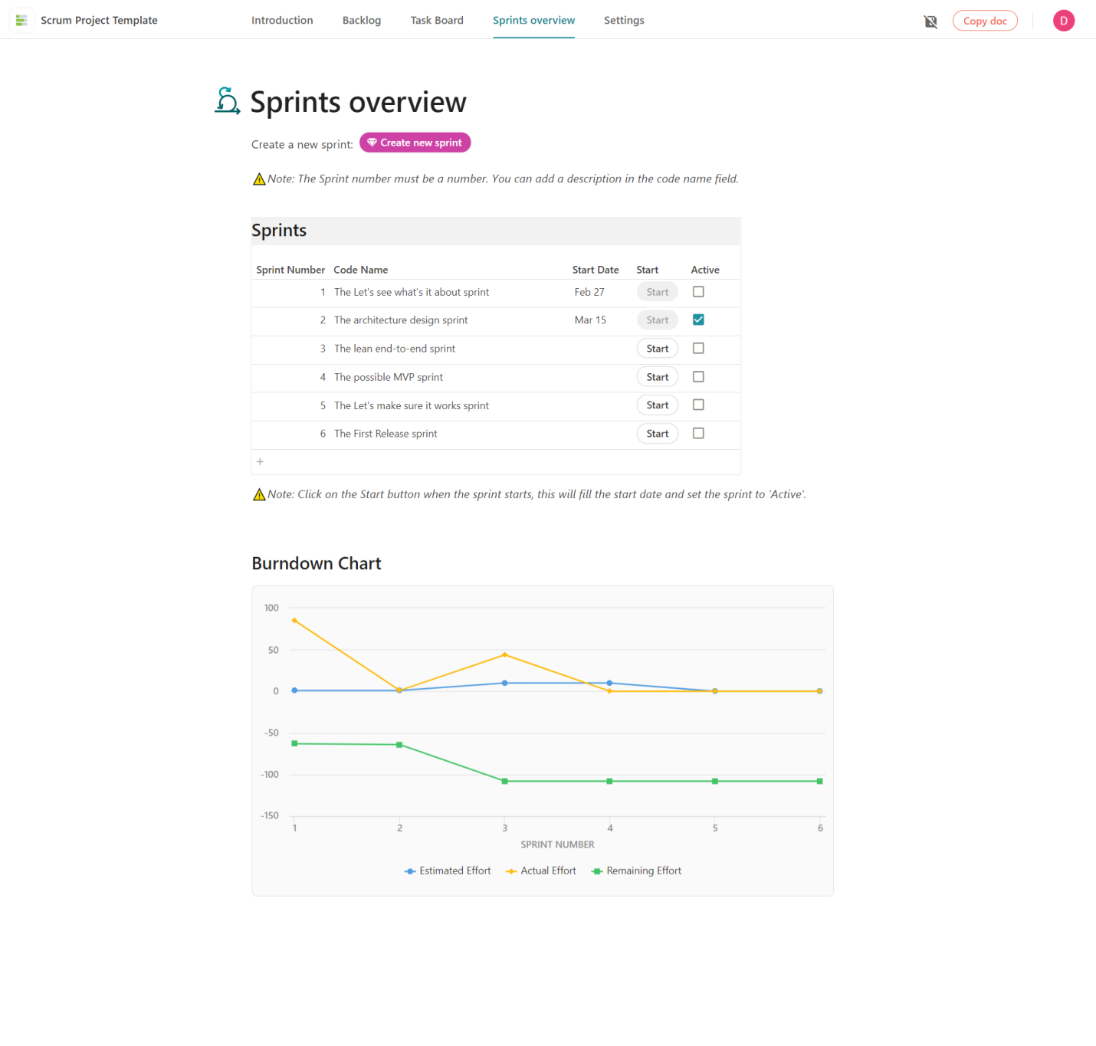

**Conclusion:**

The application has all complete features, planning the design and development in terms of sprints and then pushes the source code to the GitHub repository.